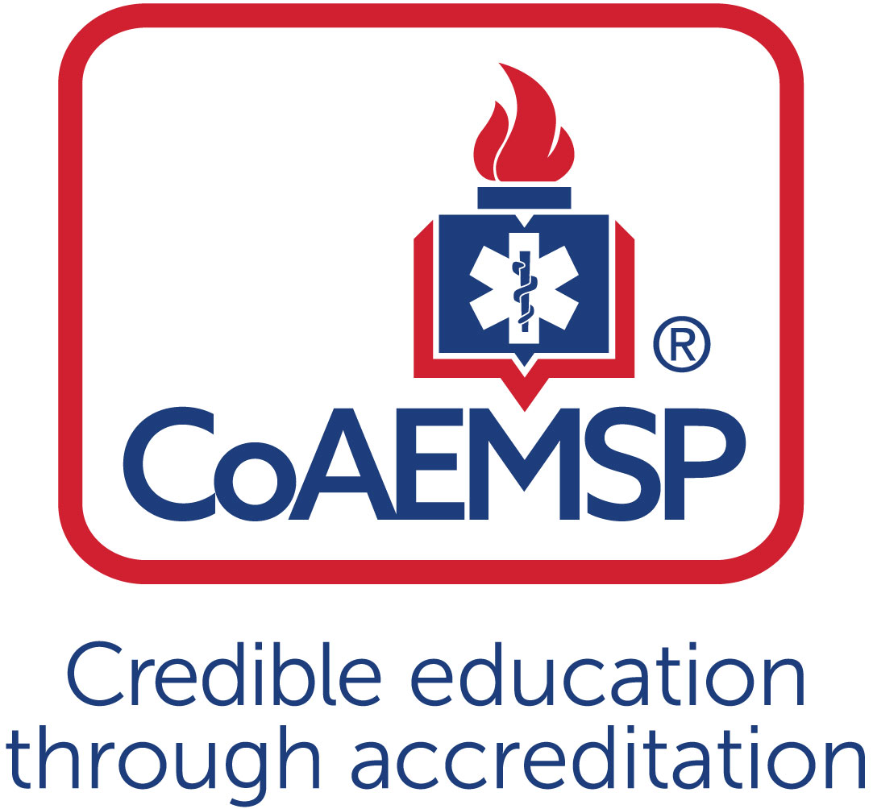
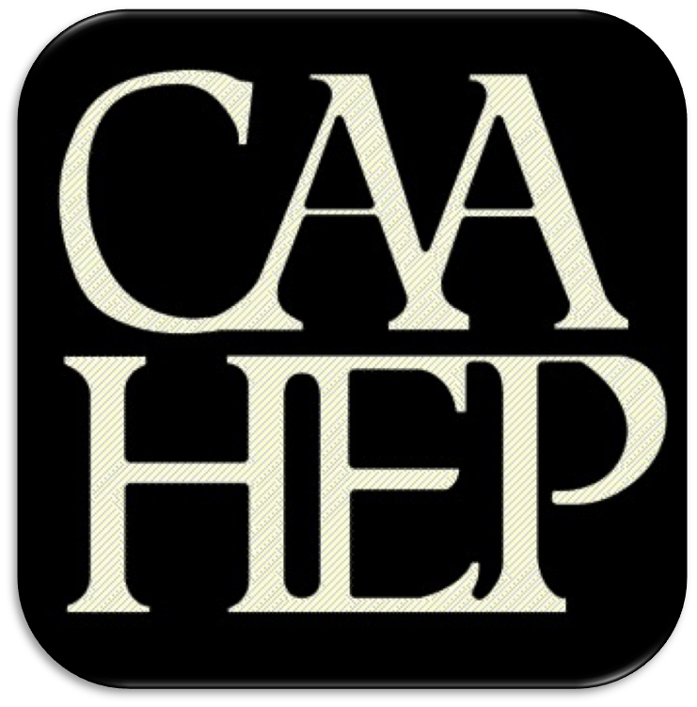

Advisory Committee Meeting Minutes

See last page for the purpose of the program’s Advisory Committee, including a description and list of responsibilities.

SPONSOR / INSTITUTION NAME: | Florida SouthWestern State College
CoAEMSP PROGRAM NUMBER: | 600034 | DATE, TIME, + LOCATION OF MEETING: | February 15,2022
CHAIR OF THE ADVISORY COMMITTEE: | Chief Dan Seiber

ATTENDANCE

Community of Interest | Name(s) – List all members. Multiple members may be listed in the same category. | Present – Place an ‘x’ for each person present | Agency/Organization
Physician(s) (may be fulfilled by Medical Director) | Dr. Alex Rodi, DO | x
Employer(s) of Graduates Representative | Bruce Gastineau  Larry Arfmann  Arthur Wolf  Curtis Rine  Randy Krause  Noemi Fraguela  Adrian Corujo  Cindi Gallman  Brian Angelson | x  X  x  x  x  x | Assistant Chief Collier County EMS  Division Chief Lehigh Acres Fire  Collier County Training Captain  Charlotte County Fire Training Captain  Ft. Myers Beach Division Chief of EMS  Training Captain Collier County EMS  Deputy Chief Lee County EMS  South Trail Division Chief of Safety/Training & EMS  South Trail Training Captain
Key Governmental Official(s) | Dan Summers  Britton Holdaway | x | Director, Emergency Management Services, Collier  Planning Manager Lee County
Police and Fire Services | Daniel Sieber  Jason Fair  Lance Pullen  Roy Brown  Chief Wahlig | X  X  x | EMS Division Chief San Carlos Park Fire  Public Safety Director Charlotte County  City of FT Myers Deputy Chief of Operations Fire  Bonita Springs Fire  Estero Fire
Public Member(s) | Barbara Jahn | x | n/a
Hospital / Clinical Representative(s) | Derek Mitchell  Jana Tuecotte  Risa Wildeman  Cathy Bartoszek  Noah Bourk  Mr. Dolan Abuaouf | x  x | Shore point Health  Lee health  NCH  Physicians Regional  Lee Health Trauma Center  Director of Academics and Medical Education at Lee Health
Other | Dr. Tammy Such  Tommy Mann | X  X | Dean School of Health Professions FSW  Senior Director of School Health Professions FSW
Faculty | Linda Welch  Mike Knoop  Tracy House  Tamara Mole  Matthew Stachler  April Bollinger  Megan Davis | x  x  X  x  x | EMS Support Specialist – EMS/FIRE Programs, FSW  EMS Support Specialist – EMS/FIRE Programs, FSW  EMS Support Specialist – EMS/FIRE Programs, FSW  EMS Support Specialist-EMS/Fire Programs, FSW  Program Coordinator-FSW  Clinical Coordinator-FSW  Program Coordinator-FSW
Sponsor Administration² | n/a | n/a | n/a
Student (current) | Ryan Koscielniak | x | Paramedic Student FSW
Graduate | Alicia Keen  Tony Santovinia | x | Paramedic Graduate  Paramedic Graduate
Program Director, ex officio, non-voting member | Joe Washburn | x
Medical Director, ex officio, non-voting member | Dr. Alex Rodi | x

Agenda Item |  | Discussion | Action Required | Lead | Goal Date
 | Call to order | Joseph Washburn: Welcome to another year of the FSW paramedic advisory board meeting. We are spread out today for Covid purposes and those of you on zoom welcome hopefully you're able to hear me ok. We have a couple things to cover today, but, most importantly, I would like to begin the meeting by saying an overwhelming thank you to Dan Sieber he has been a chair of this committee for nine and a half years and so, he is going to pass the baton to Mr. Roy Brown, and so I just again like the little applaud for Dan. We truly appreciate everything you've done for us for this committee, so thank you. | Yes / No | Washburn
 | Roll call | Dan Sieber: Thanks Joe. For everybody that's out the on zoom if you would for the attendance go ahead and put your name in the chat for us and folks in person can go ahead and fill up the roster that's coming around. Are we ready to kick it off? | Yes / No | Sieber
 | Review and approval of meeting minutes | Dan Sieber: Very good. First, item is to go ahead and get the meeting minutes approved from April 20 2021 or last year. If I can have a motion to approve the minutes.  Tracey House: I make a motion.  Sieber: We have a motion.  Roy Brown: Second.  Dan Sieber: Motion seconded any oppose? Motion carries thank you so much. Did you want anything further with that?  Washburn: no | Yes / No | Sieber
 | Endorse the Program’s minimum expectation  [CAAHEP Standard II.C. Minimum Expectation]  - “To prepare competent entry-level Paramedics in the cognitive (knowledge), psychomotor (skills), and affective (behavior) learning domains with or without exit points at the Advanced Emergency Medical Technician and/or Emergency Medical Technician, and/or Emergency Medical Responder levels.”  - Establish / review additional program goals | Dan Sieber: We will just move forward with if no questions any questions? As we do each year I’d like to make sure that one of the early orders of business is to get the endorse programs minimum expectation for Coameps is to prepare competent entry level paramedics in the cognition cognitive psycho motor and affective learning domains with or without exit points at the advanced emergency medical technician and or emergency medical technician in or emergency medical responder and levels. How about lead motion, if I could to endorse the minimum expectation for Coameps.  Jahn: Motion  Dan Sieber: I have motion second please.  Wolf: Second  Joseph Washburn: we've got motion to second all in favor.  All in attendance: I.  Dan Sieber: Any opposed? | Yes / No
 | Endorse the Program’s required minimum numbers of patient/skill contacts for each of the required patients and conditions  [CAAHEP Standard III.C.2. Curriculum]  - NEW Appendix G: Student Minimum Competency Matrix (effective July 1, 2019)  - Review summary graduate tracking reports | Dan Sieber: Very good, so, for the first kind of real change from this year for those of you will recall, last year we had set minimum program numbers for our students patient skill contacts that we have a little bit more understand better numbers now so I’ll turn it over to Joe to review an update for those numbers.  Joseph Washburn: So, for those of you that are joining us for the first time we have to make sure that students meet a minimum competency in a variety of areas and we often refer to that as the G report. As it's known over the years and with the G report, it establishes again minimum competencies for not only skills, but patient contacts in the clinical and field settings. And for the last three cohorts we have stayed right at the minimum requirements based on coamps. Now we are informed that for 2023 they will be providing us with a new type of G reporting so until that becomes active, we will like to continue from the G reports for perspective to continue those minimum numbers, and so we see what the new G report presents because we don't know what challenges that we're going to be faced, and I would hate to put the cart before the horse, by saying well we're going to do X number of patient contacts and now with the new G report we're unable to meet that so with that part I think it's important that we kind of steadfast on that, until this new report comes out, however, there's also the minimum summary tracking report so Tammy, if you could bring that up on the screen. So we're going to share with you an excel spreadsheet of minimum tracking report that we've done over the last two cohorts and a lot of what you're going to see here are also categories that are on the G report, but we can make changes here and not necessarily affect the current G report, so what we did is we looked at the two last two cohorts to look at what our minimum numbers were in these categories, and so what i'd like the committee to do is, we would like to raise our minimum numbers in these categories, for example for MED administration, you can see that, between the two classes, the minimum one that we had was and again this is both field, clinical and laboratory scenario based practice for these, and so we want to raise our minimum from 20 MED administration to make that 95 so the students would have to accomplish 95 MED administration's between all of their labs all of their clinical since all of their fields and again we feel very confident that we can hit that minimum number for that. Et tube right now we currently set up requirement for five, and the reason why it was set for five is because. at the time, that's what we were able to accomplish in just the OR with a live patient. But the summary tracking actually catches all the et tube that we do both again in the lab settings and so because of a lot of practices required, we want to change our et tubes for the summary tracking which would again include live and mannequins, we would like to raise that to 20. BVM ventilations again using the BVM through a variety of different scenarios, we would like to raise that number to 20, IV/IO’s we want to raise that to 68. And then, when it comes to our newborn infants, toddlers, preschoolers, school age, all of the pediatric parts I think that for each of those that were willing to go to a minimum of three I think that's a safe bet for us. Right now, and then I think the best part we can do is then capture the next cohorts data and again keep pushing our numbers to get the students to where they need to be as far as practice, and in saying that. When it comes to total PD type of calls again, I think that the we can easily do 51 and then for adult calls 95 geriatrics 87. Certainly, our Ob minimums we can definitely go to six right now and again, I think that I’m being conservative when I look at the first classes ss where we were versus making a second class that hit 20 again I don't want to find us in a position where we're unable to achieve that, so I think six is good number for that trauma think 52. When we look at cardiac 54 psychiatric type patients seven. Adults with shortness of breath 36. When we talked about pediatric shortness of breath, even though it says to here in the last class we have 14 I think we get at least go to five for pediatric dyspnea. For syncope type of calls 21 of damage abdominals we can do, eight. Altered mental status 24. And then, from a team lead perspective, I think we can be safe with 150 team leads again for when we're counting their tracking through the program through lab clinical and field rotations. So I think these numbers are certainly safe for us to move forward and while also maintaining our current minimums in our G report, which are going to be lower than our tracking but again until we see that new G report, I need to either sort of in a bind so if I can get some support from the advisory committee on that would be wonderful.  Dan Sieber: Any comments from the constituency a lot of numbers just tossed out will give a little time for anyone in the first in the room I’d like to comment on the numbers in front of you and question.  Roy Brown: Joe you mentioned all of the numbers were included with the lab is there any chance in the future that they would actually remove that to where it was just field.  Joseph Washburn: So, when we look at the G report there's four tables and the first table and the G report is only clinical and field and again that's where my reservation comes for us even adjusting the G report numbers because the new report I don't know those new minimums will be and I again I hate to find this in a bind where we can meet that, because then they have to come up with an action plan for that and I don't think that's our best interest. But no currently on summary tracking has to do everything we're doing lab.  Dan Sieber: And they'll send those numbers out to you anyone else?  Wolf: Why so low with the BVMs?  Joseph Washburn: Well, I think the problem that we have is that we're not doing a good job with students entering the data and they put they put an et tube in in our reporting software and fail to put down that they actually ventilated the et tube with the bvm, so I think it's a training issue because you can see from the first group to the next group we exceeded that my fear is, if we go too far with that then we don't catch it and now we've got to go back in time, so I think it's going to be a training issue for all of our ca's in our and our instructors, to make sure that those know when we're doing those kinds of things that we're capturing all of those things in our data software.  Wolf: documentation of procedures really important and I just surprised.  Joseph Washburn: I’m with you in the sense to us with this the last out going group out really stressed the importance of all of the numbers that they've been doing for their relations that they're just not they're not looking at that from they'll say they'll give 02 to that they won't choose like the bvm in the software and again I think it's a training issue on our behalf of catching up and making sure that the students are documented. So I just think we need another year will be able to take that number to a closer number of representing both.  Dan Sieber: Okay anyone else in the room, or folks online anyone wishing to ask a question or comment on the numbers, okay very good. With that can I get a motion to support the minimum’s, of the G report we're going to stay the same, and tell me see what Coamps throws at us next year. And then the numbers ever Joe's confident that we can meet doing it, the motion to endorse the programs minimums please.  Roy Brown: give a motion  Dan Sieber: and a second  Wolf: I second.  Dan Sieber: any opposed. No one in zoom land? Thank you so much carries into report and outcomes. | Yes / No | Washburn
 | Review the program’s annual report and outcomes  [CAAHEP Standard IV.B. Outcomes]  - Annual Report data  - Thresholds/Outcome data results  - Graduate Survey results  - Employer Survey results  - Resources Assessment Matrix results  - Other | Joseph Washburn: So for annual reporting of 2020. Again, coaemps as changed the way we do our annual report and it's further the year in arears. To make sure that all the students had a chance to graduate we've got graduate surveys and employer survey data to be able to place on the annual report, so the next annual report that will be doing for the year 2020 obviously the year 2020 is when we experienced the pandemic and that's where things changed for us. Where the paramedic group at that time was extended their lab or postpone for their spring term and got pushed to their summer term there didactic for that got finished up by the summer term, and then the courses that they would have had in the summer got pushed in the fall and so that group instead of graduate in 2020 actually graduated in April of 21 so when we report annually for 2021 will actually be reporting on two cohorts so for the annual report in 2020 we won't have a graduating students to report as far as our attrition or graduation numbers for that we will how after have to report on our resource matrix survey that we hand out students, we pass up to this committee, out to the Faculty as well, and so, for that we should be Is it OK so. In our Ram survey for the 2020. We were the top three positives for that RAM survey was that all categories were 100%. And that instructors and director always available to assist different instructors level experience and ride time, those were all the top three positives from the Ram survey. The top three concerns were that medical director interaction now again, this was in 2020 so we typically have the cohort do an ER rotation with Dr Rodi but with us being pushed out of hospitals at that time. The students are reporting on that didn't get an opportunity to have that interaction with that Dr.Rodi one on one. There are some students who at 70% said that there was an inaccuracy for faculty for the lab. Where again when you look at 2020 we there were days that we were short, the number of ca's that we would need for the day and those of you that are working in the field can understand you were you're being mandatory overtime, you were being exposed to covid at home which was definitely having an impact on us being able to have clinical associates in the labs and so again, I think we did the best we could, through 2021 with that shortage just based on the environment in which we were working and so those are those are the categories that we're concerned in the RAM survey.  Dan Sieber: Alright, anyone wishing to comment on the review of the survey or annual report obviously lack. Any other assessment results you want to review?  Washburn: yeah so we can talk about the graduate surveys also, so the top three for graduate surveys program received only 8 sponsors out of 25 and typically what we'll do is we email our surveys first and then, what we try to do is personally call each and every one of the students to get a response, and we were only able to log e8 responses and all the students responded that they were successfully targeted, with no prompting in all three domains, that would be the cognitive psycho motor in a separate domains. They said that Fsw prepared them well for being an entry level paramedic and they thought that again it helped with new clinical associates whenever possible because if they are more clinical associates they wouldn't have to speed up between transitions from one station to the next, for concerns. Again, our rates are low, so not sure how we can increase their rates, other than what we're doing as far as emailing and calling them. We do feel like with all of our data collection and our numbers for our surveys and our pass rates and all that definitely impacted through covid this is our lowest return rate and our last several so. I think when you look at our next group of graduates, will be able to pinpoint that we will have an increase in that area and definitely show that was that covid had an impact. From the employers, we got 18. I’m sorry 8 out of 18 returned on our employer surveys again the employers and the students were strong as an entry level paramedic. all students were well prepared to go through our paramedic academy and become credential as paramedics was another one of the comments. There were no negative comments as far as concerns for the graduating from any of the employer service so there's no concerns from that.  Joseph Washburn: Was there any questions about the graduate surveys at all, or the employer surveys persons?  Joseph Washburn: They are we tried online, I mean that's what the email them and it's a link for them to do. I think the challenge is always ever faced with is that is six to eight months after the program and depending on whether they're still working towards becoming prudential or not, are they still here in the area or not. That affects our response, I mean it'd be great if you can survey and go out and work with that really doesn't help because we don't know it's like working so it's just an it's just a challenge, I think. Coaemps recognizes the challenge on that is there, they used to penalize us for a low response rate and they stop analyzing for us from accreditation perspective, they just want to make sure that we sent out 100% to the graduates and 100% of the employers and then you know basically do the best we can get the responses back from the student. So there's no questions that's all I had for our annual report and outcome needed. | Yes / No
 | Review the program’s other assessment results  [CAAHEP Standard III.D. Resource Assessment]  - Long-range planning  - Student evaluations of instruction and program  - Faculty evaluations of program  - Course/Program final evaluations  - Other evaluation methods | Dan Sieber: Alright, moving on to the other assessments is where you want to go with that.  Joseph Washburn: I’d like to talk about long range planning I can say in previous years, that we obviously did long range planning, but it was I don't think we really formalized it before and based on come casual conversations between instructors the students yourself of what we needed to look for in the program and Coa put out a nice in your long range planning guide for us to utilize to then try to really do a more formalized long range planning, so what we did this year was we asked instructors, students, clinical associates to come in and review data on the annual report, the resource matrix, the exams, surveys, minutes from our advisory board and start to kind of lay some foundation for the program three to five years out. And so, in that meeting, the first thing we kind of talked about was the challenges that the program has been faced with have a good candidate pool of students to bring into the program and from that meeting what we think that we need to do as our first part of a long range plan was to come up with some solutions to increase that candidate pool and so from that we had a brainstorming session and what came out of that was to try a multi-pronged approach in a social media campaign which would allow us to look at different social medias than just Facebook, as a way to try to educate and entice students wanting to seek their paramedic credentials, we talked about using the different social plat forums like Twitter and tick tock. The other thing was to look at opportunities for scholarships, either in our foundation and they really thought that, from a scholarship perspective, it can be as much as assisting them to pay for school or maybe just even assisting them in some of the equipment that they have to purchase as part of their uniform can be as can be as simple as that. The other thing was to start looking at the possibility of doing maybe a continuing education program where we can teach emergency medical responder course, even though that it's not a certification recognized by the state, per se, but it might give the students high school students kind of more insight in the pre hospital care that might then guide them towards Emt and then eventually got it towards a paramedic program and then the other thing was really trying to work with our current EMT’s and you know, trying to find out their needs and really try to pick from our Emt pool of students to get them to move You know, into the paramedic areas. And Roy was part of that meeting as well, so if you have anything you want to share for that.  Roy Brown: I mean you know so far you get on get on quite a bit, I know I know there's some further discussion on. what we discussing with the different not making the transport companies in the numbers and transport companies. May you I you hit your main goal was is that over time.  Joseph Washburn: So that's from our 2 hr. meeting really felt like that was going to be our first again it'll be an annual thing and we'll just add to it, and we can kind of gauge how well we're doing with that was that's what came out of our meeting to start in our long range planning is working on increasing our applicant pool for that.  Dan Sieber: Are you in the high schools that offer the current emergency services, is there a way to get at the advertisement or talk.  Joseph Washburn: Right so we're not and again that was one of the things that was recommended that we try to get into those high school academies to be able to make some presentations to see if we can work those students again into our EMT program which will then lead to our enrollment.  Dan Sieber: Any comments from the room about those results.  Zoom: Likes the idea of high school first responder course.  Roy Brown: So the kind of time with high school I know with you know with the new high schools they open up one without really some other ones in the county you know they have all that HVAC, aviation programs, so I don't know if that can tag along with that. Chat with some of the high schools administrators, accounting programs on introducing not just hey here's some information, but maybe actual an actual program know that they can actually labeled endorse and market for themselves right. And then also, I know, we had a brief discussion on you know the competition, now that FSW faces. But then again it's going to it's going to change here, maybe in the next few years, as they have to really started publishing their information and they just have their you mentioned they're just the letters in. And it's going to be a lot tougher for them moving forward so that's kind of you know for this program with us more established.  Joseph Washburn: Agree with what Roy brings to the to the table is that starting in January of this year, the state and the national registry have ended their timeframe for students, to be come Coaemps accredited and without that accreditation you're unable to take the examination to become Florida Certified Emt or paramedic and the only schools that are able to do that is either schools that are fully accredited or they have your initial what's called a letter of reviewing where they started their accreditation process. And it will really my opinion level playing field, because then we can all now start comparing schools apples to apples versus in the past, apples to oranges and so they will all have to assess the programs and reassess our programs like we do to try to make their programs, the best scenario as well.  Dan Sieber: thank you. | Yes / No
 | Review program changes (possible changes)  - Course changes  (schedule, organization, staffing, other)  - Preceptor changes  - Clinical and field affiliation changes  - Curriculum changes  - Content  - Sequencing | Joseph Washburn: All right, oh, I think the other thing that we can talk about as far as the other assessments that we have is when it comes to our clinical field we looked at the clinical evaluations from the students and faculty and top comments, there were from the presceptors was good, IV and critical thinking skills good treatment plans, great patient assessments, display professional behavior delivered high standard of care anticipate patient needs. Some of the comments for students to improve on in the clinical settings was to continue to work on their communication and continue building their assessment techniques and skills, learn to take charge more and learn to ask more questions of their patients were comments made from our clinical settings. In the preceptor evaluations from our field agencies they were the good was good bedside manner great interaction with patients’ excellent differentials, choosing correct treatment great job of assessment treatment and interaction good IV skills Lead interpretation and differential diagnosis or spot on. Some things that we need to work on thing that was need to establish a good scene presence, they need to review trauma criteria and medication knowledge more in depth questioning of patience when patients are too vague. Start IVs sooner continue to work on skill sets, taking into consideration the priority and assigning tasks. So those are things that came back in the preceptor evals we looked at both the In 19-20 cohorts was really top three and have both positive and negative for that.  Dan Sieber: So I’m assuming on all those surveys, will continue for each cohort.  Joseph Washburn: Yes, that is a that is definitely a requirement for sure, a think and April, can kind of speak on this one of the things that we are going to change we did have a lot of non-comments just signatures from receptors in both the clinical and field and now we're going to mandate the students try to get.  April: one positive and one opportunity  Washburn: An opportunity anyone at least one positive comment in one opportunity for them in both of those settings so that we can get a little bit more feedback other than just the liker scale.  Dan Sieber: Moving on the program changes.  Joseph Washburn: So for program changes currently we have only schedule change that we're going to do is this upcoming cohort will now return to B shift, so we will have ran three cycles, we started with a B shift when we went to the shift schedule, and so we did a b shift, and we did a C shift we're in our current cohort is in A shift now and so we'll be taking applications for the next cohort which will be on B shift. So that that has changed. As far as course changes. We have no anticipation course changes from our current schedule. There will still be three didactic, semesters three lab semesters the clinical setting we have which we mentioned that our last meeting was we made it a D term so our clinicals now run from January to August getting the students more available time to get their clinical time completed. And that has been a that has been great for us so we'll continue that on the last semester will be there capstone in which they will do there ride time and put everything together for that so. You don't see any changes from course changes April from clinical is there any changes that you anticipate?  April Bollinger: yeah so we unfortunately lost our psych rotation and our pediatric rotation at lee health. I’m reaching out to lee health I’ve reached out to a few other programs as well, to see if we could get psych with them, and I have spoken by haven't heard back a definitive answer so we will be following up with lee health, to see if we'll be able to have students that at Park Royal and be able to have students at Golisano’s.  Joseph Washburn: Do we have any field updates for right.  April Bollinger: As far as field I just spoke with Lee county and now they're changing up their training and we know that now field, specifically that Lee county will be about three weeks out that we will find out the schedule for the following month. So students will just have to prepare in that aspect but as far as the rest nothing right now.  Joseph Washburn: Do have new providers we are going to use.  April Bollinger: yes yeah so we're working alongside Hendry county right now to create an agreement, they are very excited about students to be able to come out there and have the field shifts there. They'll just there we just have to complete the Agreement establishing.  Joseph Washburn: So we do have some staffing changes Linda Welch has been with us for long time is going to retire, and hopefully we're going to be able to get as much of her knowledge before she leaves. But Linda will be retiring we have a new program coordinator instructor Megan Davis here in the back, she is now full time with us. Teaching and both the Intro and in OB the pediatric trauma sections of the paramedic program. Those are two personnel changes that we will only that Megan on board and then Linda retiring still congratulations. | Yes / No
 | Review substantive changes (possible changes)  [CAAHEP Standard V.E. Substantive Change]  - Program status  - Program personnel: PD, Lead Instructor, other  - Addition of distance education component  - Addition of satellite program | Dan Sieber: Substantive changes.  Joseph Washburn: So, I would like to introduce the new dean of school health professions Dr. Tammy Such she's on zoom here she is The new Dean in terms of scope of operations overseas our EMS and fire science program. Also I’d like to introduce senior director of administration and my immediate supervisor Tommy Mann as well, who are new additions to our program so again welcome, and thank you so much for your support.  Tami Such: I’ll jump in and just say thank you all for your time today and always as you support our program. I’m happy to be new to FSW certainly I’m learning a lot and I just arrived early December so I’m just getting into the role and getting to know that our EMS offerings and certainly happy to support in every way that I can, so thank you. | Yes / No
 | Other identified strengths | Dan Sieber: Thank you so much. Do you want to talk about the SWOT analysis.  Joseph Washburn: So I prepared everyone you had time to review a SWOT analysis of the program and just to summarize where the program programs at I think the program has the strengths, certainly with our personnel our support from our administration, the equipment that we have, I think our pass rates our current pass rates for the group that just graduated we're at 77% for the first time pass rates on the National Registry. And same for second and third because the three students who have failed, and yet to make your second attempt, so those numbers will go up as they make there of second time. We definitely have seen and we still have two students outstanding them to take the exam so are certainly our first success rates getting back to where it needs to be in the 80%, if we look at our Covid group that went out and definitely saw how Covid over that in fact in our graduate groups to their first pass rates were right around 62% for first time and then they're up to 78 second. And 80 something for third when you combine the two, in which we will combine the two currently that takes our 77 down 72 when you look at all 30 some students for the two cohorts combined together brings us down to 72 for first time and leave it 72, 78 two attempts or more which is above the threshold is certainly not where we would like to mean like to be up in the 80’s or more. And I think if you look at all of the schools, because it's published on the FL Department of Health and MQA a website all of the schools pass rates are presented, we are in, we are in the top of the schools, even with those scores for pass rates for the paramedic Program. So I think everyone suffered from Covid and what that impacted the students and programs. So, if we look at some of the things that we can do better. I think again, one of the areas that we've talked about in our long-range planning is increasing our applicant pool, so that we can be picking the best candidates possible and that certainly can lead to an opportunity for us if we can get it in those areas and execute long range planning. I think another opportunity for us that we could have is do to covid we had trouble getting into the ORs for and we were able to bring in a cadaver. Where the students spent a whole day, eight hours shift just working with a Cadaver and doing endotracheal intubations, so I think, and that went very well, and I think that that's something that we can look at becoming more permanent part of the program under the right circumstances. So hopefully Tommy and I can work on ways to find funding for that to make a more regular opportunity for the students. As far as threats goes, I think that the thread that all programs are facing is there's a greater number of opportunities for students to go to schools. And with this increased opportunity it has a shrinking effect for everyone's opportunities and both the field is clinical settings. And certainly, the pandemic is it's been an ongoing threat for all of us might but some of that will subside, as I said, but certainly definitely to keep a look at as we continue to move forward.  Dan Sieber: Any comments from the room on the SWOT analysis. Anyone online wish to comment apologize I can't see the chat stuff I’m old. Thanks. Very good sir, it seems the identified action plans are in line with the long term plan | Yes / No
 | Other identified weaknesses |  | Yes / No
 | Identify action plans for improvement | Joseph Washburn: That is correct, I think that is our action plan is to start formalizing opportunities in those areas that we spoke of.  Dan Sieber: So I have asked for other comments recommendations that takes us to your professional education, sir. | Yes / No
 | Other comments/recommendations |  | Yes / No
 | Staff/professional education | Joseph Washburn: So just to give you an update on staff and professional education. All of the instructors myself are Namse Level one instructor certified we all went through the National Association in EMS educators instructor one course and we are all successful and completing that I completed the instructor level 2 course which was a lot more administrative in nature. We have attended multiple Coamps accredited workshops on how to do better at a affective domain, tracking, item analysis for final exams. And so, I think for this last year, we did an outstanding job doing some more continuing ED for the Program. | Yes / No
 | CoAEMSP/CAAHEP updates | They do know that we have an upcoming accreditation workshop that's going to happen in Oklahoma. In June I’m not sure where we will be financially, how many or who will be able to send over to look to see if we can send at least one or two to the Accreditation Workshop | Yes / No
 | Next accreditation process  (i.e., self-study report, site visit, progress report) | Just to give everybody an update our self-study for accreditation is due April 1 my team, and I have been working diligently putting all the documentation that's required for self-study together we'll be sending that off April 1 and then they will. They will come to the campus for a onsite visit anywhere between four to six months after that, once we have those days, we will get them out to the advisory because they will want to meet with the advisory team here and questions and stuff. So that is to happen this year, probably is the latter part of.  Dan Sieber: The that kind of took us through the updates and then the next is other business for any of the constitutes or you Joe? | Yes / No
 | Other business | Joseph Washburn: No, I would just again to reiterate, I appreciate everybody's time in coming in and participating in this, this is really important for our program to be able to share our data and gather insight from people like yourself where were we do where opportunities for us to do better. And then certainly share our accolades of areas that we think you're doing really well so again, I thank all of you for participating in this. I hope to get back to the day, where we're all in the same room, because I do I do like that and I look forward to that in our upcoming meetings throughout the years.  Dan Sieber: Thank you, I just like to say thank you very much, to Linda for all of our years of dedicated service thank you everyone and leadership and everybody to take the time we're going to let Dr Rodi gets some sleep I think you're just a second away here. We need to find out when the next meeting is.  Joseph Washburn: The next meeting will be. Well Okay, the next formal committee meeting will be a year from now next April, however, we will be sending out updates that we'd like to committee to again in our reconvene for the site visit | Yes / No
 | Next meeting(s) | 4/2023 | Yes / No
 | Adjourn | Dan Sieber: so busy very good looking forward to that I’ll take a motion to adjourn if nothing left.  Tracy House: Motion  Dan Sieber: Meeting adjourn.  Joseph Washburn: Thank you, everybody.  Thank you everyone! | Yes / No

Minutes prepared by Tamara Mole Date 02/24/2022
Minutes approved by Date
If item #5 above was acted on, then:
Medical Director’s signature Date
Attach Appendix G > Table 1 to verify which required minimum numbers were reviewed and endorsed (if item #4 above was acted on)

PURPOSE OF THE ADVISORY COMMITTEE
The Advisory Committee must be designated and charged with the responsibility of meeting at least annually to assist program and sponsor personnel in formulating and periodically revising appropriate goals and learning domains, monitoring needs and expectations, and ensuring program responsiveness to change, and to review and endorse the program required minimum numbers of patient contacts. [CAAHEP Standard II.B. Appropriate of Goals and Learning Domains]

Additionally, program-specific statements of goals and learning domains provide the basis for program planning, implementation, and evaluation. Such goals and learning domains must be compatible with the mission of the sponsoring institution(s), the expectations of the communities of interest, and nationally accepted standards of roles and functions. Goals and learning domains are based upon the substantiated needs of health care providers and employers, and the educational needs of the students served by the educational program. [CAAHEP Standard II.A.]

Responsibilities of the Advisory Committee
- Review and endorse the minimum program goal.
- Review and endorse the required minimum numbers of patient/skill contacts for each of the required patients and conditions.
- Verify that the Paramedic program is adhering to the National Emergency Medical Services Education Standards.
- Review Program performance based on outcomes thresholds and other metrics (at a minimum credentialing success, retention, and job placement).
- Provide feedback to the Program on the performance of graduates as competent entry level Paramedics (for employers).
- Provide feedback to the Program regarding clinical and field opportunities and feedback on students in those areas.
- Provide recommendations for curricula enhancements based on local needs and scope of practice.
- Assist with long range planning regarding workforce needs, scheduling options, cohort size, and other future needs.
- Complete an annual resource assessment of the program.

The best practice is that the chair is not the Program Director. The Advisory Committee is advising the program.
Additional faculty and administration are ex-officio members.
Add rows for multiple members of the same community of interest If the program has additional named communities of interest, list the community of interest and the name(s) that represent each.
Additional program goals are not required by the CAAHEP Standards. If additional program goals are established, then the program must measure them.

