Meeting Minutes of September 12, 2014

 | Present | Absent | Excused
Faculty
Batcher, Doris | x
Black, Cheryl |  |  | x
Coman, Marius | x
Donaldson, Kurt | x
Furler, Robert |  |  | x
Hepner, Roy | x
Hermann, Henry | x
Hooks, Ed | x
Huang, Li | x
Israsena Na Ayudhya, Thep | x
Jester, Roz | x
Koepke, Jay | x
Liu, Qin | x
Manacheril, George | x
McDevit, Dan | x
McGarity, Lisa | x
McKenzie, Jonathan |  |  | x
O’Neal, Lyman | x
Russell, Micah |  |  | x
 | Present | Absent | Excused
Ottman, Tina | x
Prabhu, Nimmy | x
Romeo, Peggy | x
Trevino, Marcela | x
Ulrich, Melanie | x
Vala, Teju | x
Verga, Vera | x
Wilcox, Bill | x
Witty, Mike | x
Wolfson, Jed |  | x
Xue, Di | x
Adjunct Faculty
Mary Shaw | x
Posey, Fred | x
Dmitri Yusen | x
Oscar Rattenborg | x
Athens, Wendy | x
Lisa Herman | x

1. Minutes of August 19 meeting: Item 10 last sentence was amended as “A committee of those teaching BSC1011 was set up to study this and make recommendation. Any change made to the prerequisite will be communicated to the Dean of Education.” The minutes were adopted unanimously.
2. Sharing teaching strategies for student success: Due to mal functioning of the microphone, this item did not take place.
3. Dr. Laura Weir, Assistant Vice President for Academic affairs talked about the Honors Undergraduate Research Project xxx2910, and an articulation agreement with UF’s College of Agriculture and Life Sciences that is under negotiation. A document containing the details of these was sent to the faculty after the meeting.
She asked the faculty to study these opportunities, discuss among colleagues and let her know by September 18th whether anyone is interested in participating in the xxx2910 project with UF.

4. New Courses
(i) PHY1020 Understanding the Physical world: Dr. Marius Coman has prepared a new course proposal form for this course and has been forwarded to the dean for approval.
(ii) BSC1050C to be renamed EVR1001C?: Dr. Lyman O’Neal and Cheryl Black will explore the possibility of renaming BSC1050C as EVR1001C. Tina Ottman pointed out that the course outcomes for these courses may be different.
(iii) PCB3063C prerequisite update: The committee formed to look into the prerequisite for PCB3063C recommended that BSC1011 need not be a prerequisite to this course. A change of course proposal form has been prepared by Dr. Robert Furler on this effect and will be sent to the dean for approval and to be forwarded to the curriculum committee.
(iv) ESC1000 Introduction to Earth Science: Dr. Rozalind Jester and Dr. Jonathan MacKenzie will work on developing this course during this academic year.
(v) Dr. Doris Batcher expressed interest in developing CHM1020 Chemistry for Non-Science Majors.

5. GE Questions
(i) Can all courses in Part A be offered? Will this require development of new courses?
Only six courses in Part A are offered at present. This means that more courses in part A need to be developed. PHY1020C, E VR1001C, CHM1020 and ESC1000 are at different stages of development.
(ii) Are there any additions/deletions to part B offerings?
Dr. Vera Verga suggested adding MCB2010C to Part B list.
(iii) Should students be able to take both courses from part A if they choose?
All students need to take one course from Part A. By a majority vote of 18 to 6, it was decided that the second course may be chosen from either part A or Part B.
(iv) Should there be a lab component for a general education science course?
This was also debated and voted on. It was decided by a majority vote of 19 to 5 that one of the two general education courses should have a lab component.
(v) Should we restrict student choice to one physical science and one biological science?
This question also was debated and voted on. Again by a majority vote of 15 to 9 it was decided that students should be free to choose any two courses without any restrictions.
(vi) Are adjuncts allowed to develop new courses?
By a majority vote it was decided that adjunct instructors should be allowed to develop new courses with adequate supervision by full time faculty.

6. Establishing Learning Outcome Goals (LOG)
(i) LOG declaration process and Appendix B was briefly discussed.
(ii) George Manacheril shared some of the possible LOG declarations for anybody who needs more clarification. He suggested that as far as possible we should share our LOG ideas with others in the department in order to enrich our efforts to improve student success.

7. Assessment Updates
(ii) Voluntary submissions of GE Assessment Assignment: Dr. Peggy Romeo reported that there are more General Education Assessment submissions from the science department than from any other department. She would like to see more TIM and GSR assignments submitted. Since Learning Assessment Committee did not meet this semester so far, there were no other assessment updates.
(ii) Common Course Assessment: The Departmental Assessment Plan Template developed by the Assessment Committee was briefly discussed. George Manacheril presented a draft Departmental Assessment Mission. Dr. Peggy Romeo remarked that it sounds more like a vision than a mission. She agreed to reword the statement to reflect the mission of the department.

8. Text book matters: The library keeps copies of current text books for the use of students. George Manacheril reported that he has received requests form the library to replace some of the old text books for CHM2025, CHM2045, CHM2032, PHY2053, OCB1000C,BSC1050C and MCB2010. Course supervisors were requested to look into the possibility of acquiring additional desk copies that can be used for this purpose. Since the department does not have a budget for text books, this is the only way we can meet this requirement. Some book sales representatives are reluctant to give out desk copies for the library.

9. Meeting time: By a unanimous vote it was decided that the departmental meeting time for this semester be moved to 1:00 pm. Since the Science Department uses Canvas Conference for the meeting, this does not cause a problem of conflict with other meetings.
10. Any other issue: George Manacheril shared a cartoon and an excerpt from the accompanying article about Randall Monroe the author of “What if?” from last week’s edition of Time magazine.

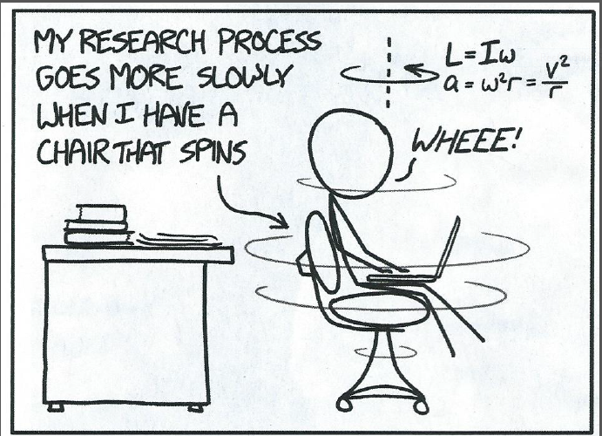 | 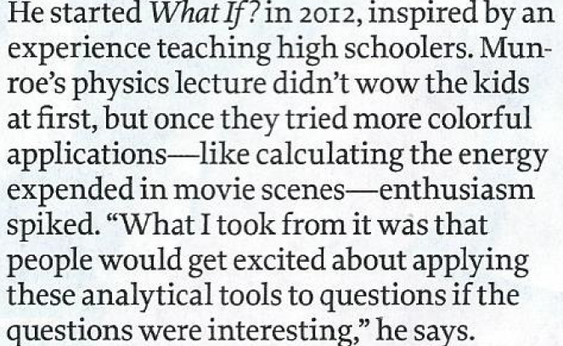  Monroe’s resulting LOG declaration is the website what-if.XKCD.com!

