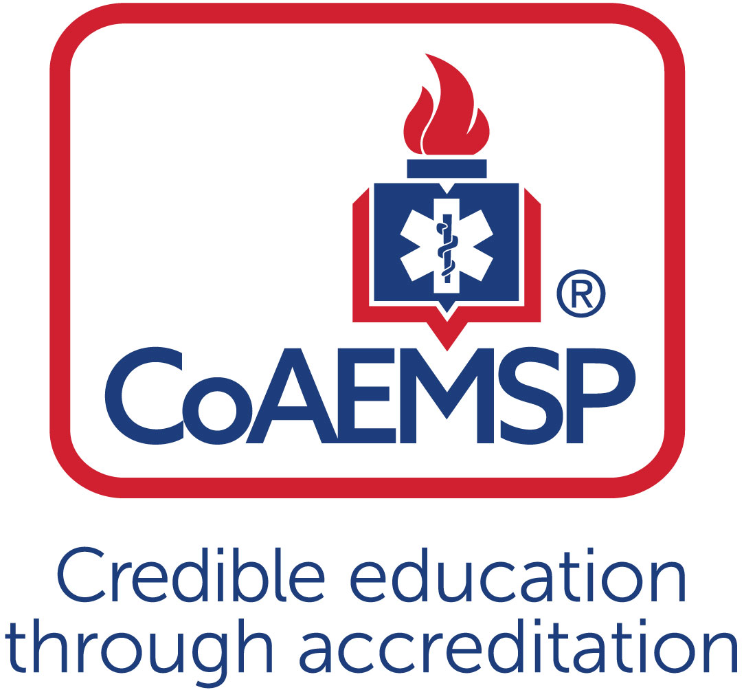

Advisory Committee Meeting Minutes

SPONSOR / INSTITUTION NAME: | FSW
CoAEMSP PROGRAM NUMBER: | 60034 |  | DATE, TIME, + LOCATION OF MEETING: |  |  | April 10, 2018  9:00 AM  Bldg B – 134
CHAIR OF THE ADVISORY COMMITTEE: | Note to Program: As a best practice, programs should appoint someone other than the Program Director to serve as the Advisory Committee Chair. The Advisory Committee is advising the program.
ATTENDANCE
Community of Interest |  | Name(s) – List all members. Multiple members may be listed in a single category. |  | Present | Agency/Organization
Physician(s)  may be fulfilled by Medical Director |  | Dr. Alex Rodi, D.O. |  | X | Medical Director – FSW EMS Programs
Employer(s) of Graduates Representative |  | Ben Abes  Anthony Demos  Noemi Fraguela  Ryan Lamb  Joe Maguire  Gerard Mallet  Michael Marcus  Nathan McManus  Lance Pullen  Curtis Rine  Daniel Sieber  Bill VanHelden  Arthur Wolf |  | X  X  X  X  X | Acting Director, EMS Chief  Cape Coral Fire Department  Training Captain, Collier County EMS  Cape Coral Fire, Chief of Professional Standards  Lee County Emergency Medical Services  Charlotte County Fire/EMS, Director of Emergency Management  Lee Health, Trauma  Charlotte County Fire/EMS, EMS Training Captain  Fort Myers Fire, Division Chief of Training  Charlotte County, Captain of Fire Training  San Carlos Park Fire District  Charlotte County Public Safety Director  Collier County EMS
Key Governmental Official(s) |  | Dan Summers |  |  | Director, Collier County EMS
Police and Fire Services |  | Anthony Demos  Ryan Lamb  Lance Pullen  Curtis Rine  Daniel SIeber |  | X | Cape Coral Fire Division  Cape Coral Fire, Chief of Professional Standards  Fort Myers Fire Division, Division Chief of Training  Charlotte County, Captain of Fire Training  San Carlos Park Fire District
Public Member(s) |  | Tom Brennan |  | X | Retired EMS/Fire Chief
Hospital / Clinical Representative(s) |  | Michael Marcus  Jo Vorwald |  | X | Lee Health, Trauma  Peace River Regional Medical Center
Other |  | Linda Welch  Mike Knoop  Matt Stachler  Tracy House |  | X  X  X  X | FSW – Instructional Assistant  FSW – Instructional Assistant  FSW – Clinical Coordinator  FSW – Staff Assistant
Faculty  ex officio, non-voting member, |  | Dr. Edward Newton |  | X | FSW – Pharmacology Adjunct Professor
Sponsor Administration,
ex officio, non-voting member
Current Student |  | Jessica Huckeby |  | X | Paramedic Student
Graduate |  | Rebecca Greene |  |  | 2013 Paramedic Graduate
Program Director  ex officio, non-voting member |  | Joseph Washburn |  | X | FSW Program Director
Medical Director  ex officio, non-voting member |  | Dr. Alex Rodi D.O. |  | X | FSW EMS Medical Director

 | Agenda Item | Acted | Discussion | Action Required | Lead | Goal Date
 | Call to Order |  | Director Washburn welcomed attendees to the meeting, everyone introduced themselves. |  | Joseph Washburn, Director of EMS Programs FSW
 | Review and Approval of Meeting Minutes |  | Each attendee was given a copy of handouts. Discussed our goal as part of the accrediting process we endorse. Additional goals can be added.  Professor Barry discussed the clinical rotations we were doing.  Dr. Rodi talked about the new cohort being better medically prepared.  We talked about our annual report  for our accreditation with some statistics.  We discussed the pharmacology change, adding new adjunct; Dr. Newton.  We approved the goal for the program and discussed the final testing to incorporate the National Registry including the written and psychomotor. Once complete, students would graduate as Medics and also have their NREMT certification.  Dan Summers from Collier EOC brought up special needs in job training for Alzheimer’s support.  Unfortunately, have not connected yet.  We set up another meeting, which is today.  Approval of meeting minutes by all attendees.
 | Program Goals & Learning Objectives  [CAAHEP Standard II.C. Minimum Expectation]  - Endorse the language verbatim for the Minimum Expectation  “To prepare competent entry-level Paramedics in the cognitive (knowledge), psychomotor (skills), and affective (behavior) learning domains with or without exit points at the Advanced Emergency Medical Technician and/or Emergency Medical Technician, and/or Emergency Medical Responder levels.”  - Establish / review any additional program goals |  | Director Washburn read the goals for CoAEMSP 2017-2018. The committee voted on the endorsement unanimously.  A question of any additional goals needed to be added for this next term?  There were no additional goals to add at this time.
 | Review and endorse the program’s required minimum numbers of patient/skill contacts for each of the required patients and conditions  [CAAHEP Standard III.C.2. Curriculum]  - Appendix G: Student Minimum Competency Matrix (effective July 1, 2019) |  | According to the accredited body, each student must have 2 types of patient/skill contact per category.  After review of ranges in lab clinical field, each setting has a minimum and maximum.  Director Washburn recommended a discussion,  moving some of these numbers forward as we are getting much better at capturing this documentation under the National Registry guidelines of the portfolio. This is allowing us to identify these types of patients, prior to this, it was  more challenging for the students to identify. With that said, I feel confident that we can move these numbers forward with the approval from the committee.  CoAEMSP Appendix G/H  Safely Administer Medications  Live Intubations  Safely Gain Venous Access  Ventilate a Patient  Assessment of Newborn  Assessment of Infant  Assessment of Toddle  Assessment of Preschooler  Assessment of School Agers  Assessment of Adolescents  Assessment of Adults  Assessment of Geriatrics  Assessment of Obstetric Patients  Assessment of Trauma Patients  Assessment of Psychiatric Patients  Assessment of Medical Patients  Assess and Plan RX of Chest Pain  Assess and Plan RX of Breathing problem  Assess and Plan RX of Change in responsiveness  Assess and Plan RX of Abdominal pain  Assess and Plan RX of Altered Mental Status  Field Internship Team Leads  These numbers are seen by the students in the clinical and field settings. If a student falls short, we offer a FINAL Lab prior to graduation.  One of the challenges we are faced with is clinical space. Looking at all the other different organizations, whom are also sending their students, we are now competing with all of the nursing programs and other EMT/medic programs.  In the OR; we are competing with FGCU intubation rotation.  We try to keep our numbers low because we are fighting for areas to get live intubations.  Hospital Clinical Rotations  This summer we are trying something new, we are hiring five (5) new Clinical Associates that are employed as nurses in the hospital, with a Bachelor’s degree or higher. These individuals have insider relationships and rapport with a better understanding on how the hospital works. We were struggling with sending our Clinical Associates whom are paramedics into the hospitals. We are hoping that these nurses will give our students a greater clinical experience.  Also, we are now working clinical rotations at Golisano Children’s Hospital. This gives our students more hands on training for pediatric assessments.  A vote was taken to endorse the minimum numbers of procedures required by the program. No objections, endorsement passes with the ability to modify as needed. | From To  7 20  2 4  21 30  2 35  2 Remains the same  2 Remains the same  2 Remains the same  2 Remains the same  2 Remains the same  2 Remains the same  34 40  45 Remains the same  2 Remains the same  17 Remains the same  2 45  36 Remains the same  4 10  9 15  Capture CPAP ventilations in FISDAP  2 10  6 Remains the same  6 10  26 40
 | Annual Report and Outcomes  [CAAHEP Standard IV.B. Outcomes]  - Graduate Surveys  - Employer Surveys  - Resources Assessment Matrix  - Thresholds/Outcomes |  | CoAEMSP is making significant changes to the annual reporting process. If you would look at the Resource Survey with the help of the committee, to assist with the survey. The survey is plugged into a matrix and tallies all responses to give us a percentage. The accrediting body is looking for a threshold of 80% of each item, if we do not meet the threshold of 80% for each item, then we need an action plan to change those things. We were able to plug the last cohort of students that graduated for all of their responses we were above the 80% threshold, the majority being 90% in those categories.  From years past, one of the areas we have made great strides in is getting the students in front of Dr. Rodi more.  Dr. Rodi now gives at least one lecture per term. Students have the opportunity to do clinical hours with him in the evening.  Dr. Rodi is here for all high stakes testing.  Please review and complete survey and get back to Joe as this is needed for our accreditation. If you have any questions or are uncomfortable answering, please reach out and Joe would be more than happy to assist. Any recommendations and/or improvements are also always welcome for the program.  CURRICULM  Matt Stachler discussed the upcoming cohort in the Fall 2018. First, we are changing textbooks from Nancy Caroline which is based on 2010 AHA guidelines. It’s been a difficult time to follow knowledge aspects of book, but making sure that we are making changes in many areas and moving over to Brady books which are 2015 AHA guidelines. More organized, much less redundant, teaching components have gone with technology offering on line modules to students, making quizzes, on line assignments, testing, the ability to listen to pod casts and so forth. The Brady book should be easier to test out of and for students to understand the material in the book. There are 5 books, so there will not be one huge book for the students to carry.  The other change that we have made is in the pharmacology. As we discussed in our last meeting bringing a pharm class  kind of outside of trying to teach within the course. Professor Newton taught the original course. We were using the textbook: Pharmacology for EMS providers.  Professor Newton commented that this first book was written by EMS out of Miami, realizing the errors, the on line question bank was also full of error, the book was the greatest challenge so really had no book to speak of. Moved on to Lippincott, 6th illustrated edition of Pharmacology. This book can be intimidating but realized it definitely gave a toned down version and gives the student by the end of the course a nice perspective of what pharmacology is all about. We can trust this book and feel confident with what’s in the book. Pharmacology is not about mathematics, nor is it how much you give, Pharmacology is the study of drugs, how they get into the body, what they do to the body and how they exit the body. Maybe doses or math might be a grey area.  Do we have a math for meds? No, but there probably should be. We may need to look at possibly a mini semester, not 16 weeks, but 8. Where can we carve an hour? Students should learn drug calculations, especially for pediatrics.  Matt reiterated that this was his first time teaching paramedics as he used to teach EMT’s, so this was an adjustment. The second year he tried not to deviate because he has an expectation of the student. Commentaries were good from the student survey. | Prep course on how to take an exam.  A possible class on Math for Meds
 | Other Assessment Results  [CAAHEP Standard III.D. Resource Assessment]  - Long-Range Planning  - Student  - Faculty  - Program  - Other |  | Joe had passed out our Program Resource Survey at the beginning of our meeting. He asked that everyone please look over and fill out to the best of their ability. If anyone had questions, to please reach out to him personally. He needs the committee to complete and turn in.  In our Annual Reports, we interviewed graduates and employers in regards to the last cohort in June 2018. Students receive emails and we initiated phone surveys due to the low number of return emails. Once the students complete their surveys, we reach out to their perspective employers to receive their feedback. This information is sent to the accrediting body.  For the 2017 CoAEMSP, we did meet the threshold of 70% of the three (3) year average for pass rates, retention and employment.  For transparency reasons and being open, Joe brought up the Pass Rates of the State Exam of all the Schools, (handout given). There were a couple of different dates,  - JAN 2016 – FEB 2018  - OCT 2017 – 03.31.2018  This report shows how high the percentage is for pass rates because everyone IS passing. The problem is, as we have discussed in the past, that the test has not been updated since 2013.  Those of you that work in the field,  both in EMS or Fire, we all know that one of the norms is to take the test, immediately get into your car and write down as many questions that you can. This now has created a study guide for those that come behind them.  The other document hand out is from the (NREMT) National Registry of Emergency Medical Technicians.  This shows the pass/fail report of our students from the last cohort: October 2017 – June 2018. If you recall, we were going to get our students prepared to take the NREMT. This was the first time we had a representative come and administer the written and psycho- motor test. Out of the 42 students that took the exam, we had a first attempt pass rate of 90% on the psycho-motor. Only three (3) had to re-test one additional station. However, what you are looking at is for the written exam report. We had 30 students attempt and only 17 pass the first time. That is a 57% pass rate which we are not happy with and will need to work harder with the next cohort to bring up our pass rates. What are our students missing that we are missing as instructors to give them to be prepared to take the NREMT?  Of the thirteen (13) eligible for re-test of the NREMT, all took the state exam and passed it the first time, in January. At this time, no one has signed up for the retake, probably due to the cost of re-test.  We need to do a better job and I am hopeful with a compliment of a full staff and more assistance in the labs and curriculum discussions of the course outlines, we can be more successful.
 | Discuss challenges to the effectiveness of clinical and capstone field internship  This may include the impediments to attaining or retaining affiliates |  | With our capstone field experience, we did very well with the last cohort, where they went into their capstone having all of their didactic, all of their clinicals, all laboratories done and their experience of working with the different agencies was far greater giving them more team leads. Everything was complete when the student reached their capstone.  In the future, we would like to bring one preceptor with each student instead of different preceptors each time. Would like to discuss at some point to make more formal moving forward, if possible.
 | Program Changes (possible changes)  - Course changes  - Preceptor changes  - Clinical and field  - Curriculum  - Content  - Sequencing |  | New Dean Position  New Associate Dean,  Dr. Elsberry retired in May 2017.  Three (3) Clinical Coordinator positions available
Substantive Change (possible changes)
[CAAHEP Standard V.E. Substantive Change]
- Program Status
- Sponsorship
- Sponsor Administrator Personnel
- Program Personnel
- Addition of Distance Education
- Addition of Satellite Program
 | Other Business
 | Next Meeting(s) |  | Advisory Committee discussed meeting in April at the end of Spring 2019 term. | Staff Assistant to send reminders as it gets closer to the date and attendees  with confirmation date.
 | Adjourn |  | Meeting adjourned at 10:20

Minutes prepared by Tracy House Date May 15, 2018

Minutes approved by Joe Washburn Date May 15, 2018

Additional program goals are not required by the CAAHEP Standards. If additional program goals are established, then the program must measure them.

