Department of
College Prep/Developmental Studies

Minutes
District College Prep Faculty Meeting
Friday, April 8, 2011
1:00 to 3:00 p.m.
G 218

In attendance were: Eileen DeLuca, Carole Nelson, Melanie LeMaster, Kevin Lavarack, Joseph Roles, Bert Lawrence, Jaime Marecz, Jennifer Grove, Dorothy Marshall, Sabine Eggleston, Caroline Seefchak, Rebecca Gubitti, Renee Hester

- Welcome
Successes and Accomplishments
Dr. Seefchak had an accomplishment to share – one of a student. She showed a projection of an English paragraph assignment that was sent to her, as a JPEG. She said it illustrated the tenacity some of our students have to follow directions – even when they cannot figure something out.

II. Textbook Selections
We have had visits from many publishers for selections of textbooks to be adopted in the specific discipline areas.
All faculty at all campuses must have input, adjunct and full-time; Curriculum Specialists are asked to please each have a documented means by which to reach a decision, and are asked to please email decisions to Dr. Seefchak by 4/13.
The deadline to submit Fall 2011 textbook adoptions to the Bookstore is Friday, April 15, 2011.

- College Prep Curriculum
Revision of Syllabi – Everyone in the department worked very hard on this. All College Prep syllabi have been revised to reflect alignment with the State of Florida Division of Colleges Common Course Competencies. These syllabi, reflecting the new course numbers, will be available on the Document Manager on the Portal and will be used starting in Fall 2011.
Common Course Assessments – Each discipline in College Prep has worked assiduously on these, and most are completed. All Common Course Assessments in College Prep will be used, as trials, during Fall Semester 2011. It is projected that they will become part of the course curricula starting in Spring Semester 2012.
PERT - Administration of the Postsecondary Education Readiness Test will begin in May.
Follow-Up diagnostics are being reviewed for each discipline and will be valuable tools for instructors to meet students’ needs.

- College Readiness Conference Data
Dr. Seefchak shared data from a Survey Monkey Survey that was sent to all participants of the College Readiness Conference, held at Edison State College in February. See attached information and data.

- QEP News
Dr. Gubitti shared that the QEP Cornerstone Course still has a targeted start date of Spring 2012. She shared that Dr. Mary Stuart Hunter, renown for her work on QEPs, has been hired as a consultant.
There will be courses that instructors can take to become qualified to teach the Cornerstone class, some of which will be available to take online.

- Commencement Ceremonies

Faculty have been asked to email Deb Kelly with their selection(s) of Commencement Ceremonies to attend in May. Dr. Seefchak read from a memo, written by Dr. Beeson, that detailed the times, dates, and degrees to be awarded at the four scheduled ceremonies.

- Fall Course Schedules
Banner “rolls” on Monday, which means course schedules will soon be made and will be made available for Fall 2011. Amanda will contact faculty members, by seniority, for their class preferences; scheduling will be done by Dr. Deluca.
Dr. Gubitti asked if only regular loads could be selected during the first round of class date and time selections, to allow more of a selection of courses for new faculty members in the department. Her suggestion was well received by those present.

- NADE Conference
Dr. Seefchak announced that the annual conference of the National Association of Developmental Education would be held in Florida next February, and the call for proposals has been posted with an early June deadline. She and Dr. DeLuca encouraged College Prep faculty to consider presenting workshops on some of the outstanding things that have been going on in our department. Dr. DeLuca mentioned the Literature Circles that are being used by Professor Hester in Reading and by Professor Tucker in EAP. Other very cool things happening in College Prep that may be things we consider presenting include Communities of Practice and the College Readiness Conference.

- Space – Office and Other
Dr. Deluca announced that some logistical changes were on the horizon for our department. After a proposed move this summer, College Prep will no longer occupy space in the G Building. It is anticipated that the college-level Math faculty will move from the H Building to the new U Building, leaving some office space. In addition, Peer Tutoring and the College-Level Math and College-Level Writing Labs will be moved to the Q Building.
Dr. DeLuca and Amanda will move to the offices in the Lab. Other space will be reconstructed and utilized to accommodate our dynamic and expanding department. There are plans for a faculty multi-purpose workroom/mailroom/copy room to serve College Prep full-time and adjunct faculty as well as college-level Math and Science adjunct faculty. There will be an assessment room, a place to hold workshops, and new classroom space.

- Adjunct Faculty Meeting
The next meeting for Adjunct College Prep faculty will be held Tuesday, April 12, from 4:30 until 5:30, in G 217. This is an important meeting, as final exams and end-of-semester procedures will be discussed in discipline groups.
All full-time faculty are encouraged to attend. Curriculum Specialists will lead the discipline break-out groups during the meeting.

- Communication
Adjunct Brochure Information – Curriculum Specialists were reminded to please give all information for these documents to Dr. Seefchak by the end of the semester. She will be working on materials for adjunct faculty during the summer. Information on these sheets will be very important to the adjunct faculty guidelines to be distributed in the fall.
College Prep Web Site – Dr. DeLuca announced that she is working with technology to construct a Web Site specifically for our department. Dr. Seefchak projected examples on the screen, and options were discussed. Dr. DeLuca asked that faculty members please send her their thoughts and suggestions by Friday, April 15.

- Awards
Dr. DeLuca announced that College Prep would be granting a student award at the annual Graduating Student Awards Ceremony starting next year. She has been in contact with Kevin Coughlin, in Institutional Research, to get data on the progress that College Prep students make after they successfully exit the College Prep program. We will take that, and other factors, into consideration when deciding on the award that will be given at the end of the next academic year.

XIII. Anything Else
Professor Marshall announced that there would be college-wide party, hosted by College Prep, in honor of Professor Kevin Lavrack, who will be retiring from Edison State College after twenty-two years. See the attached announcement that was distributed to all department chairs – to announce to all departments – last month.
Dr. Gubitti announced that she had presented at the conference of the Midwest Institute, held at Edison State College, last month. She thanked Dr. Seefchak for attending her presentation. She also announced that she had information on embroidered shirts that she would share with faculty.

Dr. Seefchak concluded the meeting and announced that the next meeting of College Prep/Developmental Studies is scheduled for Friday, May 6, at 11:00 a.m. in G 218.

Attachments:
College Readiness Conference Selected Data
Notice of Retirement Celebration in honor of Professor Kevin Lavrack

Submitted by Caroline Seefchak, Ph.D., April 2011

COLLEGE READINESS CONFERENCE – Selected Data
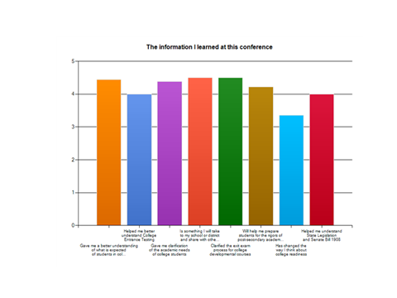

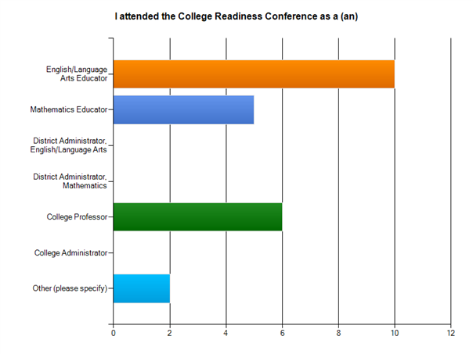

The Department of College Prep/Developmental Studies
is planning a
Retirement Celebration
in honor of
Professor Kevin Lavrack
after 22 years at Edison State College
on
Thursday, May 5,
from 12:00 until 2:00 p.m.,
in H 218.

Food and refreshments will be provided
by the College Prep Department.

