AGENDA
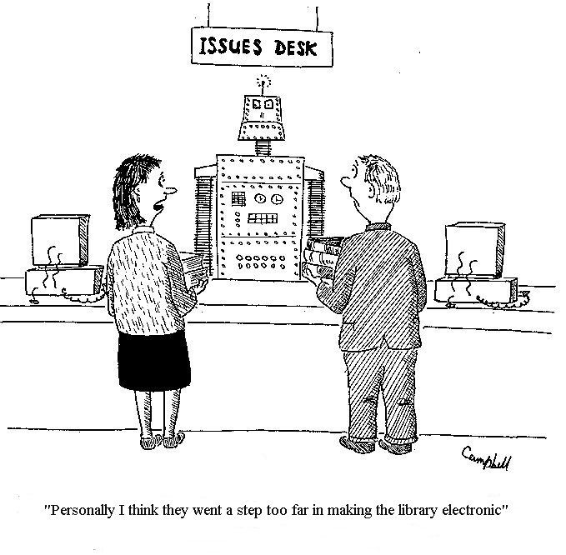

Edison State College – Charlotte Campus

Learning Resources Center

April 15, 2009

11:00 AM – 12:00 PM

Attendees: LRC Staff
Location: LRC Office
Please bring: Agenda and pen

11:00 AM – 11:05 AM | Welcome | Phenessa Jones
11:05 AM – 11:20 AM | LRC Quality  - Shelf-Reading Assignments beginning April 20th  - Student Assistants  - New Databases (ArchiveGrid, CAMIO, OAIster, & Sources in U.S. History Online)  - Aleph Upgrade: http://www.cclaflorida.org/alephv19/implementation.asp  - Public Relations/Signage  - Professional Development/Training | All
11:20 AM – 11:40 AM | Operations  - Concerns (Schedule, Customer Service, Budget Cuts)  - Weekly status reports  - Monthly thematic display (i.e. May – Get Caught Reading Month and Asian Pacific American Month) | All
11:40 AM – 11:50 AM | Campus/LRC Updates  - Staying informed on new technologies  - Participation in NLW Party, April 16th, 2:00-4:00  - New LRTA – “Equipment Technician” position  - Heart Gallery – Children’s Network of SWFL will be extended to May 23  - Cram Jam, April 21st, library will be open until 10 PM | Phenessa Jones
11:50 AM – 12:00 PM | Wrap – up  - Open Discussion  - Q & A | All

