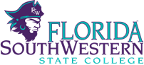
Minutes
Academic Success Department Meeting
November 14, 2014
Thomas Edison Campus, I-122, Collier G-109, Charlotte J 118, Hendry/Glades A106
1:00 p.m.

Attendance: Karen Maguire, Wanda Day, Robert Olancin, Melanie LeMaster, Duke Dipofi, Rachel Lieberman, Troy Tucker, Renee Hester, Eileen DeLuca, Whitney Rhyne, Dayami Martinez, Mary Ellen Schultz, Frieda Miller, Keith Staple, Tom Buckingham, Scott VanSelow, Kelley Newhouse, Elizabeth Yates, Sandi Towers, Rebecca Gubitti and Kathy Clark.
Guest: Grace Billington (new staff assistant)

- Welcome

Dr, Kathy Clark, Associate Dean, Academic Success welcomed everyone to the meeting and introduced her new staff assistant (Grace Billington) and the new SLS 1515 faulty (Scott VanSelow).

- Updates:

Spring Schedule: There were no questions/concerns about the spring schedule. Pending enrollment data, adjustments to the schedule will be made.

Moving: Dr. DeLuca provided an update and noted that we may be moving over the winter break or the move might not happen until summer break. Office space has been allocated when the moving plans are announced. The writing center will be moved to the library and the math center will be moving to the second floor of Building Q.

REA – Discussion concerning MOOC’s is noted below.

EAP- Troy Tucker announced that the college will be hosting the Statewide EAP Consortium of Florida in February. We look forward to welcoming this group to our campus!

QEP- Dr. Clark praised the cornerstone faculty for helping to raise over $2500 (to date) for the Unicef’s Eliminate Project. Several cornerstone professors (Walters, Towers, Olson, Staple and Rhyne) met the $100 level, Professor Davis and Olson were at the $200 level and Professor Schultz’s class raised $300. Professor Rhyne shared additional marketing information including plans for a United Way Fundraising Campaign for Spring and the FYE monthly community update. The marketing committee instituted a peer architect and cornerstone student of the month award.

Dr. Gubitti reported that there would not be a “boot camp” training session in December as the number of faculty trained was sufficient for the spring semester. However, a “booster shot” training session will be offered in April 2015 for faculty who would like additional training as well as new faculty who will be teaching the course in fall 2015.
.
Dr. DeLuca shared the following QEP data:

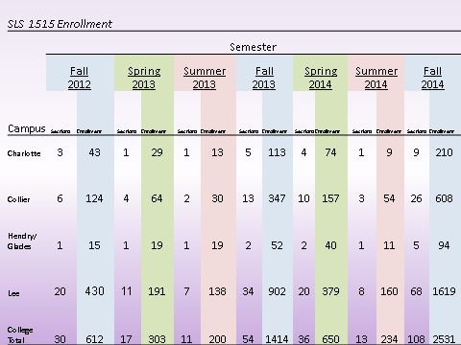

Dr. Deluca noted that the enrollment for the fall was almost double than the previous semester. We actually had almost 3000 students who needed the course in the fall; however, we could only accommodate the 2500+ students who had previously enrolled. Those students who were unable to enroll had a hold placed on their account and they will be required to take the course in the spring.

Section Coverage:

During the fall 2014 semester, 74% of the courses were taught by full-time faculty and staff. (See table below). We exceeded the 65% goal stated in the QEP concerning section coverage by full-time faculty/staff.

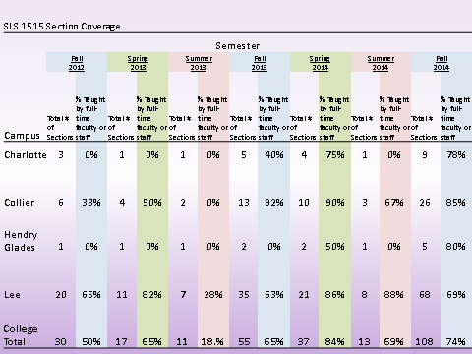

Honors Sections:

As you can see from the table on the following page, we offered 6 honors sections in fall 2014 and 4 honors sections are planned for spring 2015. Each of these sections has a theme. Advisors have been informed and encouraged to enroll students (that meet the qualifications) into the honors sections. Additional information can be found at: http://www.fsw.edu/honors.

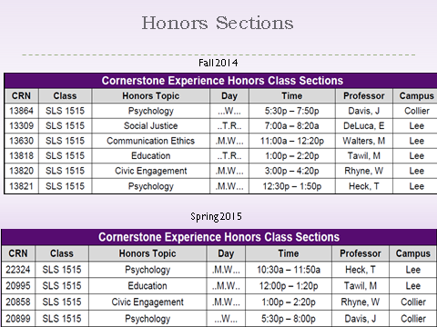

Dr. DeLuca spoke about the success of the critical thinking in careers lecture series. We are starting to build the spring schedule. It was mentioned that it was good to have different people from the same profession speak in order to get different perspectives.

A new textbook (Keys to Success) will be adopted beginning spring 2015. A sample syllabus, power points and instructors manual has been uploaded on the COP canvas page.

- SLS 1515 online

Scott VanSelow and Myra Walters have been identified to develop the SLS 1515 course online. Scott welcomed any suggestions and/or discussions concerning the development of the course. The online version of the course will be offered fall 2015.

- REA-MOOC’s
Dr. DeLuca informed the faculty that Broward College received a grant to create a College Readiness: massive online open course (MOOC). The course is available at http://www.broward.edu/academics/online/Pages/Free-College-Readiness-MOOC.aspx. The “College Readiness” MOOC is:
- game-based tool to help students prepare for the PERT
- a supplemental instructional tool for students enrolled in developmental courses
- a supplemental instructional tool for students enrolled in credit courses
Faculty are asked to provide a process for reviewing “documented student achievement”. This item will be discussed further at the next SB 1720 meeting.

- SLS Waiver form
Dr. Clark informed the group that a SLS 1515 waiver form and process has been developed for students wanting to appeal enrolling in the SLS 1515 course. The form requires two signatures (one from an SLS 1515 faculty and another signature from an academic administrator). The form also requires students to provide a printout of all academic transcripts ton include credits earned and GPA as well as a written essay which explains the reason why the student should be considered for an exemption to the requirements, a description of the student’s academic goals and a plan for how the student will achieve those goals.

- Common Course Assessments/ SLS 1515 post-tests

Faculty were reminded of the dates of the common course assessments.

- Other

Name tags are being ordered for faculty. BUC cards will need to be used in the near future to make copies.

VIII. Discipline breakout session

The next department meeting is scheduled for Dec. 12.

