EDISON STATE COLLEGE
ONLINE BUDGET TRANSFERS

Frequently Asked Questions

What are Online Budget Transfers?
Online Budget Transfers allow end users to go into Banner Self Service via the portal and enter their own Budget Transfers into the System

How do I navigate to enter a Budget Transfer online?
Log onto the portal and select the District Resources tab.

Are these Budget Transfers Approved?
Yes, each Budget Transfer will follow a specific route based on individual accounting elements such as fund, organization, etc. It will follow the routing of the old paper forms except it will be electronic. They are usually approved by the Budget Manager for that FOPAL element and then proceed to be approved by the Budget Office.

Can I track the status of my document to see what approvals it needs to be completed?
Yes, in the portal via Banner Self Service you can track the history of the document, who has approved it, who needs to approve it, what the document included, and if you are an approver yourself approve the document as well.

Can I move budget from Personnel Accounts to my Expense Accounts?
No, Online Budget Transfers can only be used for current expenses.

Can I use any account code to move my budget to?
No, you can only use pool account codes for Online Budget Transfers (60500, 60900, 63000, 63500, 64000, 64500, 699001,70000)

Can we use Online Budget Transfers for Capital Accounts?
Yes you can.

Finance & Accounting Menu (District Resources Tab)

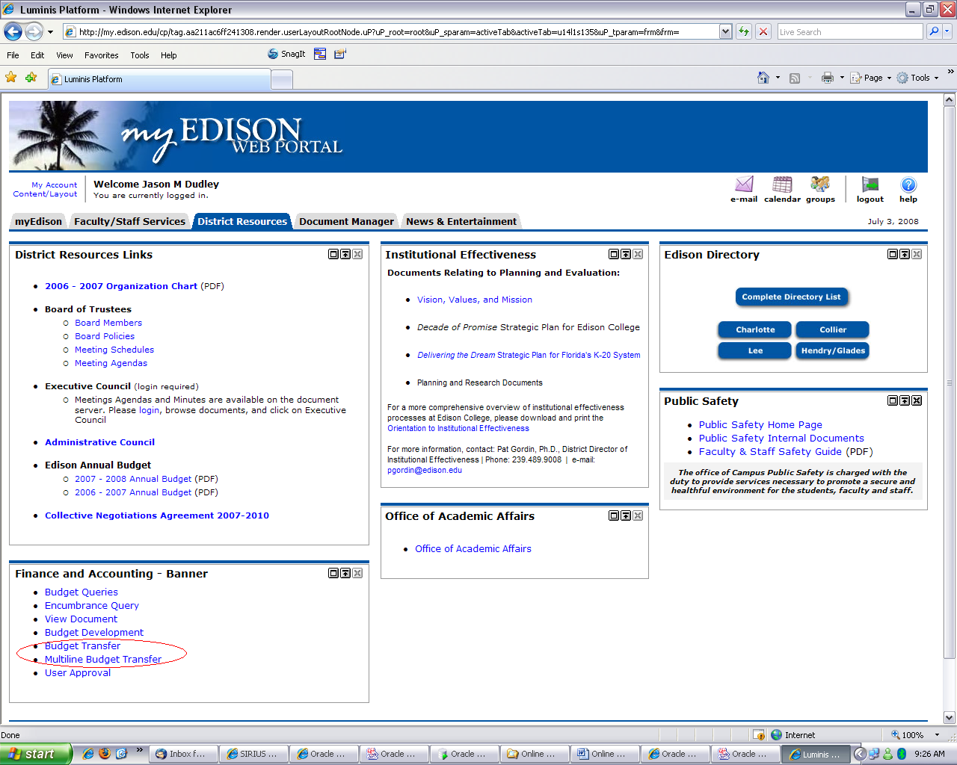

Budget Transfers are located on the portal under the Finance & Accounting Menu. There are 2 options to choose from:

Budget Transfer – This form allows you to transfer from one index (FOAP) to another. This form can only be used for 2 line budget transfers.

Multiple Line Budget Transfer – The multiple line budget transfer is the same as the budget transfer form except it allows budget transfers for up to 5 lines of FOAP elements.
In each document the pluses (transfers to) must equal the minuses (transfers from). These amounts must offset each other and add up to the document total.

Budget Transfers

Once you click on the Budget Transfer link the following form will come up:

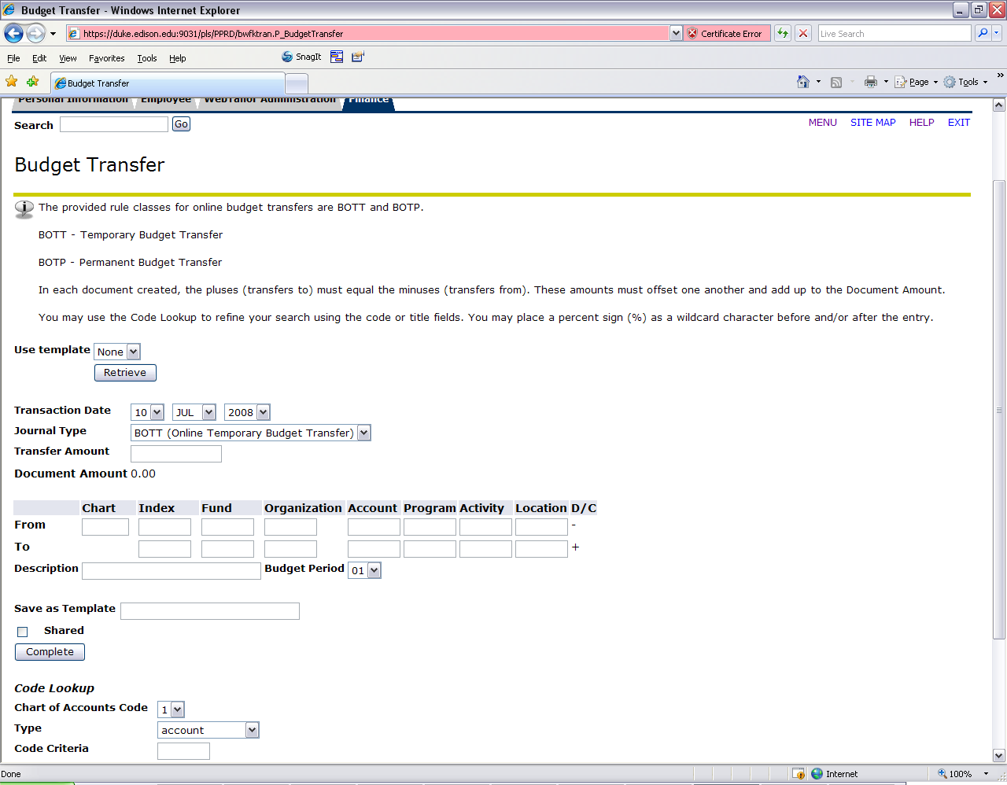

Transaction Date: Date that the transaction will be recorded in Banner. This is usually today’s date.
Journal Type: There are 2 journal types that are available to use for Online Budget Transfers. There is one for each temporary and permanent journal types. They are as follows:
BOTT - Temporary Budget Transfer
BOTP - Permanent Budget Transfer

Transfer Amount: Enter the amount that you are transferring.
Now you would enter your Chart and Index Code (Note: Always use Chart 1). Once you enter the chart and index press the complete button.
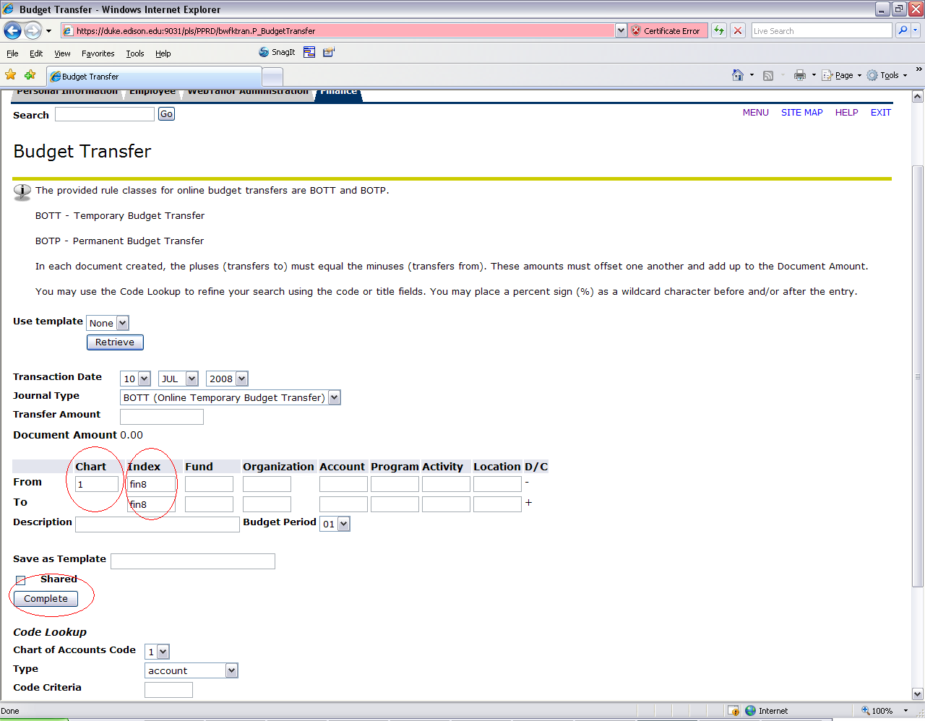

Pressing the Complete button will default all of the FOAP values tied to the index. As you can see below the values are now defaulted. You must press complete before entering any additional information.
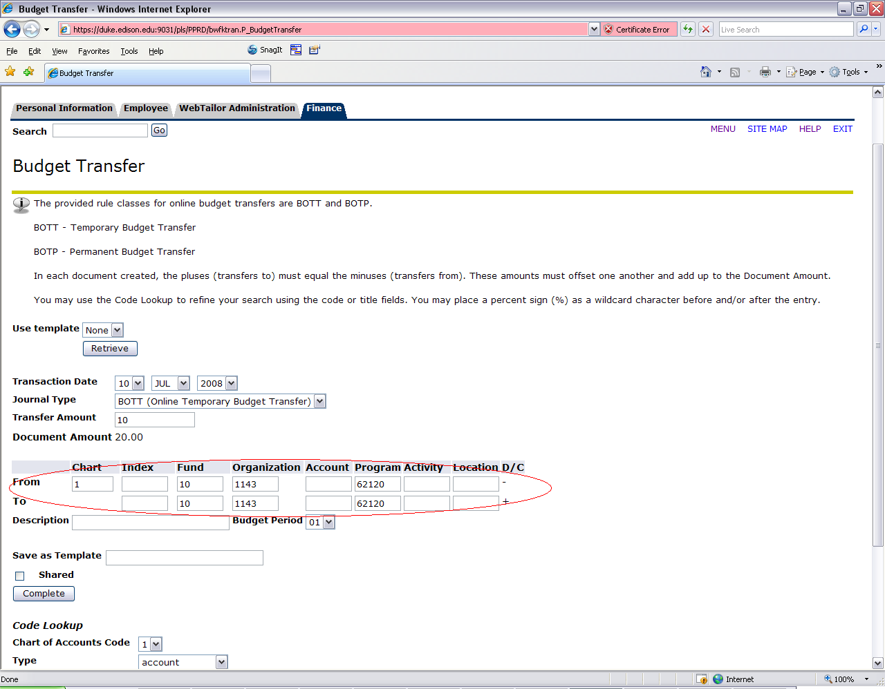

Now you would need to enter your account codes in which the transfer will be from (-) and to (+)
Description: A description of the transfer
Budget Period: Budget Period in which the transfer will be recorded. This is usually the current period. The current period does not default. You must choose the period (i.e. period 01 = July, 02 = August, 03 = September, etc.)
It should look like the following example now.
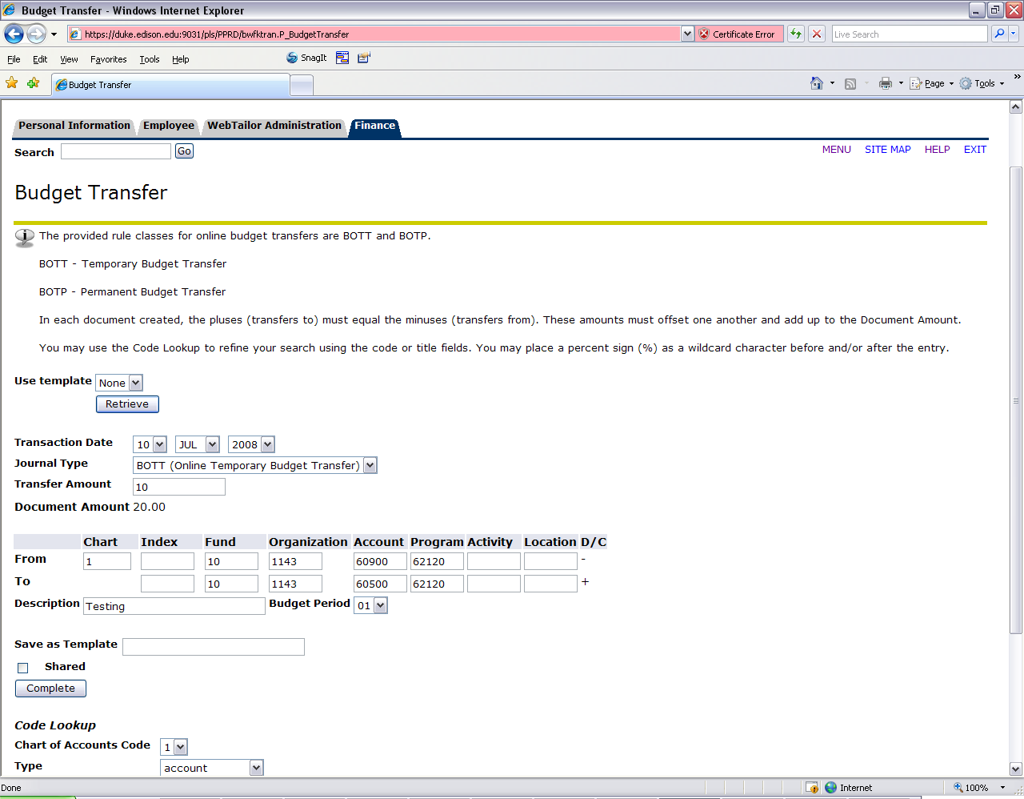

You can now complete your transfer and forward it to the approval process or you can save it as a template. If you commonly do the same budget transfers over and over it would save time to create a template.

Once you click the complete button a message will appear above the budget transfer form stating the budget transfer has been forwarded to the approval process. If there are insufficient funds there will be a notice here stating that as well and it will suspend the document.
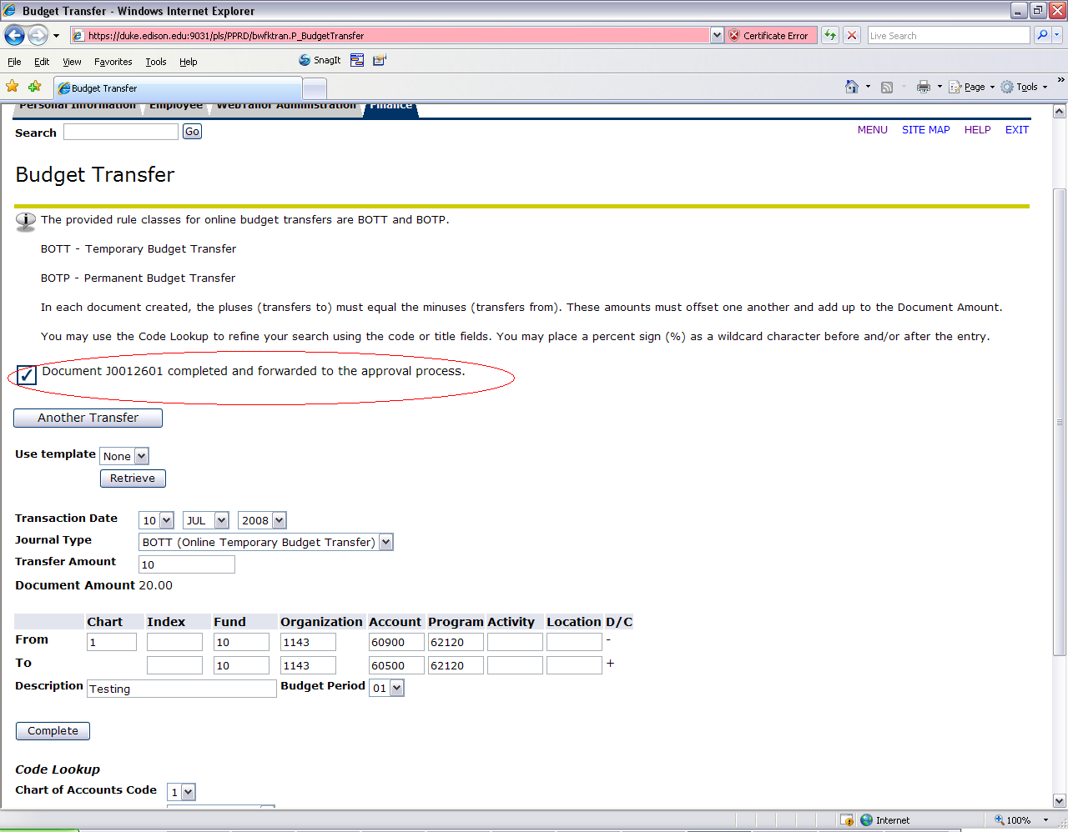

Multiple Line Budget Transfers

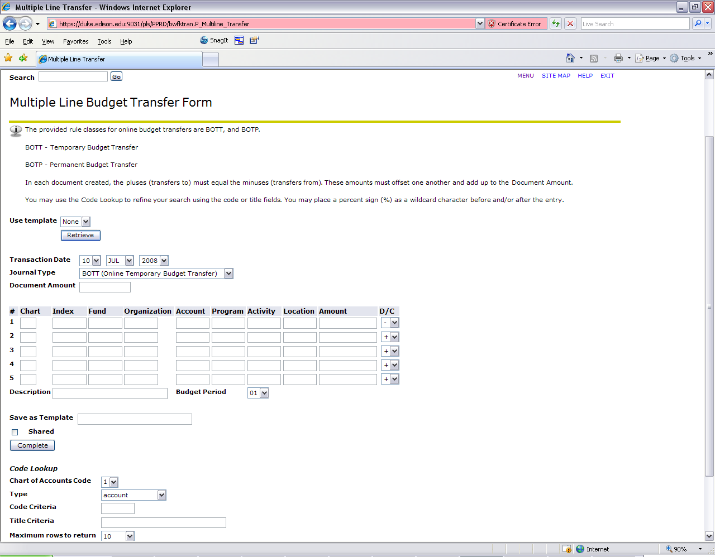

As you can see you can now enter up to 5 lines of data. There are a few differences between the budget transfer and the multiple budget transfer form. They are detailed below:

Document Amount: In the Budget Transfer form this amount was calculated for you, however in this form you will need to calculate this amount. The document amount is the total of all the pluses and minuses in the document. For example if you were moving $400 from 60900 to 60500 ($200) & 63000($200) you would add the amount for each line 400+200+200 = $800 and this would be your document amount.

D/C: In each line of the Multiple Budget Transfer form you will designate either a “+” (To) or “-“(From). Remember that the total of the pluses and minuses must equal 0

You must also add the amounts as well as the indexes before you hit the complete button to default the FOAP elements. If you forget and do not do this it is OK you will just have errors stating the amounts need to be added on each line.

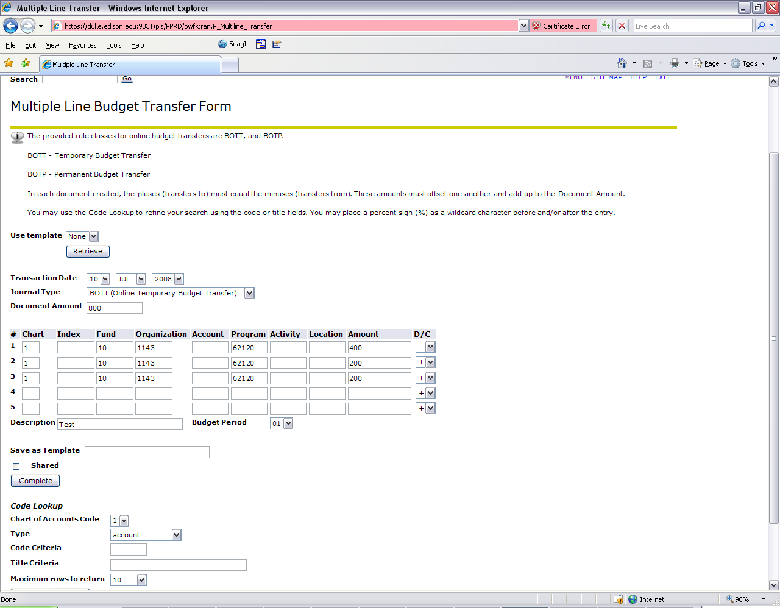

Tracking and Approving Documents
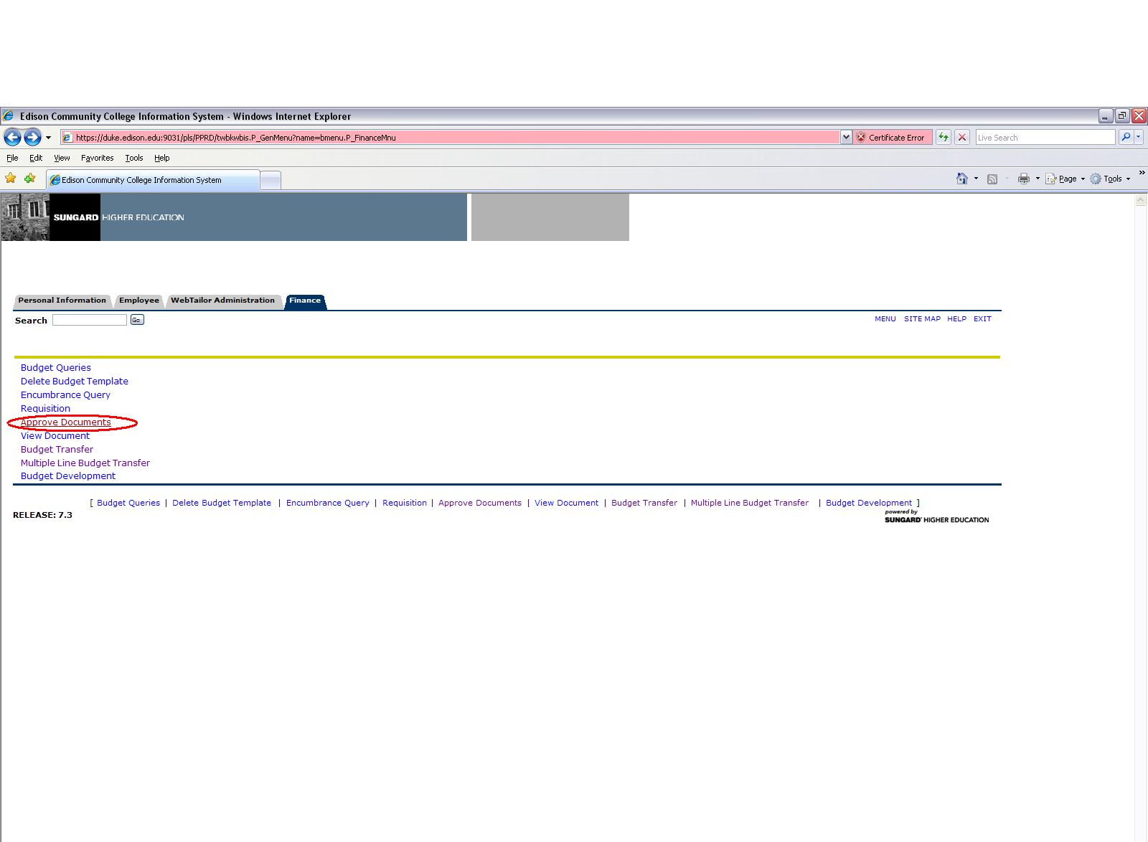

Once you click on the Approve Document link you are brought to the following form.

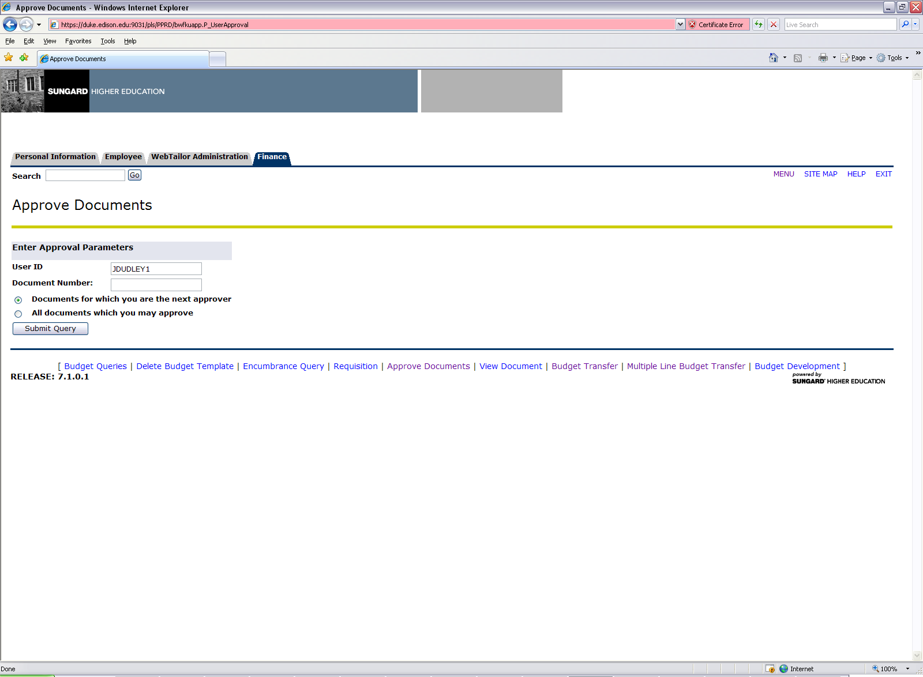

User ID: User ID you are looking up

Document Number: If you want to search on a specific document number you can enter it here.

Documents for which you are the next approver: When selected enables you to view all documents in a queue that are waiting for approval before they can proceed to the next queue.

All documents which you may approve: When selected enables you to view all documents in a queue that are waiting for approval

Once I hit the submit query button I am brought to the results of the query.

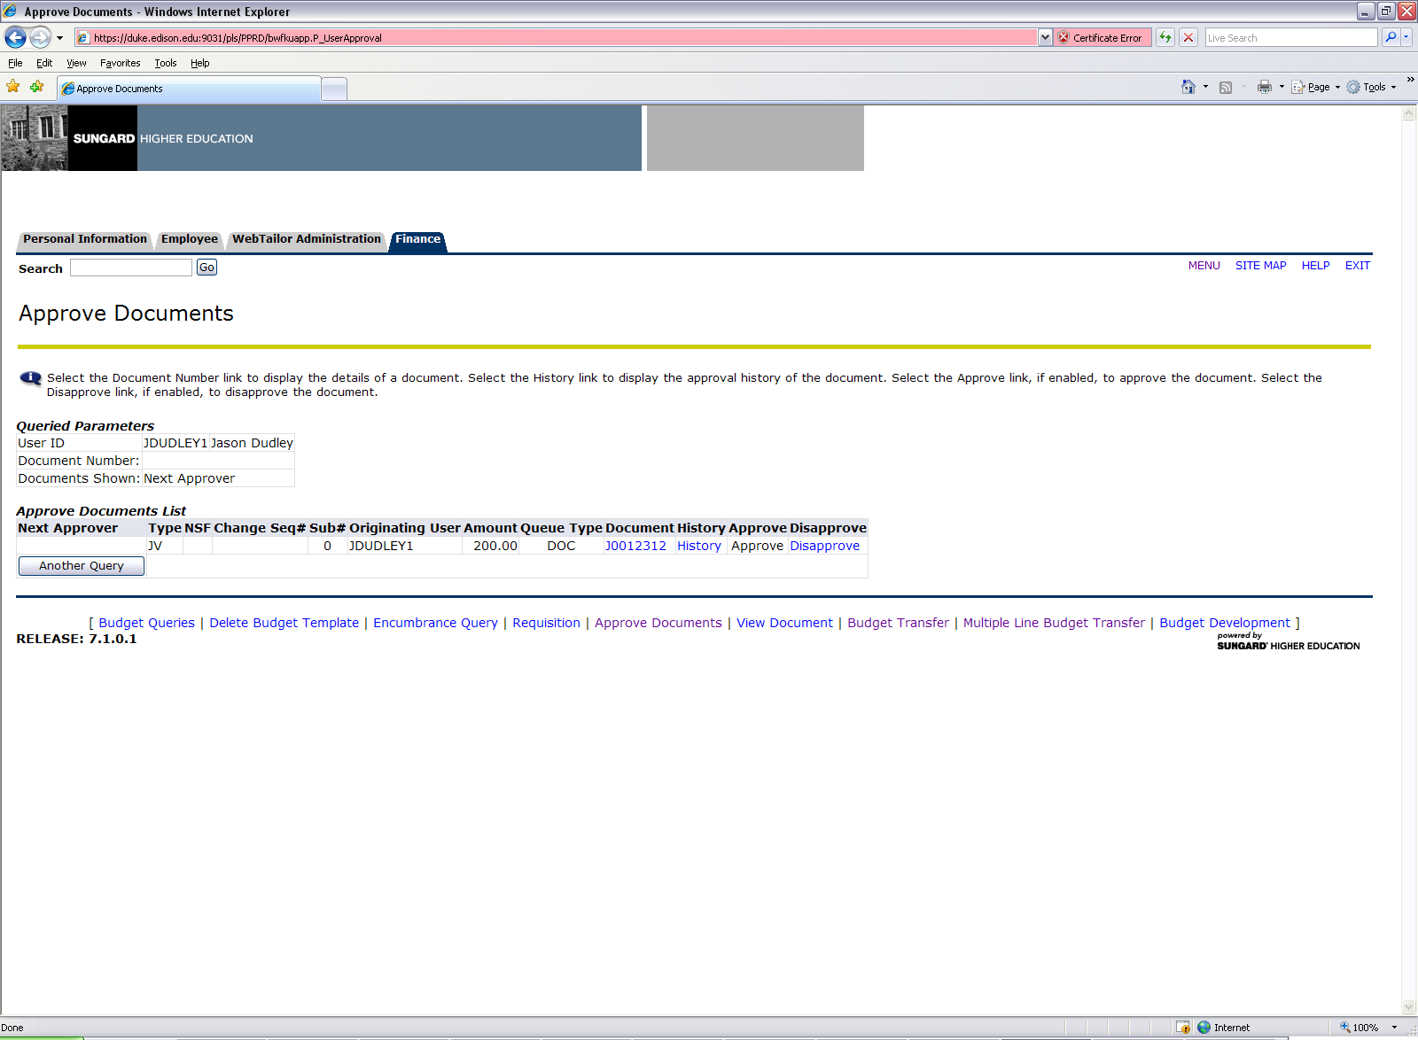

As you can see the JV we did in the example above is in the query results. The items that are highlighted in blue will allow me to drill down into the data. Since I am not an approver for this document it is in black and is not an available option to me. The form also contains the following information:

Next Approver: Next Approver indicator. The field will display a “Y” if you are in the next approval queue and must approve the document

Type: Document Type: Journal Voucher, REQuistion, INVoice, Direct Cash Receipt. In this training you will only need to be concerned with JV type.

NSF: NSF indicator. This field will display a “Y” if there is not enough budget for this document

Change Seq: Not used with Budget Transfers

Sub #: Submission number. Used only for journal vouchers and invoices to display the submission number.
Originating User: User ID of the person who created this document

Amount: Amount specified for the document

Queue Type: Displays DOC if the document is in the document queue, or NSF if there is not enough budget for the document and the document is in the NSF queue.

Document Number: Select the link to display detailed information about the document. When I click on the document I get the following screen.

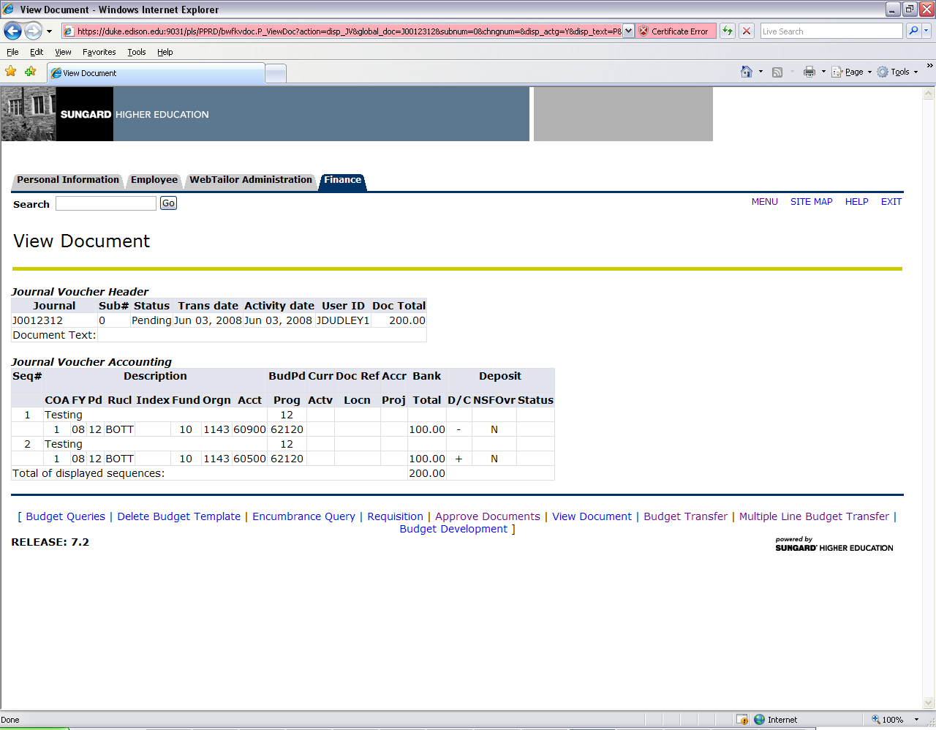

History: This link shows the approval history of the document. It will show who has approved it and who still needs to approve. When the link is selected the form will look like the following.

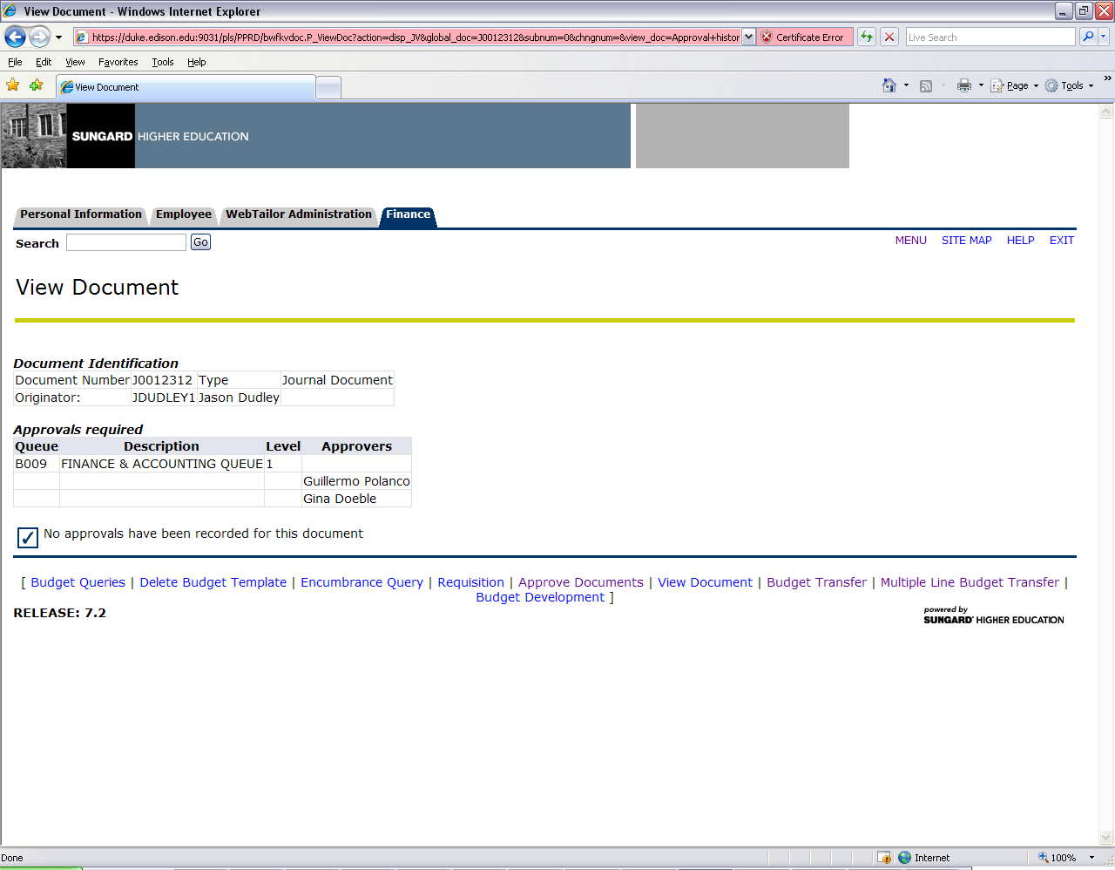

In the example above the budget transfer I created needs to be approved by the budget managers of the org(s) that the budget transfer affected. In the example above I chose organization 1143 which is Finance & Accounting so it needs to be approved by the budget managers for that org.

Approve: Link that enables an authorized approver to approve the document. The approve link is only active if the person logged in is authorized to approve the document. Once you select approve, the approve document page appears with Approve Document and Cancel buttons.

- You may enter a comment, which goes through the Banner messaging system, and then select the Approve Document button to complete the approval process.

- The Cancel button allows you to return from the Approve Document Page

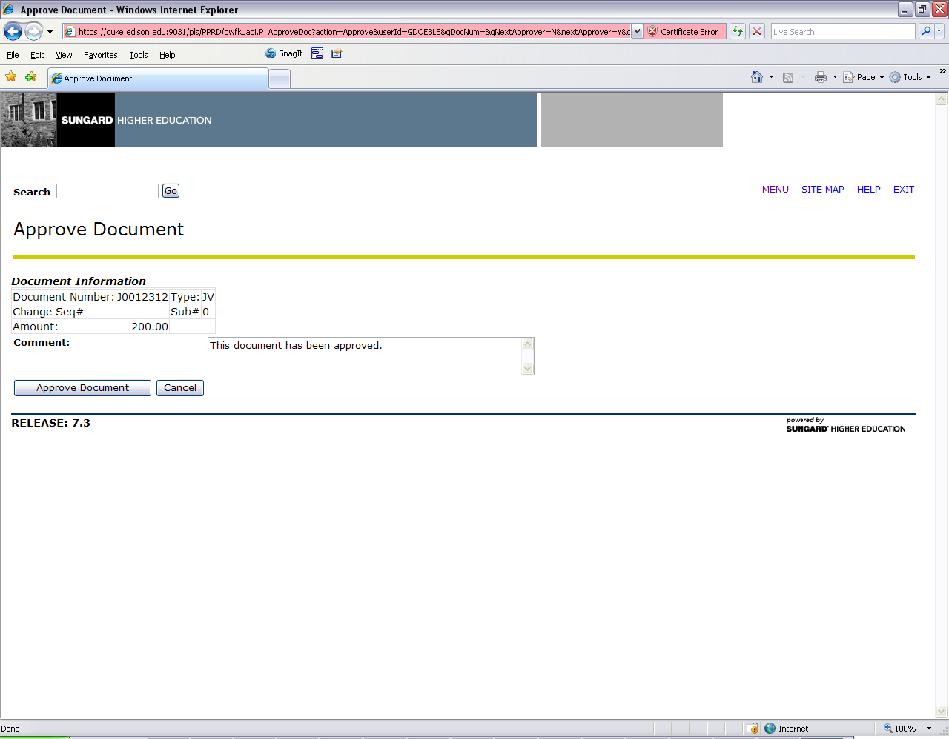

Disapprove: This link enables an authorized user to disapprove the document or reopen the document and make changes. The Disapprove link is only active if the person logged in is either authorized to disapprove the document or is the originator of the document. Once you select Disapprove, the Disapprove Document page appears with Disapprove Document and Cancel buttons.

- You may enter a comment, which goes through the Banner messaging system, and then select the Disapprove Document button to complete the disapproval process.

- The Cancel button allows you to return from the Disapproval Page

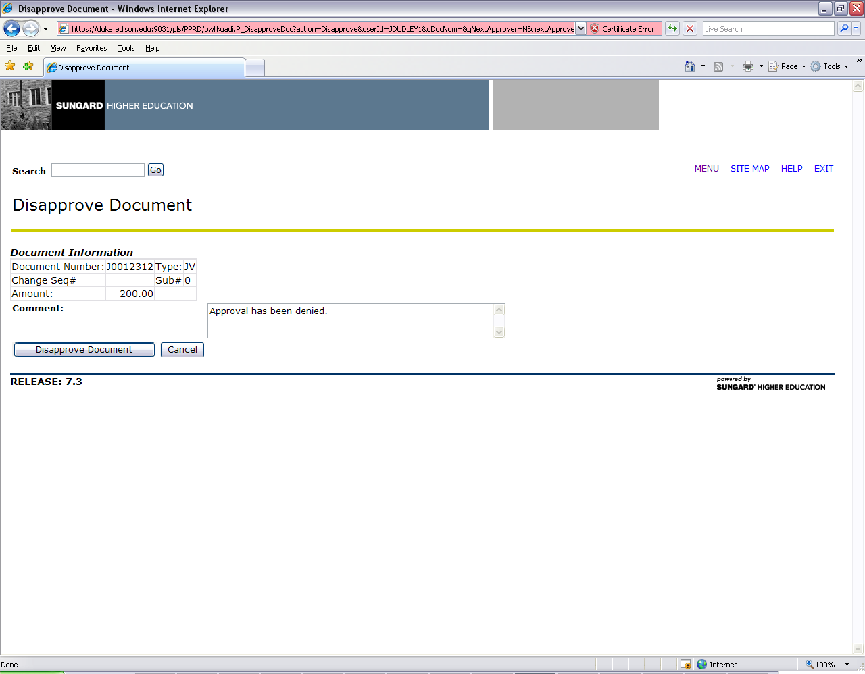

If you disapprove a Budget Transfer in this form it will be marked incomplete in Banner.

