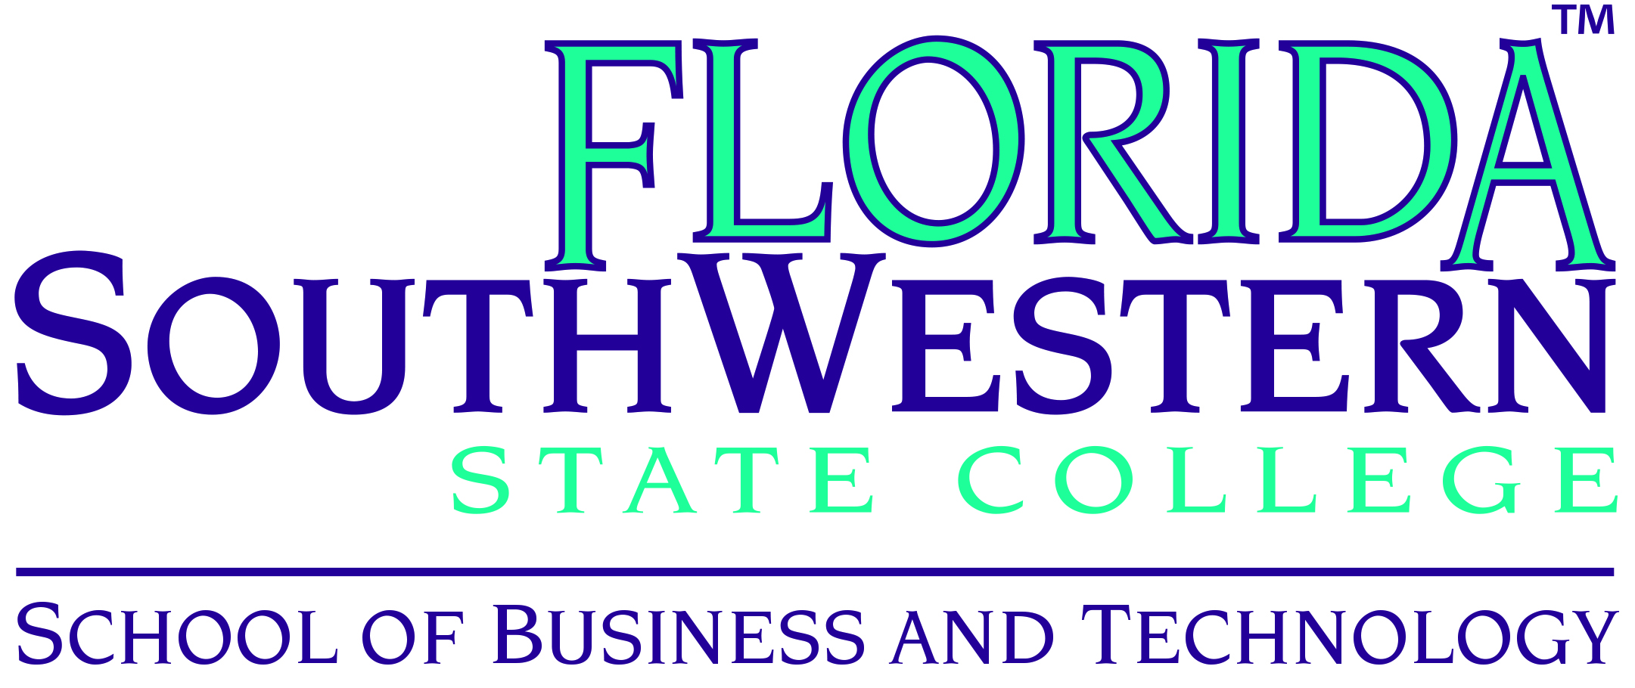

Paralegal Studies Advisory Committee Meeting
Thomas Edison Campus – Bldg U, Room 109
Friday, March 13, 2015

In Attendance: Jim Herron, guest member; Fr. David McCormick, retired member of the community; Mary Conwell, FSW; Kelsey Marshall, Paralegal and Gulf Coast Paralegal Association; and Jill De Valk, FSW.

Welcome: Professor Conwell called the meeting to order and attendees introduced themselves.

Review of Previous Meeting’s Minutes: Professor Conwell initiated a review of the minutes from the previous meeting on October 10, 2014.
Motion to approve the minutes
Motion was seconded
None opposed
Motion carried

Online Courses: Course development for online offerings is nearing completion. Business Law and Wills, Trusts and Probate courses will be developed this summer. Real Estate Law will be offered online for the first time in the summer semester.

New Full-Time PLA/Business Professor: Matthew Hoffman, JD MBA was hired as the new full-time professor for the paralegal and business programs. He began teaching this spring semester in January. Matt has been an adjunct professor for the business and paralegal programs for several years and has been heavily involved in the development of the online courses.

American Association for Paralegal Education Conference: Professor Conwell attended the National Conference in November, 2015 in Nevada. One of the presentations was regarding the opportunity for paralegal professors to receive Fulbright scholarships. FSW is supportive of the opportunities for professors and students to study a globalized economy from another country’s perspective. One idea for AS students to study abroad is to travel for 2 – 3 weeks in England, France, Germany, Latin America, Asia, or Africa to look at the court system there.

Also at the National Conference, there was a discussion on whether traditional face-to-face courses were better than online courses. There are certain intangibles that cannot be measured but online offerings are the trend.

Professor Conwell will attend the AAfPE Regional Conference at the University of Mississippi (Ole Miss) in Oxford. The Regional Conference is important to attend because it offers an in depth idea of what is happening in our region. Professor Conwell will present on the subject of transitioning from traditional courses to the online format.

Gulf Coast Paralegal Association: The GCPA has a formal mentoring program where members partner with a paralegal student. Several students have taken part in this opportunity and some have received employment as a result. The GCPA has been a super friend to FSW and the paralegal program.

ABA Reapproval Report: The reapproval report is due in October this year. Employer surveys will be sent out shortly for community input. The site visit will most likely be in 2016 or 2017. The previous site visit was in 2010 and the team consisted of a paralegal and a paralegal educator.

Lex Chapter Update: The application for the Lex Chapter national honor society was completed and transferred to Dean Meyer for approval. It is important to note that AS programs are not eligible for the same honor society here that AA students are. There will be an induction ceremony in the fall and spring semesters and the honor society offers scholarships for students continuing on with their education after the Associate level.

Paralegal Club: Professor Conwell commented that this year’s officers and club members are an active group. They recently attended a social outing at a comedy club and their meetings include guest speakers.

Other Comments: A question was raised as to what the population was in the paralegal studies program. Professor Conwell stated that there were 200 to 250 students enrolled in the program. The data can be misleading because there are many students who are already working in the field who may step out for a semester and then return. She commented that there are an increasing number of male students and international students. Some of the international students are attorneys from other countries who have immigrated here. Some countries do not acquire much more than an associate’s degree to be an attorney.

One of the reasons a full-time paralegal/business professor was hired is to decrease the number of adjuncts teaching for SACS requirements. It is necessary to keep the ratio of full-time to adjunct professors in compliance.

Kelsey Marshall commented that she liked learning from adjunct faculty because they were attorneys working currently in the field and she learned the most current knowledge from them. They used the updated terminology for example instead of saying “custody”, the modern verbiage is “time-sharing”.

David McCormick commented that we do need to have the input from the judges, paralegals, and practicing attorneys who are members of the advisory committee. Professor Conwell will request to schedule another meeting in April due to the low attendance recently noted since the meetings have changed to 7:30 a.m. from the previous lunch meetings.

Conclusion:
Professor Conwell thanked all for attending and concluded the meeting at 9:00 a.m.

