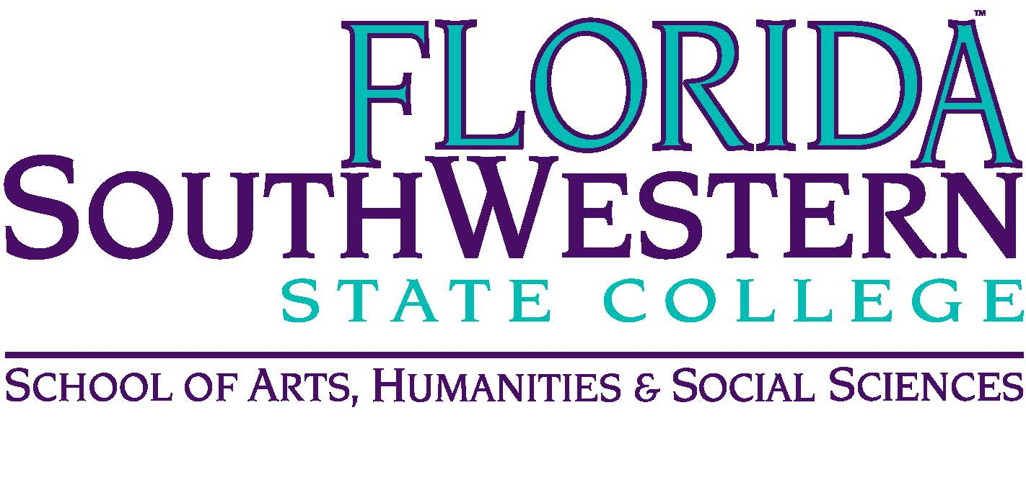
Department of Humanities and Fine Arts
Meeting Minutes
Date: April 9, 2021 – 10:00 a.m.
Location: Virtual/Online (Zoom)
Chair: Dana Roes
Minutes: Michael McGowan

 | Present | Absent | Excused
Brown | X
Chase, S | X
Chase, W | X
Doiron | X
Hoover |  | X
Lublink | X
McGowan | X
Mompoint | X
Pritchett | X
Roes | X
Sutter | X
Smith | X
Swanson | X
Molloy | X
Krupinski | X
Wurst | X
Harrington | X
Chowdhury | X
Gresens | X
Guests

- Opening
  - Call to Order: 10:00 a.m.
  - Attendance taken
  - Honoring Russell Swanson
  - Minutes from March 2021 approved
- Announcements:
  - Congrats to Stuart and Jaime (theater)
  - Congrats to the Salty Dogs (Mike and Russell)
  - Congrats to the Honors Program event success
  - Elijah, Wendy, and Russell (Interdisciplinary Humanities journal)
  - Tom’s music update
  - Art Exhibition (Fast Forward), Big Arts Sanibel (June 3rd, July 23rd opening live with 7 students)
  - Adjunct Offices are being made into a “Maker’s Space”
  - Graduation 4/30/21. Respond to the poll.
  - Form 3 was already due. Get it in.

- Information Items:
  - Assessment (Elijah): we’re being asked to do Assessment stuff after our meeting today. It’s our SACS efforts, happening today at 11 a.m. After this year, Monique is taking over for Elijah. Last Assessment committee is open to everyone, and it’s Monday, May 3rd (our last duty day), from 11-12:30. All the major FSW folks will be there. Look for Joe Van Galen’s email for the Zoom link.
  - Professional Development (Sarah): There is some money still for April-June, and they’re being approved as they come in. Get it in soon.
  - Monica (OBOC): Not doing expansive “give to everyone” approach, as we did with Harari.
  - Honors (Wendy)
  - Growth of the Arts: we need to create an advisory board, which meets twice a year. They’ll keep minutes. Get back to Dana with names for this board. For a state school to offer a four year degree, it has to be validated by the needs in the work force.
- Discussion Items
  - OERs for HUM classes. Discussed whether we need to have a hard copy of the textbook. Elijah said HUM 2235 was on its way, and adopting hard copy textbooks would delay the inevitable move. Philosophy folks are working on this for the Ethics class for fall 2021.
  - Ryan (Pathways): he’s making the argument that humanities courses are good long-term, even if there’s not a specific career path. It’s important for us to get our stats out there about the value of studying our disciplines.

- Next Meeting: next year!

