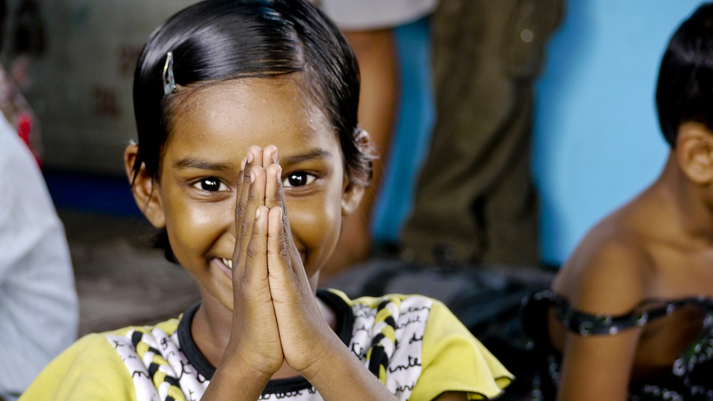

**For more details, go to: edison.edu/library/films**

**eries/**

Victim advocates from Abuse Counseling & Treatment (ACT) & the Children’s Advocacy Center of Southwest Florida will lead a discussion after the screening

**THE RUSH LIBRARY FILM SERIES**

**presents** **a FREE screening of the documentary film**

**HALF THE SKY: TURNING OPPRESSION INTO OPPORTUNITY FOR WOMEN WORLDWIDE**

**Tuesday, February 5, 6pm**

**Rush Library Auditorium, J103**