Academic Success Department Meeting
October 9, 2020
12:00-1:30pm
On Zoom https://fsw.zoom.us/j/94718353424

Agenda

I. Good News!

II. Dean’s Reminder: We are seeing students suffering from unemployment, food insecurity, homelessness, and other distress as a result of COVID-19. We may need to listen more closely to what is going on in their lives especially if they present us legitimate reasons (illness with doctor’s confirmation) why they are behind in their work. Also, as we begin Term B, please remind faculty to make good use of the Early Alert System. It seems to help get students back on track or, in some cases, informs them they are in a particular class they didn’t know they enrolled in (!!!). See Food and Self-Care Pantry graphic.

III. Spring Schedule: Dr. Page has completed the initial assignment of courses for Spring 2021. You should see your current assigned courses in Banner and Canvas. For Adjunct Professors, Dr. Page will be sending out emails with tentative spring assignments. For full-time faculty, if there was an issue with their Spring preferences, he would have reached out to them in advance of scheduling, but he will follow up with a confirmation email. Changes may still be made based on enrollment and registration. Hoping for a smoother Spring.

(Remember the short lead time after Winter Break; Jan 1 is a Friday, back to work Mon, Jan 4 and classes start Wed, Jan 6)

IV. QEP (Dr. Gus Cameron) To discuss the QEP topic, Transdisciplinary Communication, and its emerging shape(s). Get input from us on aspirational goals, new ideas, and how we might see our role in Transdisciplinary Communication in the general education curriculum at FSW.

V. Academic Support Centers (Laura Price and Sandy Sardinas) An update on the ASC’s staffing, distance tutoring procedures, and answer any questions we might have.

VI. Committee Updates

  - Curriculum Committee
  - Professional Development Committee
  - Academic Standards Committee
  - Academic Technology Committee
  - OER Committee
  - Calendar Committee
  - Learning Assessment Committee
  - OBOC
VII. PD
- Online Certifications
October 5, 2020 – Request enrollment and start certification by this date
October 27, 2020 – Complete all certification requirements to remain on the schedule for related instructional modality
October 28, 2020 – Priority registration opens for students
November 15, 2020 – Facilitation for Live Online and Online Teaching Certifications is suspended until duty days Spring 2021.

- Cornerstone Modules training set for PD Friday, October 23, 2020.
Two PD Fridays in October—October 23 and October 30.

You Received a Letter of Accommodation from ADAptive Services. What Now?

Friday, October 23, 2020 at 1:00pm - 2:00pm | Location: Zoom

When are Accommodation Requests Unreasonable?

Friday, October 23, 2020 at 3:30pm - 4:30pm | Location: Zoom

VIII. Evaluations
a. Portfolium Trainings for Full Time Faculty ongoing with the TLC
b. Mentor Assignments Made for Adjunct Faculty Mentoring and Mini-Portfolios
IX. Effectiveness Plans—Dr. Hester A reminder to each discipline area about what is being assessed. Ideas for what might help in the area of assessment.

X. EAP Update
XI. REA Update
XII. Advising Update—Silvia Guerrero-Smith
XIII. Student Engagement Update—Catherine Gorman
XIV. SLS Update
XV. Additional Items?

NOTE: Future Meetings: November 13, December 11?, January 8, February 12,
March 12, April 9 On Zoom. https://fsw.zoom.us/j/94718353424

- 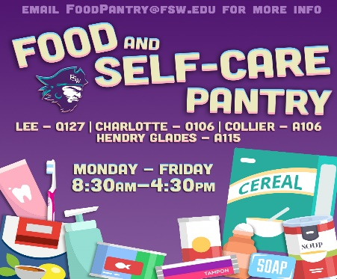
In addition to food items, we also have shampoo, conditioner, soap, deodorant, feminine hygiene products, and toothbrush/paste. Please help Student Engagement share this information with students.

Tell Your Students! If they don’t have a good Internet connection at home; if they have too many distractions at home; they can come to their FSW Campus Zoom Room to access their class.
Students--Need a place to access your Zoom class while on campus? FSW has created Zoom Rooms at every FSW location.

Charlotte
Building B Room 116 M-R: 7:30 a.m. - 7:00 p.m. F: 8:00 a.m. - 4:00 p.m.

Hendry/Glades
Building A Room 108 Check-in at the front desk M-R: 8:30 a.m. - 9:30 p.m. F: 8:30 a.m. - 4:30 p.m.

Collier
Building A Room 101 M-F: 8:00 a.m. - 10:00 p.m.

Lee Campus

Extended Hours as of 9/24!
Building U Room 102 M-R: 8:30 a.m. - 9:45 p.m. F: 8:30 a.m. - 4:30 p.m.
https://www.fsw.edu/reconnect

