Note required information: Program or certificate changes require a change to the catalog page. All change of program or certificate proposals must include the new catalog page, with all proposed changes, at the end of this document. All changes that affect the courses, words, numbers, symbols, program description, admissions requirements, and graduation requirements must be documented. Note before completing this proposal that all new courses and current prerequisite, co-requisite, core, or elective courses changes must have already been reviewed (or submitted for the same meeting) by the Curriculum Committee and approved by the Provost. The Track Changes feature in Word must be used to illustrate all changes to the catalog page.
School or Division | School of Health Professions
Program or Certificate | AS in Health Information Technology
Proposed by (faculty only) | Deborah Howard – Program Director
Presenter (faculty only) | Deborah Howard – Program Director
Note that the presenter (faculty) listed above must be present at the Curriculum Committee meeting or the proposal will be returned to the School or Division and be resubmitted for a later date.
Submission date | 9/4/2020
All Curriculum proposals require approval of the Curriculum Committee and the Provost. Final approval or denial of a proposal is reflected on the completed and signed proposal.
☐ | Approve | ☐ |  | Do Not Approve
Curriculum Committee Chair Signature |  |  |  | Date
☐ | Approve | ☐ |  | Do Not Approve
Provost Signature |  |  |  | Date
All Curriculum proposals require review by the Office of Accountability & Effectiveness.
☐ | Reviewed
Office of Accountability & Effectiveness Signature |  |  |  | Date
Section I, Important Dates and Endorsements Required
nOTE: Course and Program changes must be submitted by the dates listed on the published Curriculum Committee Calendar. Exceptions to the published submission deadlines must receive prior approval from the Provost’ Office.
Term in which approved action will take place | Fall 2021
Provide an explanation below for the requested exception to the effective date.
N/A

Any exceptions to the term start date requires the signatures of the Academic Dean and Provost prior to submission to the Dropbox.
Dean | Signature | Date
Dr. Paula Tropello
Provost | Signature | Date
Dr. Eileen DeLuca

Required Endorsements | Type in Name | Select Date
Department Chair or Program Coordinator/Director | Deborah Howard | 9/4/2020
Academic Dean or Provost | Dr. Paula Tropello | Click here to enter a date.

List all faculty endorsements below. (Note that proposals will be returned to the School or Division if faculty endorsements are not provided).
Elizabeth Whitmer, Sharon Fitzgerald

Section II, Proposed Changes
Do any of the changes affect the AA focus? (If so, a Change of Program proposal is also needed.) | ☐ Yes  ☒ No
Have the deans of the General Studies been contacted/consulted? | ☒ Yes  ☐ No
Have you attached an updated catalog page? | ☒ Yes  ☐ No
Change of School, Division, or Department
Change to program or certificate name
List below, any changes to the program or certificate prerequisites. Include course titles and credits if applicable.
List below, any changes to the General Education requirements. Include course titles and credits if applicable.
STA2023 Statistical Methods I 3 credits to be the required Gen. Ed. Math course
List below, any changes to the program or certificate Core requirements. Include course titles and credits if applicable.
  - HIM2724 Basic ICD-10 Coding is being removed from curriculum sequence
    - It will be divided into two separate classes
      - ICD-10-CM Diagnosis Coding 3 credits
      - ICD-10-PCS Procedure Coding 3 credits
    - This will provide more time to teach the PCS portion of ICD-10.
    - Will permit HIM2724 taken previously to meet the new HIM2722 ICD-10-CM course requirement.
  - HIM2253 Basic CPT-4 Coding
    - Prerequisites being updated.
  - HIM2729 Advanced Coding and Reimbursement is being removed from curriculum sequence.
    - The content covered in this course will be addressed in the new coding classes, billing class and coding simulation course.
  - HIM2214 Health Data Management is being removed from curriculum sequence.
    - The content is addressed in HIM1000 and STA2023 Statistical Methods I.
  - HIM2512 Quality Management in Healthcare
    - Credit increase from 2 to 3
    - Will provide more time to cover content that is now required.
  - HIM2279 Healthcare Reimbursement
    - Name change to Medical Insurance and Billing
    - This better reflects the actual content of the course.
  - HIM1802 Professional Practice Experience I
    - Name change to Medical Office Simulation
    - This better reflects what is actually being done in the simulation based course.
    - Load change from 6 hours to 3 hours due to online content
  - HIM2813 Professional Practice Experience II
    - Name change to Medical Coding Simulation
    - This better reflects what is actually being done in the simulation based course.
    - Load change from 6 hours to 3 hours due to online content
  - HIM2940 Professional Practice Experience III
    - Name change to just Professional Practice Experience
    - Credit increase from 2 to 3
    - Will provide for additional didactic instruction in addition to facility placement activities.

List below, any changes to the program or certificate Elective requirements. Include course titles and credits if applicable.
List below, any other changes to the program or certificate requirements.
Change to program length (credits or clock hours to complete) | From:  To:

Include complete new catalog page as an attachment. Proposals without the new catalog page will not be reviewed by the committee.

Section III, Justification for proposal
Include state frameworks, accrediting or professional organization recommendations or requirements, workforce data, and/or crosswalks.

Provide justification (below) for each change on this proposed curriculum action.
- Statistical Methods I will be the required general education math course for the AS in HIT degree program – Required by CAHIIM Program Accreditation standards.

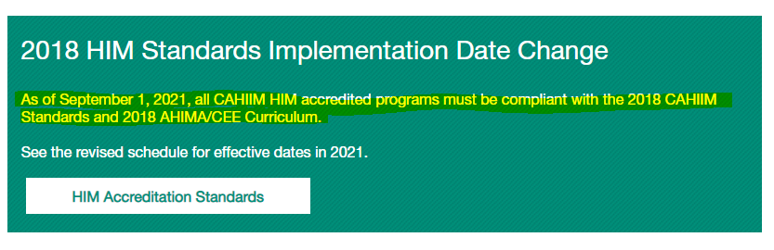

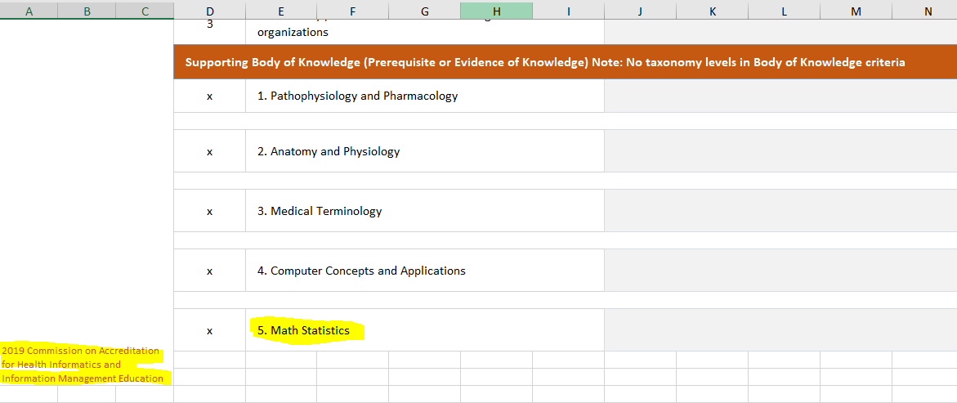
- HIM2214 Health Data Management is being removed from the curriculum sequence due to the new requirement for Statistical Methods I as the gem ed math requirement.
    - It will be taught once more in the Fall 2021 semester for the current 2020 cohort.
    - The basic descriptive statistics are already being taught in the HIM1000 Introduction to Health Information Management course and have been for the past few years.
    - The MS Access database project will be moved to the HIM2210 Healthcare Information Systems course in the Fall 2021 semester for the Fall 2021 new cohort. It will replace the RFP project.
- HIM2724 Basic ICD-10 Coding is being removed from the curriculum sequence.
    - It will be divided into two separate classes
      - ICD-10-CM Diagnosis Coding 3 credits
        - HIM2724 will be accepted as a course equivalent for the new diagnosis coding course.
      - ICD-10-PCS Procedure Coding 3 credits
    - This will provide more time to teach the PCS portion of ICD-10.
- HIM2253 Basic CPT-4 Coding prerequisites must be updated to reflect new ICD-10 courses.
- HIM2729 Advanced Coding and Reimbursement is being removed from the curriculum sequence.
    - The content covered in this course is already addressed in the coding classes, billing and simulation courses.
- HIM2512 Quality Management in Healthcare
    - Credit increase from 2 to 3
    - Will provide more time to cover content that is now required.
- HIM2279 Healthcare Reimbursement
    - Name change to Medical Insurance and Billing
    - This better reflects the actual content of the course.
- HIM1802 Professional Practice Experience I
    - Name change to Medical Office Simulation
    - This better reflects what is actually being done in the simulation based course.
    - Load hours will be reduced from 6 to 3 contact hours due to expanded online content.
- HIM2813 Professional Practice Experience II
    - Name change to Medical Coding Simulation
    - This better reflects what is actually being one in the simulation based course.
    - Load hours will be reduced from 6 to 3 contact hours due to expanded online content.
- HIM2940 Professional Practice Experience III
    - Name change to just Professional Practice Experience
    - Credit increase from 2 to 3
    - Will provide for additional didactic instruction in addition to facility placement activities.

