English Department Meeting Notes, 4/8/2022
Shawn Moore, Ihasha Horn, Michael Barach, Tom Mohundro, Jennifer Grove, Brandi George, John Pelot, Jeremy Pilarski, Suzanne Biedenbach, Cara Minardi-Power, Amy Trogan, Jill Hummel, Leonard Owens, Eric Ivy, Thomas Wayne, Jason Calabrese, Sara Dustin, Ellie Bunting, Mark Massaro, David Luther, Scott Ortolano, and Laura Tichy-Smith
*All in attendance.

I. Assessment, Dr. Cara Minardi-Power:
- Not going to spend a lot of time with the report. Mostly announcements today. Dr. Elijah Pritchett will be chair. Dr. Jennifer Summary will be part of this committee. Gen ED course assessment almost complete. What the point is? Do what we are say we are doing? Not a way to assess faculty. Any ideas for improvement. Assessment report reveals different kinds of data. For example, how 1101 students are comparing. We will be revising 1102 survey. Implement 1101 survey.
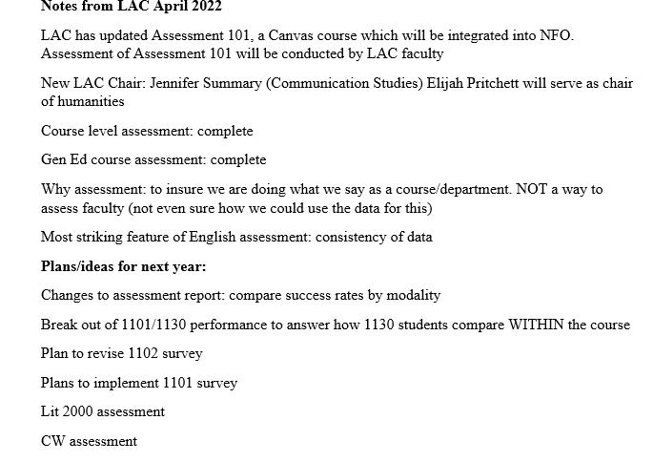

II. Writing Center Update, Prof. Lenny Owens:
- Talked about the letter I had drafted. Positive traction, good report. Dr. Deluca never saw the original request.
- Prof. Ellie Bunting: Monica did send her [DeLuca] a budget proposal. If anyone gets anything this year, they will be included. They will find out we were underpaid.
- Prof. Owens: Miscommunication to be handled and addressed. Sincere support from the college. Thank you so much.
- Dr. Amy Trogan: It was a real learning experience. I appreciate everyone’s grace in the matter. Any questions for Lenny?
- Prof. Owens: We are wrapping up our professional meetings. Several of the faculty attended these sessions. Sara, Myself, and Dr. Harris.
III. Dual Enrollment and Curriculum Committee Update, Prof. Jeremy Pilarski:
- Wrapping up observations. Completed a survey and will launch it next week. Hope to get a better understanding of concurrent faculty’s needs with the data. Will send the data to Cara for assessment. As for Curriculum Committee update, syllabus learning objective changes were approved. We will see the changes in the updated syllabi in the fall of 2022.
IV. OER UPDATE, Dr. Scott Ortolano and Prof. Lenny Owens
- Dr. Trogan: Comp I. Get the official notification for Comp I. Going through the OER institute. Scott will be working on 1101 online. Anything Lenny and Scott?
- Dr. Ortolano: That about covers it. Publishing medium. Embeds seamlessly in Canvas. PDF. Digital elements that can be added. Institute will be in early July. Mapping the outline, so there are no surprises. Our Team Name: Bearded Skunk Brigade. Name has made it up to the top and accepted.
- Dr.Trogan: I may have omitted the name when we did the official proposal. Textbook update. Keep the OER textbook.
ENC 1101 - Digital Credential Update, Dr. Suzanne Biedenbach:
- Draft state sent to the committee. Students will get this badge if they get credit for ENC 1101. If they take 1101 from another state, they get it. They’re handing these badges out like candy. We did talk them into dumbing it down. This is going to be happening to the state. Could we put together our own badge? Do the badge instead. These are the education badges offered by the state. We have purchased rights to the Badger System. I still think this Fundamental Communication Badge is dumb. So, we do have an opportunity to pick a badge.
- Dr. Trogan: Thank you, Suzanne. It’s great we were all on the same page and united against a common enemy. I appreciate your time, effort, and patience. Thank you so much for all that.
V. Supplemental, Dr. Amy Trogan:
- WEAP is going to happen not right now. Next step would be job to create a description. It’s just so chaotic or intense. This is something we could do in the fall. SLS 1515 is this something we can pursue. The tree is there, and we can shake it and see what happens. Nothing we could do about either of those.
VI. English Department Chair Update, Prof. Ellie Bunting and Dr. Amy Trogan
- No other nominations. We can just do an affirmation and say hello to our new chair.
- Dr. Amy Trogan: Dr. Sara Dustin is so detailed-oriented. She is incredibly helpful. Well respected by us. Other chairs respect Sara so much.
- Dr. Sara Dustin: Thank you, Amy.
VII. Textbooks, Dr. Amy Trogan:
- Anything we use needs to be adopted in every session. They tell you how to integrate the text into the Canvas course. I do not have an issue regarding anything regarding that. Tutorials and videos will be sent. We are moving forward to OER fall 23. My reaction was we stay the course for the year. I also did not want to throw a bunch of Comp students under pressure.
- Dr. Biedenbach: How would this work for ENC 1130? Since they are taking both courses, will they be taking it twice. So, would they be double paid. I have been using Inquisitive. Online versions. Problems with the DE Students. Online version. Didn’t get the Inquisitive access. They messed things up including Inquisitive in both texts. It’s the exact same thing, but for the two different books. Access code not working for 1130 because putting the code connected to each book. We do not have a need to have both books. Embedded in the course means none of the student will be buying hard copy. I want them to have those books in front of them. Encourage them. Save money. Include Inquisitive.
- Dr. Jennifer Grove: I students the ISBN. They can get these texts for $10. So I tell students, not go into the bookstore unless you have a coffee cup. So I vote no. I might feel differently if weren’t committed to a year. There should be a pilot course.
- Dr. Biedenbach: They can get the Canvas course for 21 days. I feel it’s being forced in everybody’s course. I don’t know. They can do this exact same thing now. Encourage them to buy online. Better off with the hard copy. Agreeing with Grove. Forcing it in every section.
- Prof. Owens: Not everyone uses a hard copy. Also, copies of They Say/I Say in the library.
- ENG Department: Votes no.
VIII. Guided Pathways, Dr. Amy Trogan:
ENC 1012. A good course to get students interested. We can cover Lit and direct communication. We need to develop a curriculum and think about what it is going to look like. We have some options because it is broad. They also have the option of taking Lit 2000. One of things Dr. Page discussed is should there be separate guided pathway for Creative Writing. We could do this. Something was said at our meeting I want to point out: We are talking about a student’s first four semesters. So, is it literature, Direct. com, or creative writing? I do not want to put all these silos. Help me figure out what to do with that. I want to teach English.
- Dr. Brandi George: Either have a general English pathway than one specific pathway. I like the creative writing pathway, that is the specificity.
- Dr. Trogan: At which semester do things become siloed.
- Prof. Ihasha Horn: Keeping these general in the beginning or then we start to silo, and after the introduction, the student picks.
- Dr. Trogan: At what point do students specialize? Should we continue on the Direct.com pathway? Give them a chance to discover?
- Prof. Owens: That’s what we mean by ENG 1012. They cover a broad range of topics. We stumbled across this. Could be the light-my-fire course. Takes in their second semester. Might identify with the course they like. That’s when they delve in the future courses.
- Dr. Trogan: Give them a chance to figure it. Give them a broader approach. I don’t know.
- Dr. Minardi-Power: Concerned we may do students harm. The degree in English should be broad-based so they have a feeling for what courses they want. Again, Broad based, meaning what are all the different ways you can write. Essay writing, journalism, book reviews.
- Dr. Trogan: I do not want to pigeonhole students. You do know what to do. Good way to figure it out. Right place. Avoid students who earn more credits than they need.
- Dr. George: I agree with not pushing students. They are only three creative courses. I don’t know. I still think they could miss out. Of course, they may get exposure to all three in case if they are general enough.
- Dr. Trogan: Any more ideas how this should go? Please share your input specific.
- Dr. George: I support the creative writing pathway.
- Dr. Ortolano: Strange prefix. It’s listed as theater arts.
IX. Faculty Updates, Dr. Amy Trogan:
- I will give you an update on when you will stop seeing me. I am making the transition out of the state. I am having a hard time finding a house. In transition may be differently than I thought. It is still in progress although progress is relative.
- Dr. Ortolano: Few final events. Monday Community of Practice Meeting. Lenny Co-Presenters. It should be a great session. Next Friday. Dr. Jill Hummel will be doing how to do group work with Covid-19 and what is going on in the FLEX classes. Important discussions. Who knows when we will be called? New programs people are learning. People learning using gaming programs. I have some ideas. Bounce off the ideas. ENG thing has been fixed.
- Prof. Horn: Sustainability working in the garden 3:30. Creative Writing is starting to rebuild itself.
- Prof. Laura Tichy-Smith: GSA trying to get more people. Recruit more officers. Our next meeting day after final. After finals party on Zoom.
- Dr. Trogan: Thank you all for what you do. Reminders. I am looking forward to the athletic event on 4/23 with communication. DE students have accommodations. If they tell you. The accommodations are not engaged with the district. They need to register with our adaptability. Any new reminders or new business.
- Dr. George: Illuminations will be open. Please encourage your students submit. We take fiction, poetry, art, etc. They can send it to illuminations.
Meeting adjourned 11:30am.
Notes by Prof. Jeremy Pilarski

