Academic Calendar Committee
Minutes
September 14th, 2021
Attendees: Anthony Valenti, Sabine Eggleston, Kelsea R. Livingstone, Brenda Knight, Danielle Orlovic, Bonnie Lawler, April Fleming, Martin McClinton, Susan C. Bronstein, Martin Tawil, April Falso
Excused: Julissa G. Roland

- Approval of Minutes
Approved
- Finalize the 2022-23 Academic Calendar. The proposed schedule was reviewed and the Committee supported recommending it to the Board of Trustees.

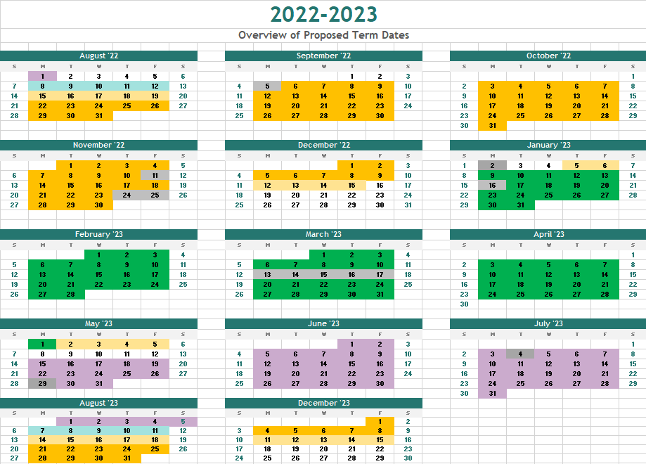

Fall 2022 Semester. The following dates were discussed and recommended
Fall Semester | Full Term | Session A | Session B
First Faculty Workday | 8/15/2022
Last Faculty Workday | 12/15/2022
First Day of Class | 8/22/2022 | 8/22/2022 | 10/13/2022
Last Day of Class | 12/3/2022 | 10/6/2022 | 12/3/2022
First Day of Exams | 12/5/2022
Last Day of Exams | 12/10/2022
Holiday 1 | 9/5/2022 | 9/5/2022 | 1/0/1900
Holiday 2 | 11/11/2022 | 1/0/1900 | 11/11/2022
Holiday 3 | 11/24/2022 | 1/0/1900 | 11/24/2022
Holiday 4 | 11/25/2022 | 1/0/1900 | 11/25/2022
Holiday 5 | 11/26/2022 | 1/0/1900 | 11/26/2022
Holiday 5 | 11/27/2022 | 1/0/1900 | 11/27/2022
Study Day | 9/6/2022 | 9/6/2022 | 1/0/1900
Study Day | 11/23/2022 | 1/0/1900 | 11/23/2022
Total Faculty Workdays | 85
Class Session by Day
Fall Semester | Full Term | Session A | Session B
Mondays | 14 | 6 | 7
Tuesdays | 14 | 6 | 7
Wednesdays | 14 | 7 | 6
Thursdays | 14 | 7 | 7
Fridays | 13 | 6 | 6
Saturdays | 14 | 6 | 7
Sundays | 13 | 6 | 6

Spring 2023. The following dates were discussed and recommended. Spring break is suggested for the week of March 13
Spring Semester | Full Term | Session A | Session B
First Faculty Workday | 1/5/2023
Last Faculty Workday | 5/5/2023
First Day of Class | 1/9/2023 | 1/9/2023 | 3/1/2023
Last Day of Class | 4/24/2023 | 2/23/2023 | 4/24/2023
First Day of Exams | 4/25/2023
Last Day of Exams | 5/1/2023
Holiday 1 | 1/16/2023 | 1/16/2023 | 1/0/1900
Holiday 2 | 3/13/2023 | 1/0/1900 | 3/13/2023
Holiday 3 | 3/14/2023 | 1/0/1900 | 3/14/2023
Holiday 4 | 3/15/2023 | 1/0/1900 | 3/15/2023
Holiday 5 | 3/16/2023 | 1/0/1900 | 3/16/2023
Holiday 5 | 3/17/2023 | 1/0/1900 | 3/17/2023
Holiday 7 | 3/18/2023 | 1/0/1900 | 3/18/2023
Holiday 8 | 3/19/2023 | 1/0/1900 | 3/19/2023
Total Faculty Workdays | 81
Spring Semester | Full Term | Session A | Session B
Mondays | 14 | 6 | 7
Tuesdays | 14 | 7 | 6
Wednesdays | 14 | 7 | 7
Thursdays | 14 | 7 | 7
Fridays | 14 | 6 | 7
Saturdays | 14 | 6 | 7
Sundays | 14 | 6 | 7

Summer 2023
Summer Semester | Full Term | Session A | Session B
First Faculty Workday
Last Faculty Workday
First Day of Class | 5/15/2023 | 5/15/2023 | 6/27/2023
Last Day of Class | 8/5/2023 | 6/21/2023 | 8/5/2023
First Day of Exams
Last Day of Exams
Holiday 1 | 5/29/2023 | 5/29/2023 | 1/0/1900
Holiday 2 | 7/4/2023 | 1/0/1900 | 7/4/2023
Holiday 3 |  | 1/0/1900 | 1/0/1900
Summer Semester | Full Term | Session A | Session B
Mondays | 11 | 5 | 5
Tuesdays | 11 | 6 | 5
Wednesdays | 12 | 6 | 6
Thursdays | 12 | 5 | 6
Fridays | 12 | 5 | 6
Saturdays | 12 | 5 | 6
Sundays | 11 | 5 | 5

- Discuss the Add/Drop period for minimester classes.
While it was recognized that allowing students to add minimester A classes into the second week of the semester, the issue of students not being able to drop classes as well as the administrative burden of maintaining the drop dates meant that the Committee did not recommend changing the add/drop dates for minimester classes.

