English Department Notes
September 9, 2022
Sara Dustin, Ihasha Horn, Michael Barach, Tom Mohundro, Jennifer Grove, Brandi
George, John Pelot, Jeremy Pilarski, Suzanne Biedenbach, Cara Minardi-Power, Amy
Trogan, Jill Hummel, Leonard Owens, Eric Ivy, Thomas Wayne, Jason Calabrese,
Mark Massaro, Scott Ortolano, Laura Tichy-Smith, Edward Krzeminski, Jennifer Grove,
David Luther, Laura Henning.

I. 8/17 Meeting Minutes Approved.

II. World Lit II Removal, Dr. Dustin.
1. Who is teaching it this year?
A. Prof. Tom Mohundro and Dr. Thomas Wayne want to teach it.
B. Dr. Dustin: Interested, Tom?
C. Dr. Wayne: I’ll teach it if I have to.
D. Dr. Jill Hummel. I get weary when we remove anything. I understand why some of the small lit courses get rid of one.
E. Dr. Dustin: We have not taught it in five years.
F. Prof. Lenny Owens. Because of the pathways, we might want to keep it; however, to lose that would be troubling.
G. Dr. Dustin: We will let Dr. Teed know.
III. Links in Lit 2000, Prof. Ihasha Horn
1. Talking about the course Ellie created. We solved the problems with third-party issues. Grades may be affected because of technology issues. Some of the content is great. No perspectives that are contemporary. Other than that, it is a great course. I remember we chatted about this. We wanted to go to these master courses. Especially, the adjuncts.
IV. Committees, Dr. Dustin
1. Committees are ready. We are ready to hear from faculty senate.
A. Prof. Horn: I have a question about renewal. I have all these different contracts. I am not sure what I need to do. Please post all you need you have none.
B. Dr. Dustin: Are you concerned about the renewal?
C. Prof. Horn: Maybe Scott and I can get together. Anything about the ICC?
D. Dr. Dustin: Not yet. We are in waiting mode. I know Scott reached out to Martin. We are still getting the process together.
V. Spring Schedule
1. Dr. Dustin, Any questions on the spring scheduling?
A. Horn: We are only offering 1102. Did I see that correctly? It looks like fall 1101.
B. Dr. Hummel: I am teaching it.
C. Prof. Mark Massaro. I have not heard anything.
D. Dr. Suzanne Biedenbach: The pathways is just a suggestion for what students should take.
E. Dr. Dustin: Make sure you send your health information to the appropriate people (Adam and Dr. Teed).
V. Fundamentals of Written Communication Badge, Dr. Suzanne Biedenbach
1. State has started offering badges and different things. Pulling together a badge. Communication is one of them. Just telling them what they wanted. It’s not what the faculty wanted. That means if they take 1101 in our institution or take AP and get credit, they will be given a badge. This badge had a lot of discussion. They made it sound like more than it really is. The only course was 1101. Either way, they get this badge. The Ed tech people have put together a Canvas module. Look for communication. Super short description. Second little component how they can access this badge. How they can print out this badge. I am not going to burn with my students with it just now. I think it is my opinion: Less than a couple of weeks. Let them know this is a thing. There are other badges. I don’t know if other badges had been created it yet. So, it’s there. I would highly suggest you put it into your Canvas course.
A. Dr. Dustin-So all students who taken Comp I will get the badge?
B. Dr. Biedenbach: Yes. Schools have different ways. We are using badger. This will something students will get as they are working. It is the most common one. Any badges they receive will go in there. I do not know a lot about it. The module is small, two things. Take look it.
C. Dr. Dustin: This should be a seamless process.
VI. Writing Center Staff, Prof. Lenny Owens
1. Not a lot yet. We wanted to get some speakers. We want Dr. Page to come. Eddie don’t be surprised if you we will be volunteered. We will also talk to Laura.
VII. Illuminations, Dr. Brandi George
1. David Kirby and other poet will be attending. There will also be a
VIII. Assessment, Dr. Cara Minardi-Power
2022-2023 English Assessment Plan
Continue to assess DE (Jeremy Pilarski)
Compare success rates by modality (1101, 1102)
We want to see if students in 1130 perform better in 1101; Break out 1101/1130 to do comparison: How do 1130 student grades in 1101 compare to traditional 1101 students?
Can we compare 1130 success rates in 1101 to historical success rates in 022?
Reword question 8 on 1102 survey?
- Question 8: I am comfortable reading and writing about, as well as discussing in class, complex and difficult issues, even if I disagree strongly with others.
Revise/complete 1101 survey and use it this year (anyone want to help revise these?)
Measurement: Likert scale

- I can compose in a variety of rhetorical modes and genres at the college level.
I can write clear comparisons of things or clear categorizations of things.
I can write to explain or describe the cause and effect of something.
I can write clear descriptions of people, places, or events.
I can write to make strong comparisons or contrasts.
I can write to define something.
I can write to tell a story or a narrative.
I can write about processes and explain clearly the steps associated with it.
I can write strong examples to support my point.
I can write to compare something using thoughtful analogies

- I can compose through multiple drafts in order to revise my writing, rhetoric, and ideas through feedback, as well as use drafting and revision as a means of inquiry.

- I can organize, compose, revise, and edit essays with clear thesis statements, coherent, unified paragraphs, and varied sentence structures and length.
I can compose, organize, revise, and edit my own writing.
I can organize my thoughts to convey a message.
I can write a clear and concise paragraph on a topic.
I can revise a thesis statement to create a coherent structure and unify purpose.
When I submit homework, I revise/edit before submitting.

- I understand how purpose, audience, context, and medium/mode shape processes of reading and composition, as well as the rhetorical situation.
I change my writing style depending on the situation.
I change my writing style depending on who I'm talking to and when.
I alter my writing process to conform with the purpose of the writing.
I can incorporate research into my own writing using
summary,
paraphrase,
direct quotation by composing academic research assignments.

- I understand the difference between primary and secondary sources.

- I can locate, analyze, and evaluate primary and/or secondary sources in a variety of modes (print, digital, visual, oral etc.) in order to conduct academic research.
Before I share information I check the source of the news
I compare sources of news before sharing it.
I am confident providing sources and evidence in research papers for class.
When writing research papers, I can find multiple sources of evidence.
I can use FSW’s academic databases.

7. I know how to cite sources appropriately and avoid plagiarism in academic research.
I can cite my sources clearly and efficiently in research papers.

Lit 2000 assessment

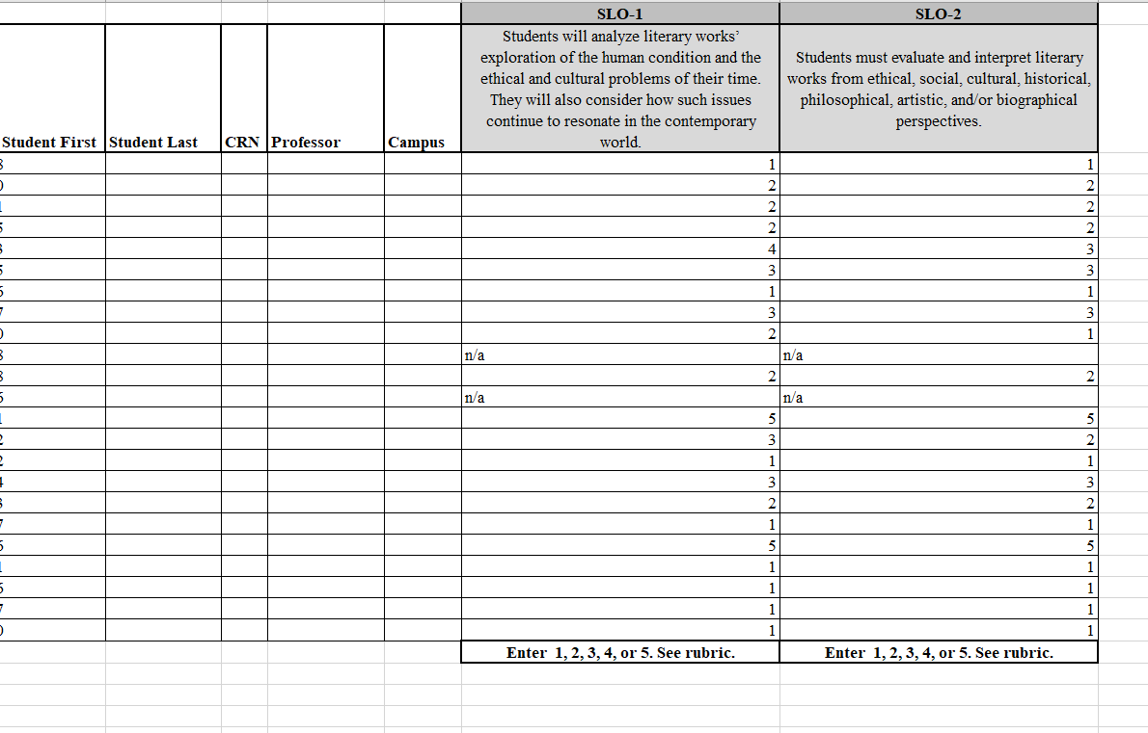
Continue working on CW faculty to do assessment
CW speaker series assessment (Brandi George)?

Coordinator Announcements for September 2022 Departmental Meetings
The AY 2022/2023 Gen Ed Assessment Plan will focus on “Visualize” and “Engage”: review with your department the courses it offers that are up for possible sampling. Explain to new and returning faculty what the process entails and what they should expect if they are selected for assignment submission.
September and October PD Fridays: Team AASPIRE and Jennifer Summary will host a series of PD events in September and October.
September 30 at 10-10:45 am---Talking About the Visualize Competency
September 30 at 11-11:45 am--Talking About the Engage Competency
November 10, 10-10:45 am--Reviewing “Think”: Analyzing Results of General Education Assessment, AY 21/22
November 10, 11-11:45 am--Reviewing "Investigate": Analyzing Results for General Education Assessment, AY 21/22
Feel free to direct faculty to reach out to Jennifer Summary or Joe van Gaalen for additional information about any of the above announcements.
A. Dr. Minardi-Power: Why did we want to change this language.
B. Dr. Hummel: It had to do with learning outcomes. We wanted to remove the narrative aspects of it. When we switched learning outcomes. I think. Maybe Amy remembers? Rebecca Harris was chair them. Did we have a normal existence. Who was in department? Did I hallucinate when we had that conversation?
C. Dr. Minardi-Power: Amy and I started working on an update survey. Looking for anyone who wants to update this. Due the same day my continuing contract. If anyone wants to help. We are going to do Lit 2000. So this is just a heads up. We are going to select random professors teaching Lit 2000. So, not a big deal.
Brandi and I trying to figure out how to do an assessment on her speaker series. Is there anything we want to address here? Anyone have any questions? TEAM ASPIRE is great.We do need a member at large at LAC. My tenure is about up. And I would like to have some choices when voting. It is really interesting. Being on LAC has helped me understand much better. I have found that really helpful. Focus on visualize and engage. I don’t think we have a lot of that. TEAM ASPIRE has PD events. Talking about engage. What these things mean and how they work in our courses. Helped last year for Think and Investigate.
D. Dr. Dustin-Is there a deadline?
E. Dr. Minardi-Power: Sooner the better. Get whole year of academic understanding. I have a background in assessment. The way we do assessment is unique here—in a good way. It all funnels back to PD. I was trained to be a writing program administrator. Made a bit more difficult. I would love to have people. Please someone join us. That’s why I joined. Amy told me they are the nicest people.
VII. ENC 1130 Sub Committee, Dr. Suzanne Biedenbach
1. Test threshold. I am on one of those Think committees. Each school has a committee. Kristy Gilford is doing it. Dual Enrollment person. Because it involves English and Math, I am on there. HB-17. Know a lot more placement. What is says anybody who is a freshman in high school from 2003 to there on, they are exempt from any type of placement testing. They are exempt from any placement. Same with college algebra. State has decided to do, people who are not exempt, homeschool, anybody else. A smallish group. Don’t know the percentages. Look for different areas of placement. Get rid of Accuplacer. Had a meeting with FSW people. There was a summer thing, but nobody went there. Some of the schools went to it, but they kind of just got together. Wish we can do this with all our students. We are all on the same page. Working meeting. Meeting every two weeks. Seven people. What they talked about, I’m not sure why I was there. What kind of scores. Talk about stakeholders. That kind of thing. Non- exempt students. Changed in the way 80%. Placed in 1101. After the cut scores were raised. 60% of non-exempt being placed in 1130. We have not been able to accommodate the students already. We had to turn students away, but it is going to get worse. Anticipating a huge demand next semester. It is a wonderful experience. We have tons of material. Super rewarding. Think about it. It is a great way to do an overload. We will do anything to help you. We will give you everything. We have same teaching philosophies. It does not change anything. 1130 is a support class. You need to teach this. 1130 is extra prep really. It’s not another 1130 course. Lots of semesters of experience. Super nice. 1101 is your 1101. An 1130.
A. Prof. Calabrese-1130 is an extra class.
B. Dr. Biedenbach: No it is addition. Course. You do the 1101 first and then the 1130. If you are doing ground, 10 of those people will leave. And then you will have those 1130 students. One on one time. Workshop class. Lenny has done it. You can get a lot of support with it.
C. Prof. Calabrese: Is it possible to have all 25 attend both? In the 1101. We never signal out the 1130. 1101 teach it. Then the 1130 comes in it. This helps the students get extra help. One that help the other.
D. Dr. Minardi-Power: My experience is difference between 1130 and 1101 not strong on the rigidity of rules. Honestly, think 1130 students are better at critical thinking. My own bias. They see very often. Not nearly as deficient.
VIII-Creative Writing Update, Dr. Brandi George
1. I already shared my event. Submissions open. Probably around in December. Creative non-fiction. If they have something cool. Have them send it to the email.
A. Prof. Horn: Details. Copy and paste it. Behalf of the creative writing members. We got 20 members. Based on word of mouth. We went from nothing. Thank you so much.
Tyler is going to our president. Official meeting is biweekly. 1:30. Canvas.
Past week had the Writing Club meet writers on stage. Something you are interested in doing, let us know.
IX. Faculty Info
1. Dr. Michael Barach: We are offering Lit 2000 in Florence. If you have a students who are interested in classical poetry please let your students know. We need at least 9 people to make this go. They are going to have to take Lit 2000 anyway. Very cool experience.
A Dr. Ortolano: Community of practice is next Friday. Return to literature. Anything is valuable to students. I am going to do a post. With a link to that the meeting. September 12: Preventing of Plagiarism. We had a meeting. We do writing with scaffolding. Putting student in situation that forces them to do something bad. Thank you so much.
B. Dr. Hummel: Bunting got us through everything but financials. We have not lost anything, but we have not gained an inch. October 6, Thursday. Next bargaining. Power in numbers. They wouldn’t give us faculty rank. Strictly for grant writing and they wouldn’t get anything. They lost nothing, but they said no. release time for stipends. Numbers matter and we all need a raise.
C. Dr. Minardi-Power: I read the blog last night. The discussion on rank stymied.
D. Dr. Hummel: I just shot down all their arguments. We weren’t doing the way state colleges were doing it. Not connected to research and tenure like a university. Are you going to do this a compensation thing. We are doing this too soon. We’ve have been doing this for 10 years. We have no idea. We are not done with this issue. Feels somewhat symbolic. Change their business records. So, I kept my cool in my.
E. Prof. Owens: We should be proud to have Jill Hummel on our side. They way discussed the process was really disturbing. It’s just longevity. It is not the way it was sold to us. Well thought-out. I was humbled to see Jill and she was having none of it. Why are they not going to give it to you.
F. Prof. Bunting: When we meet with UFF that should help us with financials.
McClinton-If he comes in and says that they do not have any money. They are mad at us right now. If we apply for more it’s going to be tough. So we are going to get UFF’s advice. The next meeting was changed 10/11. We will get back to you on that firm date. Appears they are trying to undue Deluca’s legacy at the college. It is important how we carry ourselves at the college. How we do this. The impact of losing stipends is foundational to shared governance. It will look bad on them to go to impasse on everything. I don’t know what the strategy is yet. How we are responding not reacting. Show up in numbers. We need to be strategic about this.
G. Dr. Dustin: Thank you, Jill, and Ellie. I want to be there as well. I just do not remember it being so contentious. Let us support or other faculty members. Let us pull together and support.
X. OER Textbook. Prof. Lenny Owens and Dr. Scott Ortolano
1. Using pressbooks. Just wanted to mention that we passed with flying colors. Diving in to putting the book together.
B. Dr. Dustin: Super exciting. Some textbook problems. OER textbooks are coming. Be as supportive as we can. Problem solver, but not perfect. This is what we always do.
C. Dr. Jennifer Grove: Students have this resource. They need to have a lot of time. It’s good that they will have it.
XI. Dual Enrollment and Curriculum Committee, Prof. Jeremy Pilarski
1. Not a lot of news regarding DE for the moment. We do have some new people starting this fall. We also have observations coming up in the spring. I plan to do those observations in person. As for Curriculum Committee, I look forward to working with Dr. Minardi-Power and Dr. Biedenbach on ENC 1130 language. I have also decided to take the Vice Chair position. We will need another member from the English department to join the Curriculum Committee.
* Meeting adjourned at 11:30
*Notes, Prof. Jeremy Pilarski

