English Department Notes
March 10, 2023
9:30–11:00
Sara Dustin, Ihasha Horn, Michael Barach, Tom Mohundro, Brandi
George, John Pelot, Jeremy Pilarski, Suzanne Biedenbach, Cara Minardi-Power, Amy
Trogan, Jill Hummel, Leonard Owens, Eric Ivy, Thomas Wayne, Jason Calabrese,
Mark Massaro, Elle Bunting, Scott Ortolano, Jennifer Grove, Edward Krzeminski
*All in attendance.
I. February meeting notes approved.
II. OER, Dr. Scott Ortolano and Professor Lenny Owens
Our efforts were a success, and we are looking good.
Numbers that showed with OER projects we did. We have the potential to save students over $400K. $343 of those dollars for 1101. 88% voted yes for the OER textbook. Overall, people are happy with the project.
III. ENC 1101, Online Shell, Dr. Sara Dustin
Dr. Dustin: Dr. Jester approved the outline, so, I think we are all set.
Dr. Ortolano: We should be ready. It should be done by this spring, going into the rest of the spring and summer.
Dr. Dustin: It’s a lot. We approved the adoption of the OER text. Thank you!
III. Nursing, APA
Dr. Dustin: Professor Marty Jenner wants to know if we can teach APA. Her nursing students are lacking citation skills. Profs. Henning and Pilarski have experience teaching it. Anyone else interested?
English Department as a Whole: Not interested. Prof. Jenner should spend more time teaching APA if she wants it. We should, if possible, hire a WAC (Writing Across the Curriculum) person.
IV. Assessment, Dr. Cara Minardi-Power
LAC notes for discipline 3.10.2023
General Education assessment 78% complete (estimated completion March 20)
Email verification sent out to faculty for assessment soon or already done
Assessment 101 in beta testing
PD dates:
March 31 10:00 am Visualize
March 31 11:00 am Engage (really recommend you go!

LAC coordinator position changes
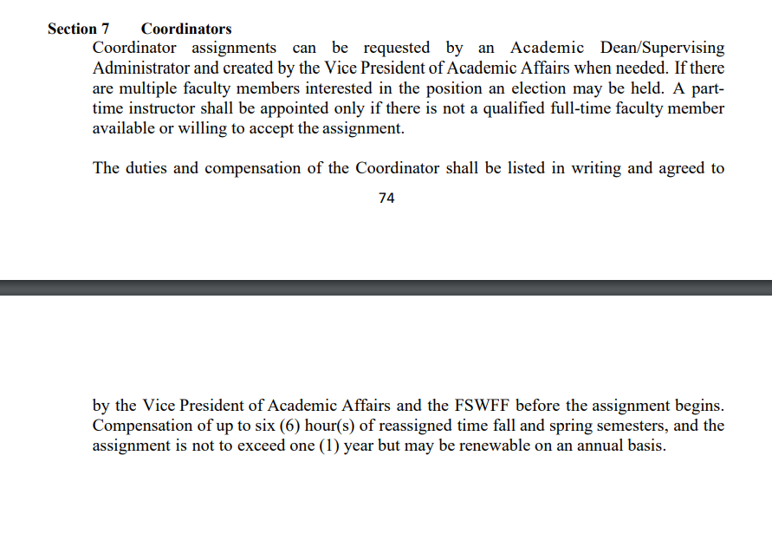
Not sure how this is going to play out yet. I have discussed it with Dean Teed, deans have no answers yet.
V. Professional Development Committee, Dr. Scott Ortolano
Traveling in August or September. The initial review time is coming up this month. Our funding may be kept. So, I think we are heading in a good direction. We have authorized a little more a bit more on the PD meeting. Jason will be part of the meeting. Think of some PD that you need and or use, and we will get that funding next year.
VI. OTOC Update, Prof. Jason Calabrese and Eric Ivy
Prof. Calabrese: No updates right now. Our competition for the contest is noon today. That’s all I have.
VII. Creative Writing, Dr. Brandi George
Dr. George: Nance Van Winkel. She will be in the auditorium, or you watch it through Zoom. The event will be April 4th, 3:30-4:30. Illumination, third issue.
VIII. Faculty Updates
English Department: Discussed Chat GP and plagiarism. Dr. Teed wants everyone to be vigilant and proactive. Academic Misconduct forms tend to be cumbersome and time consuming to fill out. The outcome serves as a warning and does not ultimately discourage the student from doing it again unless it is a multiple offense. Perhaps a community of practice on plagiarism and Chat GP will help.
IX. Curriculum Committee and DE Update, Prof. Jeremy Pilarski
Trying to get them to give me videos for observations. We are hurting without Dr. Sterk, who served as a district liaison. Dr. Teed is looking for a replacement. I have a couple of submissions. May have to mark the submissions as incomplete. As for Curriculum Committee, a lot of work on CVT, RET, and Nursing is being done. Next meeting may be split into two.
*Meeting adjourned at 11:00.
Notes, Prof. Jeremy Pilarski

