School of Health Professions

PROFESSOR: Sindee K. Karpel, MPA, RRT, AE-C | PHONE NUMBER: 239-985-8306
OFFICE LOCATION: A-115 | E-MAIL: sindee.karpel@fsw.edu
OFFICE HOURS: By appointment | SEMESTER: Summer 2019

COURSE NUMBER AND TITLE, CATALOG DESCRIPTION, CREDITS:

HSC 4555 PATHOPHYSIOLOGIC MECHANISMS (3 CREDITS)

The advanced diagnostic process is emphasized in this course with a focus on the causes of Cardio Pulmonary disease and injuries that impact the CP System structure and function. Disease etiology and pathogenesis of pulmonary disease as well as potential therapeutic actions are developed with critical thinking in response to the diagnostic process; treatment choices are also emphasized.

PREREQUISITES FOR THIS COURSE:

Admission into the BAS Cardiopulmonary Sciences Program; Prior to enrolling in any upper level course (course number beginning with a 3 or 4), students must complete the following courses with a grade of “C” or better: ENC 1101 English Composition I, ENC 1102 English Composition II, and three semester hours of college level mathematics; or permission from the appropriate academic dean.

CO-REQUISITES FOR THIS COURSE:

None

- GENERAL COURSE INFORMATION: Topic Outline.

  - Pathphysiologic Mechanisms of Cardiopulmonary Diseases
  - Etiology
  - Differential Diagnosis
  - Clinical Manifestations
  - Morbidity and Mortality
  - Pathogenesis
  - Treatment plan

ALL COURSES AT FLORIDA SOUTHWESTERN STATE COLLEGE CONTRIBUTE TO THE GENERAL EDUCATION PROGRAM BY MEETING ONE OR MORE OF THE FOLLOWING GENERAL EDUCATION COMPETENCIES:

Communicate clearly in a variety of modes and media.
Research and examine academic and non-academic information, resources, and evidence.

Evaluate and utilize mathematical principles, technology, scientific and quantitative data. Analyze and create individual and collaborative works of art, literature, and performance. Think critically about questions to yield meaning and value.
Investigate and engage in the transdisciplinary applications of research, learning, and knowledge. Visualize and engage the world from different historical, social, religious, and cultural approaches. Engage meanings of active citizenship in one’s community, nation, and the world.

A. General Education Competencies and Course Outcomes
- Listed here are the course outcomes/objectives assessed in this course which play an integral part in contributing to the student’s general education along with the general education competency it supports.

General Education Competency: Evaluate

Course Outcomes or Objectives Supporting the General Education Competency Selected:

  - Analyze and evaluate the etiology, clinical manifestations, differential diagnosis, pathophysiology and treatment of pulmonary and cardiac disease entities.
  - Evaluate a patient case to determine the differential diagnoses, therapeutic actions and alternatives for treating a patient.

Listed here are the course outcomes/objectives assessed in this course which play
a supplemental role in contributing to the student’s general education along with the general education competency it supports.

General Education Competency: Think

Course Outcomes or Objectives Supporting the General Education Competency Selected:

  - Construct a grid of differential diagnoses from history and physical, to recommendations for appropriate clinical laboratory tests.
  - Recommend appropriate clinical laboratory tests based on a differential diagnosis grid.

DISTRICT-WIDE POLICIES:

PROGRAMS FOR STUDENTS WITH DISABILITIES
Florida SouthWestern State College, in accordance with the Americans with Disabilities Act and the College’s guiding principles, offers students with documented disabilities programs to equalize access to the educational process. Students needing to request an accommodation in this class due to a disability, or who suspect that their academic performance is affected by a disability should contact the Office of Adaptive Services at the nearest campus. The office locations and telephone numbers for the Office of Adaptive Services at each campus can be found at http://www.fsw.edu/adaptiveservices.

REPORTING TITLE IX VIOLATIONS
Florida SouthWestern State College, in accordance with Title IX and the Violence Against Women Act, has established a set of procedures for reporting and investigating Title IX violations including sexual misconduct. Students who need to report an incident or need to receive support regarding an incident should contact the Equity Officer at equity@fsw.edu. Incoming students are encouraged to participate in the Sexual Violence Prevention training offered online. Additional information and resources can be

found on the College’s website at http://www.fsw.edu/sexualassault.

REQUIREMENTS FOR THE STUDENTS:

This is an online course. All of the work is completed online and submitted online. Students are expected to submit all quizzes, assignments, and discussions no later than 11:59 pm on the due date. Five points will be deducted for lateness. The amount deducted will appear on all quizzes, assignments, and discussions.

Students are expected to regularly access their Course in Canvas and check for announcements, e-mail, and discussion board topics.

The course is organized to follow the outline posted. A topic is the name of a learning module. For each learning module, students are expected to complete the assigned reading, watch the videos, and review the presentations, complete exercises and/or post to the weekly discussion board. Students are expected to complete their assignments by the 11:59 pm on the published due date. Each late discussion board participation and/or assignment submission will receive deductions as per the discussion rubric.

Students may complete work in advance of the schedule. That is, students may work ahead in this course; HOWEVER, students need to ensure that they participate in the week’s assigned discussion.

- ATTENDANCE POLICY:

Your attendance at the Canvas website will be monitored through your participation in the weekly discussion board and by the submission of your assignments.

Each late discussion board participation, quiz submission and/or assignment submission will receive a point deduction as per the corresponding rubric. If no submission is made by 3 days after the due date (Tuesday at 11:59 pm) a grade of ZERO will be given for that discussion/ quiz/assignment.

GRADING POLICY:
Include numerical ranges for letter grades; the following is a range commonly used by many faculty:

90 - 100 | = | A
80 - 89 | = | B
70 - 79 | = | C
60 - 69 | = | D
Below 60 | = | F

(Note: The “incomplete” grade [“I”] should be given only when unusual circumstances warrant. An “incomplete” is not a substitute for a “D,” “F,” or “W.” Refer to the policy on “incomplete grades.)

Activity | Total Number | Point Value | Total
Discussion Boards (class participation) | 6 | 25 each | 150
Topic Quizzes | 12 | 30 each | 360
Topic Assignments | 4 | 35 each | 140
Final Project | 1 | 350 | 350
 |  | TOTAL | 1000

REQUIRED COURSE MATERIALS:

Lilly, LS (2016). Pathophysiology of Heart Disease: A Collaborative Project of Medical Students and Faculty. (6thed.). Philadelphia: Wolters Kluwer. ISBN 9781451192759

West, J & Luks, AM (2017). Pulmonary pathophysiology: The essentials. (9th ed.). Philadelphia: Wolters Kluwer. ISBN 9781496339447

RESERVED MATERIALS FOR THE COURSE:

There will be online links to websites made available on the course website.

CLASS SCHEDULE:

See the Canvas website syllabus area for a detailed schedule.

ANY OTHER INFORMATION OR CLASS PROCEDURES OR POLICIES:

Assignment guidelines:
There will be assignments due for specific modules throughout the semester. Each assignment will consist of multiple-choice questions and/or essays. These assignments will come from the reading assignment(s) for that particular module.

All work is to be completed solely and independently by the student. Inclusion of facts, ideas, quotes, or other materials from outside sources must be cited and referenced in all work. Failure to cite references may constitute plagiarism. Evidence of cheating and plagiarism are cause for disciplinary action by Florida SouthWestern State College. According to Florida SouthWestern State College, plagiarism and cheating refer to the use of unauthorized books, notes, using the copy and paste function, or otherwise securing help in a test; copying tests, assignments, reports, or term papers; representing the work of another person as one's own; collaborating without authority with another student during an examination or in preparing academic work (including and not limited to quizzes, discussions and other assignments), or otherwise practicing academic dishonesty.

Students agree by taking the course all required papers may be subject to submission for textual similarity review to Turnitin.com for the detection of plagiarism. All submitted papers will be included as source documents in the Turnitin.com reference database solely for the purpose of detecting plagiarism of such papers. Use of the Turnitin.com service is subject to the Terms and Conditions of Use posted on the Turnitin.com site.

Zero-Tolerance Policy: Florida SouthWestern State College maintains a zero tolerance policy for academic dishonesty. Any student found in violation of academic honesty will subject to sanctions, which may include up to receiving a grade of "F" in this course. Any School of Health Profession student that receives a grade of "F" for academic dishonesty in any course may be permanently dismissed from the program they are enrolled.

The discussion board is intended to simulate classroom discussions. This is comparable to the classroom and participating in a discussion. Unlike the classroom where everyone is there on the same day, some students log on at different times and days. This means you will have to check back into the discussion board to see what other students are saying.

There will be a total of 6 topics on the discussion board that each student is required to answer. In addition, each student will be required to make at least two (2) replies to the other students' postings. Each topic is worth 25 points. The Discussion Rubric below shows the break down for the grades:

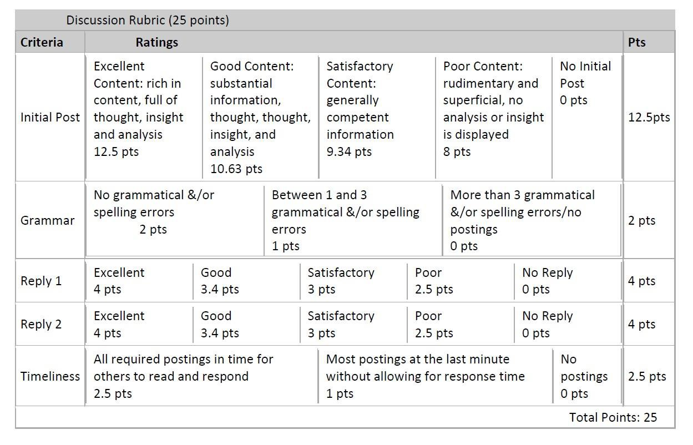

Below is an example of a question posed by the instructor and the initial post to it and the replies made by other students:

Question 1
Describe the 'perfect' teacher and give reasons for the characteristics you have chosen.

[Initial Post]
Describe the 'perfect' teacher and give reasons for the characteristics you have chosen.
I have to alert you that my parents are both retired teachers, so they instilled in me a lot of morals/values/characteristics that teachers would apply towards their students, for which I am forever thankful.
I would have to start out by saying the "perfect" teacher, if there ever was such a person would have to have some of the following characteristics. (A) This person would be a problem solver. They would have to come up with solutions for problems. Not necessarily in fighting situations, but when student get in a bind and direct them how to make the right choice and how to be strong and as my family says, "Figure it out."
(B) Then they would have to be able to understand a student’s mental ability/status. What I mean is understand them. Know how they react, think, feel, etc. Know they need individual attention. Know where they lack and strive. Know what they require and know they can never let them down. Do their best to full fill their needs. (C) Be an idol. Students need people to model off of, people to look up to, people who make life-long impressions. They need people who impact their mind. (D) Be a positive guide

in their life. Build trust, directs them correctly and never fails them or shies away. And lastly, (E) Be a motivator. Never allow a student to limit themselves. Always make them strive for bigger and better things. Make them seek visions and full fill them. Broaden their horizons and motivate them. Encourage, inspire, think logically, and think outside the box.
And always, make learning fun and an experience that they will never forget.
Here are two replies to other students' postings from the same student. You can see this student also had well thought out replies and they were of substance.

[Student Reply to the above Post]
After reviewing your post, it made me think. You make some valid points. It is vital that a teacher pick up a student's learning needs and responds adequately. If this fails to happen, it not only hurts the student, but everyone involved. It also wastes everyone's time. I like your point (2). You state that teachers should collaborate with students to achieve learning goals and in turn, motivate them to learn on their own. I think that happens a lot in online instruction. The professors put the material out there and set goals and we are to learn on our own. Also, being friendly with students but stressing the mutual respect is huge.
There has to be a mutual respect or problems arise. I also like where you said, "This is important since students should respect their teachers but still feel that the teacher is approachable." It reminds me of something that I learned last semester in another class. It is kind of like when you are in administration. You need to have the mutual respect, but in turn, you need to have an open door policy where people feel comfortable enough to approach you about things. Good point!!! And of course, your last point is very valid. If a teacher makes such an impact they improve the students’ life in anyway, then their work there is done!!! And that is valuable!!!

[Student Reply to the above Post]
You bring up a valid and important point, "the "perfect teacher" needs to love his or her teaching profession." You have to love what you do and be passionate about it or it means nothing. If your heart isn't into it then it's pointless. Just like with any other professions, teachers need to be admired and shown just how important they are, not only to the people whom they work alongside, but the students also. I also see teachers as being like a 2nd set of parents also. Sometimes when students have nowhere to turn at home, they need someone at school whom they trust and knows they care about them. I agree with you in saying that teachers must have open minds. They have to be able to help any students regardless of their situation. For a teacher to take a student to a whole new level of learning and expand their horizons is huge. Not only for present day, but also for their future. Great post!

