AGENDA
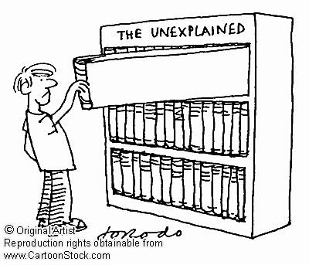

Edison State College – Charlotte Campus

Learning Resources Center

November 6, 2009

10:00 AM – 11:00 AM

Attendees: Library Advisory Committee (Tom Rath, Margaret Desjardins, Marilyn Herlin, and Phenessa Jones)
Location: LRC Large Study Room
Please bring: Agenda and pen

10:00 AM – 10:05 AM | Welcome | Phenessa Jones
10:05 AM – 10:20 AM | Library Advisory Committee  - Purpose (p.8 in ESC Libraries policy)  - SACS  - Past, Present, and Future  - Agenda development | All
10:20 AM – 10:40 AM | Collection Development  - ESC Libraries CD policy (p.10, 12-16 in ESC Libraries policy)  - Formal request system for documentation purposes  - Request quality and quantity  - Review process | All
10:40 AM – 10:50 AM | LRC Quality  - Library services in support of scholarship & research  - Suggestions for enhancing LRC services | All
10:50 AM – 11:00 AM | Wrap – up  - Open Discussion  - Q & A | All

