# *Librarians Retreat*FSW Logo

**Meeting Minutes**

**Date:** 7/19/2016, 9:00 PM – 3:00 PM

**Location:** J-326

|  | Present | Absent | Excused |
| --- | --- | --- | --- |
| Timothy Bishop | x |  |  |
| Cindy Campbell | x |  |  |
| Jane Charles | x |  |  |
| Eileen DeLuca | x |  |  |
| Frank Dowd | x |  |  |
| Arenthia Herren | x |  |  |
| Peggy Phetterplace | x |  |  |
| William Shuluk | x |  |  |
| Anthony Valenti | x |  |  |
| Mary Ann Walton | x |  |  |

Meeting was called to order at 9:10 AM.

1. Review Program Unit Plan (Eileen DeLuca and Bill Shuluk)
   1. Professor Shuluk welcomed the group and introduced Dr. DeLuca to review the unit planning process. At the beginning of the year, the Librarians worked with Bill to establish benchmarks related to Library Operational goals. These were documented through compliance assist, the unit planning software. At the current meeting, Dr. DeLuca and Professor Shuluk discussed the progress made in AY 2015-2016.
      1. Two operational goals have been set forth in the unit planning not only to keep the Libraries moving forward in the proper direction for the college community but, to also align with the standards placed forth by the accrediting body the Southern Association of Colleges and Schools Commission on Colleges (SACSCOC). The college is approaching the 5 year interim report in 2017.
      2. In developing these operational goals Professor Shuluk began by framing the overall plans referring to the language of SACSCOC standards because as a member institution of the accrediting body we represent their organization through our work. The goals follow:
         1. Collections adequately support the core curricula.
            1. By the end of 2015 the collections will be updated for the curricula and structure.

This is through collection mapping, the process of analyzing and matching the physical and electronic resources content with the programs of study offered by the college.

* + - * 1. Reviewing age of collection information to ensure resources are current and appropriate for research activities.
        2. Division-wide inventory was conducted to ensure holdings are accurate.
        3. Other activities have also been conducted to ensure this planning objective continually will be maintained.
      1. Bibliographic instruction matches program needs
         1. Professor Charles is an active member on the Learning Assessment Committee and is also the key Librarian over library assessment activities. To support this operational goal Professor Charles, along with the rest of the Librarians, have been active in the following areas:

Providing workshops and documentation to professors to create successful research assignments.

Tracking and analyzing student and faculty satisfaction data of library services and resources from surveys.

The creation of Truth Seeking workshops for the First Year Experience program students.

Can request feedback results from Professor Whitney Rhyne, Director of First Year Experience.

* + 1. Dr. DeLuca stated that every department is engaged in unit planning activities and effectiveness reports are due by August 26, 2016.
  1. The next meeting of the Library Advisory Committee is expected to occur during Professional Development days for Fall 2016.
     1. August 19-24, 2016.
        1. Dr. DeLuca suggested that Professor Shuluk share survey results reports at that meeting.
  2. Discussion of the SACSCOC 5 year interim report
     1. This will be a time when all units of the college will be reviewing and revising the original report sent to the accrediting body and providing updates and documentation. One area which the Library will need to update is the documentation for qualified staff (Comprehensive Standard 3.8.3).
     2. Other areas to examine:
        1. The Hendry/Glades Center is an area needing further review because of the new construction at that site. Not enough information has been given to provide Library Services enough direction to provide the basis for staffing and hours at that site’s library.
        2. As we move forward, what do we need to explain, we are in a good place. Professor Bishop and Professor Herren led a presentation at a recent at SACSCOC conference with online tutorials.
        3. As the library works toward the operational goals documentation will need to be collected to show progress and demonstrate the different library services.
  3. Questions?
     1. Statement from Professor Dowd: Having a good comprehensive overview that ensures we are on track with our planning and goals with our hands-on programs would be helpful.
        1. Response from Dr. DeLuca: The library supports all of our schools at the college and we need to show that we do provide such resources. This should be something which is to document.
     2. Statement from Professor Herren: Knowing that the unit plans are constantly evolving and able to be partially completed makes the process more comfortable.
        1. SACSCOC language helps shape our goals.
     3. Statement from Professor Shuluk: Continuing the plans for the next planning cycle, working on more collection development activities, and working on how to improve instruction and workshops are areas we know need to be consistently focused on to better our services.
     4. Statement from Professor Bishop: The goals are more practical, attainable and realistic, rather than lofty.
        1. It is important to showcase what the library does which supports on-going activities at the college.
     5. Professor Shuluk moved the conversation forward by mentioning the Nextgen ILS system.
        1. This is a legislatively mandated change to have the Florida Public University and College libraries under one unified Library Automation System. The process of this is moving along well and training for the new system is still is to be determined.
        2. No known issues with the progress of implementation.

1. Surveys (Eileen DeLuca and Bill Shuluk)
   1. The library, in 2015, had Dr. Joseph Van Gaalen evaluate the results from the Faculty Survey of Library Resources and Services, now an annual survey instrument, and invited him to present his results to the librarians on how to interpret the data and what conclusions could be drawn from the data. During his presentation Dr. Van Gaalen demonstrated how this data does support our current operational goals.
      1. One of the findings in the data were that the various professors believed that the students need the assistance our librarians and need to come into the library to improve their research skills.
         1. Arethina is doing a workshop on the ACRL framework of “Authority is Constructed and Contextual”.
            1. For the ACRL Frames and their meanings please consult the *Framework for Information Literacy for Higher Education* <http://www.ala.org/acrl/standards/ilframework>
            2. The more that the college faculty and the faculty librarians share and learn through workshops, conferences, and other professional development opportunities helps to shape our collective knowledge of everyone involved.
         2. Dr. Van Gaalen will be asked to work up similar qualitative feedback for the annual Student Library survey which is conducted each Spring Semester.
      2. The streaming video content had a low response rate, effort should be placed into seeking more detailed feedback from the faculty on how we can better improve this type of offering. Perfection is not a requirement.
      3. Question 23 of the Faculty survey stated “Listed below are examples of Library services and resources that could be expanded. Please indicate the level of priority to expand for each item.”
         1. Faculty respondents indicated that the priority should be placed on expanding the ebooks and databases. These are the areas where collection development activities have been focused and with the faculty support from these results it further validates the collection development efforts made.
      4. Dr. DeLuca charged the Librarians to review the survey items in Dr. Van Gaalen qualitative review of the survey and to ensure the changes are reflected in the surveys Fall 2016 roll-out.
         1. Professor Charles mentioned that the surveys are ever evolving tool. Though the survey instruments have been reviewed by the College’s Office of Effectiveness they stagnated for some time in terms of updated language.
            1. Professor Charles has been charged by Professor Shuluk to provide Assessment oversight.
         2. Dr. DeLuca suggested that Professor Shuluk with presenting the qualitative feedback from Dr. Van Gaalen as an agenda item for the Library Advisory Committee.
   2. Regarding the Spring Student Library Survey the areas which the library consistently has lower satisfaction levels are in the areas of: Size of Library, Study Space, and Library Hours. All other areas listed (Library Computers, Library’s Website, Library Staff, and Amount of Library Resources) consistently are satisfactory.
      1. It was noted that surveys can always be a polarizing tool in terms of feedback. Providing extreme high satisfaction and low satisfaction due to situations with patrons.
2. Updates on Collective Negotiations (Eileen DeLuca and Frank Dowd)
   1. Professor Dowd has sat in on some of these meetings. Everything that can be addressed in the negotiation process has been addressed. Some areas within the negotiations needed to be updated, discussed, and reviewed. The contracts for faculty are not completed yet because the structure of School of Arts, Humanities, and Social Sciences has not yet established with the retirement of Dr. Alford, Dean. There were some proposed language for the new structure which the faculty raised. More discussion will be held in the next meeting in August 2016.
      1. Question from Professor Herren: What clarification can be made about the structure of the School of Arts, Humanities, and Social Sciences?
         1. Presently the Dr. Jeffrey Stewart is working on the Interim Dean for the School. One proposed structure is there would be one Dean of Arts and Science and then an Associate Dean in each area. This structure was only proposed for feedback and favorability from the faculty and stayed tabled. More time will be given to carefully collect feedback on how the schools should be structured and will be discussed at the Fall Provost Meeting. In order to collect proper feedback Dr. Stewart wants the chairs to gather feedback about the structure. A search for the new Dean will result either way.
      2. Question from Professor Charles: What would be the ramifications of the change from department chairs to the new system? What are the benefits and drawbacks of moving away from the current system?
         1. Chairs would be negotiated with the Associate Dean system.
         2. The one college model has worked well but it has some areas need improvement. The faculty on all the campuses feel there is a lack of say.
            1. Would one Dean and two Associates be helpful to better listen to the faculty voices? Or in turn make this worse due to the travel required? One benefit to the chairs would be the removal of scheduling.
      3. Question from Professor Herren: Has there been thought of the financial impact of hiring Associate Deans?
         1. It depends on what the faculty would believe would work to fill in the gaps before the college would make any budgetary decisions.
      4. Question from Professor Bishop: Has there been talk of a salary increase?
         1. Both Professor Dowd and Dr. DeLuca stated that no salary increases have been brought up within these sessions. The main discussion and focus has has revolved around contracts.
   2. A meeting is planned to happen before faculty come back to campus for the Fall 2016 Semester so discussions can take place and then another meeting would be made to have faculty participate in the discussion.
3. Areas of responsibility (William Shuluk)
   1. To better delegate the functions of the Library Professor Shuluk, over the past weeks, has spoken with each Librarian to get their feedback to determine each of their roles. The following are the Librarian and their delegated role:
      1. Professor Arenthia Herren will be in charge of print and physical artifacts division-wide. The ordering process will not change, OASIS will still be used for material selection and then orders will be passed through Arenthia. If any material objections are raised they will be discussed with the ordering librarian for a final determination. It is important to note that this system has been implemented not to discourage material selection it is merely in place to provide a layer of review to ensure the collections are mapped to the curricula and that the collection development outline is being followed. Professor Herren will be in very close communications with Professor Campbell who will be charged over e-content.
      2. Professor Cindy Campbell will be in charge of Streaming Content, Patron Driven Acquisition (PDA), eBooks, Database Selection, and e-Content Collection Management. Professor Campbell will be in close communication with Professor Herren for ordering needs.
         1. Professor Bishop comments: This partnership is beneficial and would like direction from both Professor Campbell and Professor Herren on what subject areas materials are needed for each of the campuses.
      3. Professor Timothy Bishop will be in charge of the Libraries website and Social Media activities.
         1. Professor Charles was previously in charge of the website for many years. Professor Bishop will be working closely with the College’s webmaster Samiah Zabel to continue improving the Libraries website.
         2. The College’s website is again being redesigned and the transition process will begin July 21, 2016. During the transitionary period the website will appear very damaged. By the beginning of August 2016 the new website will be up and running. As soon as the major changes have been posted please send feedback to Professor Bishop.
      4. Professor Jane Charles will be in charge over Research Instruction, Assessment, and LibGuides.
         1. All surveys and other assessment instruments will go through Professor Charles.
         2. LibGuides content will not be controlled by Professor Charles, only their subject delegation. The goals and purpose to LibGuide management are:
            1. Standardized method of delivery of content and design.

Professor Charles has been working with Professor Rebecca Yost, Coordinator of Faculty Development and Training on best practices to reduce textual content on LibGuides.

* + - * 1. Weeding under-utilized guides.

Based on academic offerings and site analytics

* + - * 1. Ensuring that the different content areas being offered in the College’s curriculum are represented.
        2. Exploring LibGuides 2.0 and the requirements for migration to this upgraded system.
        3. Reassign current guides or topics amongst all of the Librarians.

Professor Dowd Commented: The Summer semester is always a perfect time to review currently assigned research guides and update them so they “appear” like someone is looking at them. This is due to the fact that the last updated date is stated on the guide’s header.

* 1. If any conflicts or grievances should arise from this delegation of duties they should be addressed to Professor Shuluk.

1. Overview Charlotte Library operations (Mary Ann Walton)
   1. Professor Walton provided the following updates for the Vernon Peeples Library located on the Charlotte Campus:
      1. The Charlotte Campus is still there and the Bell Tower outside of the Library building is a PokémonGo gym. They have seen many students playing PokémonGo and have been finding out information about Teams and encouraging their activity within the Library.
      2. One side of the double front door into the library has been retrofitted to open automatically for accessibility. Motion is used to activate the door. During the retrofitting of the one side the break bar was replaced and it has greatly reduced the noise level in the library. The staff are anticipating the other door’s break bar to be updated to further reduce noise.
      3. The Charlotte campus has received an increase in Research Instruction Sessions for Summer A & B, Truth-Seeking Workshops requests. Fall 2016 Research instruction session are presently being scheduled and the First Year Experience Introduction to Library Services and Truth-Seeking Workshops are scheduled for Fall.
      4. The Charlotte Campus has a big Welcome Week each year for students during this time there will be a Lunch & Learn session of the Introduction to Library Services. Lunch will be provided to those in attendance for the event.
      5. The Physical Collection Inventory conducted on the Charlotte Campus was completed in 6 days. Due to the inventory process, 15 items were identified as missing and subsequently have been withdrawn. These items were most likely missed during weeding projects over the year. The shelves still have room for adding new items.
      6. Library Assistant Colleen Kasson took lead on rearranging and organizing the print serials collection held within the library. Popular serials are now at eye level for easy reach and access.
      7. All of the staff participated in examining the Reserve Collection to check if the textbooks were current. Several textbooks were either moved to circulation or withdrawn because they are older. Anatomy and Physiology students are heavily utilizing the bones and other anatomical models.
      8. The certificate has been granted for the Western Michigan University (WMU) to offer classes within the state of Florida, more specifically space has been allocated on the Charlotte Campus for WMU’s pilot training program. The potential impact that this may have on the Library is unknown. Dr. Wright will continue to advise as work progresses.
      9. The staff have been taking their Summer vacations over the semester; Professor Walton is scheduled to take vacation August 8-18, 2016.
      10. The Library will be hosting the Charlotte Campus ice-cream social on July 28, 2016.
2. Overview Collier Library operations (Anthony Valenti)
   1. Professor Valenti provided the following updates for the Library located on the Collier Campus:
      1. The Collier Campus student computers are due for an equipment upgrade this year, the current technology is 7 years old. Technology Services will be coordinating with Professor Valenti.
      2. Within the Library there has been a meeting room which was set up for faculty but it has been under utilized over the years due to its isolated location. The Collier Campus Library has recently been utilizing the room as an unofficial study room for students. The space has been allocated on campus for a proper faculty meeting room, unfortunately this will result in a loss of the current furniture in the space.
         1. Professor Shuluk stated that funds have been allocated in this year’s budget for furniture and other needed miscellaneous expenses.
      3. Elizabeth Wilson, Library Assistant will be retiring soon.
      4. Professor Valenti is currently weeding the collections on Collier Campus. This process has been slow due to a lack of carts to place out the discarded materials for students.
3. LIS2004: Introduction to Internet Research, Updates (Frank Dowd)
   1. Course revision committee has finished its work and the newest revisions have been uploaded. Professor Dowd is currently working in the Canvas Shell to make needed changes and proofreading the course content. The revisions should be completed by the end of next week. The Florida College System Council of Instructional Affairs Learning Resources Standing Committee controls the LIS2004 Course.
   2. The Course Revision Committee has been charged to completely update the curriculum offered for the course to comply with the new ACRL Information Literacy Frameworks and to also update the pedagogical standards and curriculum design. The current LIS2004 course complies with the original charge to “developing a one-credit, web-based course which would teach basic Internet research skills.” This will be the last year Professor Dowd will be serving on the Course Revision Committee.
      1. Question from Professor Walton: After the updates have been finished may a copy of the course outline be provided to those not teaching the course?
         1. Professor Dowd will provide a synopsis of the content once it is completed.
   3. This new charge will result in a total revamp of this 10 year old course started in 1997 and will make the course more practical and not so theoretical.
4. Overview Hendry/Glades Library operations (Arenthia Herren)
   1. The Hendry/Glades center is getting a new building and the Library is getting it’s own dedicated space with study rooms. The move is expected to occur in January 2017. The issue of theft prevention has been addressed with Dr. Wright by both Professor Shuluk and Professor Herren and is still an ongoing discussion. The area where the library is located in the new building is being marketed as a library/lounge. The library is in waiting of more definitive plans. The Academic Support Center will have their own dedicated space in the building and will not require the sharing of resources. The library will be able to independently closed and not affect other departments/divisions.
      1. As mentioned by Professor Shuluk in regards to the Collier Campus: Excess budget money has been set aside to cover expenses which may come up for furniture and other miscellaneous needed expenses.
5. Print and Physical Collection Management (Arenthia Herren)
   1. Professor Herren presented an update of the collections division-wide [included in Appendix A] highlights of the presentation follow:
      1. As indicated by circulation statistics after weeding activities occurred during 2015 the book loans fell for each campus. The Thomas Edison (Lee) Campus had the most dramatic decrease in book lending after weeding.
         1. It is important to note that the deselected materials for the Circulating Collection were items with zero loans which were cataloged 5 or more years ago.
      2. Weeding cycle has been established:
         1. Summer 2017 - Nursing/Health Sciences and Technology. Average age of Nursing books is 2005. This area will need review with nursing faculty.
         2. Summer 2018 - Social Science, Business, Legal, Education, and Science.
         3. Summer 2020 - Philosophy, Psychology, History, Fine Arts, and Literature.
      3. Basis for future collection development activities:
         1. A review of the reference desk observations will be taken into collection development consideration because these are first-hand insights into what the students are researching.
         2. Providing materials at the Academic Program level first, then activities will continue down toward a course-level approach.
      4. Question was posed: What should we do if we have no subject experts in the area of which you are developing?
         1. Utilizing WorldCat to view the holdings of other college and university libraries, though not a feature within OASIS looking at peer institutions is a good direction. Copies of electronic catalogs will be distributed.
6. Electronic Resources Management (Cindy Campbell)
   1. Database Portfolio
      1. Database statistics will be produced the first week of August 2016, they are produced quarterly. In general database usage has seen an increase.
      2. Science Database Changes:
         1. Natural Sciences by ProQuest has been cancelled, usage statistics to the database were poor, and did not merit continuing the expenditure. Science faculty were consulted prior to this decision.
         2. Science in Context by Gale has been added back, this product has a greatly improved interface. Trials were utilized by the science faculty before purchasing decision was made.
         3. Also added to the Science Databases is Environmental Science by EBSCO.
            1. Science portfolio covers the type of resources our students and faculty are utilizing and seeking.
      3. The Office of General Counsel notified the Library that the Ovid database is not ADA compliant for screen reader technology. Based on this information the database may be cancelled due to their inability to become compliant.
         1. Professor Campbell has reached out to EBSCO for pricing on the Cochrane database for evidence-based practice focused nursing.
         2. CINAHL by EBSCO has updated the amount of journals offered.
            1. With these two databases we should have enough content to provide for the nursing students and faculty.
            2. Bill is meeting with Dean Collins to discuss this situation.
   2. Patron Driven Acquisition (PDA)
      1. So far this program has been running for the past three months, there have been some glitches but most of them have been resolved. There has been some positive feedback from students in a survey sent out to those who utilized the program. Though some students did not feel the titles were delivered fast enough. Comments were passed to the group [included in Appendix B]
         1. Professor Walton mentioned that some students wait until the last minute to work on research assignments which may contribute to the negative feedback regarding the service.
         2. Turn around time is about 24 hours in order to cross-check print and other electronic sources, and determine the suitability for the collection. The negative comments had come as a result of a non-purchase decision due to the age level of the books which were requested by the students.
         3. Title requests rank in descending order by subject area:
            1. Medicine: 246
            2. History: 139
            3. Social Sciences: 110
            4. Fine Arts: 75
            5. Business/Management: 66
      2. Professor Shuluk opened the floor for comments:
         1. Professor Bishop commented: That he experienced many occasions on the reference desk where search resulted in many titles which seemed to be clogging the catalog with results for requestable items. Some publishers, he also noted, were not the most reputable.
            1. Professor Campbell requested that Professor Bishop let her know what publishers needed to be placed on a black list.
         2. Professor Herren commented: The PDA model should be more immediate; the program utilized should be pre-paid account based and purchase trigger after so many clicks or uses. The program needs to provide the whole title without the five minute limit. Would be interested in seeing repeat usage of the titles that were purchased.
         3. Professor Valenti commented: That a faculty member liked having the five minute preview of the resource.
         4. Professor Dowd commented: There have been many students who were confused and he needed to assist them.
         5. Professor Charles commented: that she had a couple students who benefited from the PDA titles but during teaching research instruction sessions it has been frustrating because there are so many PDA titles in the catalog. She mentioned that it is not a bad experiment but wording must be adjusted inside the records or with prompts and that the amount of titles should be dropped down.
            1. Professor Campbell proposed the number should be 30-50 thousand within the past 4 years but only in the areas where we have seen good usage and then reevaluate the usage statistics.

Professor Shuluk believes this current model should be kept for another semester before looking into other PDA models. Short term usage models are still convoluted compared to the request to buy method.

* + 1. Action was made based on the feedback and discussion; Professor Shuluk decided: the PDA titles will be in the areas of nursing and health care, sociology, and business management and the amount of titles in the catalog should be 10 thousand or less titles at most. The wording presented to patrons must be changed. Reevaluate the program in November 2016.
       1. Professor Campbell will work with Professor Valenti for how to best word the different areas to patrons. Professor Valenti will serve as a secondary point person for this project.
    2. New library management system will have a PDA system built in. Presently MANGO is not very friendly with being able to drill down by which items are held within a PDA collection or owned by the library.
  1. Budget
     1. Some funds will be free and may be used to update furniture.
     2. Print paralegal books collection will be pared back significantly. Cindy has worked closely with Dean Myer and Prof. Conwell concerning this collection.
     3. Encumbrances:
        1. $35,000 in eBooks
        2. $24,000 in physical books
        3. $6,000 in streaming video
           1. When the library was purchasing DVDs exclusively the cost for audio/visual materials was about $20,000.
           2. Kanopy has the Criterion Collection the library will purchase a DDA type model where a film can be viewed 3 times before a title is triggered for purchase.

Professor Bishop asked: The Criterion Collection DVD contain many extras, do the online streaming versions have these extras within the Kanopy database?

This is something to examine further.

* + - * 1. Swank costs have been whittled down working with Dr. Wendy Chase.

All streaming content has been set to around $5,000 in the budget.

Many classrooms do not have the proper technology to view in the classroom.

If statistics are not high enough to justify continued purchases it will be dropped.

* 1. Professor Walton asked: Were the consortial membership costs increasing?
     1. Professor Shuluk mentioned they did not increase costs based on the profile options identified for this upcoming year.
     2. Instruction, Assessment, & LibGuides (Jane Charles)
  2. Professor Charles began speaking about the Research Instruction proposal she created [included in Appendix C] because assessment and LibGuides had been addressed earlier during the retreat.
     1. Professor Charles made the point that whenever professors get in front of a classroom of students and lecture for an hour, no matter how many questions are asked to engage them students disengage at a certain point. The librarians need to meet the needs of the professors and students and still effectively teach. The idea proposed to tweak research instruction delivery is a Research Instruction Workshop. It has been found that the students in the present workshops actively participate and are involved in the process, these workshops are an 75-90 minutes long and the workshops have been hitting core areas while having one-on-one instruction for the last 45 minutes.
     2. When scheduling these sessions the Librarian taking the calls should as the following questions:
        1. Do you require the students in your class to complete a research assignment?
           1. If the instructor answers No, then offer the typical Introduction to LIbrary Services
           2. If the instructor answers Yes, then ask

Can you email the assignment instructions so the librarian can properly construct the workshop?

* + - 1. Do you plan to review the research assignment with the students before the requested workshop date?
         1. If the instructor answers Yes, the ask

Will the students have already selected their research topic before the library workshop?

* + 1. Teaching a Research Instruction session with no assignment or focus is difficult to provide a discussion on what the library can provide in terms of resources and/or services.
       1. Presently the librarian taking the intake call tries to get the research assignment before adding session
       2. Professor Dowd comments: Adding short audio-visuals into the session does tend to grab the students’ attention.
    2. Another successful practice with the workshop concept is the scheduling of follow-up sessions. These follow-up sessions have been happening with Dr. Sara Dustin’s ENC1102 sections. Professor Charles and a couple other librarians present mentioned that provided these follow-up sessions was a rewarding experience for themselves and the students.
    3. The current Chair of the English department on the Thomas Edison (Lee) Campus supports the proposed workshop model of instruction and this experiment is something that Professor Charles would like to expand past the English department for other subjects.
       1. Professor Walton asked: Do all of the Cornerstone classes invite a librarian to provide research instruction or a library services introduction?
          1. Professor Charles answered: No not all of the sections request a research instruction session, many of the students do come to the Truthseeking or Introduction to Library Services Workshops for the GPS requirements for SLS1515.
    4. After trialing these workshops with the ENC1101/1102 sessions research will be placed into the assessment data and results will be published.
    5. When will the pilot begin?
       1. Fall 2016: Begin with two English Faculty before full roll-out in Spring 2017.
          1. Workshop method will be encouraged but not mandatory.
       2. Professor Shuluk and Dr. Eileen DeLuca will meet with the English Department Chair to add the library on the agenda of the next English Department meeting to pitch the workshop proposal.
          1. After meeting with the English Faculty there should be an increase in the Workshops being requested with more faculty to work with.
  1. The other idea proposed would be to have a set of scheduled Introduction to Library Services workshops not during scheduled class times to have students get the basics and then the more focused workshops would be assignment based.

1. Tutorials (Timothy Bishop)
   1. Professor Bishop addressed the future of the video tutorials offered by the Libraries and included Professor Herren in the conversation. Presently the videos are out-of date due to the evolving nature of the college’s website, vendor website’s interfaces, and database offerings by the library. The videos are very time consuming to produce.
      1. Many of the librarians utilize these clips in research instruction sessions and link to them, they are very valuable and everyone would like to see these kept and up-dated.
         1. The college’s videographer, Keith Ingram, may be able to produce the videos for us with a script provided.
      2. Professor Bishop needs to know when website changes will be forthcoming in order to plan.
      3. Considerations for the videos:
         1. Accessibility - Closed-captioning support and any other compliance and accessibility needs.
         2. Hosting - What service(s) does the college approve for video hosting?
            1. Vimeo was the last known approved service. YouTube though it does create on-the-fly closed-captioning, has very restrictive terms and conditions.
         3. Branding - College’s logo.
2. Presentation by Browzine Vendor
   1. Professor Campbell introduced the vendor, who was present via webconference, to the Librarians.
      1. Began at 2:03pm. [PowerPoint Requested]
         1. 1,200 layers of taxonomy with durable links.
         2. Each journal title has durable link as well.
         3. Scopus journal ranking.
            1. Professor Bishop asked the vendor about the indexing of popular journal titles, which seemed to be non-present, but academic titles were well represented.

The vendor mentioned that popular titles are not supported in the platform presently, but a link will be provided by Browzine to the SFX linking page.

* + 1. Ended the call with vendor.
  1. Professor Shuluk mentioned: This technology may be good as having a virtual journal room terminal.
  2. Professor Campbell mentioned that Flipster by EBSCO is doing popular titles and academic but this platform works differently than Browzine.

1. Other considerations
   1. Professor Valenti asked: The new English Composition textbook will support MLA 7 and not MLA 8 which one should be used?
      1. Must meet with the English Department to determine which version to use or have them specify in their assignments which version to use. The librarians will be supplied with MLA 8 to provide assistance.

Meeting adjourned at 3:30PM.

## Appendix A

Slide 1

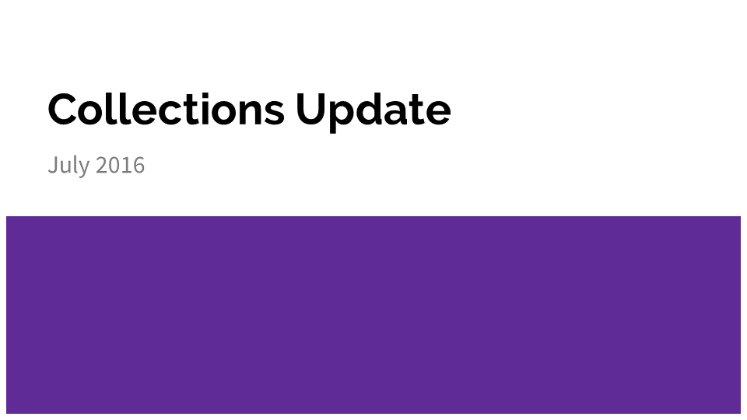

Slide 2

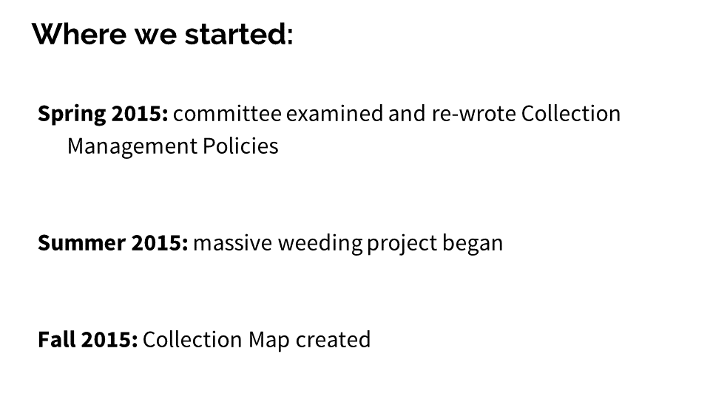

Slide 3

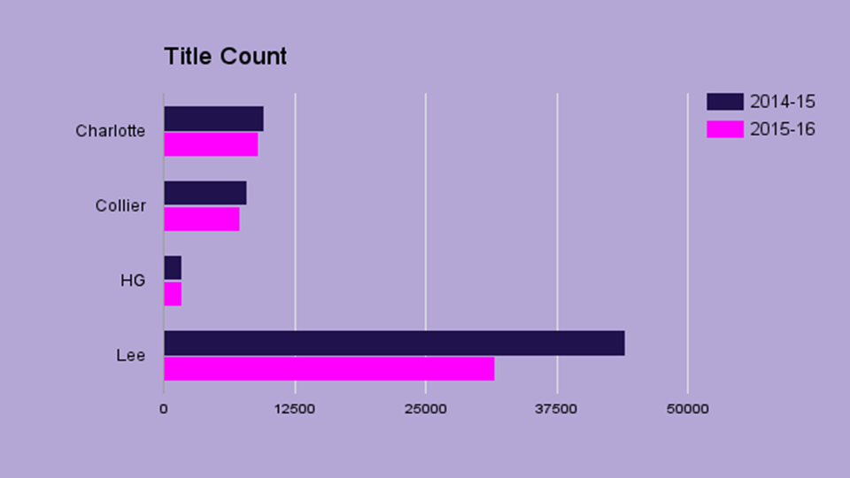

Slide 4

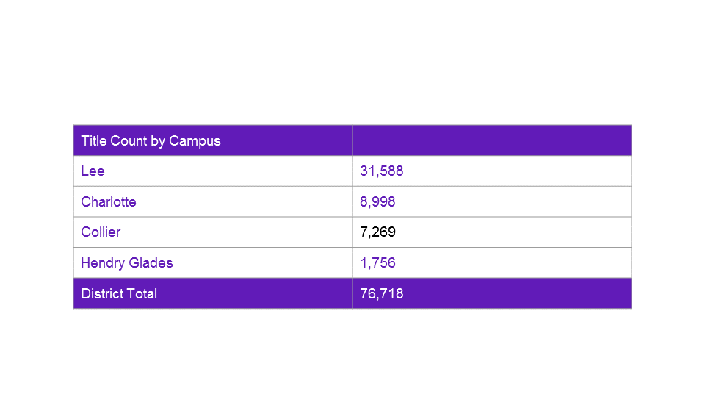

Slide 5

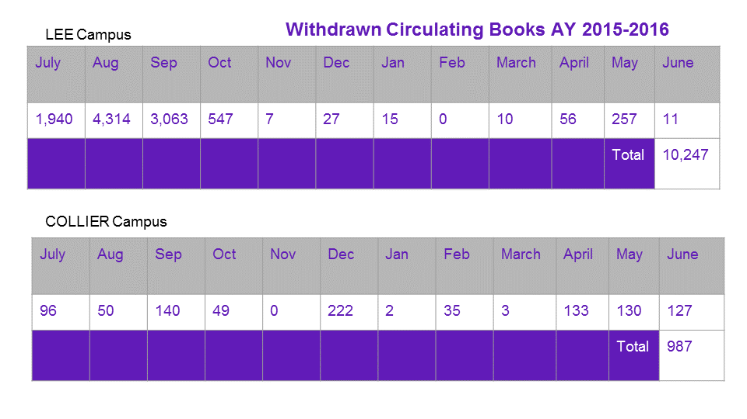

Slide 6

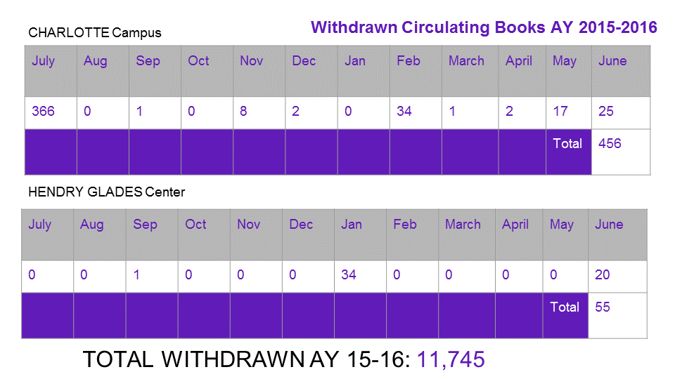

Slide 7

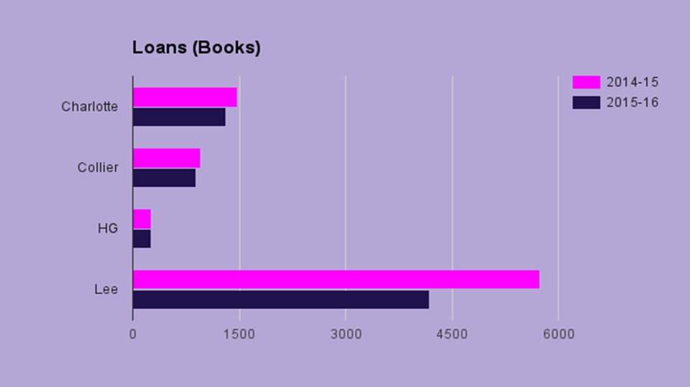

Slide 8

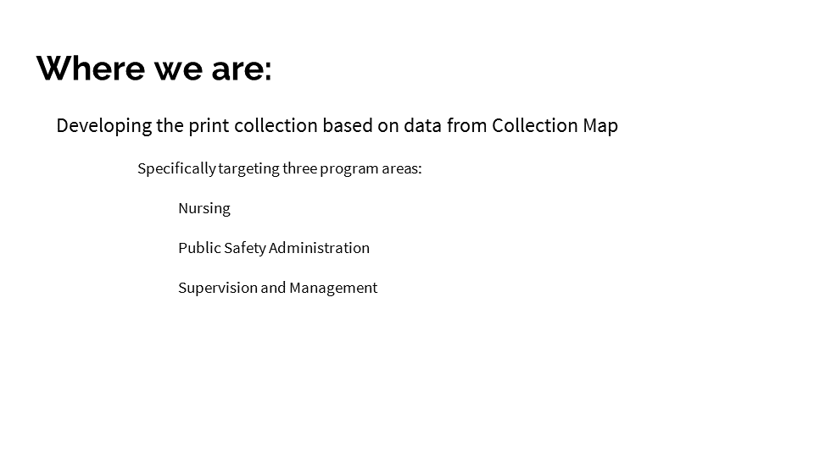

Slide 9

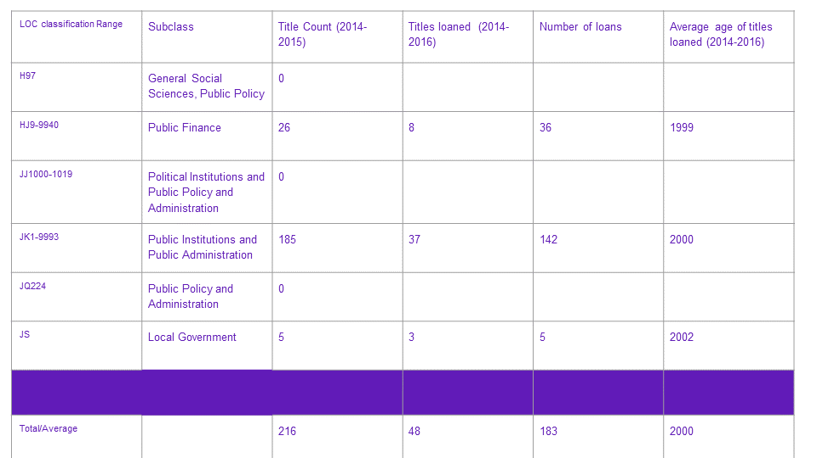

Slide 10

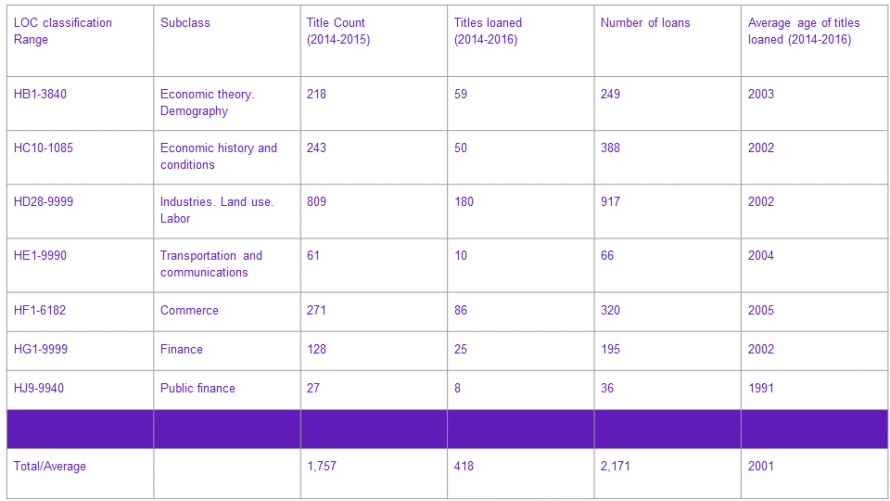

Slide 11

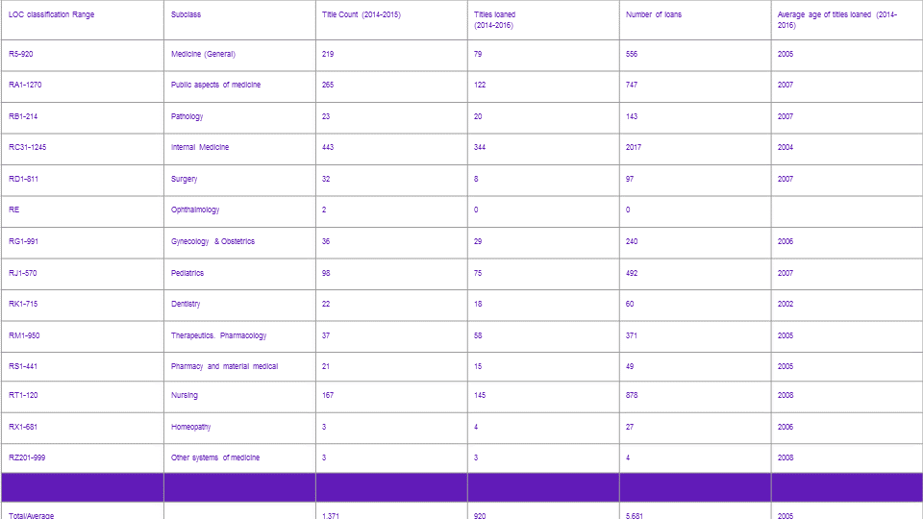

Slide 12

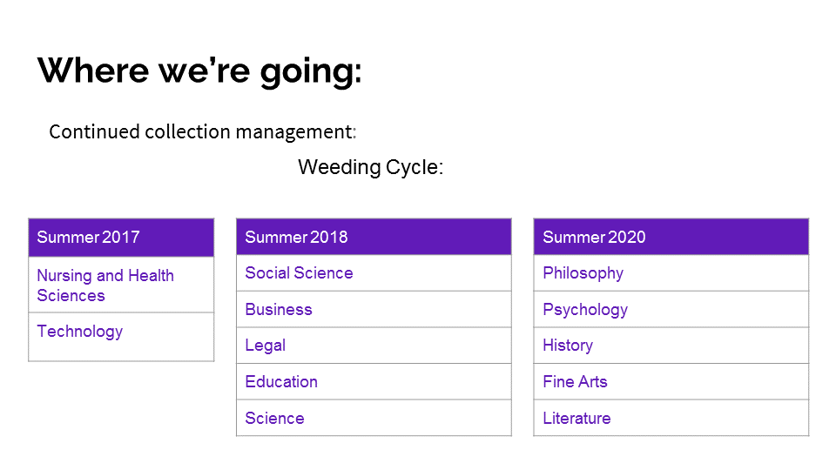

Slide 13

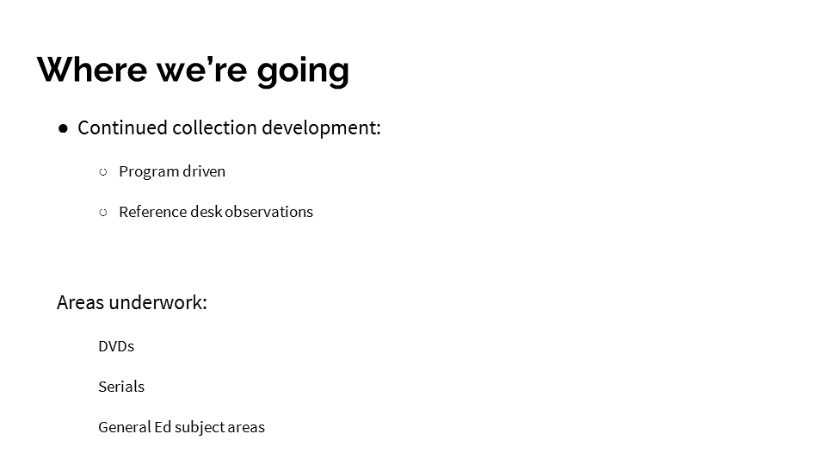

## Appendix B

* This item has very credible, reliable, and important information.
* For my drama essay in Composition 2 class.
* Also need it for my drama essay in Composition 2 class.
* Thank you :)
* This resource provides the needed information for my research.
* I am hoping to use this as a reference book for my cap stone project for my bachelors in nursing. I graduate in June.
* I would like to request this to use as a source for a research paper.
* I'm doing a research paper for my HUS1400 Alcohol and Other Drugs online class and must source a book, however, I am unable to get to the school to check it out. Thank you in advance for allowing me to do research with this book online.
* I am doing a research project on General Anxiety Disorder and would like to read chapter 4 of this text.
* I would like to access this book online
* would like to access this book online
* Need for research paper
* Would like to read this book as part of a research proposal I am working on.
* Would like to use this book for a research proposal I am working on with another faculty member. Would like as long of access as can be provided.
* research paper
* This resource would be very helpful to a paper I am currently writing for my English Comp class!
* Would like to read for a research proposal I am working on with a couple of faculty members. Wold like as much access to this as you can get us.
* For informational speech class.
* I AM AWAY IN PA MY MOM JUST GOT DIAGNOSED WITH ALS AND WE ARE GOING TO DR. TODAY TO DISCUSS CAN I HAVE ACCESS TO ONLINE VERSION?
* Would like to have this for research purposes. Chapter 8 is needed
* need it for WOH 1030 reseach paper

## Appendix C

**Research Instruction Proposal**

**July 2016**

**Objective:** Provide formal Research Instruction that students can apply more readily, and deliver instruction that is relevant, useful, and engaging. Best practices indicate students benefit most when their professor reviews the research assignment for which the professor has scheduled a formal Research Instruction with his/her students *before* a librarian teaches the Research Instruction. Students also often benefit more when a librarian devotes a brief amount of time to lecture, and spends the majority of class time working with students on a one-on-one basis.

**Instructional Model:** Provide Research InstructionWorkshops rather than Research InstructionSessions. A Research InstructionWorkshop would entail an approximately 20 to 25 minute overview of core tools, methods, and resources, followed by ca. 40 to 45 minutes of one-on-one Research Instruction, working with students’ specific research topics.

**Target Group/Timing:** We can pilot this model at **Lee only** in Spring 2017 with English Comp Faculty, most of whom assign at least one research driven assignment per course. In Fall 2016, Faculty Librarian Jane Charles will ask two ENC Faculty to participate in a test run.

**Delivery:** When *any professor* wants to schedule (via email, phone, in person, etc.) a Research Instruction with a librarian, ask him/her the following 4 key questions first:

1. Do you require students to complete a research assignment for your course?
2. If so, would you email me the assignment instructions to share with the librarian who will teach the workshop?
3. Do you plan to review the research assignment with your students before the requested workshop date?
4. Will your students have selected topics *before* your requested workshop date?

Inform the professor that librarians can deliver the Research Instruction as more workshop/less lecture, as outlined above. Ask the professor if he/she is interested in scheduling a workshop rather than a lecture-based session. If the professor, regardless of subject discipline, wants a more traditional RI, we shall accommodate him/her. If the professor is interested, explain how the librarian will teach the workshop.

**What to Cover in 20-25 Minutes:**

1. **Website:** Show students how to get to the Libraries’ homepage.
2. **Interface:** Highlight the Interface as the go to place to access Library search tools.
3. **Resources:** Point out the links to our most useful resources: the Research Tutorial, Research Guides, and Citation Guides. Simply point to them and briefly state their purpose, e.g., “Click citation guides to learn how to correctly format your paper, cite sources, and review a sample paper.”
4. **Search Tools:** A) DemoAdvanced Google, explaining that some relevant and scholarly sources are only accessible on the Internet, especially government sources. Do a quick search using .gov in Advanced Google. B) Point out the **Discovery Tool**, noting that the main search box retrieves results from the databases and the Libraries’ catalog (books and film). C) Explain the basics of accessing books and film from the **Catalog** without demo. D) Encourage them to access **Articles in** **Databases** to find scholarly journal articles and other periodical articles. Click the link to show the log in; explain how to log in; and land on the subject list of databases. E) Highlight the **General** category; briefly explain the purpose of the different classes of databases – reference, all topic search, and niche searching, e.g., **Opposing Viewpoints** – and click **Academic Search Complete**, showing an example of a basic search page in a typical database. Click Advanced Search. Perhaps demo a basic sample search. Select “Full Text” and “Scholarly (Peer Reviewed) Journals;” search for _____, e.g., Civil War; do a phrase search (See #5), point out the subject link on the Advanced Search homepage to pinpoint the LOC subject; change the dropdown to subject; add a term like United States to “Select a Field”; click a result to show a record; and point out the PDF (if available) and the cite link. Return to Advanced Search; explain that they can do combination searching, e.g., search for Civil War via Title, United States in “Select a Field,” and slavery via Subject to get targeted results.
5. **Search Methods:** A) Tell students that they can use a variety of methods, e.g., phrase searching, truncation, wildcards, Boolean searching, subject searching, etc., to retrieve better results. B) Encourage them to learn about search methods by clicking “Research Tutorial” and “Quick Guides” and reviewing *Searching Skills*. C) Encourage students to use advanced search to effectively and efficiently find results.
6. **Halting for Demo:** If students consistently pose a particular question, concern, or request, e.g., “How do I get a citation from a database?” stop the class, direct them to look up front, and demo the appropriate action.

**When working with professors who do NOT assign a research assignment for their course OR who won’t have reviewed the research assignment and/or whose students won’t have a research topic selected before their scheduled Research Instruction:**

1. Gently encourage professors who do not assign a research assignment in their courses instead to consider scheduling an Introduction to Library Services Workshop; to encourage their students to attend one of the regularly scheduled Introduction to Library Services Workshops offered by librarians, as listed on the Libraries’ website; or to schedule a traditional lecture-driven Research Instruction Session, noting both the benefits and drawbacks of lecture-driven RIs. (See objective.)
2. Encourage professors who won’t have reviewed the research assignment with their students, or whose students won’t have selected research topics *before* the professors’ preferred RIdate, to try a Research Instruction Workshop. Reassure all professors that this is not a requirement.