**Academic Calendar Committee**

**Minutes**

April 26st, 2024

Attendees: Susan C. Bronstein; Anthony Valenti; Sabine Eggleston; Joycellen Rollins; Bonnie Lawler; April Fleming; Brenda Knight; Timothy Bishop; Julissa Roland; April M. Falso; Andrae Jones

Absent: Danielle Chandonnet

1. Overview of Academic Year 2025-26

Based on the AY2024-25 calendar, the 2025-26 calendar was presented. The Committee concurred with the recommendations:

Fall 2025 Faculty workdays, 8/18/2025– 12/19/2025; semester days, 8/25/2025 – 12/2/2025; finals 12/3/2025 – 12/9/2025; no study day after Labor Day so that MW class sessions = TR class Sessions

Spring 2026 Faculty workdays, 1/5/2026 – 5/4/2026; semester days, 1/7/26 – 4/21/26; finals 4/21/26 – 4/28/26

Summer 2026 Semester days, 5/11/2026 – 8/1/2026

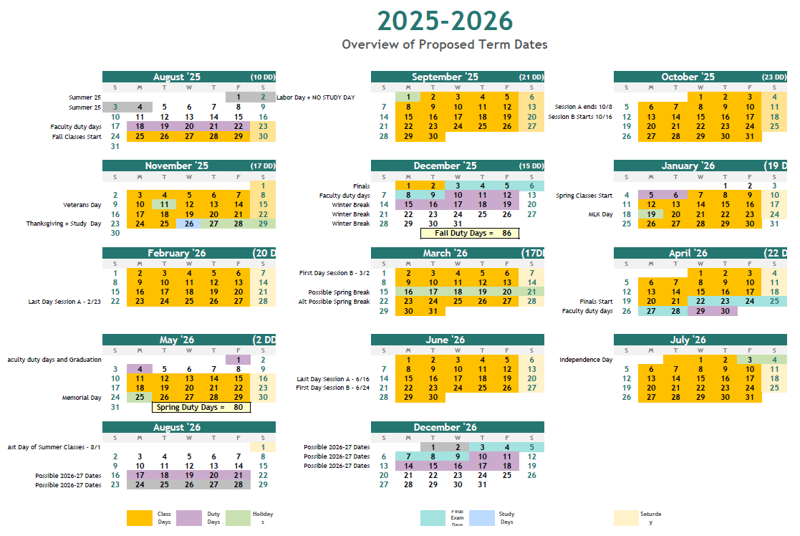

1. Fall 2024 Semester. The following dates were discussed and recommended.

Note: the date recommended for Convocation would be Wednesday 20th August, 2025

Because Veteran’s Day is a Tuesday, a Tuesday Study day would mean 26 TR sessions and 27 MW sessions. Not adding the Study day after Labor Day would mean 27 MW and 27 TR sessions.

|  |  |  |  |
| --- | --- | --- | --- |
| **Fall Semester** | **Full Term** | **Session A** | **Session B** |
| **First Faculty Workday** | 8/18/2025 |  |  |
| **Last Faculty Workday** | 12/19/2025 |  |  |
| **First Day of Class** | 8/25/2025 | 8/25/2025 | 10/16/2025 |
| **Last Day of Class** | 12/2/2025 | 10/8/2025 | 12/2/2025 |
| **First Day of Exams** | 12/3/2025 | Last class | Last class |
| **Last Day of Exams** | 12/9/2025 | Last class | Last class |
| **Holiday 1** | 9/1/2025 | 9/1/2025 | 1/0/1900 |
| **Holiday 2** | 11/11/2025 | 1/0/1900 | 11/11/2025 |
| **Holiday 3** | 11/27/2025 | 1/0/1900 | 11/27/2025 |
| **Holiday 4** | 11/28/2025 | 1/0/1900 | 11/28/2025 |
| **Holiday 5** | 11/29/2025 |  | 11/29/2025 |
| **Study Day 1** | No T Study Day | No T Study Day | 11/26/2025 |
| **Study Day 2** | 11/26/2025 | 1/0/1900 | 1/0/1900 |
|  |  | 1/0/1900 | 1/0/1900 |
| **Total Faculty Work Days** | 86 |  |  |

The table below shows the number of sessions per day for Fall 2025:

|  |  |  |  |
| --- | --- | --- | --- |
| **Fall Semester** | **Full Term** | **Session A** | **Session B** |
| **Mondays** | 14 | 6 | 7 |
| **Tuesdays** | 14 | 7 | 6 |
| **Wednesdays** | 13 | 7 | 5 |
| **Thursdays** | 13 | 6 | 6 |
| **Fridays** | 13 | 6 | 6 |
| **Saturdays** | 13 | 6 | 6 |
| **Sundays** | 13 | 6 | 6 |
| **MW** | 27 | 13 | 12 |
| **TR** | 27 | 13 | 12 |

1. Spring 2026. The following dates were discussed and recommended. Spring break is suggested for the week of March 16th, but the College would wait until Jan/Feb 2025 to make a final decision based on input from the School Boards. May 1st 2026 was recommended for Commencement

The date for State of the College is to be determined

|  |  |  |  |
| --- | --- | --- | --- |
| **Spring Semester** | **Full Term** | **Session A** | **Session B** |
| **First Faculty Workday** | 1/5/2026 |  |  |
| **Last Faculty Workday** | 5/4/2026 |  |  |
| **First Day of Class** | 1/7/2026 | 1/7/2026 | 3/2/2026 |
| **Last Day of Class** | 4/21/2026 | 2/23/2026 | 4/21/2026 |
| **First Day of Exams** | 4/22/2026 | Last day of class | Last day of class |
| **Last Day of Exams** | 4/28/2026 |  |  |
| **Holiday 1** | 1/19/2026 | 1/19/2026 | 1/0/1900 |
| **Holiday 2** | 3/16/2026 | 1/0/1900 | 3/16/2026 |
| **Holiday 3** | 3/17/2026 | 1/0/1900 | 3/17/2026 |
| **Holiday 4** | 3/18/2026 | 1/0/1900 | 3/18/2026 |
| **Holiday 5** | 3/19/2026 | 1/0/1900 | 3/19/2026 |
| **Holiday 6** | 3/20/2026 | 1/0/1900 | 3/20/2026 |
| **Holiday 7** | 3/21/2026 | 1/0/1900 | 3/21/2026 |
| **Holiday 8** | 3/22/2026 | 1/0/1900 | 3/22/2026 |
| **Total Faculty Work Days** | 80 |  |  |

The table below shows the number of sessions per day for Spring 2026:

|  |  |  |  |
| --- | --- | --- | --- |
| **Spring Semester** | **Full Term** | **Session A** | **Session B** |
| **Mondays** | 13 | 6 | 7 |
| **Tuesdays** | 14 | 6 | 7 |
| **Wednesdays** | 14 | 7 | 6 |
| **Thursdays** | 14 | 7 | 6 |
| **Fridays** | 14 | 7 | 6 |
| **Saturdays** | 14 | 7 | 7 |
| **Sundays** | 14 | 7 | 7 |
|  |  |  |  |
| **MW** | 27 | 13 | 13 |
| **TR** | 28 | 13 | 13 |

1. Summer 2026

|  |  |  |  |
| --- | --- | --- | --- |
| **Summer Semester** | **Full Term** | **Session A** | **Session B** |
| **First Day of Class** | 5/11/2026 | 5/11/2026 | 6/24/2026 |
| **Last Day of Class** | 8/1/2026 | 6/17/2026 | 8/1/2026 |
| **Final Exams** | Last day of class | Last day of class | Last day of class |
| **Holiday 1** | 5/25/2026 | 5/25/2026 | 1/0/1900 |
| **Holiday 2** | 7/3/2026 | 1/0/1900 | 7/3/2026 |
| **Holiday 3** | 7/4/2026 | 1/0/1900 | 7/4/2026 |

(Note: changed Last Day of Session A so that we have 6 Wednesday Session rather than 5, making both MW and TR classes 11 sessions rather than 10 and 11 ).

The table below shows the number of sessions per day for Summer 2026:

|  |  |  |  |
| --- | --- | --- | --- |
| **Summer Semester** | **Full Term** | **Session A** | **Session B** |
| **Mondays** | 11 | 5 | 5 |
| **Tuesdays** | 12 | 6 | 5 |
| **Wednesdays** | 12 | 6 | 6 |
| **Thursdays** | 12 | 5 | 6 |
| **Fridays** | 11 | 5 | 5 |
| **Saturdays** | 11 | 5 | 5 |
| **Sundays** | 11 | 5 | 5 |
|  |  |  |  |
| **MW** | 23 | 11 | 12 |
| **TR** | 24 | 11 | 12 |
| **TWR** | 36 | 17 | 18 |
| **MTWR** | 48 | 22 | 24 |

1. The Registrar’s office, Academic Affairs and HR will move forward on building out the Calendar using these dates. The Committee will reconvene in August to confirm all dates before documents being sent to the Board of Trustees for final approval.