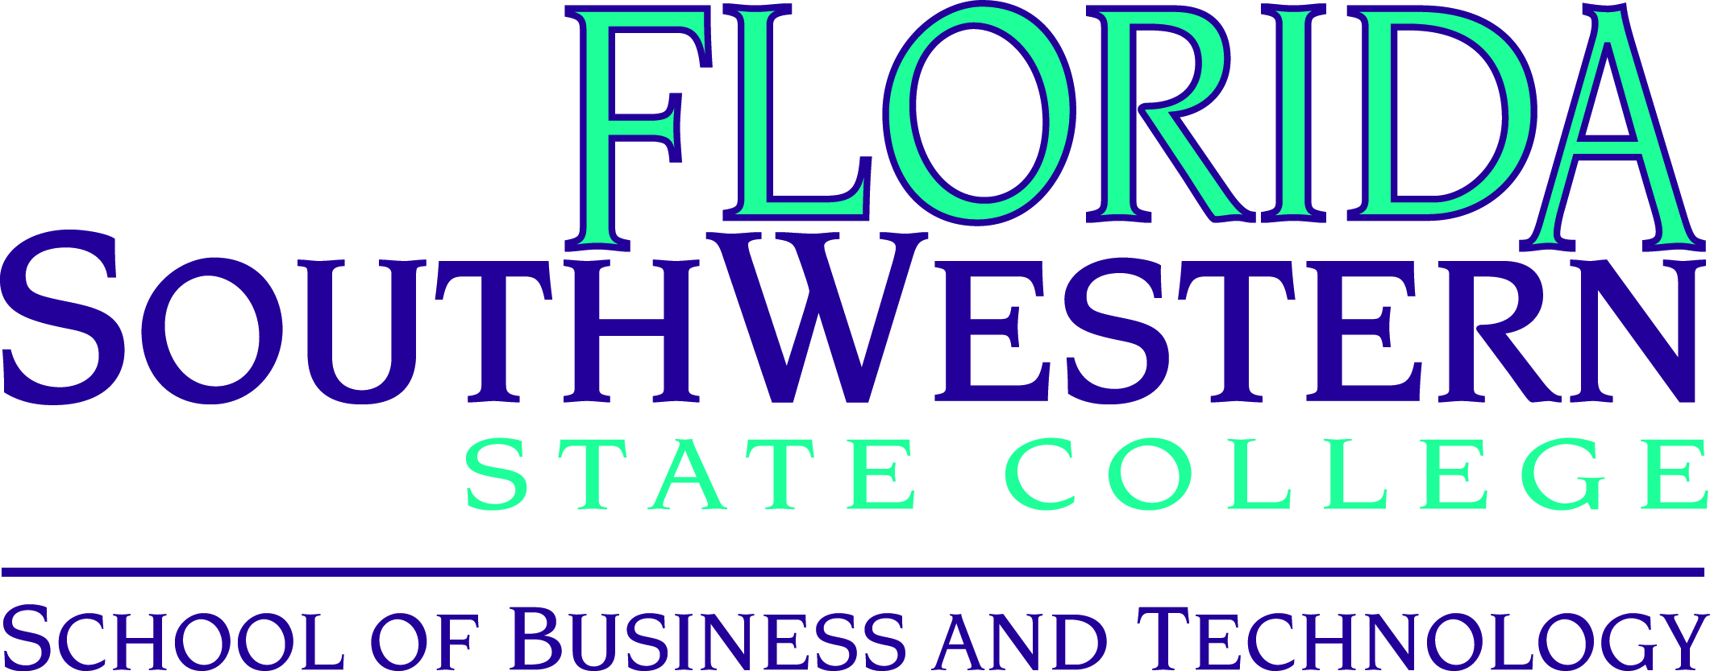

**Department Meeting**

**Friday, September 9, 2016 – 1:00 – 3:00 p.m.**

**Thomas Edison Campus – U 106**

|  |  |  |  |
| --- | --- | --- | --- |
|  | **Present** | **Absent** | **Excused** |
| **Administration** |  |  |  |
| Dr. John Meyer, Dean | X |  |  |
| Dr. Thomas Rath, Associate Dean | X |  |  |
| **Program Coordinators** |  |  |  |
| Andrew Blitz | X |  |  |
| Mary Conwell | X |  |  |
| David Hoffman | X |  |  |
| Dr. Richard Worch | X |  |  |
| **Faculty** |  |  |  |
| Jim Barrell | X |  |  |
| Leroy Bugger | X |  |  |
| Vincent Butler | X |  |  |
| Alisa Callahan | X |  |  |
| Dennis Fahey |  |  |  |
| Matthew Hoffman | X |  |  |
| Deborah Johnson | X |  |  |
| Tim Lucas | X |  |  |
| Michael Nisson | X |  |  |
| Cynthia Wilson-Orndoff | X |  |  |
| Jennifer Patterson | X |  |  |
| William VanGlabek | X |  |  |
|  |  |  |  |
|  |  |  |  |

|  |  |  |  |
| --- | --- | --- | --- |
|  | **Present** | **Absent** | **Excused** |
| **Staff** |  |  |  |
| Tom Carr | X |  |  |
| Jill De Valk | X |  |  |
| Lisa Dick | X |  |  |
| Pablo Gallegos | X |  |  |
| Kristen Hayden | X |  |  |
| Steve Kelly |  |  |  |
| Sandra Mink |  |  |  |
| Mark Morgan | X |  |  |
| Al Nault |  |  |  |
| Michelle Zamniak | X |  |  |
| **Other Staff** |  |  |  |
| Jackie Beard | X |  |  |
| Douglas Goldman | X |  |  |
| Adrian Kerr |  |  |  |
| **Adjunct Faculty** |  |  |  |
| Philip Coale | X |  |  |
| **Guests** |  |  |  |
| Dr. Kathy Clark |  |  |  |
| Randy Manning |  |  |  |
|  |  |  |  |

**Welcome:**

The meeting convened at 1:00 PM with a welcome from Dr. Thomas Rath, Associate Dean of the School of Business and Technology.

**Guest Speaker:** Dr. Kathy Clark, Associate Dean of Academic Success discussed the Cornerstone First Year Experience (FYE) beginning with the history. Dr. Steve Adkins discussed the concept of the Quality Enhancement Program (QEP) and how the administration and faculty could get along. These ideas culminated with Cornerstone.

1. 2008 – Critical student learning issues were identified
2. 2009-2019 – Nine committees with 120 faculty and staff members participated in a self-study regarding the college’s foundation of excellence
3. 2011 – The Steering Committee was originally co-chaired by Dr. Rath and Dr. Clark with six subcommittees regarding student learning, student support, training and development, orientation, communication, and evaluation and assessment.
4. 2012 – In spring, a pilot Cornerstone Experience course began with full implementation of the FYE Program by the fall semester.
5. 2016 – Fifth year interim report – Faculty support is at 50%

Dr. Clark explained about the benefits of the Cornerstone Experience course which helps the student become familiar with everything about the college. Dr. Clark described one of the assignments, the Go-Picture-Scribe (GPS) where students are required to visit a professor, attend two academic workshops, meet with their academic advisor, and utilize one of the Academic Support Centers.

Dr. Clark mentioned that the Cornerstone Experience course is the most assessed course throughout the college. She spoke about sense surveys which measures student engagement in the first two weeks that they are in college. Also the critical thinking test measures confidence and reasoning and how well the student trusts themselves. Peer architects help students in their transition to FSW. They are mentors assigned to the Cornerstone class and are available to meet students and present workshops to assist the students. There has been a steady increase in retention rates with an increase of 3% of students returning from the spring 2016 semester.

Faculty and staff are eligible to teach the Cornerstone Experience course if they have completed a Master’s degree and have completed the 10 Cornerstone modules. Each of the 10 modules are offered every semester. All students who have earned less than 30 hours of college credits must enroll in the Cornerstone Experience course. In the fall 2016 semester there are 120 classes with 3,258 students enrolled.

Dr. Clark also mentioned the Critical Thinking Lecture Series for fall 2016 includes guest speakers regarding a range of subjects such as Norman Love, FSW President Dr. Jeff Allbritten, and Bill Frazer about the business of beer. Faculty may bring their students, but please contact FYE to make sure there is enough space available to accommodate.

The future of FYE includes the expansion of faculty and student engagement. The new positions of Advisor II staff members will be teaching the Cornerstone Experience.

Dr. Meyer commented that it is good to have SoBT faculty representation embedded in the Cornerstone Experience courses. This is an opportunity to help students who may not be signed up for the correct program or certificate. All SoBT faculty should assess FYE student in their Introduction courses to help locate any problems early on.

**Program/Faculty Updates:**

* Introductions of new staff:

Kristen Hayden – Coordinator of Student Success

Pablo Gallegos – Instructional Assistant for Business

Tom Carr – Student Success Advisor II – Embedded with new advising process

Mydajah Williams – XCEL-IT Program Office Assistant

* We have received approval for new course development
* SoBT 2015-16 Operational Outcomes Results:

1. Student Success Initiative – 21 students of the 2015-16 catalog year were selected from all AS and BAS degree programs in SoBT. The purpose of the operational outcome was to increase student success and retention and for the augmentation of this student success initiative. This outcome was partially met.

Results include the following:

1. Overall GPA averages for the 21 students were lower for both Fall 2015 and Spring 2016 compared to SoBT students in general and FSW students as a whole.
2. The 21 students earned a lower rate of attempted hours compared to SoBT students and FSW students.
3. The 21 students were retained from fall to spring at a higher rate than SoBT students but at a lower rate than FSW students.

Factors for the discrepancy in GPA may include the following: small sample size and summer 2016 results were not reported.

As proof of the concept argument there has been a new advising model implemented. SoBT is now responsible for advising 1849 students in our programs. The individual schools are responsible for advising students within their own school. S Building advisors will be responsible for AA degree seeking students.

In order to improve student success and retention, staff and faculty need to watch for early indicators of problems such as poor attendance. We all need to be responsible to recognize these signs.

1. Refinement of learning and program assessment plan and cycle: after reviewing the results from student learning assessment and after review and approval of SoBt faculty, a new plan will be implemented for the next assessment cycle. Problems with the previous plan include technology issues in the assessment data collection, instructor variance, data contained outside of the agreed platform, and programs that need added assessment measures.

Results: The outcome was partially met. 61% of the AS and Certificate programs met the 80% goal. One program area was at 67%.

**FSW/Department Updates:**

* Faculty evaluation reminders will be sent in September to faculty who are on an annual contract
* Perkins Grant data – we need a mechanism in place to follow students’ employment information. We have a survey for baccalaureate students. SoBT needs faculty input to create surveys to capture data for reports. The survey could be distributed at the end of the fall semester. The state tracks employment information (FETPIP) but the information is 2 years old. We would have current information with the survey results.
* Advising Model: One of the changes is that Tom Carr will begin fielding all emails for the SoBT account. Dr. Rath, Michelle Zamniak, Mark Morgan, Kristen Hayden, and Tom Carr will be advising all degree seeking students of SoBT Programs.
* Crime Scene Technology and Paralegal Studies Programs – The state and committees are currently reviewing the state frameworks for the Crime Scene and Paralegal programs. We have offered to host both committee meetings at FSW which will give us recognition. We hosted the aviation meetings last year.
* Gold Standard Articulation:

IT Faculty please list industry certifications. The Microsoft standard has changed. We need to determine which certificates are fundable. Most of the certificates that we offer are not fundable. There is a $5 million pool available. $1000 for each student and $436 per fundable industry certification. The state’s articulation: Microsoft Office Suite certification is worth 3 credits towards a corollary program such as CGS 1100. The Industry Certification says what course is awarded credit and the local agreement says that you can award more credit but you cannot award less credit.

* Assessments:
* The Assessments measured should be kept in the CANVAS shell.
* It’s not necessary to change your existing assessment methods, but take and extract.
* Use a rubric in excel for the assignment measured so we can put into compliance assist.
* Example: There are 9 outcomes in Business Administration. In CGS 1100 a simple assignment to use as an assessment measure for the framework to demonstrate appropriate software would be to generate a Microsoft Word document.
* Reconceptualize the process and identify an assignment that is straight forward to demonstrate the learning outcome.
* The ETS exams are used as assessments for some of the programs
* Think about 2 or 3 things that we are already doing to measure the learning outcome
* It’s difficult to prove when the data is corrupt or there are so many items. We have imperfect data if we can’t document the results properly.
* We are doing a better job than we can demonstrate.

**The meeting was adjourned to the various programs’ breakout sessions**

*Meeting minutes interpreted and reported by Jill De Valk*