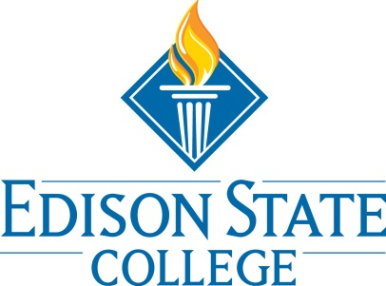

FYE Programming Meeting
April 5th at 11:00am in S-262D with Video Conferencing

Whitney Rhyne | Present | Helen Algernon | Present
Angela Hodge | Absent | Linda Johnsen | Present
Brooke Roughgarden | Absent | Martin Tawil | Present
Cal Majure | Absent | Megan Jensen | Present
Christy Gilfert | Present | Nicole Fisher | Absent
Cindy Campbell | Absent | Rebecca Gubitti | Absent
Fran Thomas | Present | Tara Marion | Present
Kevin Kennedy | Present | Thomas Rath | Present

The meeting begin with a review of the successful events from the spring semester on each campus. Whitney shared that on Lee campus total attendance for FYE Programming attendance increased from the fall to spring semester. This is atypical since the spring semester typically has a smaller student population on campus and fewer Cornerstone Experience classes run in the spring term. Highlights for the semester for each campus include Collier’s strong attendance for their Evening programming. Linda also mentioned that Cornerstone students donated supplies to a charitable organization to help within the community. Charlotte and Hendry Glades had great success with their Games on the Green event and Lee campus added FYE/Financial Aid workshops for the spring semester. The Financial Aid sessions were successful, two sessions were held in March and two in April.
The next item up for discussion was upcoming summer programming plans. Whitney passed out a flyer for Summer A programming on Lee campus (see attached flyer). The other campuses don’t have Cornerstone Experience classes until the Summer B term. Linda’s programming plans for the summer includes: Games on the Green event, volunteering with Habitat for Humanity and PA Socials. Linda mentioned a possible name change away from PA Socials.
Whitney would like to provide an initial programming review for Spring 2013 but does not yet have college wide AccuTrack database access. Whitney is happy to report that Lee campus programming attendance increased since the fall semester and there is still a week or so left of FYE programming for the spring semester.
Whitney challenged the group to begin to think about what type of FYE programming they might like to see for the Fall 2013 semester. Dr. Tawil noted that a resume/cover letter workshop offered by Career Services through the FYE Programming would be beneficial for his students.
Minutes submitted by Whitney Rhyne

