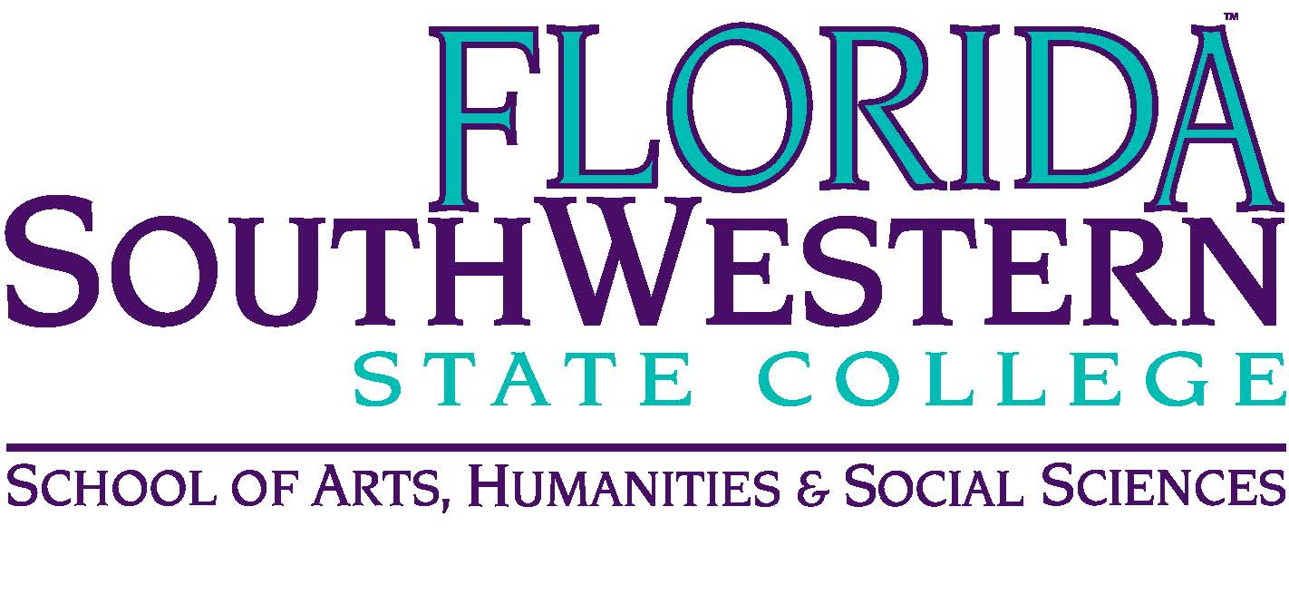**Department of Humanities and Fine Arts**

**Meeting Minutes**

**Date:** October 9, 2020; 10:00 a.m.

**Location:** Virtual/Online (Zoom)

**Chair:** Dana Roes

**Minutes:** Michael McGowan

|  |  |  |  |
| --- | --- | --- | --- |
|  | Present | Absent | Excused |
| Brown | X |  |  |
| Chase, S | X |  |  |
| Chase, W | X |  |  |
| Doiron | X |  |  |
| Hoover | X |  |  |
| Lublink | X |  |  |
| McGowan | X |  |  |
| Mompoint | X |  |  |
| Pritchett | X |  |  |
| Roes | X |  |  |
| Sutter | X |  |  |
| Smith | X |  |  |
| Swanson |  | X |  |
| Molloy | X |  |  |
| Krupinski | X |  |  |
| Wurst | X |  |  |
| Harrington | X |  |  |
| Chowdhury | X |  |  |
| Gresens | X |  |  |
| Guests | Rebecca Harris (QEP) | | |

1. Opening
   1. Call to Order: 10:00 a.m.
   2. Attendance taken
   3. Minutes from Sept. 2020 approved
2. Announcements:
   1. Congrats to Myriam for her book being accepted to Liverpool University Press. More Details:
      1. Title: *Televising Transnational Trauma: Visions and Versions of Slavery in the Americas*
      2. Summary: the book compares serialized representations of slavery in narrative historical dramas set in North America, the Caribbean, and South America as they appear(ed) on broadcast television and digital media platforms. This work is an analysis of the visual constructs of collective histories and memories that transcend international borders, have national and regional contours, adhere to generic conventions, cultural norms, production agendas (ideological, aesthetic, commercial), while also impacting individual lived experiences and collective cultural memories.
   2. Mike Molloy has new AS in Music Production in development
   3. Make Florence Announcement to classes: [www.fsw.edu/internationaleducaiton](http://www.fsw.edu/internationaleducaiton).
   4. Spring schedules: you can make a change NOW, but not for much longer. Reach out to Brian Page.
   5. Adjunct Faculty Mentors: see the reminder email a few weeks ago. Contact mentees. Also, if you haven’t done the training in the past three years, you need to do it again (see below)
   6. Covid-19 Updates: check the link yourself, but last time Dana checked we had 15 cases. Myriam had a student hospitalized, Stuart had a student who was sick on campus, etc. Website: <https://www.fsw.edu/reconnect/cases>.
   7. Modalities: are we happy with them? Mostly. Surviving, not thrilled.
      1. Unhappy students: tell them to drop and sign up for Fall B.
      2. Student compassion and assistance: [www.fsw.edu/bucscare](http://www.fsw.edu/bucscare) - and be flexible in our policies. Guide them to our services. Also, keep in mind the particulars of Zoom (and their Chatlog for attendance purposes)
3. Information Items:
   1. Assessment update (Elijah):
      1. Elijah the final list for the Fall assessment, and we’re not on any of it.
      2. College is doing syllapalooza. Doesn’t impact us much (since we did assessment the right way the first time)
      3. Make sure our classes are teaching the Gen Ed competencies (not as a rule book, but rather as an accurate reflection of what we teach in our classes)
      4. Other departments are revamping their syllabi. Now’s the moment to review our syllabi. Make changes now. Deadline for Curriculum Committee for Fall 2021 implementation: Dec. 3. But, there will be PD sessions in Spring to workshop with Deans/Chairs about learning competencies.
      5. Reaffirmation next year by SACSCOC.
   2. Professional Development Update (Sarah):
      1. New TLC director last week
      2. Two PD Fridays in October: 10/23 and 10/30 (none in Nov.).
      3. Mentor training: Oct. 30th. Must do training (2 hour virtual session). If you’ve done it in the past three years, no need to do the class again.
      4. Deadline for travel funds: end of November (lots of money rolled over, $40,000). Apply to go to virtual conferences ($2,000 cap).
   3. Ryan: New system for Curriculum Committee. In the Portal, this is how to propose a course/change:
      1. Doc Manager
      2. Academic Affairs
      3. Academic Committees
      4. Curriculum Committee
      5. 2020-21
      6. Check Instruction documents
      7. CurricuLog Login (email Sheila or Jeffery Peterman)
      8. Fill out forms (new and old)
      9. See “help” button if needed
      10. Signatures not needed anymore, and mistakes are ironed out before the CC meeting
      11. Start proposal with little icons (which don’t look like buttons, but are)
      12. Proposals go to Dana first and then up
      13. Ask Ryan for help if you have questions
   4. Rebecca Harris and the QEP:
      1. Ryan is the point person for us on that committee. Send him question or information before November to process this
      2. Four directions of the subgroups:
         1. Common Gen Ed Assessment (not same assignment, but some component that’s assessed across the curriculum)
         2. Capstone or Portfolio Project at end of AA degree
         3. New course or program fitting within AA (maybe learning communities)
         4. Student or community research project
      3. Where we are: figuring out which or what combination of these four things we’d like to do for the QEP
      4. Feedback from our dept:
         1. What we’re doing already:
         2. What we’d love to do: unify knowledge-seeking fields, explore arts therapy, medical humanities, Spring Break trips, cross-field publication and communication (faculty talking to each other)
         3. Tell Ryan if you have other ideas
   5. Tell Brandi George if we have students interested in the *Illumination* journal where they’re publishing art and writing.
   6. Wendy: drive in Black Mariah on Friday, 11/7 in BB Mann parking lot. Double Feature (short films: documentary, animation, narrative). Link on the page to donate to foodbanks. Also “Vast of Night” (sci fi) with social message, shot in OK City (Soderberg backed).
4. Next Meeting: 11/13 at 10 a.m.
   1. Discussion ideas: What kind of country do you want to live in? Liberal arts long term? Put thoughts on the Discussion Board of the Canvas site.