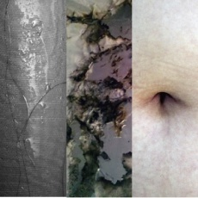
COUILLARD | KRUPP | MALECOT
2010 Fall Portfolio Exhibit
Nov 30 – Dec 5

This exhibition represents the culmination of a semester of work by three advanced
art students. Two of these works are the result of performance art pieces created earlier
in the semester. Erin Krupp’s piece was inspired by the death of a close friend who committed
suicide after enduring months of bullying. Krupp explores the contradictions inherent
in American culture which praises the virtues of rugged individualism while simultaneously
demanding conformity if someone veers too far from the mainstream. To make
this piece she covered wood in reflective material, wrapped it in a sheet and randomly
scattered gunpowder on top. Participants were given small bits of fabric cut from the
sheet to light on fire and throw down to ignite the gunpowder. What remains is a charred
indictment of intolerance. The image burned into the materials is abstract, forcing the
viewer to become an active agent in the interpretive process while the white sheet
evokes a burial shroud and the reflective surface implicates the viewer in a culture of
violence.
Claire Malecot’s piece was created during Art Walk in downtown Ft. Myers as she
stood in a display window obsessively cutting paper in large circles while actively ignoring
those who were watching her. The sight of a young woman on display in a space that
is traditionally designed for lifeless mannequins who tempt the consumer thwarts our expectations of such a space and causes us to reflect on our own repetitive, mindless, and
obsessive actions. The fact that she is in the process of creating something—an active
agent rather than a passive object —further challenges our assumptions about consumer
culture. Although we never see the final product of her work, her action seems
more meaningful than our vapid habit of defining ourselves by the inanimate objects we
buy.
Genie Couillard offers us a series of abstracted photographs of her hair called
Molded Habit. Women’s hair has long been a symbol of sexual power but these extreme close ups of hair-- snaking down walls and clinging to shower curtains that look remarkably
like flesh, cause us to reconsider the metaphor. Disembodied and contrasted against a
variety of textures, we can delight in the sheer elemental nature of hair or invent an endless
variety of narratives inspired by our own experiences to explain each image. For
Couillard, hair has always been a key element to her identity: whether a source of conflict
as it clogged drains and annoyed roommates, or a source of delight as she altered
its length and style to reflect her latest love.
The range of work in this show testifies to the development of each artist who has
moved far beyond the simplistic understanding of art as an object of beauty that is hung
on a wall or perched on a pedestal. This is not art that is validated by its price tag but art
that adds value to the human experience by pushing us to rethink our culture and
become active participants in the creative and interpretive process. The sheer range of
materials--from gunpowder to a grandmother’s bellybutton--suggests that this is art that
offers us new ways of knowing; new parameters for understanding ourselves, our relationships,
and our society.
- Dr. Wendy Chase
November 30, 2010
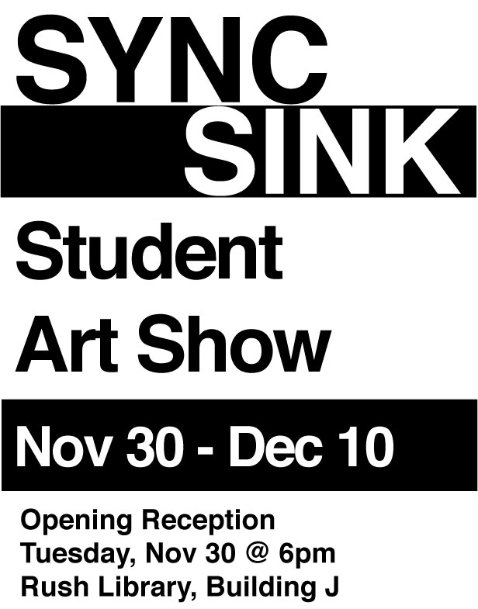
SYNC/SINK
Student Participants (2nd Floor)
DRAWING 2 INSTALLATIONS
Student Participants (3rd Floor)
Galen Aune
Mis Piece Gravity
Matt Carlson
Untitled
Rich Croll
Untitled
Genie Couillard
Point of Origin
Tai Goggins
Guardian
Mike Grodem
Descent
Maria E. Jijon
Untitled
Erin Krupp
Out of Water
Megan Mosallem
Untitled
Andrea Mucci
Brothers
Alex Novicki
11
Kaleena Rivera
Luxurious
Caitlin Rosolen
Sinking in Sync to the Loss of
Our Dreams
Melissa Smalluck
Are you positive?
Clearly Stuck
Matthew Carlson
Jessica Cusumano
Cameron DeMay
Matthew Dewhirst
Jacqueline Donlon
Marienne Figueroa

2010 Fall Portfolio
Advanced Students
Genie Couillard
Molded Habit
Erin Krupp
Portrait of My Brother
Adriana Flores
Taijhryl Goggins
Minerva Gutierrez
Erin Krupp
Mesha Peterson
Melissa Smalluck

(1st Floor)
**details on back
Claire Malecot
Paper
Claire Malecot
84 49 26

