Note: Before completing this proposal, all core courses for a new program or certificate must have already been reviewed (or submitted for the same meeting) by the Curriculum Committee and approved by the Provost. In addition, the complete catalog page must be included at the end of this document.
School or Division | School of Business and Technology
Proposed by (faculty only) | William Van Glabek, Dr. Jennifer Patterson
Presenter (faculty only) | William Van Glabek
Note that the presenter (faculty) listed above must be present at the Curriculum Committee meeting or the proposal will be returned to the School or Division and must be submitted for a later date.
Submission date | 10/10/2020
All Curriculum proposals require approval of the Curriculum Committee and the Provost. Final approval or denial of a proposal is reflected on the completed and signed proposal.
☐ | Approve | ☐ |  | Do Not Approve
Curriculum Committee Chair Signature |  |  |  | Date
☐ | Approve | ☐ |  | Do Not Approve
Provost Signature |  |  |  | Date
All Curriculum proposals require review by the Office of Accountability & Effectiveness.
☐ | Reviewed
Office of Accountability & Effectiveness Signature |  |  |  | Date

Section I, Important Dates and Endorsements Required
nOTE: Course and Program changes must be submitted by the dates listed on the published Curriculum Committee Calendar. Exceptions to the published submission deadlines must receive prior approval from the Provost’ Office.
Term in which approved action will take place | Fall 2021
Provide an explanation below for the requested exception to the effective date.
Type in the explanation for exception.

Any exceptions to the term start date requires the signatures of the Academic Dean and Provost prior to submission to the Dropbox.
Dean | Signature |  |  | Date
Provost | Signature |  |  | Date

Required Endorsements | Type in Name | Select Date
Department Chair or Program Coordinator/Director | Dr. Jennifer Patterson | 10/10/2020
Academic Dean or Provost | Dr. Debbie Psihountas | 10/10/2020

Library Review: Has the Libraries’ Collection Manager been contacted about the new program or certificate and discussed potential impacts to the libraries’ collections?
To: Professor William Van Glabek
From: Professor William Shuluk, Librarian liaison School of Business and Technology.
Subject: review of Library support for proposal of new degree offering, Business Analysis Specialist AS.
Date: 24 September 2020.
After our meeting on 16 September I have reviewed Library Resources that are relevant to the course proposals and curriculum. These resources included E-Books, Research databases and print books. I performed a number of searches in each medium utilizing subject headings germane to the course descriptions. Sample results:
- E-books – 2019 publication date.
- Search terms Data Administration - 63 titles.
- Search terms Digital Accounting - 32 titles.
- Search terms Data Based Marketing – 64 titles.
- * there are some titles that appear in more than one search.
- If appropriate and consistent with our Collection Management policies, I would work with faculty to add additional eBook titles to our collection in areas identified by faculty.

- Print books – 2015 – 2018 publication dates.
- 30 hard copy , non -text titles on topics such as business finance, statistics, data analysis. If appropriate and consistent with our Collection Management policies, I would work with faculty to add additional current print titles to our collection in areas identified by faculty.

- Research databases - Searches using relevant subject headings across a number of databases in our portfolio yields thousands of scholarly articles, magazines, newspaper articles and videos from current and archival related literature and streaming sources. I have included a screen shot of the databases most relevant to the program proposal.

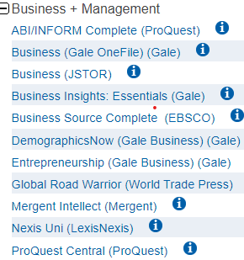
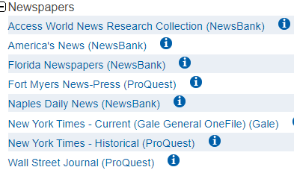

It is my opinion that our current holdings would meet the research needs of faculty and students for the AS degree Business Analysis Specialist.

William Shuluk - Librarian

List all faculty endorsements below. (Note that proposals will be returned to the School or Division if faculty endorsements are not provided).
William Van Glabek, Dr. Jennifer Patterson, Dr. Timothy Lucas, Dr. Mary Myers

Section II, New Program or Certificate Information (must complete all items)
List new program or certificate. | Business Analytics (AS-1552120106)
Describe (below) the process by which the need for the new program or certificate was identified. Along with the summary, delineate the parties that have endorsed the new program such as Advisory Board, Faculty, and/or Ad Hoc Committees. Submit Minutes of meetings and endorsements along with this form.
Business analytics is increasing being stressed in undergraduate business and accounting curriculum. This was evident during the TACTYC Conference for accounting educators with business analytics seminars taking a complete day of the three-day conference last year. Florida Department of Education offers an AS in Business Analytics. This proposed AS for FSW follows Florida guidelines and closely resembles the AS program that is offered at Broward College.

Current Job listings of Local SWFL Employers:
- Hertz: 3 current open postings for analysts
- Chicos FAS: 3 current open postings for analysts
- Lee Health: 51 current open postings for various analysts
- NCH: 6 current open postings for analysts
- Lee County: 3 current open postings for analysts
- Collier County Government: 1 current open post for analyst
- Arthrex: Over 30 current open postings for various analysts
Job Outlook
According to U.S. Bureau of Labor Statistics (BLS)*, employment of management analysts – including business analysts – is expected to grow 14% from 2018 to 2028, which is much faster than the average for all occupations.

The number of jobs for all US business analysts will increase from the current 364,000 openings to 2,720,000 by 2020, per the BA Times.

Provide a summary of the Program needs analysis.
Use of SoBT faculty and existing classroom space.
Dr. Jennifer Patterson
Dr. Timothy Lucas
Dr. Mary Myers

Provide a summary of the Salary Levels that graduates of this Program can expect to make.

National estimates for this occupation:
Employment estimate and mean wage estimates for this occupation:
Employment (1) | Employment  RSE (3) | Mean hourly  wage | Mean annual  wage (2) | Wage RSE (3)
709,750 | 0.7 % | $45.94 | $95,560 | 0.4 %
Percentile wage estimates for this occupation:
Percentile | 10% | 25% | 50%  (Median) | 75% | 90%
Hourly Wage | $23.90 | $30.80 | $40.99 | $54.70 | $74.19
Annual Wage (2) | $49,700 | $64,060 | $85,260 | $113,770 | $154,310

U.S. Bureau of Labor Statistics

URL address: https://www.bls.gov/oes/current/oes131111.htm

Employment & Pay Information for Florida
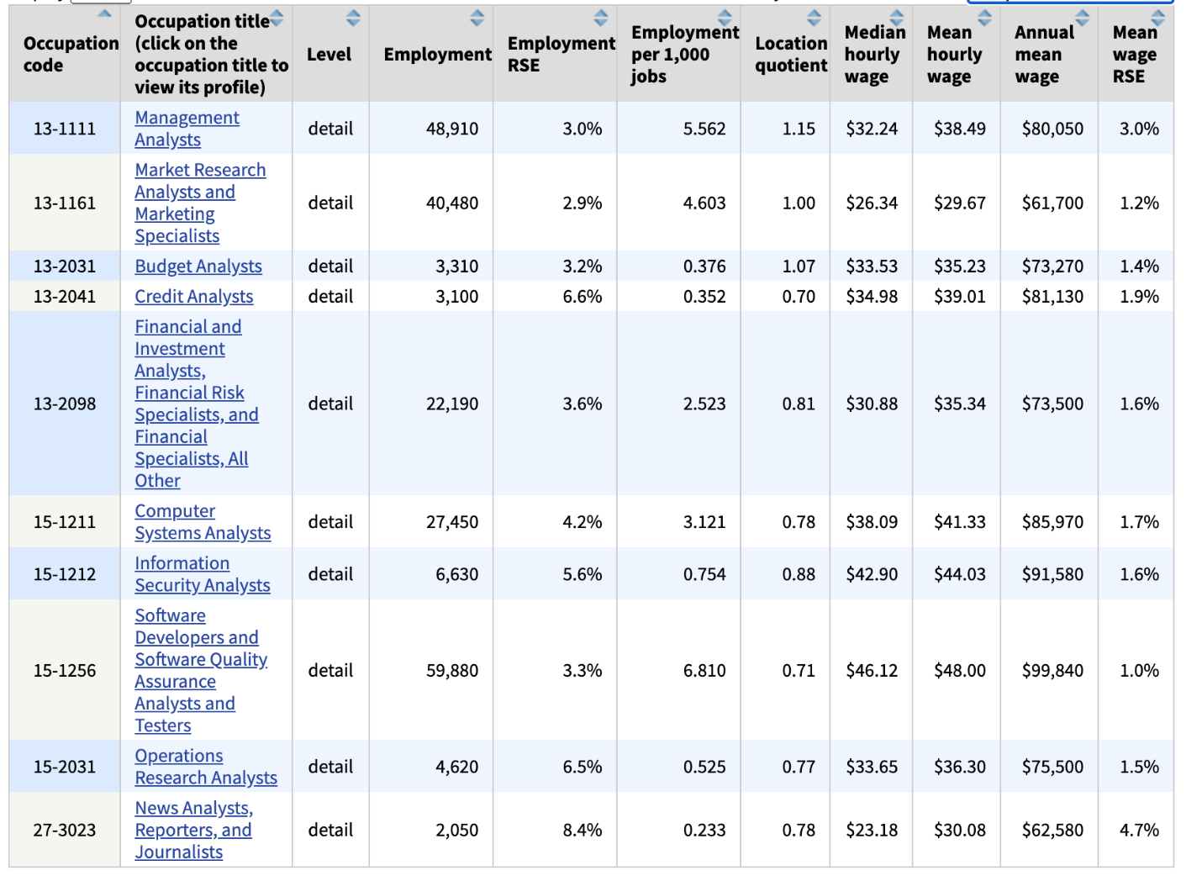
U.S. Bureau of Labor Statistics
Florida SouthWestern State College Area – Charlotte, Collier, Glades, Hendry, & Lee Counties
SOC Title |  | 2019 | 2027 | Growth | Percent Growth
13-1111 | Management Analysts | 2156 | 2722 | 566 | 26.3

Briefly describe the existing resources available needed to implement this new program.

Utilize core General Education curriculum along with current SoBT course offerings. Microsoft Excel software program (free to students with Microsoft 365 account at FSW).
Briefly describe the additional resources needed to implement this new program.

Additional course offerings of QMB Business Statistics and ISM 2200C Applied Business Analytics
Briefly describe any Program Accreditation required for this program.

No additional
Briefly describe any Industry Certification available for student to take during or following completion this program.
IIBA International Institute of Business Analysis
Project (below) the average enrollment for core courses.
25 – 30 ppl
Describe (below) how this projection was determined.
Examined average number of students in existing SoBT classes
List (below) similar programs or certificates at other colleges and universities.
AS Business Analytics Broward College
https://www.broward.edu/academics/_docs/program-maps/2020-2021/business/as-business-analytics-2508.pdf

BS – Analytics & Informatics Florida Gulf Coast University
https://www.fgcu.edu/cob/programs/isom/analytics-bs

For AS and Certificate Programs: Attach a Copy of the related FLDOE Curriculum Frameworks. Copy and paste the "Standards” from the FLDOE framework (one standard per row). List the FSW course or courses in which that Standard is taught.

Program Title: Business Analytics
Career Cluster: Business Management and Administration
FLDOE Framework Standard | FSW Course
01.0 Prepare and use financial information about business organizations to support decision making | ACG 2021
02.0 Manage business information using appropriate software | CGS 1100
03.0 Describe information systems and requirements analysis. | ISM 2200C
04.0 Demonstrate effective business communication and collaboration skills. | MAN 2021, CGS 1100
05.0 Describe how data is organized and examine the business intelligence process used in transforming data to useful information | QMB 2100
06.0 Design and build business application using database management systems. | ISM 2200C
07.0 Evaluate business and financial information to support internal decision making. | ACG 2071
08.0 Describe the implications of professional values, ethics, and attitudes in business. | GEB 2430
09.0 Demonstrate fundamental techniques and methods used in the analysis of computerized business activities. | QMB 2100

Catalog Page

Business Analytics, AS

Purpose
The Associate in Science (AS) in Business Analytics program provides coherent and rigorous content aligned with challenging academic standards and relevant technical knowledge and skills needed to prepare for further education and careers such as business management analyst, database analyst, budget analyst, database administrator, and operations research analyst. It also prepares students for entry into a variety of baccalaureate degree programs in related disciplines such as accounting, business administration, management, and finance. The content includes but is not limited to the principles, procedures, and theories of producing financial and market intelligence by querying databases and creating reports and developing methods for identifying data trends existing in information sources.

Program Structure
This program is a planned sequence of instruction consisting of 60 credit hours in the following areas: 18 credit hours of General Education Requirements, 39 credit hours of Business Analytics Core Requirements, 3 credit hours of Elective Requirements.

Course Prerequisites
Many courses require prerequisites. Check the description of each course in the list below to check for prerequisites, minimum grade requirements, and other restrictions related to the course. Students must complete all prerequisites for a course prior to registering for it.

Graduation
Students must fulfill all requirements of their program major in order to be eligible for graduation. Students must indicate their intention to attend commencement ceremony, by completing the Commencement Form by the published deadline.

General Education Requirements: 18 Credit Hours

- ENC 1101 - Composition I 3 credits
- ENC 1102 - Composition II 3 credits
- ECO 2023 Principles of Microeconomics 3 credits
- ECO 2013 - Principles of Macroeconomics 3 credits
- General Education Mathematics Course - STA 2023 Statistical Methods 1 3 credits
- Any General Education Humanities Course (PHI 2100 Introduction to Logic recommended) 3 credits

Business Analytics, AS Degree Core Requirements: 39 Credit Hours

- ACG 2021 - Financial Accounting 3 credits
- ACG 2071 - Managerial Accounting 3 credits
- CGS 1100 - Computer Applications for Business 3 credits
- CGS 2511 - Advanced Spreadsheet Computing 3 credits
- SLS 1331 - Personal Business Skills 3 credits or SLS 1515 - Cornerstone Experience - 3 credits
- FIN 2001 - Business Finance 3 credits
- MAN 2021 - Management Principles 3 credits
- ISM 2200C Applied Business Analytics 3 credits
- MKA 2701 Visual Informatics 3 credits
- MAR 2644 Data Based Marketing 3 credits
- QMB 2100 Business Statistics 3 credits
- MTB 1103 Business Mathematics 3 credits
- GEB 2430 Ethics in Management 3 credits
Business Analytics, AS Degree Elective Requirements: 3 Credit Hours

- Any 1000 or 2000 level course in Accounting, Business Management, Computer Technology, Finance, Mathematics, & Marketing with the course prefixes: ACG, CGD, CIS, CNT, COP, CTS, ENT, FIN, GEB, ISM, MAN, MAR, MKA, MNA, MTB, SBM, SLS, TAX, MAC, MAT

Total Degree Requirements: 60 Credit Hours

Section III, Personnel and Resources Needed (add rows as necessary)
Faculty position(s) (List discipline) | Full time or adjunct? | Total annual expenses
QMB | FT preferred | existing
ISM | FT preferred | existing
Staff position(s) (List title) | Full time or part time? | Total annual expenses
None | N/A
Describe (below) library resources needed to support this program or certificate. Explain rationale for response, even if answer is none.
Listed above from Bill Shuluk
Describe (below) the technology, facilities, laboratory, or other resources needed to support this program or certificate.
Currently all software and technologies are met to initiate this program.
List (below) the estimated annual amount required for educational materials and supplies or other operating expenses for implementation of the new program or certificate.
Existing expenditures
Identify (below) the funding source to be used for personnel and operating expenses.
Existing expenditures

Section III, Justification for proposal
Provide justification (below) for this proposed curriculum action.
Business Analytics is a growth field due to business’s reliance on information provided through technology. Pursuing an AS in Business Analytics provides a student the option to pursue business analysis in health care, finance, manufacturing, and government. This degree provides a balance of general education, accounting, management, marketing, statistics, and information technology in establishing a sound foundation in business analytics. Locally and nationally there is a growing need for qualified people into business analytics. The growth in the field of business analytics is expected to grow by 14% through 2028 nationally and 26% locally.

