Budget Query Procedures for Banner Self-Service

Log into the Edison College Portal at my.edison.edu.
Click on the District Resources tab.

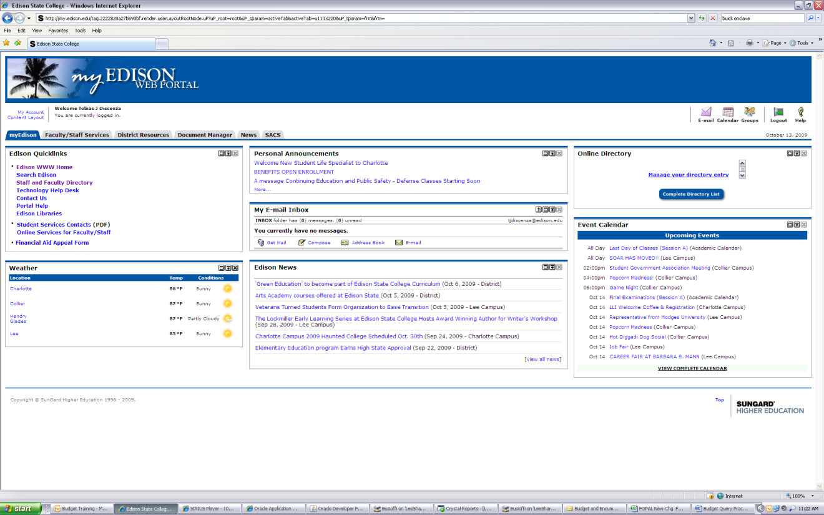

Scoll down to the bottom left to view the Finance and Accounting Channel and then click on Budget Queries.

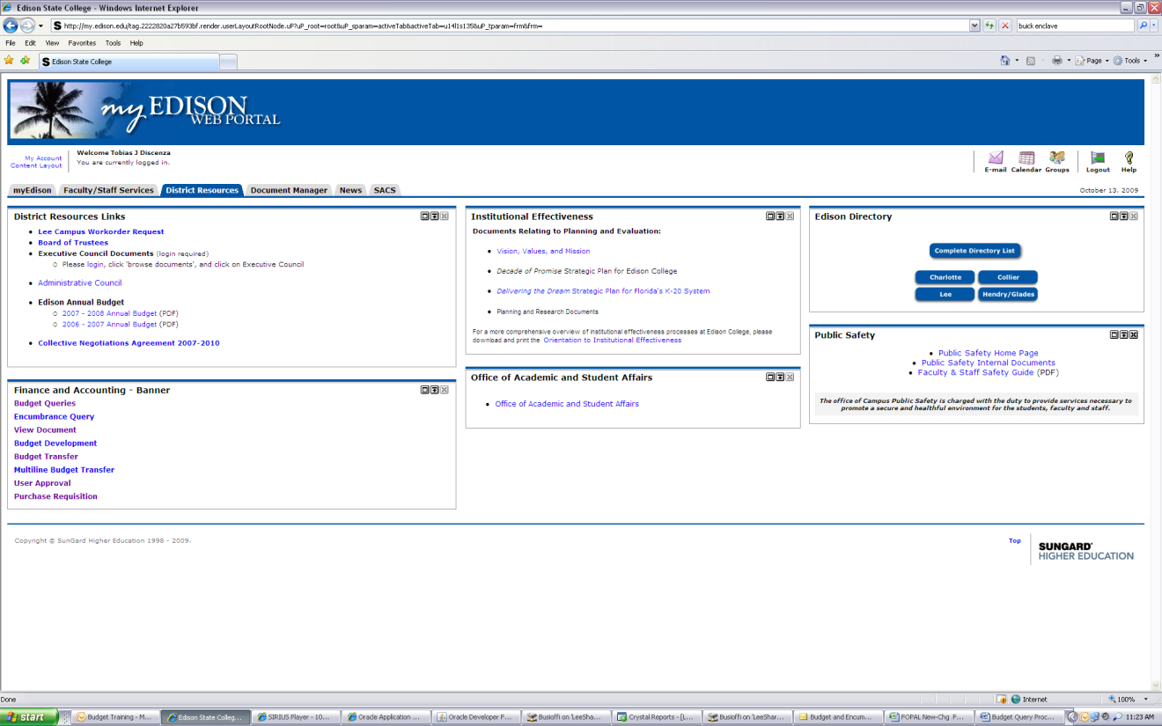

To view a Budget Quick Query, click the drop down menu.
Budget Status by Account allows you to view detailed information for a specific account code.
Budget Status by Organizational Hierarchy allows you to view budget information for a specific org.
~These two options can be downloaded into an Excel Spreadsheet~
For this example - To review a Budget Quick Query, choose this option from the drop down menu.
Click Create Query.

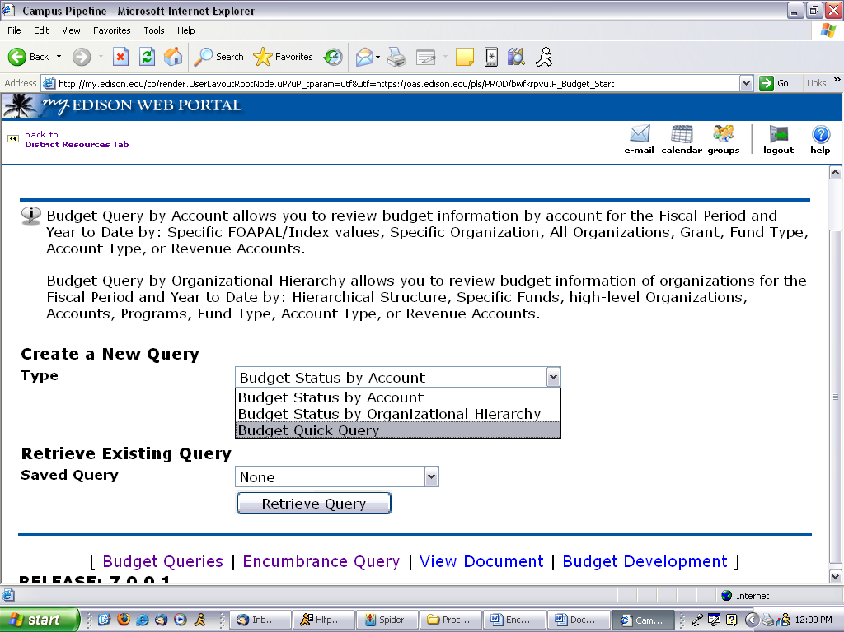

Ensure Fiscal Year is correct.
Enter 1 for Chart of Accounts.
Enter YOUR Index Code.
Click Submit Query.

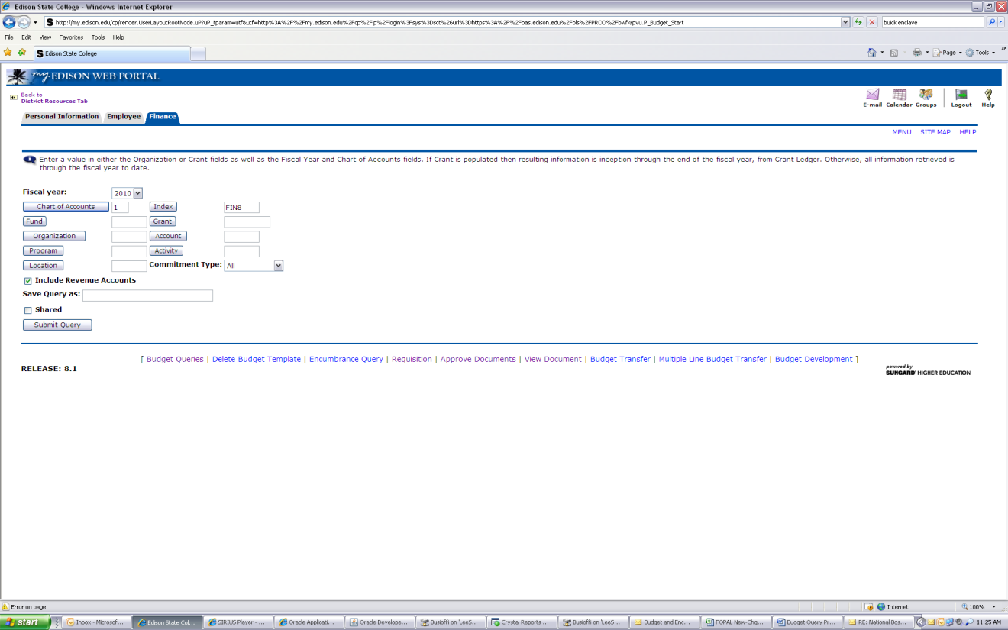

Clicking Submit Query will populate the Fund-Organization-Program.

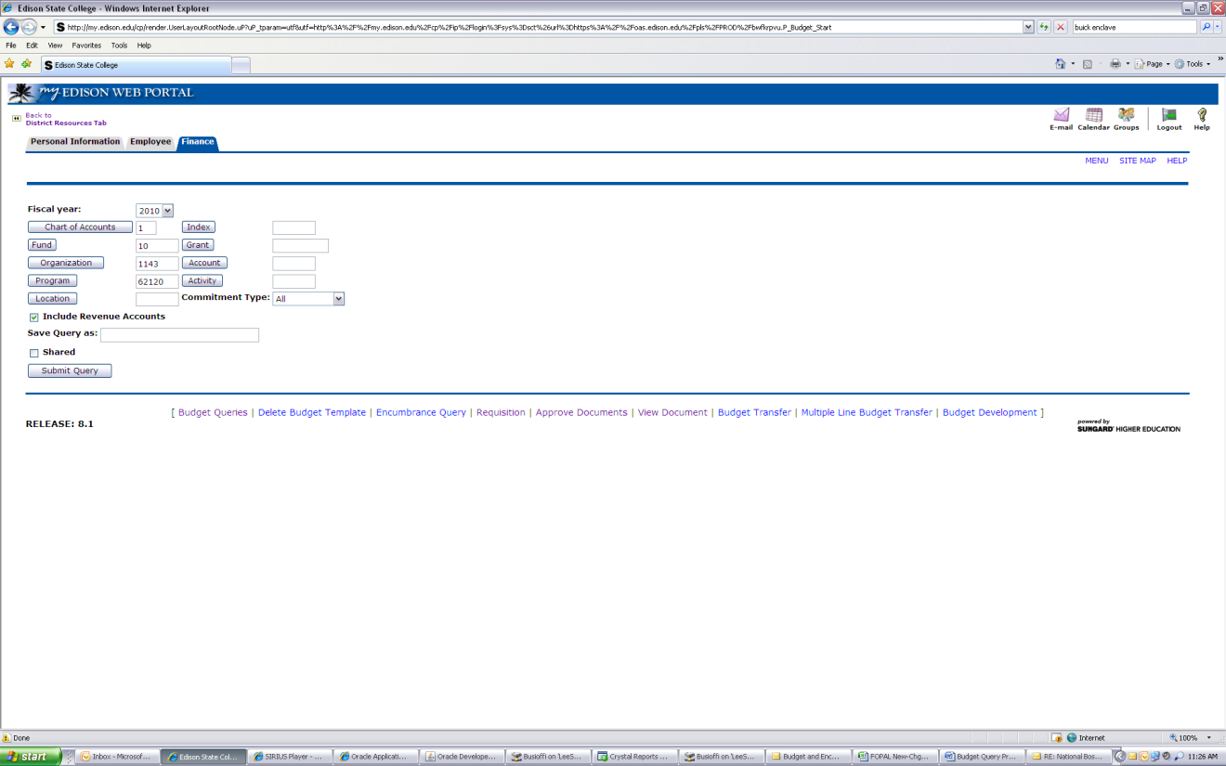

Click Submit Query a second time to view detail.
This will show the Available Balance for all account codes and a Report Total for all records.

