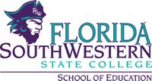

April 18th, 2016
12:30pm
Faculty | Present | Absent | Staff | Present | Absent
Dr. Anne Angstrom | X |  | Kristin Corkhill | X
Prof. JoAnne Devine | X |  | Kathie DiLascio | X
Dr. Julia Kroeker | X |  | Megan Just | X
Dr. Regina Miller | X |  | David Koehler | X
Dr. Mary Robertson | X |  | Rachel Malone |  | X
Prof. Joyce Rollins | X |  | Dr. Larry Miller | X
Dr. Caroline Seefchak | X
Faculty Meeting Minutes
- Textbooks
  - All web-based
  - Cost is a factor when considering adoption of new edition of text book
  - If using the same textbook, it will be automatically updated to the newest edition available
  - Can request help from auxiliary services to place textbook orders
- SOE Website Updated
  - Changes still need to be made to the layout of the page
  - Awaiting new college website to make further changes
- Service Learning
  - New template available on Canvas under files
  - Template should be uploaded under assignments
  - Student will upload as many templates as needed
    - Ex: 1 template for KDE event, 1 template for Family Math Night
  - Submissions will be reviewed by Dr. Anne Angstrom and Joyce Rollins
  - Templates can be uploaded throughout the semester, however, hours will only be updated about once a semester
  - Faculty should only have to sign off on logs
  - Will no longer be using Live Text
    - If student has service learning completed partially in Live Text, they should transfer the information straight into Canvas
  - Service learning template works best on PC
- EdCamp – Conference with school districts
  - Informative video: https://www.youtube.com/watch?v=I7DwCI7j0Bg
  - Discussion based professional learning camp
  - Consists of 4 discussion sessions
  - September 2016, either 9/17 or 9/24 at 8:30am
  - Coordinated by Lee District Curriculum and Staff Development
    - Members of FSW SOE have also been asked to join the steering committee
    - Open to professional educators from Lee Schools and teacher candidates and interns from FSW SOE
- Open House
  - Jessica Barnett, new Academic Advisor
  - Took place on 5 campuses – 10 names taken
  - Tables need manipulatives
    - Ideas and suggestions should be brought to Dr. Larry Miller
  - Move the time of the open house
    - Could be held during Free Application Week
    - Could be held during a different time of the day, lunch
- Emergency planning in ECE centers
  - Dr. Caroline Seefchak and Dr. Dawn Levasseur volunteered to serve as reviewers
  - Text messaging system has been put in place
  - Contact Dr. Larry Miller to review policies
- Dual Enrollment fee change and new articulations
  - Will begin charging private schools for students in DE program
- Fall Internships
  - See Dr. Anne Angstrom memo
- ECE Professional Development Partnerships
  - SOE is drafting articulation with Naples YMCA
- Budget Updates
  - New ECE field experience specialist
    - Will be funded by Perkins Grant
  - Kagan Training
    - 100 people, 1 day, $20,000
    - Could be held on Tuesday or Thursday in Fall 2016
      - Could invite night students and interns
      - Could be used as a recruiting opportunity
  - Mileage should be submitted to David Koehler by 5/5
- DOE State Reporting Updates – Meg Just
  - Refer to attachment
  - Elementary Ed/ESOL/Reading ranking improved from 2013-2014 and 2014-2015
    - 2013 – 1.8, 2014 – 2.5, 2015 – 2.8
    - Unverified employment of FSW graduates down from 133 in January to 9 in April
- We will pay for you to take GK, ProEd, and Subject Area Exams
  - Professors and educators are encouraged to take exams to gain more insight on the testing material
- Online learning conference 5/2 from 9:00am to 12:00pm
- Special topics curriculum change: subject area and ProEd diagnostic
  - Faculty voted unanimously to add subject area and ProEd diagnostic to special topic curriculum in fall 2016
- GKT prep course updates
  - 17 applications turned in, 8 seats left
    - Applications are due on 4/20
  - Could become an elective course
- Prerequisite changes (draft, not final)
  - Fall 2017, Diversity and Technology may not be required for admission to B/S in elementary and middle grades language arts
    - Could introduce as an elective course
    - Could infuse subject material into other courses

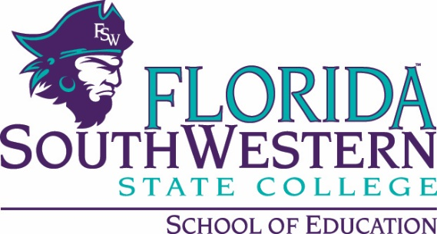
FLDOE State Reporting Update
April 18, 2016

- Title II Contextual Data Cleaning
  - Higher Ed Opportunity Act; accountability
  - Data were evaluated for missing FTCE completion and returned to the FLDOE.
    - July 2010 to August 2015
    - 41 errors detected.
- Title II Contextual Data Report
  - Section I: Contact Info for Dean
  - Section II: Teacher Quality Enhancement Partnership Grant (We don’t participate).
  - Section III: Accreditation
  - Section IV: Supervised Clinical Experiences (e.g., avg. clock hours prior/during student teaching; # full-time equivalent faculty in supervisory roles, # of students in supervised clinical experiences).
  - Section V: Admission Requirements
  - Section VI: N/A
  - Section VII: Annual Goals
  - Section VIII: Assurances
* NOTE: This was submitted on March 30, 2016. Thanks to Anne for helping interpret “clinical” hours served.
- 2014-2015 APPR
  - In January 2016, we were made more aware of how the Annual Program Performance Report (APPR) was calculated for schools of education across the state.
    - Placement of program completers in public and private schools
    - Retention of completers employed in instructional positions.
    - Performance of students in preK-12 assigned to our graduates (VAM scores)
    - Performance of students in pre-K-12 assigned to our grads by subgroup (VAM)
    - Results of program completers’ annual evaluations
  - To get an APPR score…
    - 3+ completers in the placement performance metric (VAM) or retention info
    - 2+ completers with an annual eval for the performance metric
    - “computing the mean of the performance scores awarded to programs for teacher placement, teacher retention, annual evaluations, student performance and student performance by subgroup”
  - Only one (1) program has met enough criteria to get a ranking, and we improved our ranking from 2013-2014 and also from 2014-2015!
These rankings are based mainly on VAM scores and bonus points for critical shortage areas.
Summative Score: | 2015 | 2014 | 2013
Elementary Ed/ESOL/Reading | 2.8 | 2.5 | 1.8

- Completer & Candidate Information for 2014-2015 (due/turned in by April 15, 2016).
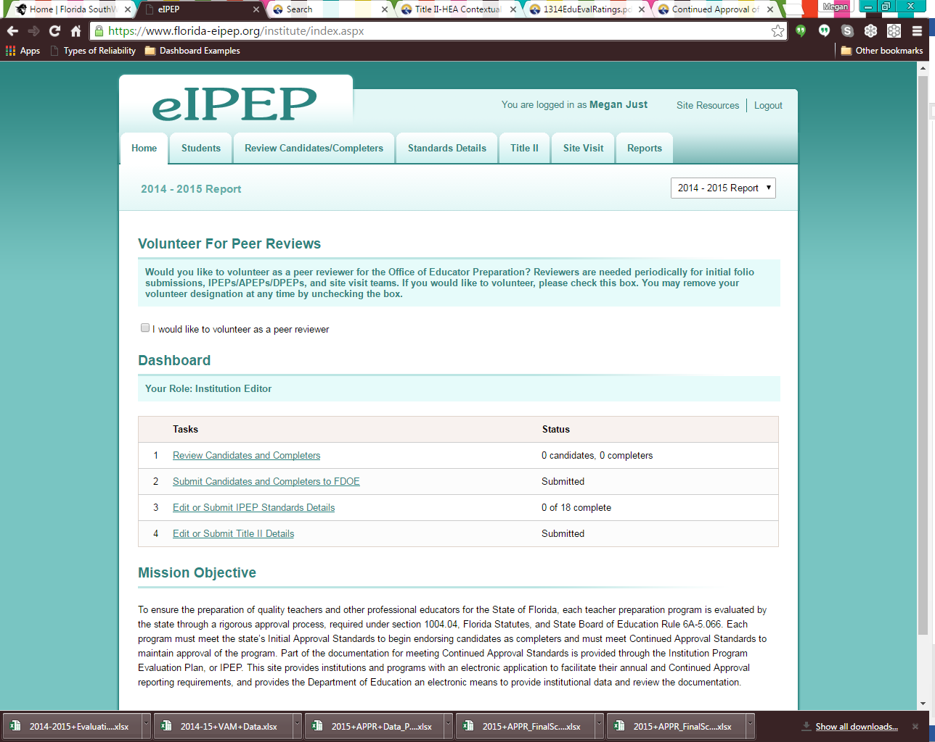
This indicates that we have submitted our 2014-2015 teacher candidate and completer data. This information was updated through the Florida College System (FCS) process headed up by Barb Perrine. We do not submit this information directly through our office; however, I verified our submission with help from IR (Abby Willcox) this spring.
After the FLDOE uploaded our submission, I examined the data files housed in the eIPEP system. Errors were found regarding some students. Using reports generated by Institutional Research, updated GPAs for completer data were added.

Other Completer Data: Employment Verification
In preparation for the next IPEP submission this fall, we have established a process for verifying employment of our graduates within public and private schools.

* We have signed letters from the Directors of Human Resources from Charlotte, Collier, Hendry, and Glades. Lee is working on it.

