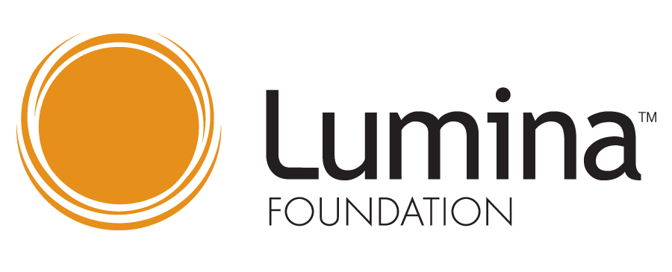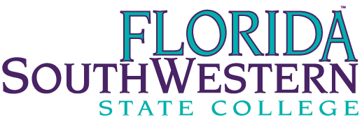
SWFL Talent Hub FSW Action Team
Meeting Minutes for May 28,2020

Kelli Dunlap | Present | Amber McCown | Present
Dr. Christy Gilfert | Present | Dr. Debbie Psihountas | Present
Brenda Knight | Present | Dr. Tom Rath | Present
Amanda Lehrian | Absent | Whitney Rhyne | Present
Keith Martin | Present | Dr. Matthew Sanchez | Absent
Dr. Martin McClinton | Present

Dr. Christy Gilfert provided an overview of the FutureMakers Coalition, which aims to transform SW Florida’s workforce by increasing the proportion of working-age adults with post-secondary credentials. In support of this work, the FutureMaker Coalition, which is comprised of industry leaders, educators, and community organizations, applied and was awarded the Talent Hub designation, which is a Lumina Foundation award. The talent hub designation indicates that a community has shown the capacity and capability to significantly increase the number of residents with post-secondary credentials. 26 cities nationwide have received this designation.

The Southwest Florida Community Foundation, FGCU, and FSW are the signatories on the grant. The stated goals for FSW are listed below.

  - Enrollment of 3% of the target group (adults with some college, but no degree) into an FSW associates degree program
    - Of this population, a 50% associate or certificate degree completion rate within 3 years of initial enrollment
    - Implementation of a completion scholarship at FSW for the students in this population.
  - Increase transfer enrollment of FSW graduated by 10%
  - Reverse transfer of AA with FGCU
  - Develop and implement record sharing agreement with FGCU to streamline transfer admissions
  - BS in Elementary Education at HG (cohort of 12 or more students starting Fall 2020)
  - Enrollment of 3% of the target stop out population into an FSW bachelor’s degree program
  - Develop shared recruitment materials and a joint enrollment activity plan
Whitney Rhyne shared FSW student stop-out data relating to the first goal (enrollment of 3% of the target group (adults with some college, but no degree) into an FSW associates degree program). The stop-out data includes students who were away from FSW for three semesters with the last term of attendance from 2019-2009. Reviewing a decade worth of stop-out data revealed that a large portion of our stop-out students (48% or 12,558) would be more accurately classified as early transfers and attended another education institution after leaving FSW. 6,750 credentials were earned at other educational institutions by FSW early transfers.
26,104 students comprised FSW’s true stop-out students. 57% (14,956) of students who stopped out were in good academic standing, earning 591,067 credit hours, and completing 77.7% of attempted credit hours with a mean GPA of 2.59. 64% of the students in good academic standing received financial aid while attending FSW. 2,994 students earned 60+ credit hours, while another 2,185 students earned 45-60 credits hours before departing from FSW.
The stop-out student population are evenly distributed between the FSW service areas. 8,219 students or 55% of stop-out students had addresses within Lee county at their point of last attendance. 3,781 students or 26% reside in Collier county, 1704 or 11% live in Charlotte county, 687, 5% reside in Hendry/Glades counties, and 565 or 4% had addresses that were out of state. AA General Studies was, of course, the top major accounting for 57% of students, pre-med, and business admin/mgmt. rounded off the top three majors.
The group discussed the first goal. Dr. Debbie Psihountas noted that students in AS programs may be a good population to promote the earning of post-secondary credentials. Dr. Psihountas also mentioned that Schultz funding could be a possibility to financial support students who may only need 1-2 classes to complete their certificate.
The group discussed that the students would need to re-apply to re-enroll. Dr. Martin McClinton recommended that the deans could identify classes where students are closest to completion. Dr. Thomas Rath noted the need to identify students’ preferences for campus/online coursework. Dr. Gilfert emphasized the importance of reviewing a student’s financial balance. Amber McCown noted the possibility of pushing the list of students into recruit for a targeted campaign for AA seeking students. There were conversations about the time intensive case management process. Dr. Gilfert noted in past stop-out campaign students denoted that they were unhappy with the college and that staff engaged in the communication campaign would need to be aware and prepared to handle those conversations. Dr. Gilfert noted with this grant, there is access to funding for program outreach but not to support scholar dollars.
The group reviewed the second goal, to increase transfer enrollment of FSW graduated by 10%. Whitney shared the three-year trend of AA graduate subsequent enrollment. 80% of FSW’s 2016-2017 AA grads continued their education after graduation. 75% of 2017-2018 AA graduates continued their education, and 68% of 2018-2019 grads. 2018 is the baseline for the purpose of the goal of increasing enrollment by 10%.The committee reviewed the remainder of goals.
- Reverse transfer of AA with FGCU – Waiting for state leadership/guidance
  - Develop and implement record sharing agreement with FGCU to streamline transfer admissions
Below ways FSW currently shared data with FGCU
    - FSW AA 30+ list of students who denote interest in FGCU delivered 1-2 each semester (fall, spring, summer). This list provides the student’s anticipated program of study upon at FGCU.
    - List of FSW Collegiate H.S. and Clewiston Institute anticipated graduates that meet FGCU’s ECS 3.0 GPA requirement
    - List of Honors Scholar Program completers interested in attending FGCU
  - BS in Elementary Education at HG Cohort of 12 or more students starting Fall 2020 – currently about six students are enrolled in B.S. elementary education classes at H/G for fall.
  - Enrollment of 3% of the target stop out population into an FSW bachelor’s degree program
Whitney shared that of 15,377 students who earned a credential that could easily transition to another program at FSW, 4,573 of those students had no other educational enrollment/records through the NSC. Nursing, paralegal, and Business Admin. Had the highest number of AS grads with potential for returning for an FSW baccalaureate degree.
  - Develop shared recruitment materials and a joint enrollment activity plan
FGCU and FSW utilize shared recruiting materials promoting the Destination FGCU program. New this past spring, FSW hosted FGCU advisors for several advising access days.
The Lumina Foundation Talent Hub grant is through June 30, 2021. Reports are due 8/31/20, January 2021, and June 2021.
Minutes respectfully submitted by Whitney Rhyne

