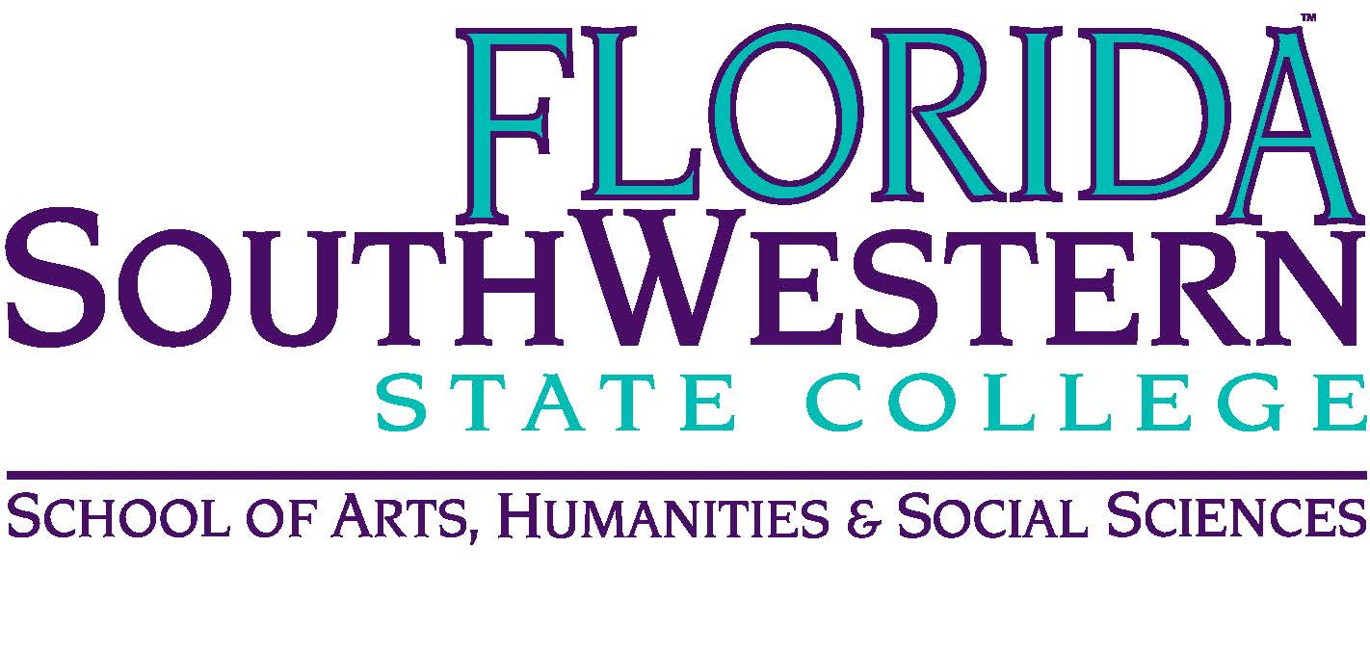
Department of Humanities and Fine Arts
Meeting Minutes
Date: October 11, 2019, 10:30 a.m.
Location: Edison/Lee campus (L-138)
Chair: Dana Roes
Minutes: Michael McGowan

 | Present | Absent | Excused
Brown | X
Chase, S | X
Chase, W | X
Doiron | X
Hoover | X
Lublink | X
McGowan | X
Mompoint | X
Pritchett | X
Roes | X
Sutter |  | X
Smith | X
Swanson |  | X
Molloy | X
Krupinski | X
Wurst | X
Guests

- Opening
  - Call to Order: 10:30 a.m.
  - Attendance taken
  - Minutes from September approved
- Announcements:
  - Textbook Adoptions: due Monday morning
  - Brain Bowl: Monica/Dale – wondering whether we’ll have a team ready. We’re considering an FSW-only competition (between campuses). Potential stipend (not sure yet)
  - Honors Program: let Wendy know if you want to design a seminar
  - Theater: “Technical theater” program in Fall 2020 (potentially)
  - Art: submitted a new A.S. degree to Curriculum Committee (6-9 new classes, including Artificial Intelligence, Emerging Technology, etc.). Might be a few years out for a Bachelor’s
  - Colloquium: 3 major events, getting times and funding solidified (will report more in our next meeting). Our speakers so far:
    - Lisbeth Delecruz Santana (artist at border)
    - Julie Wade (rising star in queer poetics)
    - Russell’s friend Craig from Mercer
  - Upcoming events
    - 10/16: 3 pm – Union Meeting. It’s important that we’re there.
    - 10/16: Faculty Recital at 7 p.m. in J-117.
    - 10/23: Research Expo in J-103 (hosted by Joe Van Gaalen), including Mike Molloy’s presentation on waves and a poster session, etc.
    - 10/20: Rock Ensemble in J-103
    - 10/21: Jazz show at 7:30
    - 10/25 at 8:45 a.m. – Sarah Lublink’s “Democratizing Dialogue” (on Collier)
    - 10/25: New Safe-Zone training on Collier (new format)
    - 10/25: Assessment workshops on Lee
    - 11/8: Black Mariah (for Dorian victims): $10 for public, students get in free if they get tickets ahead of time (Wendy will send info out), good selection of films. Doors open at 6 pm, Screening at 7.
    - 11/22: Friday Food Pantry volunteering (2,500 meals distributed): 8:30 a.m. until 4:00 p.m. (possibly in U-building)

- Information items
  - Sarah: PD Committee update: Safe Zone reminder. Traveling Jan-March it’s due at end of November. July travel deadline is end of March.
  - Co-curricular programming funding request: ask Dana for details (Dec. 1 and Feb. 1 deadlines). Alcohol requires FEE grant.
- Discussion Items
  - O.E.R. for HUM classes: Dale has a shell for 2235, and we’ll start there. Dale will have a Spring semester course release to curate the material.
  - QEP idea:
    - Pathways is coming down the pike
    - Break the model of education as business
    - Maybe an expansive “health and wellbeing” area, which would house smaller areas underneath: “campus culture” and “mindfulness” and participating in “cultural events” etc.
- Next Meeting: Friday, 11/8 at 10:30 a.m. (Location TBA)
ACTION ITEMS:
- Email Mike McGowan if you think of QEP ideas.
- Send Dale your Renaissance to Enlightenment material: readings, music links, etc.

