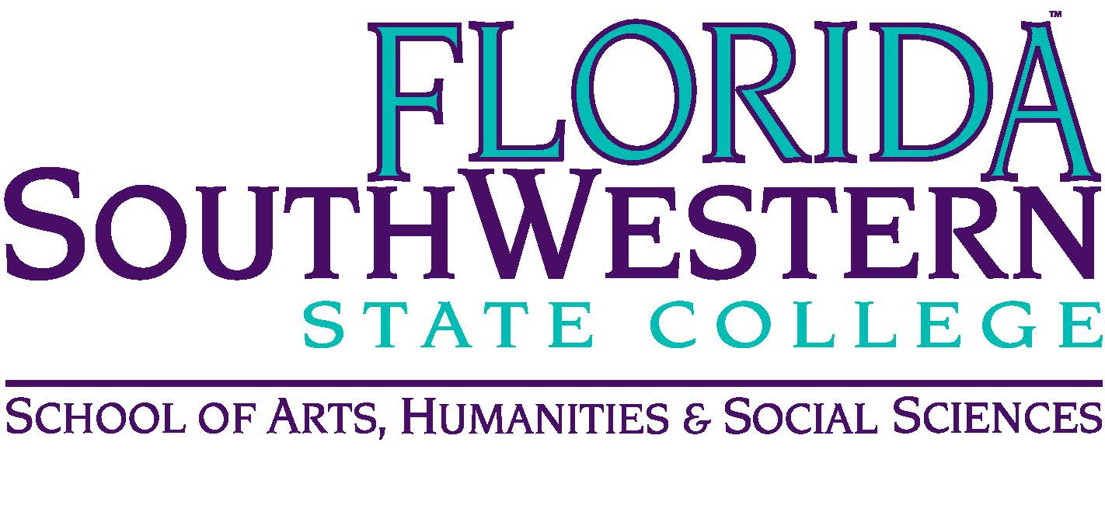
Department of Humanities and Fine Arts
Meeting Minutes
Date: November 12, 2021 – 10:00 a.m.
Location: Virtual/Online (Zoom)
Chair: Dana Roes
Minutes: Michael McGowan

 | Present | Absent | Excused
Brown | X
Chase, S | X
Chase, W | X
Doiron | X
Hoover |  |  | X
Lublink | X
McGowan | X
Mompoint | X
Pritchett | X
Roes | X
Sutter |  | X
Luther |  | X
Smith | X
Molloy | X
Krupinski | X
Wurst | X
Harrington | X
Chowdhury | X
Gresens | X
Guests | Kenneth Puls

- Opening
  - Call to Order: 10:00 a.m.
  - Attendance taken
  - Minutes from October 2021 approved
- Announcements:
  - Theater: go see the play
  - Music: go hear the music
  - Assessment: talk to Elijah if you’re interested in helping grade assessments in the spring (according to rubrics). Also see Shimul’s presentation in the research expo.
  - PD: new funds for non-travel related expenses (books, membership fees). See here for the application: https://forms.gle/A9JY3fJiBnyDaniK6.

- Information Items:
  - Climate Survey: make sure you do it by today (11/12/21).
  - Need representatives for Curriculum Committee and Faculty Senate (Mary Myers has been representing us for years). Elijah will communicate to Faculty Senate.

- Discussion Item: “The New Puritans” by Anne Applebaum in The Atlantic

- Next Meeting:
  - 12/10/21 at 10:00 a.m.
  - Zoom link: https://fsw.zoom.us/j/95723378548

