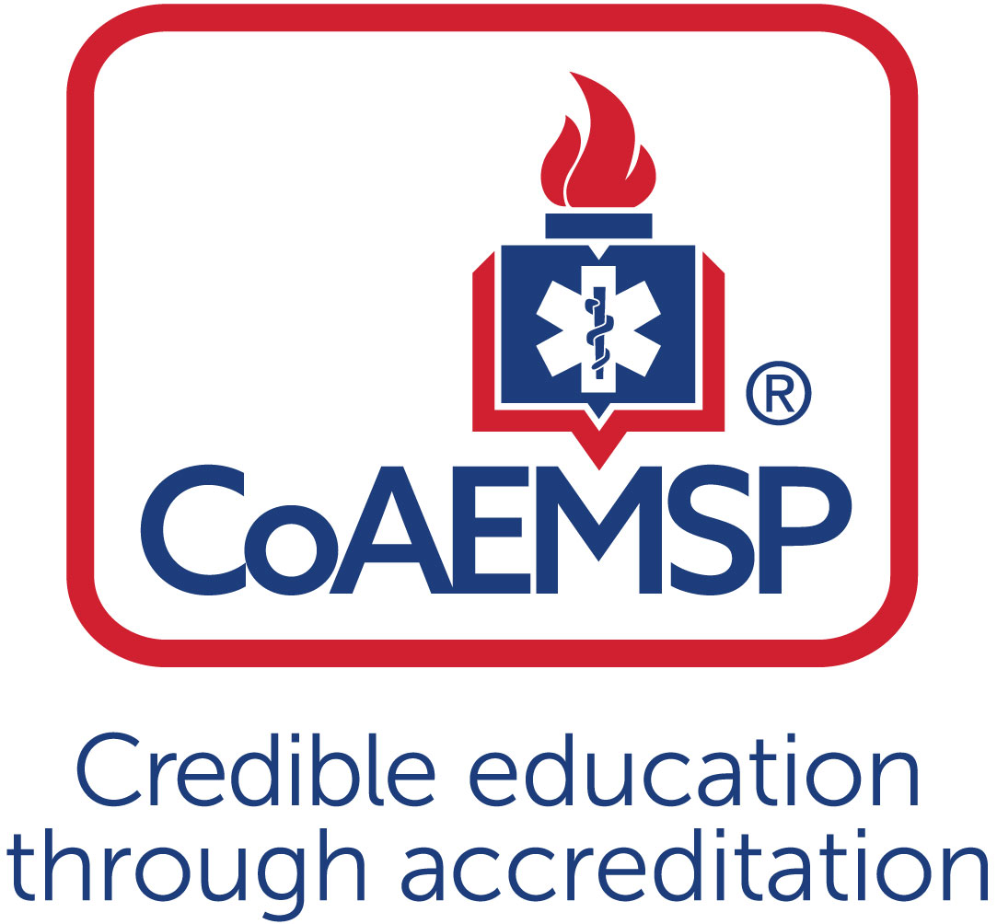
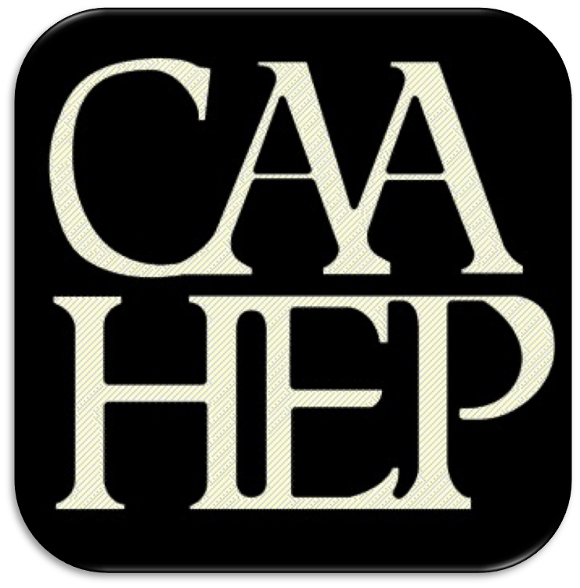

Advisory Committee Meeting Minutes

See last page for the purpose of the program’s Advisory Committee, including a description and list of responsibilities.

SPONSOR / INSTITUTION NAME: | Florida SouthWestern State College
CoAEMSP PROGRAM NUMBER: | 600034 | DATE, TIME, + LOCATION OF MEETING: | October 15,2019
CHAIR OF THE ADVISORY COMMITTEE: | Chief Dan Seiber

ATTENDANCE

Community of Interest | Name(s) – List all members. Multiple members may be listed in the same category. | Present – Place an ‘x’ for each person present | Agency/Organization
Physician(s) (may be fulfilled by Medical Director) | Dr. Alex Rodi, DO | x
Employer(s) of Graduates Representative | Ben Abes  Anthony Demos  Noemi Fraguela  Ryan Lamb  Joe Maguire  Gerard Mallet  Michael Marcus  Nathan McManus  Lance Pullen  Curtis Rine  Daniel Sieber  Bill VanHelden  Arthur Wolf | X  x | Acting Director, EMS Chief  Cape Coral Fire Department  Training Captain, Collier County EMS  Cape Coral Fire, Chief of Professional Standards  Lee County Emergency Medical Services  Charlotte County Fire/EMS, Director of Emergency Management  Lee Health, Trauma  Charlotte County Fire/EMS, EMS Training Captain  Fort Myers Fire, Division Chief of Training  Charlotte County, Captain of Fire Training  San Carlos Park Fire District  Charlotte County Public Safety Director  Collier County EMS
Key Governmental Official(s) | Dan Summers | x | Director, Emergency Management Services, Collier
Police and Fire Services | Anthony Demos |  | Cape Coral Fire Division
Public Member(s) | Tom Brennan  James Connelly |  | Retired EMS/Fire Chief  Community Member/Prior Student
Hospital / Clinical Representative(s) | Theresa Foley |  | Lee Health
Other
Faculty | Linda Welch  Mike Knoop  Tracy House  Tamara Mole  Matthew Stachler  Stewart Shrader  Tresa Hibben  Rima Stevens  Kari Duckworth  Roy Brown |  | EMS Support Specialist – EMS/FIRE Programs, FSW  EMS Support Specialist – EMS/FIRE Programs, FSW  EMS Support Specialist – EMS/FIRE Programs, FSW  EMS Support Specialist-EMS/Fire Programs, FSW  Clinical Coordinator-FSW  Pharmacology Adjunct Professor-FSW  Clinical Coordinator-FSW  Clinical Coordinator-FSW  Pharmacology Adjunct Professor-FSW  Clinical Coordinator-FSW
Sponsor Administration² | n/a | n/a | n/a
Student (current) | Alicia Keen | x | Paramedic Student FSW
Graduate | Rebecca Greene |  | Paramedic Graduate 2013
Program Director, ex officio, non-voting member | Joe Washburn | x
Medical Director, ex officio, non-voting member | Dr. Alex Rodi | x

Agenda Item |  | Discussion | Action Required | Lead | Goal Date
 | Call to order | Chief Dan Seiber | Yes / No | Sieber
 | Roll call | Everyone welcome, Introductions around the room of everyone and agency/or organization they are from. | Yes / No | Sieber
 | Review and approval of meeting minutes | Review Minutes from April. Edit moving forward, Gerald Mallet has retired his replacement is Patrick Fuller. Nathan McManus agency correction Lee county Trauma Service. Motion to Approve Minutes. Granted. | Yes / No | Sieber
 | Endorse the Program’s minimum expectation  [CAAHEP Standard II.C. Minimum Expectation]  - “To prepare competent entry-level Paramedics in the cognitive (knowledge), psychomotor (skills), and affective (behavior) learning domains with or without exit points at the Advanced Emergency Medical Technician and/or Emergency Medical Technician, and/or Emergency Medical Responder levels.”  - Establish / review additional program goals | Chief Dan Sieber calls motion to endorse program minimums : “To prepare competent entry-level Paramedics in the cognitive (knowledge), psychomotor (skills), and affective (behavior) learning domains with or without exit points at the Advanced Emergency Medical Technician and/or Emergency Medical Technician, and/or Emergency Medical Responder levels.”  Motion Approved and 100% I’s. | Yes / No | Sieber
 | Endorse the Program’s required minimum numbers of patient/skill contacts for each of the required patients and conditions  [CAAHEP Standard III.C.2. Curriculum]  - NEW Appendix G: Student Minimum Competency Matrix (effective July 1, 2019)  - Review summary graduate tracking reports | Joe: If you can look at the two page form in the packet, last meeting we spoke about how the accreditation body made recommendations to contacts live with live patients the students need to see either in the in clinic, field or capstone setting. We agreed to keep it to those minimums till we have the opportunity to run them multiple times. The next column is the lab totals. These are the scenarios that they are going to be in change of. Example: lab setting at least 8 lab scenarios. Medical form is 34 scenarios. When we look at those we have broken them down into summative and formative. Summative is when they are doing the scenario from start to finish. Formative is picking up the scenario when they are one scene already and ending with treatment. Summative is 20 min, formative could be less depending on the scenario. They will do the summative as the lead but still be paired up in teams. National Registry has multiple skill sheets that the students are to be proficient at. Like Obtain a patient history is a four-page document. We are asking them to practice with fellow students and once they are successful 2 times then come do it with an instructor. So these numbers are based on success. They have to do these skills this many times.  Sieber: Any questions?  Mcmillion: When it comes to skills peer to peer, if they do 5 let’s say of oral intubation and then start to regress do they remain at 5.  Washburn: Yes, it would stay at 5 till they can succeed at it again. What we learned about the skill with the out going cohort is we tried to do them during class and it was taking away from scenarios. We talked about this last meeting is we created a lab in the beginning and took way the last lab that was during the capstone. We are doing nothing but skills is this first lab.  Sieber: Motion to approve lab numbers.  Art: Motion  Mcmillion: Second  All in favor.  Sieber: Last meeting we adjusted some minimums for clinic times and contact to follow recommended guidelines from CoAemps. We are going to talk about some of the challenges and solutions.  Washburn: Areas of concern are peds trauma. We have had an average of about 8 so our highest #18 is 3 the minimum is 6. Another is toxicology/overdose. Highest is #17 average is #7 we still have some that have seen more. I’m looking for the committee to endorse a change in curriculum to extend clinical rotation to 2 terms spring and summer 27 weeks instead of 12 weeks for just summer. We want to give them more opportunity to see these patients. We are not increasing the time.  Stevens: We got some feedback from the students. We had them with the nurses in the ICU and PCU one on one. They said they are not getting a lot with practice. We are having them have more time in the ER and a more focused assessment. I’m working on getting some PA’s during today to pair up with them in the ER. Peds and O/B is also another area we are having problems with. We are trying to target that we are going to give them an extra peds day. Also a total of 3 days of psych rotation.  Sieber: Need an endorsement for the change in term. Any questions?  Motion/ Second.  Stinett: Yes I think it would be a great change for the future.  Approve lab numbers.  Tracking includes lab, clinical and field internship experiences and is completed via an electronic tracking FISDAP. Tough books are now up and working in lab. Faculty review student  documentation throughout the didactic and lab phases and throughout  the clinical and capstone field internship phases and provide feedback  as needed on progression of completing the competencies in the  portfolio.  One challenge is to have students continue to  document encounters after they have met the minimums. | Yes / No | Joe
 | Review the program’s annual report and outcomes  [CAAHEP Standard IV.B. Outcomes]  - Annual Report data  - Thresholds/Outcome data results  - Graduate Survey results  - Employer Survey results  - Resources Assessment Matrix results  - Other | Sieber: 17-18 Annual report any questions?  Washburn: CoAemps made change. Now we are able to report in the arrears. Are numbers are done its from the graduating group of 2018. We did well with attrition and NREMT results are 93% pass rate. Problem areas are Graduate survey and job placement. We only got back 14 of the Graduate surveys. We are working on getting a hold of them again this month. If we could send you guys a list of our graduates if they are not responding. You can then let us know if any are working for you then fill out the employment surveys. I think the only solution is to call and email more frequently.  Mcmillion: Is there any kind of correlation to job placement to how many times they take the test/NREMT exam? And is there any correlation to how many times they take the test to how long they stay at a job?  Washburn: We have never looked at that statistic. If you think it would be beneficial we can. We have to look at data for the college accreditation as well.  Sieber: I would just caution because the DOE only last year was able to say that they are reporting 1st/2nd pass rates.  Washburn: I would agree but our stats come from the NREMT website. They are on point and yes the states would tell us something different.  Wolf: Doesn’t the national registry track where students are employed?  Washburn: Not to my knowledge  Wolf: I know the state does.  Washburn: I could call them and ask. I cant see anything in my login portal.  Everyone who has gone through a recert has to report.  Washburn: We have a very narrow window to gather this information. But I will defiantly look into and see if it will help at least to say where they are working.  Wolf: From the MQA it will tell you who they are working for.  Washburn: I don’t think I have ever seen it.  Mcmanus: Looking at the attrition was there a certain area they were having trouble with?  Washburn: Due to grades when we looked at that number it was because of A/P 1 and 2. Maybe a couple from the Pharm class.  Mcmanus: Did they reapply?  Washburn: I don’t have any that cam back that was because of A/P. I had 3 that failed later on in the semester and they came back.  Sieber: We want to speak about some other data issues.  Washburn: To recap last meeting we talked about doing a selective process for medics to cut down on attrition. The last couple cohorts have been around 78 with a graduates at 42-44 then 72 with 40 graduates the current cohort had 60 and is down to 26. Maybe we were letting people in that weren’t sure what they were up against. We gave them all an exam first. We had around 56 applicants. We tested them on Anatomy and physiology, math, EMT skills and reading comprehension. We gave them a composite score then add them all up and got an average. We had about 35 students that we interviewed. We looked at if the student was dressed for an interview professionally. Some of the questions asked were why did they want to me a paramedic? We graded them on a liker scale from 0 to 3. Do they have any knowledge of the profession? Do you work for an agency and do you realize that this class will run on the B shift? How much time did they think it would take them outside of class? We got a very large range of answers. How are they preparing for all the work needed to successfully complete these courses? We then debated between myself, Dr. Rodi and Matt Stachler which candidates would be best. We had 24 students that we invited them to enroll in the course. So far we did have 2 withdrawal due to personal reasons. One was a family illness and the other a death in the family. They both admitted it was taking them away from class. I believe we have a very strong cohort this time.  Krause: Did you think about when you were pretesting to add a practical portion or scenarios?  Washburn: This was our first time doing it. I think that we are not opposed to it. What will be interesting is to see how this new cohort goes through the skills then we can see if we need to add them to the interviews.  Dr. Rodi: I think our goal is to get the best student who is most prepared. You just can’t open it to everyone because you lose almost 50% of your students. Medical schools don’t just let everyone in. We are not opposed to any mechanism.  Washburn: I think it will have a positive impact. Talking about clinicals and patient contacts we got some feedback from the current out going cohort. We are doing well with scheduling the clinicals they had a lot of patient contacts. They had plenty of IV practice. In the past we have had remarks that they don’t get enough practice. We have gotten a lot of supplies now. We are purchasing items from china to make it more affordable. We also got medication vials and have labels that look like the real labels on meds. They draw up tap water and push them. We have tried to make is as real as possible. We just got a donation from Collier county Ems. They will be donating another ambulance. So we will be able to put an ambulance at each campus. That will also help with the Medics when we do our MCI events here at the LEE campus. When we do those events we would like people from your agencies to help if possible.  Sieber: Lets review some program changes.  Washburn: Our biggest challenges has been if I was being trained by one person then go to another person and they would do it another way There is no consistence in the lab. We developed an FSW protocol guide. We looked at all of your protocols and what was interesting was they where written for people who are already medics. Dr. Rodi said isn’t there a national one that covers everything. And there is a step by step guide. We took it and created a 365 page book with pharm at the end. The students have more pharm them all your crews carry because we wanted them to have everything.  Dr. Rodi: It’s a work in progress to some degree.  Review 17-18 Annual report date.  Attrition is still a problem: We had 6 drops for unknown reasons, 1 drop due to getting a job, and 7 fail a class along the way. That’s a total of 14 from the original 54.  National Registry exam results updated. 65% first pass, 93% cumulative pass within 3 attempts.  We are not getting responses back from graduate or employer surveys. See annual report data. So our Job placement numbers are low. Which creates a problem with the annual report and opens up more questions because we are below the threshold. Possibility: Distribute paper surveys to employers at the Advisory Committee meetings and explain that employers can evaluate multiple graduates on one survey if all ratings are the same.?? | Yes / No
 | Review the program’s other assessment results  [CAAHEP Standard III.D. Resource Assessment]  - Long-range planning  - Student evaluations of instruction and program  - Faculty evaluations of program  - Course/Program final evaluations  - Other evaluation methods | With the current cohort (19-2020) that just started we did a new entrance procedure, with an entrance exam and interview process. Joe see: Assessment scores with the interview questions and spreadsheet with all of the data.  Students complete evaluations on faculty each month when in the  didactic session.  Course Evals= Matt =EMS 2602L. 18-19 cohort  Complaints: CA’s talking down to students, attitudes towards the students negative, favoritism, each CA has a different way of doing things not in line with NREMT Standards more along the lines of where they work. Schedule kept changing at last min. Not an organized class.  Positive: Provided many resources. Help was available if needed, lots of scenarios, and plenty of cardiology prep.  Course Evals_ Rima EMS 2646 Clinical experience 18-19 cohort  Complaints: wanted more ED/ER time, spent a lot of time on ICU floor, and other floors was not helpful. Slow in summer. Preceptor problems: they did not want our help, didn’t know we where coming, no help getting the patients we needed.  Positives: Scheduled very well, lots of patient contact experience in field time, well organized, lots of IV practice, instructor Stevens always checking in made things go smooth.  Budget: We got 2 more ambulances, 4 new mannequins (Gamaurd) , buying things from china, making the hands. | Yes / No
 | Review program changes (possible changes)  - Course changes  (schedule, organization, staffing, other)  - Preceptor changes  - Clinical and field affiliation changes  - Curriculum changes  - Content  - Sequencing | Implemented new Paramedic protocol book.  Changing clinicals to run as a D term starting in Spring 2019 running through the summer.  Pharmacology got a new book to teach with so the curriculum has changed and we are making tweaks as we go.  This is the last semester we are running the lab 2677 in the final semester and have a new lab 2600 at the beginning going over skills. That started with the newest cohort.  Adding Park Royal to clinical affiliations for Psych hospital | Yes / No
 | Review substantive changes (possible changes)  [CAAHEP Standard V.E. Substantive Change]  - Program status  - Program personnel: PD, Lead Instructor, other  - Addition of distance education component  - Addition of satellite program | n/a | Yes / No
 | Other identified strengths | Adding another staff member to help with CoAmps. Not having the lab at the end of the program. | Yes / No
 | Other identified weaknesses | Attrition remains a concern and as mentioned previously, the EMS program is initiating a screening process all so mentioned above. | Yes / No
 | Identify action plans for improvement | Implement a screening process and provide more detailed information  on the expectations and rigors of the program to prospective students.  Work with students on success strategies as they enter the program. | Yes / No
 | Other comments/recommendations | Ask anyone on board if they have recommendations. | Yes / No
 | Staff/professional education | CoAemps January 2020 seminar Tammy will be going to that. Accredicon last year was attended by Mr. Washburn.  Webinars put on by fisdap and CoAemps as well as the college puts on education seminars every quarter for us to attend. | Yes / No
 | CoAEMSP/CAAHEP updates | None. | Yes / No
 | Next accreditation process  (i.e., self-study report, site visit, progress report) | Annual Report is Due March 2020 for the 17-18 Cohort  Self-study report is due May 2020, then the site visit is happening sometimes towards the end of 2020. During the site visit they will be interviewing people from this committee. | Yes / No
 | Other business |  | Yes / No
 | Next meeting(s) | 4/2020 | Yes / No
 | Adjourn |  | Yes / No

Minutes prepared by Date
Minutes approved by Date
If item #5 above was acted on, then:
Medical Director’s signature Date
Attach Appendix G > Table 1 to verify which required minimum numbers were reviewed and endorsed (if item #4 above was acted on)

PURPOSE OF THE ADVISORY COMMITTEE
The Advisory Committee must be designated and charged with the responsibility of meeting at least annually to assist program and sponsor personnel in formulating and periodically revising appropriate goals and learning domains, monitoring needs and expectations, and ensuring program responsiveness to change, and to review and endorse the program required minimum numbers of patient contacts. [CAAHEP Standard II.B. Appropriate of Goals and Learning Domains]

Additionally, program-specific statements of goals and learning domains provide the basis for program planning, implementation, and evaluation. Such goals and learning domains must be compatible with the mission of the sponsoring institution(s), the expectations of the communities of interest, and nationally accepted standards of roles and functions. Goals and learning domains are based upon the substantiated needs of health care providers and employers, and the educational needs of the students served by the educational program. [CAAHEP Standard II.A.]

Responsibilities of the Advisory Committee
- Review and endorse the minimum program goal.
- Review and endorse the required minimum numbers of patient/skill contacts for each of the required patients and conditions.
- Verify that the Paramedic program is adhering to the National Emergency Medical Services Education Standards.
- Review Program performance based on outcomes thresholds and other metrics (at a minimum credentialing success, retention, and job placement).
- Provide feedback to the Program on the performance of graduates as competent entry level Paramedics (for employers).
- Provide feedback to the Program regarding clinical and field opportunities and feedback on students in those areas.
- Provide recommendations for curricula enhancements based on local needs and scope of practice.
- Assist with long range planning regarding workforce needs, scheduling options, cohort size, and other future needs.
- Complete an annual resource assessment of the program.

The best practice is that the chair is not the Program Director. The Advisory Committee is advising the program.
Additional faculty and administration are ex-officio members.
Add rows for multiple members of the same community of interest If the program has additional named communities of interest, list the community of interest and the name(s) that represent each.
Additional program goals are not required by the CAAHEP Standards. If additional program goals are established, then the program must measure them.

