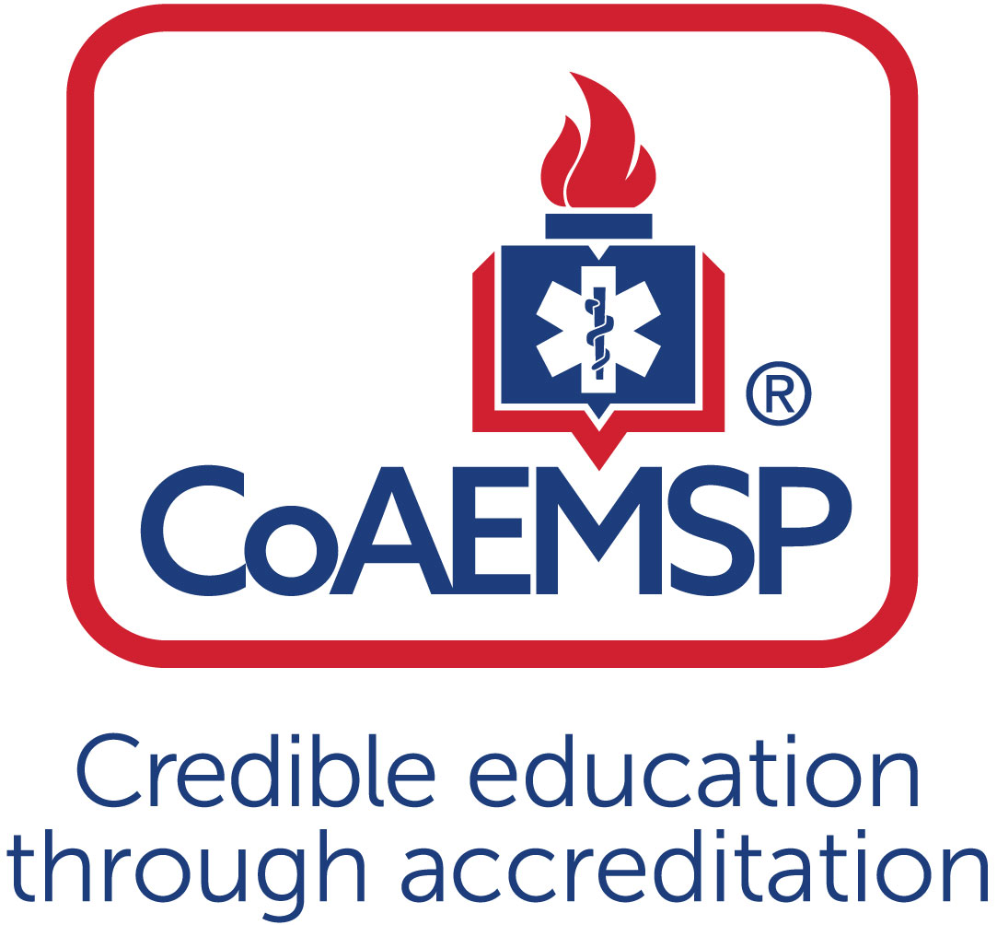
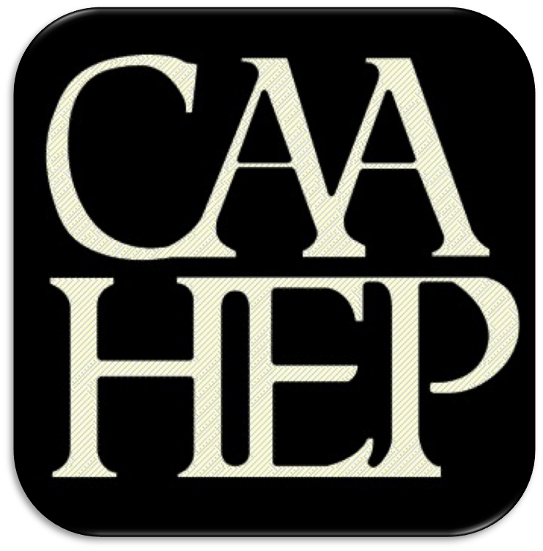

Advisory Committee Meeting Minutes

See last page for the purpose of the program’s Advisory Committee, including a description and list of responsibilities.

SPONSOR / INSTITUTION NAME: | Florida SouthWestern State College
CoAEMSP PROGRAM NUMBER: | 600034 | DATE, TIME, + LOCATION OF MEETING: | May 26, 2020
CHAIR OF THE ADVISORY COMMITTEE: | Chief Dan Seiber

ATTENDANCE

Community of Interest | Name(s) – List all members. Multiple members may be listed in the same category. | Present – Place an ‘x’ for each person present | Agency/Organization
Physician(s) (may be fulfilled by Medical Director) | Dr. Alex Rodi, DO | x
Employer(s) of Graduates Representative | Ben Abes  Anthony Demos  Noemi Fraguela  Ryan Lamb  Joe Maguire  Gerard Mallet  Michael Marcus  Nathan McManus  Lance Pullen  Curtis Rine  Daniel Sieber  Bill VanHelden  Arthur Wolf | x | Acting Director, EMS Chief  Cape Coral Fire Department  Training Captain, Collier County EMS  Cape Coral Fire, Chief of Professional Standards  Lee County Emergency Medical Services  Charlotte County Fire/EMS, Director of Emergency Management  Lee Health, Trauma  Charlotte County Fire/EMS, EMS Training Captain  Fort Myers Fire, Division Chief of Training  Charlotte County, Captain of Fire Training  San Carlos Park Fire District  Charlotte County Public Safety Director  Collier County EMS
Key Governmental Official(s) | Dan Summers |  | Director, Emergency Management Services, Collier
Police and Fire Services | Anthony Demos |  | Cape Coral Fire Division
Public Member(s) | Tom Brennan  James Connelly |  | Retired EMS/Fire Chief  Community Member/Prior Student
Hospital / Clinical Representative(s) | Theresa Foley | x | Lee Health
Other
Faculty | Linda Welch  Mike Knoop  Tracy House  Tamara Mole  Matthew Stachler  Stewart Shrader  Tresa Hibben  Rima Stevens  Kari Duckworth  Roy Brown | X  X  X  X  x | EMS Support Specialist – EMS/FIRE Programs, FSW  EMS Support Specialist – EMS/FIRE Programs, FSW  EMS Support Specialist – EMS/FIRE Programs, FSW  EMS Support Specialist-EMS/Fire Programs, FSW  Clinical Coordinator-FSW  Pharmacology Adjunct Professor-FSW  Clinical Coordinator-FSW  Clinical Coordinator-FSW  Pharmacology Adjunct Professor-FSW  Clinical Coordinator-FSW
Sponsor Administration² | n/a | n/a | n/a
Student (current) | Alicia Keen | x | Paramedic Student FSW
Graduate | Jared Sullivan | x | Paramedic Graduate
Program Director, ex officio, non-voting member | Joe Washburn | x
Medical Director, ex officio, non-voting member | Dr. Alex Rodi | x
 | Lisa Sofallow | x | Bayfront Health

Agenda Item |  | Discussion | Action Required | Lead | Goal Date
 | Call to order | Joseph Washburn | Yes / No | Washburn
 | Roll call | Welcome please sign into zoom chat that will be our roll call and record of who was here. | Yes / No | Washburn
 | Review and approval of meeting minutes | Review Minutes from October 2019. We talked about areas of the G report. We also spoke about our clinical settings. We spoke about attrition being an issue. We are going to hold off on approve these minutes will Dan Sieber can call a roll call. | Yes / No | Washburn
 | Endorse the Program’s minimum expectation  [CAAHEP Standard II.C. Minimum Expectation]  - “To prepare competent entry-level Paramedics in the cognitive (knowledge), psychomotor (skills), and affective (behavior) learning domains with or without exit points at the Advanced Emergency Medical Technician and/or Emergency Medical Technician, and/or Emergency Medical Responder levels.”  - Establish / review additional program goals | Washburn: calls motion to endorse program minimums : “To prepare competent entry-level Paramedics in the cognitive (knowledge), psychomotor (skills), and affective (behavior) learning domains with or without exit points at the Advanced Emergency Medical Technician and/or Emergency Medical Technician, and/or Emergency Medical Responder levels.”  Motion Approved and 100% I’s. | Yes / No | Washburn
 | Endorse the Program’s required minimum numbers of patient/skill contacts for each of the required patients and conditions  [CAAHEP Standard III.C.2. Curriculum]  - NEW Appendix G: Student Minimum Competency Matrix (effective July 1, 2019)  - Review summary graduate tracking reports | Washburn: Last meeting we talked about COAemps having a minimum of patient contacts and skills. Etc. (sharing screen of the new appendix G report in FISDAP) We said we wanted to us the same numbers that COAmps has set out for our first cohort till be have a baseline. We are still at that point now. I think we will have to run 2 or 3 cohorts threw to get a good idea of where we can increase numbers accordingly. (pulling up the G report for one of our current students and sharing screen). When the boxes turn green that means we have met the minimums. We were very lucky to be able to be involved with GIVE a Child a Smile Day to help us with our peds numbers. We partnered with the Dental. We were giving them kind of a health and wellness exam.  Rima: We also added a day in the spring for Peds rotation.  Washburn: I think we should be able to meet the peds section no problem but I was concerned before. And once we have a few cohorts go threw with these numbers we can figure out what are the realistic numbers for our program. As you can see the first column is skills which we did in there first semester. We are still learning about this report and how to enter the information and where it should be populating in the G report. | Yes / No | Washburn
 | Review the program’s annual report and outcomes  [CAAHEP Standard IV.B. Outcomes]  - Annual Report data  - Thresholds/Outcome data results  - Graduate Survey results  - Employer Survey results  - Resources Assessment Matrix results  - Other | Washburn: ( sharing screen of our 2018 annual report). It’s a little misleading, its almost a a year and half in the past. They did this so that we can gather all the data especially the employer and graduate surveys which don’t go out till 6 months after. We graduated 40, we met the retention/attrition threshold. National Registry 40 students took it, 37 passed within 3 attempts. That is a 92.5% pass rate. We would like to have the first attempt number go up it was 26. And the 3rd attempt go down. I think with the changes that we have implemented we will see that start to happen. Job placement it was a 29 positive placed. So a 72.5%. This number going forward will depend on what the economy does and if the agencies go on a hiring freeze etc. Graduate surveys we had 13 respond and it is always difficult to get any feedback once they are gone. But the response that we did get back we have to do an analysis and create an action plan. Overall they were really good. We need to make sure that we get these surveys out. We have come up with a plan to capture emails and phone numbers. Also we have a much smaller cohort size now so it will be easier to get them all. Our action plan was and is what we did, reduced the size of our cohort. Employer surveys we suffer in getting them back. We had 6 returns 4 of them said the students didn’t need any prompting. 2 said there was some cognitive marginal and that they wait for instructions. Comments where all very positive. I am hoping that the advisory board can help us get these survey’s back to us. Ram results showed that we were deficient in two areas. One of them is a repeated one which is physician interaction. That is outside of Dr. Rodi. It is the other ER physician interaction. We are now with the current cohort having them also be around an ER physician that Dr. Rodi recommended and a PA. We are trying to increase their exposure, but I cant predict how often if at all they will on the truck see or speak with a physician.  The second area was Financial resources, this is the first time we have seen this one come up. We were a little confused because we have our own academic advisors for our program as well as the college having a very robust financial aid department. I think we should just watch it.  Tammy: It did not pop up on the most rest ram surveys.  Washburn: So yes I think it was an anomaly.  Stachler: Do you have any data from other schools that we can compare ourselves to in regards to the financial aid? Because I feel like we do pretty well with getting students the money they need.  Washburn: I am not sure and I don’t know if anyone does a comparison. Matt I would like you to share with the group this last group that just graduated the accolades that you received.  Matt: I just received a phone call last week from an instructor for the National Registry. He told me he ran one of our students threw testing and the student was by far one of the best students he has every seen take the National Registry. He wanted to reach out to us and let us know that the program must be doing an amazing job. He was from Georgia.  Washburn: Also we have had discussions with the agency’s locally they are all pleased with the entry level students we are graduating from our program.  Matt S: I am still in contact with individuals at the agency I used to work for and they have been telling me that the students from our program are ready to credential almost right away. Also Collier EMS has gotten a few of our students and they have said they have made quite an impact down there.  Washburn: Do you know who? Art is here.  Matt: Jessica Huckaby.  Wolf: Yes, I can verify that. She has. | Yes / No
 | Review the program’s other assessment results  [CAAHEP Standard III.D. Resource Assessment]  - Long-range planning  - Student evaluations of instruction and program  - Faculty evaluations of program  - Course/Program final evaluations  - Other evaluation methods | Washburn: Lets talk about Covid. As soon as the stay at home order was put in place we tried to figure out the best course of action. We stopped the Medics Lab time. At that time the state did not give any direction. But we knew how important it was to do face to face training. We also pulled the Medics from the hospital about a week before the hospitals kicked everyone out. Last meeting, we spoke about expanding the clinical time over two semester which we did. Now we are waiting for the hospitals to open back up to students so they can finish their clinical hours. We did finish their didactic portion. Through zoom. May 18th they allowed us EMS back on campus under strict guidelines. So we will be finishing up there lab section over summer. There summer classes have been pushed to start in the Fall 2020. Then capstone/ride will begin in January 2021. Since then the state has come out with standing orders till at least October to allow programs to simulate at least 50% for both clinical and field time. Our position is that we don’t want to have to exercise that yet. One of the reasons is that we don’t know what it would look like? If you tell me you just are giving them a scenario in the lab then you are really actually extending lab time. We can definitely simulate their ride time we have multiple ambulances. If we do have to do this because this continues we can use the sim lab over in the nursing area. It will take planning and resources for to do that.  Lisa: We are hoping to be able to let students back in the Fall Semester. But no guarantees. | Yes / No
 | Review program changes (possible changes)  - Course changes  (schedule, organization, staffing, other)  - Preceptor changes  - Clinical and field affiliation changes  - Curriculum changes  - Content  - Sequencing | Washburn: The input we have received from the new cohort has overall been good with the changes we made. The initial lab that they have now in the beginning we where going to do a couple testing days, what we found was we were over zealous. We tested them on all there skills we just don’t test them in large groups. We start testing them after a few labs on the things they learned. Matt what have you been seeing?  Matt: When I get them in the spring they would come in as EMTs and not have done a lot of the medic skills. It’s very difficult to get going. It has helped tremendously we can start doing scenarios much sooner.  Washburn: Rima can you let us know what you had emailed me about in terms of clinicals.  Rima: Well we have extend the clinical hrs. till from Jan to Aug. With the lab being added in the beginning it has helped to prepare them more for clinicals. We did add Psych rotation. But with COVID we did not get into before shut down. Park Royal was very excited to have there first Medic group. The only part we are having some challenges is the OR. Cape coral is the only one that does a lot of ET intubations. Lisa is that something that maybe we can work with Bayfront on getting some medics into your OR?  Lisa: I can talk our surgical services directors. I thought we always did have your medics rotating?  Rima: No, I have been in contact with Kathleen Boyd in the past and nothing came of it.  Lisa: I will see what I can do for you.  Washburn: We did lose two students out of this cohort. They wanted to get there certificates faster then what we where offering. They went to a different school. We have only lost one for academic reasons.  Matt: We would really like to have our graduates to come back and be CA’s if possible. We would really like to have them because they know what we expect. They have to have 3 years worth of paramedic work to be a CA. But we are going to start reaching out to them.  Dr.Rodi: The students that I had in the ER did a good job with what they tried to expose them to and I let them do some hands on things. A few watched me do an LP. We had them during the time of year when our census wasn’t very high. Now its even worse. They cut all our hours. Biggest issue right now is PPE. We are seeing now more walking COVID patients. And we are not allowing any visitors. The students all liked Dr. Guthery. She loves to teach.  Rima: I think the variety of schedules between Dr.Rodi and Dr. Guthery and the PA Bess has given the students a lot more options. We are able to get them in quicker that way.  Dr.Rodi: Bess is a great teach, she has great clinical experience having done surgery and medicine and ER and OB. | Yes / No
 | Review substantive changes (possible changes)  [CAAHEP Standard V.E. Substantive Change]  - Program status  - Program personnel: PD, Lead Instructor, other  - Addition of distance education component  - Addition of satellite program | n/a | Yes / No
 | Other identified strengths | Of Advisory Board being able to have meetings like this aka zoom. | Yes / No
 | Other identified weaknesses | We are not getting the OR rotations for ET intubations. | Yes / No
 | Identify action plans for improvement | We want to wait to move forward with simulation just yet. | Yes / No
 | Other comments/recommendations | Ask anyone on board if they have recommendations. | Yes / No
 | Staff/professional education |  | Yes / No
 | CoAEMSP/CAAHEP updates | The changes made on the annual report in regards to attrition and retention. If a student drops with in the first quarter we do not have to count them. A lot of new paperwork for COVID but it does not apply to us just yet. | Yes / No
 | Next accreditation process  (i.e., self-study report, site visit, progress report) | We were supposed to have our site visit the end of this year. For right now everything is cancelled until further notice. | Yes / No
 | Other business | We are in the process now of choosing the students for our next cohort. They will be on C shift. We will just rotate every year. We have 28 applicants for 24 slots which is far less then what we have had in the past. We usually have 50 to 55. We think part of it is COVID. | Yes / No
 | Next meeting(s) | 4/2021 | Yes / No
 | Adjourn | Thank you everyone! | Yes / No

Minutes prepared by Date
Minutes approved by Date
If item #5 above was acted on, then:
Medical Director’s signature Date
Attach Appendix G > Table 1 to verify which required minimum numbers were reviewed and endorsed (if item #4 above was acted on)

PURPOSE OF THE ADVISORY COMMITTEE
The Advisory Committee must be designated and charged with the responsibility of meeting at least annually to assist program and sponsor personnel in formulating and periodically revising appropriate goals and learning domains, monitoring needs and expectations, and ensuring program responsiveness to change, and to review and endorse the program required minimum numbers of patient contacts. [CAAHEP Standard II.B. Appropriate of Goals and Learning Domains]

Additionally, program-specific statements of goals and learning domains provide the basis for program planning, implementation, and evaluation. Such goals and learning domains must be compatible with the mission of the sponsoring institution(s), the expectations of the communities of interest, and nationally accepted standards of roles and functions. Goals and learning domains are based upon the substantiated needs of health care providers and employers, and the educational needs of the students served by the educational program. [CAAHEP Standard II.A.]

Responsibilities of the Advisory Committee
- Review and endorse the minimum program goal.
- Review and endorse the required minimum numbers of patient/skill contacts for each of the required patients and conditions.
- Verify that the Paramedic program is adhering to the National Emergency Medical Services Education Standards.
- Review Program performance based on outcomes thresholds and other metrics (at a minimum credentialing success, retention, and job placement).
- Provide feedback to the Program on the performance of graduates as competent entry level Paramedics (for employers).
- Provide feedback to the Program regarding clinical and field opportunities and feedback on students in those areas.
- Provide recommendations for curricula enhancements based on local needs and scope of practice.
- Assist with long range planning regarding workforce needs, scheduling options, cohort size, and other future needs.
- Complete an annual resource assessment of the program.

The best practice is that the chair is not the Program Director. The Advisory Committee is advising the program.
Additional faculty and administration are ex-officio members.
Add rows for multiple members of the same community of interest If the program has additional named communities of interest, list the community of interest and the name(s) that represent each.
Additional program goals are not required by the CAAHEP Standards. If additional program goals are established, then the program must measure them.

