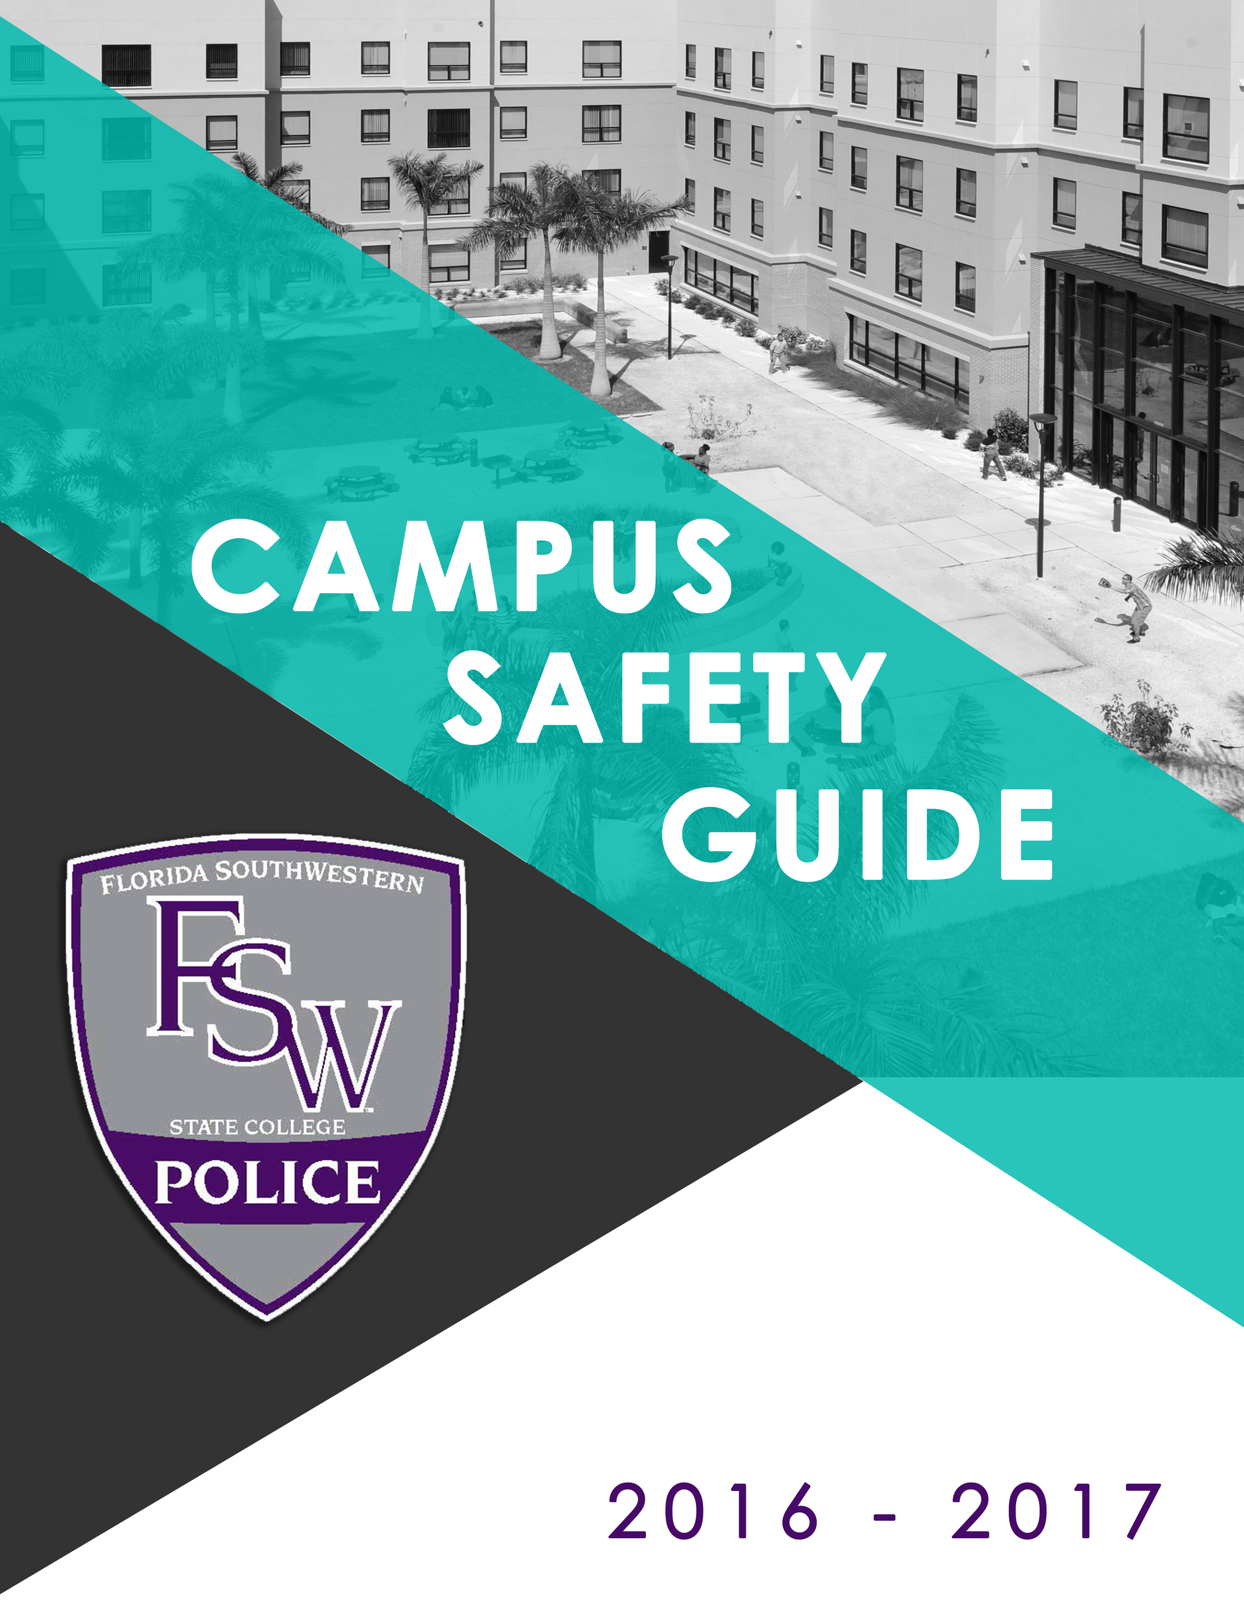
2017 - 2018
CONTENTS

MESSAGE FROM FLORIDA SOUTHWESTERN STATE COLLEGE CAPTAIN OF PUBLIC SAFETY. 3
THE COLLEGE DEPARTMENT OF PUBLIC SAFETY 4
ACCESS TO COLLEGE FACILITIES AND PROPERTY 5
SECURITY CONSIDERATIONS IN THE MAINTENANCE OF CAMPUS FACILITIES 5
KEY AND ACCESS CONTROL CARD CONTROL 5
STUDENT OF CONCERN 5
BEHAVIORAL INTERVENTION & RECOMMENDATION TEAM (B.I.R.T) 6
OFFICE OF COUNSELING 6
PUBLIC HEALTH RESOURCES 6
HOW TO REPORT CRIMES AND OTHER EMERGENCIES ON CAMPUS & GUIDELINES THAT ENCOURAGE ACCURATE REPORTING CRIMES 6
THE PHONE NUMBERS FOR THE PUBLIC SAFETY OFFICES AND LOCAL EMERGENCY NUMBERS ARE AS FOLLOWS: 9
POLICIES: ALCOHOL, DRUGS, TOBACCO, WEAPONS, & SEXUAL ASSAULT 10
THEFT 20
IDENTITY THEFT AND IDENTITY FRAUD 21
CYBER SAFETY 22
SUSPICIOUS PERSON 23
BOMB THREAT - SUSPICIOUS PACKAGE / VEHICLES 23
SAFETY GUIDELINES FOR ARMED SUBJECTS, HOSTILE INTRUDER SITUATIONS 23
HAZARDOUS MATERIAL INCIDENTS 24
FIRE AND FIRST AID | SICK OR INJURED PERSON 24
IN THE EVENT OF FIRE 25
IF YOU ARE TRAPPED OR UNABLE TO EXIT 25
EVACUATION PROCEDURES 26
CONDUCT STANDARDS 26
COLLEGE DISCIPLINARY SYSTEM 27
LIGHTHOUSE COMMONS 29
ANNUAL REPORT OF CRIME STATISTICS 31

Florida SouthWestern State College
Campus Safety Guide | 2017 - 2018

Message from Florida SouthWestern State College CAPTAIN of Public Safety

Our staff is committed to providing a safe and orderly environment in which learning, working, and other activities at the College have the opportunity to excel. The safety of our campuses is a cooperative effort of students, employees and visitors and all of us must assume responsibility for our own personal safety as well as the protection of our personal as well as college property.
The Campus Safety Guide provides important information concerning your safety and security on campus. This information allows students, employees and visitors to be informed and involved in making decisions about personal safety.
Providing a safe environment includes removing the opportunity for criminals by locking and removing valuables from your car, increasing safety by driving cautiously and defensively, by acting responsibly and respectfully to others, which will assist in making the campus as safe and friendly as possible.
If we can be of any assistance, please contact any public safety staff member you encounter on campus or call the campus public safety office. Additionally, please check our website for helpful information http://www.fsw.edu/publicsafety/. Together we can make everyone’s College experience a positive and enjoyable one.

Reginald Mitchell
Captain of Public Safety, Florida SouthWestern State College

The College Department of Public Safety

The Department is responsible for law enforcement, public safety, security, and emergency response on all campuses. The main office is located on the Thomas Edison (Lee) Campus.
Police, Public Safety officers and Security are assigned to provide a highly visible, proactive patrol on campus property. The Charlotte, Collier and Lee campuses have sworn law enforcement officers in addition to non-sworn public safety officers on Lee campus and contract security on the Charlotte and Collier campuses. The law enforcement officers of the Department receive their enforcement authority through provisions of Florida Statutes. All College law enforcement officers’ are certified by the State of Florida after completion of training requirements as set by the Florida Department of Law Enforcement’s Criminal Justice Standards and Training Commission. Our law enforcement officers have full law enforcement authority including arrest powers on all property owned by the College.
The Public Safety officers (Techs) and contract security officers are all experienced in public safety and although they do not have arrest powers they are permitted to use reasonable and necessary force to protect themselves and others from bodily harm.
The Department has an excellent working relationship with all regional law enforcement agencies, including the sheriff’s offices of Charlotte, Collier, Hendry and Lee counties which are the agencies having jurisdiction where our campuses are situated. The sheriffs’ offices are available to assist upon request and the College maintains mutual aid agreements with the sheriff’s offices for cooperative services.

Access to College Facilities and Property

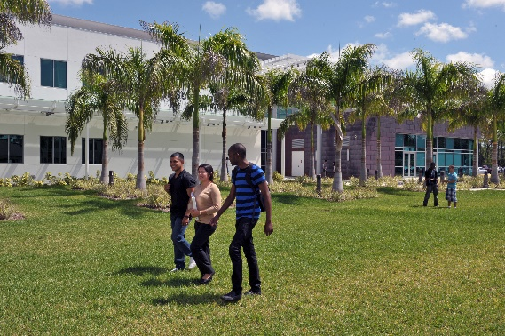
As a public College, we have many buildings and events open to the general public. FSW maintains normal hours of operation and permits access after-hours only on specific needs. Any individual who is not authorized by their employment or status as a student or does not have legitimate business or any other authorization, license or invitation to enter or remain or anyone committing any act tending to interfere with the normal, orderly, peaceful, or efficient conduct or activities of such facility or is being destructive of college property may be directed to leave, escorted from campus or arrested.

Security considerations in the maintenance of campus facilities

The College buildings and grounds are maintained to provide a safe environment for all who come to campus. A variety of personnel from various departments, including Facilities Planning & Management, Auxiliary Services, Student Life, Information Technology and Public Safety work together to ensure all components that comprise the safety system are operational. This includes exterior lighting, fire and smoke detection systems, call boxes/assistance phones, and maintenance of landscaping, sidewalks and traffic control. If you observe any safety issue, please contact the campus public safety so corrective action can be initiated.

Key and Access Control Card Control

Protection of issued keys and Access Control cards is extremely important. Do not lend keys or cards, particularly if you are unsure of a person’s authorization.

Student of Concern

Often you can help students exhibiting concerning behaviors by asking some basic questions, listening, providing the student with information and making referrals to campus resources to help them. You can take proactive steps to help a student follow through and make contact while still letting the decision to seek help reside with the student.

Go to: http://www.fsw.edu/studentofconcern.

Behavioral Intervention & Recommendation Team (B.I.R.T)

B.I.R.T. is a collaborative interdisciplinary committee of college officials intended to meet two distinct objectives. First, to enhance institutional awareness of potential threats to campus safety, second, to provide students and employees with opportunities to assess and manage problematic behavior before this behavior becomes a formal violation of the Student Code of Conduct. BIRT encourages faculty, staff, and students to report behavioral issues that represent disruptions that may affect the learning environment.

For more information or to file a report, go to: http://www.fsw.edu/birt

Office of Counseling

Provides a variety of free and confidential services including consultation, on-campus, short-term counseling and off-campus outreach programs. Each campus has an office and various hours. See the web page for more information or to schedule an appointment. Go to: http://www.fsw.edu/counseling
- Charlotte Campus:
(941) 833-5329
- Collier Campus:
(239) 732-3414
- Hendry/Glades Center:
(863) 674-6002
- Thomas Edison (Lee) Campus:
(239) 489-9046

Public Health Resources

Your health and safety is important to us! We remind all students and employees to use common sense tips to stay healthy. If you are feeling ill, we encourage you to see a doctor and take time off if necessary. At this time the College does not have an on-campus health clinic. See the web page for links to area health departments and health related web sites. Go to: http://www.fsw.edu/publichealthresources.

How to Report Crimes and other Emergencies on Campus & Guidelines that Encourage Accurate Reporting Crimes

Generally, the Public Safety office should be the first department contacted after an incident occurs at a campus or College site. Upon preliminary investigation, other appropriate local law enforcement agencies may be notified to assist campus police or assume the investigation. NOTE: For medical or life-threatening emergencies, or threats or assaults that require immediate attention by police should be reported first by calling 911 and then each campus public safety office, if possible. Additionally, for emergencies or assistance you may use the telephones in each classroom or the RAVE Guardian program, described below. Public Safety personnel will assist victims in reporting crimes that occurred off-campus to the appropriate law enforcement agency.

Prompt reporting of criminal actions, suspicious persons or behavior, potentially hazardous situations and emergencies to Public Safety is encouraged to allow the department to respond as quickly as possible. So that we appropriately promote the safety of our community, prevent and accurately report crimes, we encourage persons to report on-campus crimes to Public Safety. Individuals may choose not to make a formal report and may or may not seek victim support services. We encourage persons to report crimes for those that may be unable to do so or may be incapacitated. Everyone has a role in bystander intervention.

Prompt reporting allows for evidence in criminal matters to be collected and preserved for use in criminal prosecution. Even after making a report there is no obligation to prosecute/testify in a case.

Stay Connected FSW College Emergency Notification System
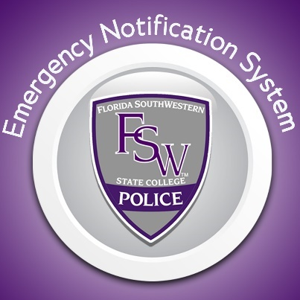
The College Emergency Notification System is a text messaging and e-mail emergency notification system for events on campus. Please keep your information current in your Portal to receive calls and text messages (Students & Employees)

Instructions can be found at: https://www.fsw.edu/alert/index.php

Weather Emergencies

The College will announce closures for weather-related emergencies thru the FSW Emergency Notification System, email, the college webpage and the news media. Please check the public safety webpage and the Public Health Resources webpage for preparedness and response information for weather-related emergencies. http://www.fsw.edu/publichealthresources/

Campus Wide Evacuation

Should you receive word through the Emergency Notification System or verbally from people around you to “evacuate” the campus, the following procedure should be used:
- If inside a campus building, shut down all electronic devices in your area and leave the building in an orderly and calm manner.
- If you have means to leave campus, do so in an expeditious yet safe manner. Follow traffic directions from officials while departing from campus.

- If you do not have transportation, follow instructions given in the emergency notification message and by emergency personnel on campus.
- For additional information and details check the FSW website.

RAVE Guardian

FSW offers students, faculty and staff free access to the Rave Guardian App to provide an extra layer of security that is right at your fingertips. The Rave Guardian, or as it is known for FSW as BUCS Guardian, provides rapid and proactive communications with friends, family, co-workers, FSW public safety, and even 9-1-1 emergency. By using BUCS Guardian FSW students, faculty and staff are able to set safety timers, manage and message guardians of their choosing, and have quick access to emergency communication services. This service is free to our FSW students, faculty, and staff, just use your assigned college email account to set up your account. Download the app today by clicking the icon below and start setting up your account and inviting your guardians.

Alertus Desktop Notifications

Whenever FSW Public Safety issues an emergency alert, all faculty and staff desktop workstations, computer labs, instructor’s stations, and student workstations will display a full-screen pop-up message. These pop-up alerts are in addition to those you may receive on your mobile devices and are not meant to replace them. http://www.fsw.edu/alert

Classroom Phones

Our classrooms have phones that only allow calling out for emergencies or assistance and for our Emergency Notification System to deliver messages. Pick up the phone: Press 1, goes directly to 911. Press 2 to call public safety, Press 3 for IT Help Desk and Press 4 for the switchboard.

Hearing, Sight, or Speech Impaired

Those who use specialized telephone equipment please call the Florida Relay Service 711 which can communicate with people who use standard telephone equipment. To call Florida Relay, dial 7-1-1.

Anonymous Tips Regarding Criminal Activity or Suspicious Behavior

Can be made thru a link on the forms section of the Public safety webpage. http://www.fsw.edu/publicsafety/anonymoustips.
Sexual Assault and Misconduct can also be reported anonymously through the link, Report Sexual Misconduct Now on the Public Safety webpage. http://www.fsw.edu/sexualassault/report

Timely Warnings, Emergency Notifications and Daily Crime & Fire Logs

The Department issues Emergency Notifications promptly to the campus community when a crime, emergency or dangerous situation poses an immediate threat to the health or safety of students, employees, or others on campus. Timely Warnings are issued when there is a specific crime or incident that represents a serious or continuing threat to the campus community. Timely Warnings and Emergency Notifications are sent via the FSW Emergency Notification System which sends messages via telephone, email, or text messages; postings in conspicuous places around campus, and posted on the college social media sites of Facebook and Twitter. Messages at times may be posted on the College web page.

The Department maintains a daily crime/fire log database. The log includes the date, time nature, and general location of each crime or fire reported to the Department. The log is available for review on the Public Safety webpage.

TOP 5 EMERGENCY TIPS

1. Common Sense: Your best asset is basic common sense and logic.
2. Stay Calm: Panic only leads to confusion and inactivity.
3. Scene Safety: Stay mindful of what is occurring around you.
4. Call 911: Never hesitate to call.
5. Information: Emergency personnel will need information from you when you call, and when they arrive; be aware and do your best to remember what you can.

The phone numbers for the Public Safety offices and local emergency numbers are as follows:

Lee Campus | Off Campus | On Campus
Public Safety | 239-489-9203 | 11203
Local Emergency | 911 | 9911
Charlotte Campus | Off Campus | On Campus
Public Safety | 941-637-5608 | 55608
Local Emergency | 911 | 9911
Collier Campus | Off Campus | On Campus
Public Safety | 239-732-3712 | 33712
Local Emergency | 911 | 9911
Hendry/Glades Center | Off Campus | On Campus
Public Safety | 863-674-6017 | 66017
Local Emergency | 911 | 9911

Policies: Alcohol, Drugs, Tobacco, Weapons, & Sexual Assault

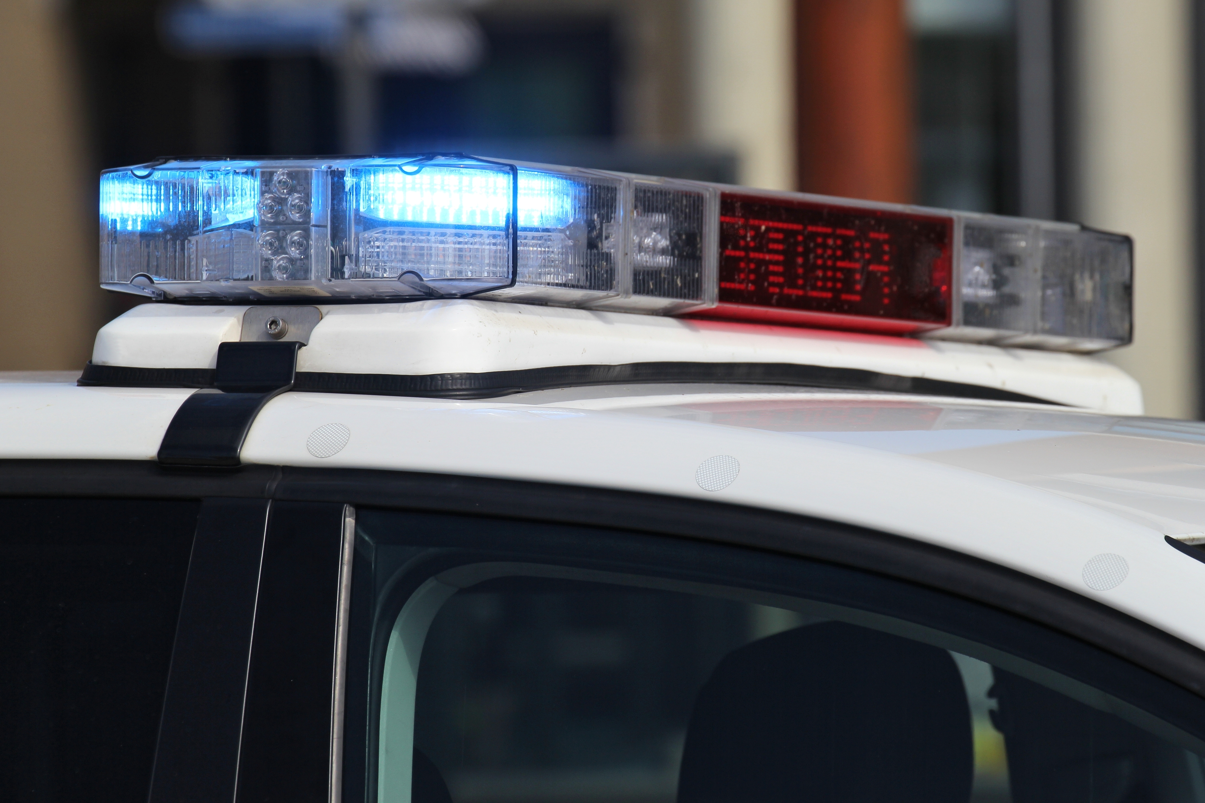Policies set a standard of conduct which is most conducive to a safe environment. It is not the intent to reprint these policies in this guide, but to give you some general knowledge of those policies which most affect your safety and security here at the College. You should consult the Student Code of Conduct, College Policies and College Operating Procedures, as needed.

The College is committed to preserving the safety and security of students, employees and visitors to the college and will not tolerate criminal or disruptive behavior, including but not limited to dating violence, domestic violence, stalking, assault, batteries, sexual batteries, or other conduct that results in harm to people or property; possession of deadly weapons on College property; unwelcome sexual advances, requests for sexual favors, and other verbal (including written and electronic communications) or physical conduct of a sexual nature, or intimidating conduct or harassment that disrupts the teaching/learning and/or work environment or results in fear for personal safety.

These acts carried out off College-owned or leased property but directed at College employees, students, or visitors while conducting official College business are a violation of this policy. Off-site threats include but are not limited to threats made via telephone, electronic or conventional mail, or any other communication medium. Those violating these laws are subject to criminal prosecution and further action by the College. Any student found in violation of these policies will be subject to disciplinary action up to and including dismissal. Any employee found in violation will be subject to disciplinary action up to and including termination.
The Discrimination and Harassment Policy, Campus Violence Prevention and other policies are available on the college website.

Students or employees who wish to report harassment or sexual misconduct should contact:
- The College Title IX Coordinator/Equity Officer. 239-489-9051, equity@fsw.edu
- Office of the Vice President for Student Affairs and Enrollment Management, 239-433-6950
- Human Resources Office, 239-489-9293
- Department of Public Safety, 24 hours a day, seven days a week

To view complete policies and procedures, see:

- Board of Trustees Polices
http://www.fsw.edu/board/policies/

- College Operating Procedures
http://www.fsw.edu/generalcounsel/cop

- Code of Conduct
http://www.fsw.edu/codeofconduct

Use, possession, or distribution of alcoholic beverages is strictly regulated. State law prohibits consumption or possession of alcoholic beverages by persons younger than 21 years old. The law also prohibits persons 21 or older from providing alcoholic beverages to minors. A person misrepresenting his or her age to obtain alcoholic beverages is in violation of the law. County ordinances prohibit consuming alcohol and open containers in public areas. With a few exceptions, possession of alcoholic beverages on College campuses is prohibited.

Violators of alcohol policies are subject to the provisions of applicable state laws as well as College disciplinary actions.

Assistance and alcohol abuse counseling is available for both students and employees through the College Counseling Services and the Employee Assistance Program (EAP).

Illegal Drugs

Florida law and College policies prohibit the use, possession, or distribution of narcotics or controlled drugs without a valid prescription. Violators of drug laws and policies are subject to the provisions of applicable state and federal laws as well as College disciplinary actions.
This policy is based on the Florida Comprehensive Drug Abuse Prevention and Control Act, the Drug-Free Schools and Communities (Campuses) Act of 1989 and Federal Anti-Drug Abuse Act of 1988 and is supplemented by College administrative policies and procedures.
Assistance and drug abuse counseling is provided for both students and employees available through College Employee Assistance Program (EAP) and Office of Counseling Services.

TObacco-Free Environment

FSW is dedicated to providing a safe and healthy environment for students, employees, and visitors to the College, which includes eliminating tobacco use as part of our commitment to promoting healthy practices and choices for individuals.
Tobacco use is prohibited on all property and in all facilities owned, leased or operated by the College, including all vehicles owned or rented by the College.
There are no designated smoking areas on such College property. Tobacco use includes all types of tobacco and tobacco-like products including smoke-less tobacco and any other smoking or smoking simulation products including electronic cigarettes.

Weapons

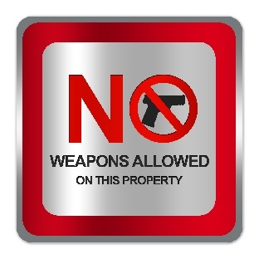
Possession and/or carrying of firearms, electric weapons, destructive devices or other weapons on campus is prohibited, except as permitted by statute. Firearms are not permitted to be carried on campus, except for those carried by law enforcement officers; a member of the military engaged in authorized training or armored car security servicing our campuses. It is not unlawful for a person 18 years of age or older to possess a concealed firearm or other weapon for self-defense or other lawful purpose within the interior of a private conveyance, without a license, if the firearm or other weapon is securely encased or is otherwise not readily accessible for immediate use.

The unauthorized use or possession of weapons, which includes, but not limited to: electric weapon or device, destructive device, or other weapon including a razor blade, box cutter, or knife on campus is prohibited.

Campus Violence Prevention and Title IX

The Department of Public Safety provides immediate assistance to the victim of crimes and initiates immediate investigative processes to apprehend the perpetrator of the crime. The Department may notify the sheriff’s office to investigate and/or work closely with them in the investigation. Complaints of sexual battery/rape, domestic violence, dating violence and stalking are serious criminal offenses that may be processed within the criminal justice system, according to the desire of the victim. Criminal offenses committed by students also are a violation of the College student code of conduct and violators are subject to College disciplinary sanctions as provided by the code of conduct. Efforts will be directed toward assisting the victim at all stages of the investigation and judicial process that may follow.

FSW has a Title IX Coordinator and Equity Officer responsible for the college’s compliance with federal laws and regulations relating to sex discrimination in education programs and activities as well as retaliation for the purpose of interfering with any right

or privilege of Title IX of the Civil Rights Act of 1964. Sexual misconduct against students, including sexual harassment, sexual assault, rape, and sexual exploitation, can be a form of sex discrimination under Title IX. These cases can be independent of any other proceedings initiated, including criminal prosecutions or student Code of Conduct case.
For additional information on the Title IX, see: http://www.fsw.edu/humanresources/equityofficer

Sanctions and protective measures can range from warnings, probation, no contact orders, removal from class/housing, expulsions and others. The standard of proof for college disciplinary hearings must meet the preponderance of the information (i.e., more likely than not that a student violated the code of conduct).

SAFETY ESCORTS
Felling uncomfortable? An escort by public safety staff is available during evening or night-time hours on campus by calling the campus public safety office. A public safety or police officer will be sent to escort you to your car.

The College understands and commits its efforts toward successfully dealing with the trauma experienced by victims of crimes, including among others, sexual battery, domestic violence, dating violence and stalking. The policy of the college is to prohibit, as being incompatible with the mission of the College, the commission of all forms of sexual violence and other crimes of violence by, or upon, any member of the college community, including students, employees, and guests. For our purposes of investigating and reporting the following offenses are defined as follows:

Consent: means the express communication or mutually understandable actions or words of the parties who are, or have been, involved.
- A sexual encounter is considered consensual when individual(s) willingly and knowingly engage in sexual activity.
- Consent cannot be procured by the use of physical force, compelling threats, intimidating behavior, or coercion: The use of coercion can involve the use of pressure, manipulation, substances, and/or force. Ignoring the objections of another person or pressuring them is a form of coercion. Consent may never be given by a minor even if the other participant did not know the minor’s age.
- Knowingly engaging in sexual activity with someone who is incapacitated by alcohol or drug use, unconsciousness, disability, involuntary physical constraint, sleep, or other forms of helplessness does not constitute consent. Incapacitation is a state where a person cannot make a rational, reasonable decision because the person lacks the ability to understand his or her decision.
- The use of alcohol or drugs does not diminish one's responsibility to obtain consent and does not excuse conduct that constitutes sexual misconduct under Florida SouthWestern State College’s rules, regulations and policies. If at any time during a sexual act confusion or ambiguity regarding consent arises, each individual involved in the activity should stop and clarify the other's willingness to continue. Neither person should make assumptions about the other’s willingness to continue.
- Consent to one form of sexual activity does not imply consent to other forms of sexual activity. Previous relationships or previous consent for sexual activity cannot imply consent to sexual activity on a different occasion.
- Silence, passivity, or lack of resistance cannot be interpreted as consent.
- Consent can be withdrawn at any time.

Dating violence: Violence committed by a person who is or has been in a social relationship of a romantic or intimate nature with the victim; and the existence of such a relationship shall be determined based on a consideration of:
- the length of the relationship
- the type of relationship, and
- the frequency of interaction between the persons involved in the relationship.
For the purpose of this definition, dating violence includes, but is not limited to, sexual or physical abuse or the threat of such abuse. Dating violence does not include acts covered under the definition of domestic violence.
Domestic violence: A felony or misdemeanor crime of violence committed by:
- a current or former spouse of the victim
- a person with whom the victim shares a child in common
- a person who is cohabitating with or has cohabitated with the victim as a spouse or intimate partner;
- a person similarly situated to a spouse of the victim under the domestic or family violence laws of the state of Florida, or
- any other person against an adult or youth victim who is protected from that person’s acts under the domestic or family violence laws of the state of Florida
Sexual Exploitation: is any act of taking non‐consensual, unjust or abusive sexual advantage of another person for one’s own advantage or benefit or to benefit or advantage anyone other than the person being exploited.
Sexual Exploitation includes, but is not limited to:
- Causing or attempting to cause the incapacitation of another person in order to gain a sexual advantage over such person
- Prostituting another person (i.e., personally gaining money, privilege or power from the sexual activities of another)
- Non-Consensual videotaping, photographing, or audio‐taping of sexual activity and/or distribution of these materials via media such as, but not limited to, the Internet
- Exceeding the boundaries of consent (e.g., allowing another person to observe consensual sex without the knowledge of or consent from all participants)
- Voyeurism and
- Knowingly or recklessly transmitting a sexually transmitted disease (including HIV) to another individual
Sexual Harassment: is any unwelcome verbal, nonverbal, written, electronic or physical conduct of a sexual nature. Sexual harassment also includes acts of intimidation, bullying, aggression or hostility based on gender or gender-stereotyping, even if the acts do not involve conduct of a sexual nature.
Examples of sexual harassment include instances in which:
• Submission or consent to the behavior is reasonably believed to carry consequences for the individual’s education, employment, on-campus living environment, or participation in a College activity. Examples of this type of sexual harassment include: pressuring an individual to engage in sexual behavior for some educational or employment benefit, or making a real or perceived threat that rejecting sexual behavior will carry a negative educational or employment consequence for the individual.
• The behavior is so severe or pervasive that it has the effect of substantially interfering with the individual’s work or educational performance by creating an intimidating, hostile, or demeaning environment for employment, education, on-campus living, or participation in a College activity.
Examples of this type of sexual harassment include:
• One or more instances of sexual assault
• Persistent unwelcome efforts to develop a romantic or sexual relationship
• Unwelcome sexual advances or requests for sexual favors
• Unwelcome commentary about an individual’s body or sexual activities
• Repeated and unwelcome sexually‐oriented teasing, joking, or flirting and
• Verbal abuse of a sexual nature.
Sexual Misconduct: is any unwelcome conduct of a sexual nature, including any conduct or act of a sexual nature perpetrated against an individual without consent. Sexual misconduct can occur between strangers or acquaintances, including people involved in an intimate or sexual relationship. Sexual misconduct can be committed by men or by women, and it can occur between people of the same or different sex. The College encourages reporting of all sexual misconduct.
Sexual misconduct includes but is not limited to:

• Dating Violence
• Domestic Violence
• Non-forcible sex acts, which are unlawful sexual acts where consent is not relevant, such as sexual contact with an individual under the statutory age of consent, as defined by State law, or between persons who are related to each other within degrees wherein marriage is prohibited by law
• Sexual Assault
• Sexual Exploitation
• Sexual Harassment and
• Stalking
Stalking: engaging in a course of conduct directed at a specific person that would cause a reasonable person to:
- Fear for the person’s safety or the safety of others; or
- Suffer substantial emotional distress.
For the purpose of this definition--
- Course of conduct means two or more acts, including, but not limited to, acts in which the stalker directly, indirectly, or through third parties, by any action, method, device, or means follows, monitors, observes, surveils, threatens, or communicates to or about, a person, or interferes with a person’s property.
- Substantial emotional distress means significant mental suffering or anguish that may, but does not necessarily, require medical or other professional treatment or counseling.
- Reasonable person means a reasonable person under similar circumstances and with similar identities to the victim.
(Refer: Clery Act § 668.46)

For additional information and how to report an incident, see: Understanding and Reporting Sexual Misconduct. http://www.fsw.edu/sexualassault/report

PREVENTING SEXUAL BATTERY AND OTHER VIOLENT CRIMES

The best defenses against sexual battery and other violent crimes are alertness and awareness. At all times, including dating situations, you should:

• Let a friend or roommate know with whom you will be, where you will be, and when you expect to return. Leave an address and phone number.
• Do not let peer pressure influence the amount of alcohol you consume.
• Trust your feelings and instincts. If you feel threatened, there’s probably a good reason. Get away fast.
• Report any assault or threat of assault to public safety or, if off campus to a police department having jurisdiction, as soon as possible.

BYSTANDER ACCOUNTABILITY

According to the National Sexual Violence Resource Center
An engaged bystander is someone who intervenes before, during, or after a situation when they see or hear behaviors that promote sexual violence. It is common for people to witness situations where someone makes an inappropriate sexual comment or innuendo, tells a joke about rape, or touches someone in a sexual manner. Bystanders might also witness other forms of sexual violence. Bystanders who witness the behavior or hear the comment can intervene in a positive way that will help create a safer environment.

Engaging Bystanders in Sexual Violence Prevention:
http://www.nsvrc.org/sites/default/files/Publications_NSVRC_Booklets_Engaging-Bystanders-in-Sexual-Violence-Prevention.pdf
http://itsonus.org/

WARNING SIGNS OF VIOLENT BEHAVIOR

- Making direct or veiled threats to kill/harm self or others;
- Referring to or preoccupation with other incidents of workplace violence;
- Exhibiting intimidating, belligerent, insubordinate, defiant or challenging behavior;
- Exhibiting confrontational, angry, easily provoked, unpredictable, restless, or agitated behavior;
- Having a history of violent, reckless, or antisocial behavior;
- Having a fondness or fascination with firearms;
- Blaming others for anything that goes wrong, with no sense of own responsibility;
- Exhibiting recent marked performance decline;
- Exhibiting changes in personality, mood, or behavior;
- Crying excessively;
- Becoming unkempt—grooming habits decline;
- Crossing behavioral boundaries, such as excessive phone calls, personal emails and/or visits;
- Engaging in substance abuse;
- Encountering serious stress in personal life.

Relationship violence is the most common form of violence in the workplace.

SIGNS OF RELATIONSHIP VIOLENCE

- Anxiousness, crying, significant changes in behavior;
- Frequent or sudden absences;
- Frequent tardiness or leaving work early;
- Fluctuations in the quality of work for no apparent reason;
- Difficulty concentrating and decreased productivity;
- Isolation from colleagues and social activities;
- Excessive number of phone calls or emails from family members and/or friends;
- Disruptive personal visits to the workplace;
- Visible injuries, often with an explanation of an “accident”; multiple injuries in different stages of healing; unexplained delay in seeking medical treatment for injuries;
- Stress-related illnesses and/or anxiety-related conditions such as heart palpitations, hyperventilation, and panic attacks.

WHAT TO DO IF YOU ARE SEXUALLY ASSAULTED OR BATTERED
Get to a Safe Place
Once you are safe, call 911 and/or the public safety office.
MEDICAL ATTENTION
Get immediate medical attention. You may also have injuries of which you are unaware. Seeking medical attention does not mean that you need to press charges.
Evidence Collection: Try to preserve all physical evidence, have photos taken of injuries, medical treatment provides necessary documentation also.
- In sexual assaults it is important to remember not to bathe, shower, douche, brush teeth, or change clothing as this destroys evidence. Evidence is also destroyed or compromised by smoking, drinking or eating. If possible, these activities should be avoided prior to evidence collection. The evidence collection process is completed at a hospital.
- Calling the police or even talking with them does not mean that you have to follow through on prosecution or file a formal report.
- If you choose to receive medical care from an emergency room or hospital, a Sexual Assault Forensic Exam (SAFE) Kit will be completed and there is no fee for this examination.
- All survivors have the right to have an advocate present during the entire exam and hospital visit. A victim advocate is available to accompany you.
- If you believe you were drugged prior to the sexual assault, it is important to disclose that information so that a drug screen can be done.
- HIV testing is available and should be discussed. You can ask for more information about testing and testing sites, or contact the Victim Advocate for information regarding free, anonymous and confidential HIV testing.
- Stalking and Harassment cases, document each occurrence, dates, times, locations, what was said. Keep letters, notes, emails, texts, gifts or other objects sent to you.
POLICE CONTACT - WHAT TO EXPECT
Deciding to press criminal charges and involve the police is a personal decision. If you decide to report the incident to the police, below are some points to take into consideration:
- Contact the police in the municipality where the sexual assault took place as they have jurisdiction to investigate. If you are unsure of the location, contact the police where you think the crime occurred. If the assault occurred on college property, contact 911 and/or Public Safety. If you are unsure, contact the Public Safety office and they will assist you.
- Although a patrol officer/deputy is generally the first to respond, a trained detective will do the investigation.
- The survivor has the right to have a Victim Advocate present during all medical and law enforcement procedures.
- The interview will usually focus on the events prior to the initial contact with the assailant, a detailed account of the behavior and words used by the survivor and the assailant, a detailed account of the assault and a description of the assailant.
PROSECUTION – WHAT’S INVOLVED?
There are several steps involved in this process. Some information to take into consideration about prosecution:
- Once the police finish their investigation, all evidence is turned over to the State Attorney’s Office, where it is reviewed. A Prosecutor is assigned and will then make decisions regarding the case. The survivor becomes a witness if the case moves forward.
- The law also limits the admissible evidence concerning the survivor’s prior sexual activity. As state law mandates, a victim’s name or address is not publicly disclosed, published or broadcast in any mass communication
- There are several levels of the prosecution process, including issuance of a warrant, arrest, arraignment, suppression hearing and the trial. Some steps require the survivor’s presence in court.
PROTECTION ORDERS

Victims of sexual crimes, domestic violence, dating violence and stalking who fear for their safety or fear the offender might contact them can seek an injunction sometimes referred to as a restraining order or protection order. The college thru its disciplinary process may also issue no contact orders for offenses involving students.

BRINGING COLLEGE CHARGES
Sexual Battery, Domestic Violence, Dating Violence, Stalking and all other crimes are also a violation of the College Student Code of Conduct and other college policies.
- If found responsible, the student may be expelled or suspended from the college. A range of other penalties may be chosen by the Conduct Board that hears the complaint.
- The standard of proof is different than for criminal prosecution, which must have proof beyond a reasonable doubt. In college cases, there must be clear and convincing evidence that the accused individual did violate the regulation. The Conduct Board is trained on the procedures to follow for the criminal and conduct behavior that comes before it, but does not use formal rules of criminal procedure and/or technical rules of evidence as are applied in criminal or civil courts. The procedures will provide a prompt, fair and impartial investigation and resolution. In cases involving allegations of sexual assault, domestic violence, dating violence or stalking the Board will ensure among other rules and statutes that each party receives notice of the outcome and that protections afforded under Florida Statutes are followed to protect the rights of the survivor/victim.
- Survivors/victims have the option of bringing college and/or criminal charges or neither.
SEEKING PROFESSIONAL COUNSELING/THERAPY
Professional counseling is often helpful for survivors because it provides a safe place to talk about your experience at your own pace with someone who is objective and trained in these issues. When thinking about the option of counseling, the following points can be taken into consideration:
- Each survivor has his/her own recovery timetable. Some people are ready for counseling right away and others delay. Some never seek assistance. Remember, no matter how long ago or recently the assault occurred, counseling can be considered.
- Counseling is usually an on-going process. It provides a place for survivors to process the impact of the assault over time.
VICTIM SERVICES

If you are the victim of, or a witness to a crime, this information will help explain your rights within the legal system. Investigating officer will provide you with the required information. Our close relationship with other service providers allows us to refer you to them for services beyond that which we can offer.
The state of Florida Crime Victims Bill of Rights is part of the state constitution.

Florida Victim Services Directory http://myfloridalegal.com/vicdirect.nsf/Twentieth%20Judicial%20Circuit!OpenView

Resources for Students
http://www.fsw.edu/assets/pdf/publicsafety/Resources%20for%20students.pdf

Contact Information
- Charlotte County: Center for Abuse and Rape Emergencies, Inc. (CARE) (941) 627-6000
- Collier County: Collier County Sheriff's Office Victim/Witness Assistance Section (239) 793-9213
- Lee, Glades, Hendry Counties: Abuse Counseling and Treatment, Inc. Advocacy and
  - Counseling Services (239) 939-3112
- Student Assistance Program (SAP) Call Counseling Office

Registered Sexual Offenders and Predators
In accordance with Florida statutes and federal law, individuals designated as Sexual Predators or Sexual Offenders must register with the Florida Department of Law Enforcement (FDLE). Convicted sex offenders from out of state must register in Florida within 48 hours of establishing residence.
FDLE has established a toll-free number (1-888-fl-predator) or (1-888-357-7332) that allows the public to request information about sexual predators and sexual offenders living in their communities and around the State. The FDLE has created a web tool for interested parties to search their database. This database may be used to find sex offenders and predators by name, address, city, county, or zip code.
FDLE has established an on-line search function that allows the public to request information about sexual predators and sexual offenders registered as enrolled, employed, or volunteering at an institution of higher education with the Florida Sexual Offender Registry, http://offender.fdle.state.fl.us.
To Search:
Click the red “Offender Search” button
On the gold “University Search” button click “Begin Search”
Select the Institution and campus and submit your search.

Theft

Our Campuses are not immune from thefts many times because students and employees leave doors unlocked and valuables unprotected. As with crimes against the person, your best defense against thieves is vigilance. Recognize that danger exists and take precautions. Here are a few suggestions for on and off-campus:

- Keep your doors and windows locked.
- Don’t hide your spare key outside your apartment.
- Don’t lend your keys or Access Cards. For emergencies leave a key with a trusted friend/neighbor.
- Don’t keep large amounts of money in your room or apartment.
- Don’t advertise that you aren’t home by letting mail or newspapers accumulate on your doorstep or by recording a revealing message on your answering machine. Ask friends not to leave messages on your door.
- Don’t leave valuables unattended.
- Keep your checkbook, jewelry, and cash in a locked drawer/box.
- Engrave your driver’s license or state ID number on valuable possessions (FL----) without a serial number.
- Make a list of your valuable possessions including make, model, serial number, and description. Keep one copy in a safe place and another with your insurance papers.
- Ask service or repair persons to show their identification before admitting them to your room or apartment.
- Never reveal your Personal Identification Numbers or bank account numbers to anyone.
- Lock your bicycle with a sturdy lock, weaving it through frame, spokes, and rack.
- Always lock your car. Don’t leave valuables inside.
- Don’t leave laundry unattended in laundry rooms.
- Don’t lend your credit cards to anyone. Keep a list of your cards and their numbers with your insurance papers.
- Maintain adequate insurance coverage.
- Report thefts to the police at once.

Identity Theft and Identity Fraud

Identity theft and Fraud is a crime in which someone wrongfully obtains and uses another person’s personal data in some way that involves fraud or deception, typically for economic gain. This personal data could be a Social Security number, bank account and credit card info, telephone calling card numbers, and other valuable identifying data.

With identity theft and fraud, which are often computer-aided, there are measures that can be taken to reduce or minimize the risk of becoming a victim. These measures can be taken by remembering the word “SCAM.”

Be STINGY about giving out personal information to others unless you have a reason to trust them. Limit the information you provide to trusted sources, especially your Social Security number, driver’s license, and birth date. Should someone telephone or send an e-mail with an “unbelievable” credit card offer or notification of an alleged “prize” being won, do not offer any personal data, but rather ask that they mail an application or written notification of some type. If one is later received from a company, the Better Business Bureau can be contacted in an effort to determine whether or not the company is legitimate.
If you think you've become a victim of identity theft or fraud, act immediately to minimize the damage to your personal funds and financial accounts, as well as your reputation.

Federal Trade Commission:
https://www.identitytheft.gov/

U. S. Department of Justice:
http://www.justice.gov/criminal/fraud/websites/idtheft.html

Florida’s Identity Theft Victim Kit: Office of the Attorney General Florida
http://myfloridalegal.com/pages.nsf/Main/CBBEBA3F2583433385256DBA004BC600?OpenDocument
CHECK financial information regularly and examine records for any unrecognized/unauthorized transactions. Should such transactions be noted, the banking institutions and credit card companies should be contacted immediately.
ASK periodically for a copy of your credit report. The three principal credit reporting companies are Equifax, Experian, and TransUnion. These three companies, as well as the United States Federal Trade Commission, are accessible online. AnnualCreditReport.com provides a free annual report.
MAINTAIN careful records of banking and financial transactions as well as maintaining your personal computer security. Computer security can be fortified by installing any number of spyware programs and by installing firewalls. Changing passwords frequently and reducing any file sharing also can aid in the security of personal computers. Report any suspected identity theft or identity fraud to the police.
http://www.justice.gov/criminal/fraud/websites/idtheft.html

Cyber Safety
HARASSMENT AND STALKING ON-LINE…WHAT DO I DO?

With today’s Social Media technology people are experiencing on-line harassment and stalking referred to as cyberharassment and cyberstalking. Defined, Cyberstalking means to engage in a course of conduct to communicate words, images, or language by or through the use of electronic mail or electronic communication, directed at a specific person, causing substantial emotional distress and serving no legitimate purpose. Cyberharassment means to engage in a course of conduct conducted through the use of electronic mail or electronic communication directed at a specific person, which causes substantial emotional distress and serves no legitimate purpose.

If your life is in danger, call 911 immediately, if you believe you are a victim of these cyber-crimes, call and report them. Because these are “borderless” crimes resident students can report these occurrences to campus public safety, others should report to the law enforcement agency where they live.

In all cases there are some things you should remember:
- Notify your cell phone carrier of harassing and threatening text messages
- Do not delete messages or emails, keep them for an investigator
- Certain posts, Snapchats or other messages that can be deleted or self-destruct do a screen shot and save the posts or message.

There are a number of web sites that provide information on prevention and reporting these offenses:
- Stop.Think.Connect: http://www.dhs.gov/stopthinkconnect
- Fight Cyberstalking: http://www.fightcyberstalking.org/
- Stay Safe On-line: https://www.staysafeonline.org/

Social media sites provide safety, security and privacy information to their users, some of the popular sites include:
- Facebook Family Safety Center: https://www.facebook.com/safety
- Twitter Safety & Security: https://support.twitter.com/groups/57-safety-security#
- Instagram Security Tips: https://help.instagram.com/369001149843369
- Pinterest Security: https://help.pinterest.com/en/articles/safe-mode
- Google Safety Center: https://www.google.com/safetycenter/
- Tumblr Safety: http://digitalsafety.tumblr.com/
- Flickr Safety: http://www.fightcyberstalking.org/privacy-settings-flickr/
- Vine policies: https://vine.co/privacy
- Tagged Safety and Security: https://support.tagged.com/hc/en-us/sections/200955958-Online-Safety-Security
- Ask.fm Safety Center: http://safety.ask.fm/
- YouTube Privacy and Safety: http://www.fightcyberstalking.org/privacy-settings-youtube/

Suspicious Person

What is suspicious behavior?
- Anything that is “out of place” given the time and conditions.
- Abnormal behavior, clothing, or activity.
- Examples include:
  - Person running as though they were being pursued.
  - Carrying certain property at odd hours or locations (i.e. office machinery, laboratory equipment, locked bicycle, property inside their clothing, etc.)
  - Person(s) walking slowly in hallways attempting to open doors.
  - Person(s) attempting to hide at the sign of others.
- Make note of the person(s):
  - Sex
  - Race
  - Clothing Description
  - Approximate Age
  - Location
- Contact Public Safety.
- If possible, maintain sight of the individual from a safe distance.
- Do NOT attempt to apprehend, identify or detain the individual.

Bomb Threat - Suspicious Package / Vehicles

- Suspicious packages, bags, or cars should be reported immediately.
- Evacuate the surrounding area. Stay at least 300 feet away from the affected building/vehicle.
- DO NOT USE CELL PHONES OR TWO-WAY RADIOS.
- Contact Police 911 from a landline phone.
- Direct police personnel upon arrival.

WHAT ARE CHARACTERISTICS OF A SUSPICIOUS PACKAGE?

- Powdery substance on outside, or inside of a package.
- Excessive postage, incorrect titles or titles with no name, handwritten or poorly typed address.
- Disproportional weight to size
- Oddly shaped

WHAT ARE CHARACTERISTICS OF A SUSPICIOUS VEHICLE?

- Low riding vehicles, especially with disproportionate weight toward the back of the vehicle.
- Vehicles left running with no driver
- Vehicles parked haphazardly in apparent effort to hurriedly ditch, instead of properly parking the vehicle.

Safety Guidelines for Armed Subjects, Hostile Intruder Situations

HOSTILE INTRUDER/ ACTIVE SHOOTER/ SHOOTING

- Direct all students, staff, and visitors in the immediate area into securable rooms or out of the area.
- Lock interior and exterior doors.
- Close and lock all windows, and close all blinds.
- Barricade points of entry using available resources (i.e. chairs, desks, tables, etc.)
- Turn off the lights.
- Get all persons inside the room out of visible range from the exterior.
- Once the room has been secured, do not allow any additional persons inside.
- Contact Police at 911.
- Provide the last known location of the shooter.
- Keep noise and movement to a minimum.
- Remain calm; it may be an extended period of time before being contacted by Police whose first duty is to address the armed person(s).
- Do not respond to any voice commands until it can be verified that they are being issued by police.
- Do not question any instruction or command issued by police. Following all directions will provide evidence that you’re a victim, not suspect.

Hazardous Material Incidents

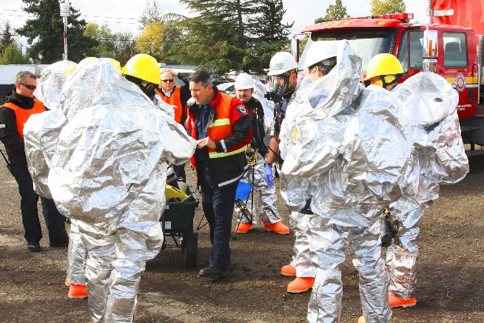
- Immediately vacate the area. If you are willing and able, locate and assist persons with special needs (including those injured) on your way out.
- Evacuate the surrounding area. Stay at least 300 feet away from the affected area.
- Contact 911 and be prepared to share the following information:
  - Has anyone been exposed to the substance?
  - Do you know what type of substance it is? Specific material name? Solid, liquid, gas?
  - Where does it appear to be coming from?
  - Is the substance contained?
  - Are there any hazardous material placards on the container?
- Direct police and fire personnel upon arrival.

Fire and First Aid | Sick or Injured Person

1. Determine basic nature of sickness, or injury.
2. Stay with the patient.
3. Contact 911 and Public Safety.
4. Follow all directions given by the Dispatcher.
5. If available, send someone to the nearest access point to meet and direct police / fire personnel to the patient.
6. Get additional patient information:
a. Name
b. Age
c. Medications Taken
d. Chronic Problems

In the Event of Fire

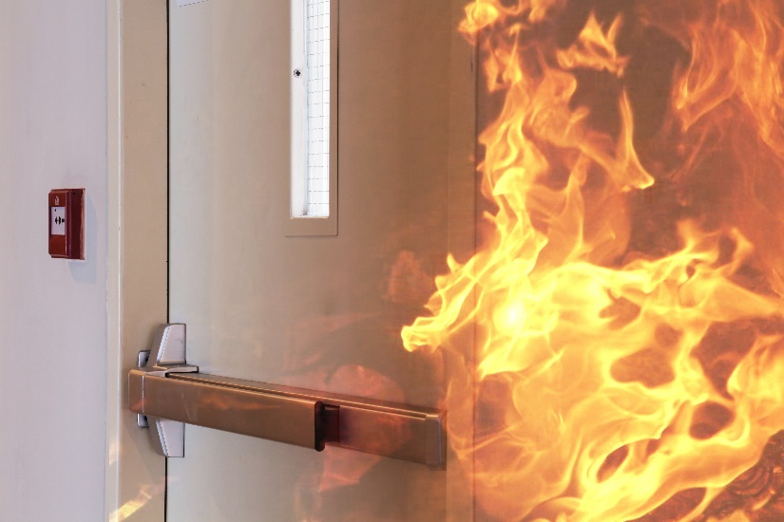
1. If you discover a fire in your area: alert others in the immediate area, get out, and close the door behind you. Immediately pull fire alarm. *If comfortable and trained with the use of a fire extinguisher (see below).
2. If you are willing and able, locate and assist persons with special needs (including those injured) in the immediate area.
3. Evacuate the building through the nearest exit. DO NOT USE ELEVATORS!
4. If the building is filling with smoke, exit the building by crawling on the floor.
5. Once outside the building, move to a safe area, Contact 911 from a safe place.
6. Direct emergency personnel upon arrival. Notify them of pertinent information regarding possible individuals still in the building.

USING A FIRE EXTINGUISHER

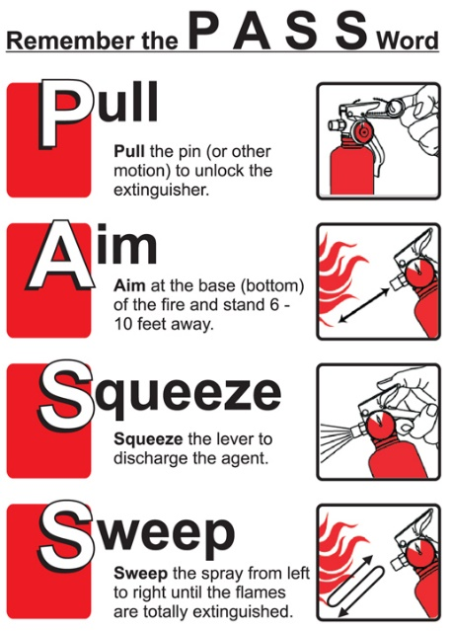
1. Pull fire alarm.
2. Contact 911.
3. Only use a fire extinguisher on small fires, and when comfortable and trained to do so.
4. Should any doubt exist on whether the fire can be extinguished, immediately exit the building and await response from Fire/Rescue.
5. Use the PASS method to extinguish the fire.

Pull the pin
Aim low, at the base of the flames
Squeeze the handle
Sweep from side to side should the fire
re-ignite, repeat the steps as needed.

If You Are Trapped or Unable to Exit

- Stay calm, and take steps to protect yourself.
- If possible, move to a room with an outside window.
- If there is a working phone, call 911 and tell the dispatcher where you are. Do this even if you can see the fire department from the window.
- Stay where rescuers can see you through the window, and wave a light-colored item to attract their attention.
- Stuff clothing, towels, or blankets around the cracks in the door to help keep smoke out of your refuge.
- If possible, open the window at the top and bottom. Be ready to shut the window quickly if smoke rushes in.
- Be patient. The rescue of occupants of large structures could take time.

Evacuation Procedures

BUILDING EVACUATION
- Notice to evacuate the building(s) will be transmitted via the fire alarm system (continuous horn blast) or, in the event of an alarm failure, by verbal instructions from designated authority.
- When the fire alarm horns sound, immediately evacuate the building in accordance with the evacuation instructions posted adjacent to each door.
- Proceed to the designated assembly area and await further instructions. Do not interfere with emergency equipment or personnel.
- Instructors:
  - Ensure all students evacuate in a prompt, orderly manner. Assist physically challenged students as required.
  - Close any windows that may be open.
  - Close the classroom door as you exit.
  - Account for all students upon reaching the assembly point.
The all-clear signal shall be passed verbally by Emergency personnel or designee.
Note: The building alarms sound only in the building in which activated. You must report the emergency via telephone. Portable communications devices i.e., radios/walkie-talkies, pagers or cellular phones are not to be used during a bomb threat due to the fact that some bombs may be detonated by transmitted signals. DO NOT USE THE ELEVATOR DURING A FIRE.
CAMPUS EVACUATION
- Evacuation of all or part of the campus grounds will be announced by the emergency personnel as directed.
- All persons (students and staff) shall immediately vacate the site in question and re-locate to another part of the campus, or off campus, as directed.

Conduct Standards
FSW is committed to maintaining a civil environment that fosters learning and personal development. All members of the FSW College community are responsible for their own behavior and are expected to be familiar with the rules and regulations of the College pertaining to academic affairs, social conduct, and student activities. Students are expected to uphold appropriate standards of behavior and to respect the rights of others.
Each student, by registering, accepts to obey the rules and regulations of the College. Students are responsible for the observance of all board policies and procedures as published in the College Catalog, the Student Handbook, Housing Rules, Board of Trustees policy, and other College documents. Students who fail to observe College regulations or to maintain acceptable standards of personal conduct are subject to disciplinary action.

College Disciplinary System

The Dean of Students coordinates all student judicial proceedings. Complete information on the judicial process can be found within the Student Code of Conduct.

Students charged with violations of a Student Code of Conduct will be given adequate notice of the charges and allegations against them, and be provided an opportunity to address these charges. In cases where the alleged offender’s conduct poses a threat to the College community, the Dean of Students may choose to impose an immediate interim suspension until a hearing can be convened to determine the facts of the case. Both the alleged victim and the alleged offender are allowed to be accompanied by an advisor of their choice during the proceedings, and will be informed of the final outcome of any campus disciplinary hearing.
Students found responsible for violations of sexual misconduct will be sanctioned according to the options outlined in the Student Code of Conduct and/or Title IX procedures. This can include suspension, or expulsion from the College, changing class schedules or room assignments at Light House Commons.

Residential students living in Light House Commons must abide by their housing contract and rules of housing.

PERSONAL SAFETY AND CRIME PREVENTION PROGRAMS
FSW Department of Public Safety provides educational programs to the campus community, as requested and at other announced times. As crime and safety trends change our programs will adapt and if there is a topic of interest not listed here, please contact us.

ALCOHOL, DRUGS AND THE LAW
This program is an overview of laws and policies related to the possession and use of alcohol, responsible use of alcohol and consequences of alcohol violations. Topics include the use of fake identification, college policies and procedures.

BICYCLE SAFETY AND REGISTRATION
Decrease your chances of being injured and tips to prevent thefts. Registration includes affixing a numbered decal to a bicycle and recording the information about the owner and the bicycle in the event the bicycle is stolen. Participation in bicycle registration is voluntary.
DOMESTIC VIOLENCE/DATING VIOLENCE/SEXUAL ASSAULT AND STALKING
What to do if you or someone you know becomes a victim of these crimes. This type of violence is one of the most prevalent types of violence on campuses everywhere. You will learn to identify warning signs, prevention and safety techniques and what your legal recourse is. Resources and assistance providers available both on campus and within the local community are important and their roles will be discussed.

FIRE ALARMS, EVACUATION PROCEDURES/FALSE ALARMS/BOMB THREATS
Learn what procedures to follow when a fire alarm activates, using fire suppression equipment and legal/disciplinary consequences of causing a false fire alarm.
ON-LINE AND TECHNOLOGY SAFETY
Learn about cyber security, privacy, sharing information, online shopping, respecting others online and other topics will be covered.
ORIENTATION PROGRAMS FOR NEW, TRANSFER, OR INTERNATIONAL STUDENTS
Public Safety regularly provides information reviewing the safety and security measures the college has in place and how to use those services. Orientation programs are very useful to those new to the college.

PERSONAL SAFETY
Designed to inform and educate on the vital issue of personal safety. Common sense, smart decision making, being aware of one’s surroundings and the buddy system are among the topics discussed to arm the community against personal violence. Sometimes referred to as Rape Prevention the information in this program is vitally important to the college community.

PROTECT YOUR PROPERTY
Topics include what an individual can do to secure property, mark property for identification or record information and prevent property from being stolen. Find My Phone, laptop recovery software, etc.

RAPE AGGRESSION DEFENSE (RAD)
Self-defense course for women only, the class is taught over 3 consecutive days. Includes classroom discussion involving options in various types of situations, and how and why to make a decision to resist or not, principles of self-defense, and resistance. Students will learn stances, yelling, movement, blocking, and escape methods along with many other defense techniques.

SPRING BREAK AND TRAVEL SAFETY
This program provides important safety tips for students traveling on spring break. Travel overseas or domestically and how to protect yourself at the hotel, beach and other locations.

SUSPICIOUS PERSONS (DEFINING BEHAVIORS OF CONCERN)
Frequently people in the community see individuals or situations that simply do not seem right to them. This program provides an overview of suspicious activity and encourages individuals to trust their instincts. If something seems out of place to you as a community member there may be something actually wrong and you should notify public safety.

WHAT TO DO IF STOPPED BY POLICE, PUBLIC SAFETY OR COLLEGE PERSONNEL
Includes discussion concerning student rights and responsibilities under the law and the Code of Conduct, with an emphasis on duty of provide identification, fake identification, trespass, weapons on campus, assembly, traffic stops, etc.

WORKPLACE VIOLENCE
This program defines workplace violence and identifies the typical characteristics of offenders. Individual participants will also learn what they can do to prevent this growing form of violence.

SAFE PROGRAM
Educational awareness, crime prevention program that provides women with information to help reduce their risk of exposure to violence and introduces them to physical aspects of self-defense.
ON-LINE PROGRAMS

Through a secure log-in on the public safety web page, students and employees are able to view by live streaming training videos on the following topics:

Dating Violence – Presented to a live audience of college students this narrative story is designed to elicit thinking and dialogue about the issues of dating violence. 30 minutes.
Hostages at Home – Features five women from different ethnic and socioeconomic groups who have survived domestic violence. Dispels myths about domestic violence and examines the effects on the community. 52 minutes.
Speak Out & Stand Up – Raising awareness about sexual assault, this features a dramatization of a sexual assault on a college campus with testimonies from survivors and experts in the field. 25 minutes.
ReThink Rape – Re-frames the issue of sexual violence away from blaming the victim to placing responsibility on the perpetrators. 7 minutes.
Someone You Know – Looks closely at the troubling realities of sexual assault on a college campus. Features survivors, counselors, campus police and students. 20 minutes.
Campus Confidential – An inside look at College Culture. Understanding sexual assault, legal consent, and bystander intervention. 30 minutes.
Playing the Game 2 – Explores the issue of sexual assault and date rape and the dynamics of sexuality, dating, communication and alcohol use. 12 minutes.
Flashpoint on Campus – Recognizing and preventing violence on campus. 22 minutes.
Preventing Mass Casualty Shootings in a Campus Setting – University of Wisconsin. 5 minutes.
We Don’t Haze - This 15-minute documentary, produced by the Clery Center addresses both how to recognize hazing and how to take realistic steps to prevent hazing on campus.

What you can do when there is a bomb threat - Although a bomb threat may seem rare, they happen every day across the nation. Reacting quickly and safely to a bomb threat could save lives, including your own.

LightHouse Commons

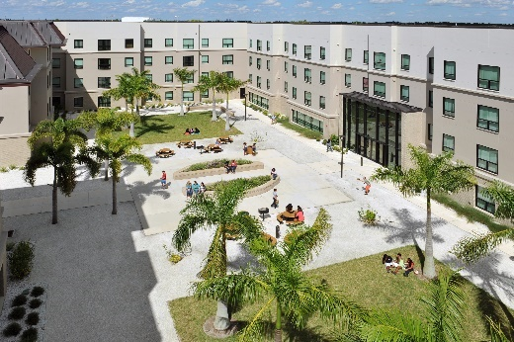
A residence hall located on the Lee campus, housing 400 students opened in August 2012. Access to the building is restricted to residents and authorized guests. Card reader access controls the main doors and doors to each suite. Suites are either two-bedroom or four-bedroom. Public safety has an officer working the front desk 24/7 and Residence Life has live-in staff and resident assistants in the building.

RESIDENCE FIRE SAFETY

The Campus Fire Safety Right-to-Know Act requires colleges that maintain on-campus student housing facilities to publish an annual fire safety report that outlines fire safety systems, policies, practices, and statistics.
A Fire Log will be maintained of all fire-related incidents occurring within the Light House Commons residence hall. This log will include the incident type, date incident is reported, date and time of occurrence, general location of each reported incident type and the disposition of the incident if that information is known.
Inquiries regarding the fire log should be directed to the office of Public Safety.
An institution with on-campus student housing facilities is required to:
- Maintain a log of all reported fires that occur in those on-campus student housing facilities,
- Publish an annual fire safety report that contains fire safety policies and fire statistics for each of those facilities, and
- Submit the fire statistics from the fire safety report annually to Department of Education
Fire is defined as any instance of open flame or other burning in a place not intended to contain the burning or in an uncontrolled manner.

FACILITIES AND FIRE PROTECTIONS SYSTEMS
The building and each suite/bedroom is protected by a full sprinkler system and fire alarm system. When a fire alarm is activated, the fire department and Public Safety are notified. Lee campus police and public safety officers work 24 hours a day, 365 days a year and will respond. Residence Life personnel will also respond to determine the cause of the alarm and how the fire department should respond. In addition to the sprinkler and alarm systems, the building contains portable fire extinguishers in designated locations. FSW contracts with several fire inspection services to test alarms and sprinklers and all systems meet National Fire Protection (NFPA) requirements. The fire alarm system is tested on an annual basis to meet NFPA requirements.
Public Safety and Residence Life staff will conduct inspections of the fire extinguishers in the building at least on a monthly basis.
FIRE SAFETY EDUCATION AND TRAINING
Public Safety, Residence Life, along with the fire department, conduct in-depth fire safety training with the Residence Life staff each year. Training sessions on fire safety, fire evacuation protocol, and the role of the Resident Assistant (RA) in any fire related emergency are conducted each year during Resident Assistant training. The RA’s are also trained on fire extinguisher use. Planned fire drills, coordinated with the local fire department, Public Safety, and Residence Life staff are conducted each year. Fire evacuation procedures are also published in the Housing Guide and can be found at http://housing.fsw.edu/
In addition to the planned fire drills, the Residence Life staff performs fire and life safety inspections in every suite/bedroom each month to ensure no fire/life safety issues exist.
FIRE SAFETY POLICIES
The following are prohibited in the residence hall:
  - Smoking
  - Use of candles and/or incense
  - Use of open flame appliances
  - Tampering or playing with fire extinguishers, smoke detectors, sprinkler heads, exit lights, emergency lights, or other emergency equipment
  - Starting a fire
  - Leaving food cooking unattended
FSW MISSING RESIDENTIAL STUDENT NOTIFICATION PROCEDURE
In the event that a student is determined to be missing, the Office of Housing and Residence Life will attempt to notify the listed contacts for the student as well as those emergency contact persons identified in BANNER within 24 hours. For each such student who is under 18 years of age, and not an emancipated individual, the Office of Housing and Residence Life is required to notify a custodial parent or guardian no later than 24 hours after the time that the student is determined to be missing.
When a report of a missing student is received by the Office of Housing and Residence Life, the department will conduct a preliminary investigation in order to verify the complaint and to determine the circumstances relating to the reported missing student. If the student's absence is verified, within 24 hours the incident will be reported and shared with FSW’s Office of the Dean of Student Affairs, Public Safety and the Lee County Sheriff’s Office. All entities will continue the investigation to locate the missing student. If, after further investigation, the missing student is not located, all entities will determine the most efficient manner of continuing the investigation.

ANNUAL REPORT OF CRIME STATISTICS

POLICY FOR REPORTING THE ANNUAL DISCLOSURE OF CRIME STATISTICS

The Department prepares this report to comply with the Jeanne Clery Disclosure of Campus Security Policy and Crime Statistics Act. Florida SouthWestern State College Annual Security Report can be accessed on the Web by visiting the Campus Safety link on the FSW home page at http://www.fsw.edu/publicsafety or through the U. S. Department of Education website: http://ope.ed.gov/security/Index.aspx. This report includes statistics for the previous three years concerning reported crimes that occurred on campus; in certain off-campus buildings or property owned or controlled by the College and on public property within, or immediately adjacent to and accessible from, the campus. The report shows campus crime, arrest, and referral statistics including those reported to public safety, designated campus security authorities (including but not limited to directors, deans, department heads), and local sheriff’s offices’. The report also includes institutional policies concerning campus security, such as policies concerning sexual assault, and other matters.

 | Violent Offenses |  |  | 2017 |  | 2018 | % Change
 | Murder |  |  | 0 |  | 0
 | Rape |  |  | 0 |  | 0
 | Robbery |  |  | 0 |  | 0
 | Aggravated Assault |  |  | 0 |  | 0
 | Violent Offense Total |  |  | 0 |  | 0
 | Violent Crime Rate |  |  | N/A |  | N/A
 | Property Offenses |  |  | 2017 |  | 2018 | % Change
 | Burglary |  |  | 0 |  | 0
 | Larceny |  |  | 11 |  | 6 | -45.5%
 | Motor Vehicle Theft |  |  | 0 |  | 0
 | Property Offense Total |  |  | 11 |  | 6 | -45.5%
 | Property Crime Rate |  |  | N/A |  | N/A
 | Total Index Offenses |  |  | 11 |  | 6 | -45.5%
 | Clearance Rate for Index Offenses |  |  | 0.0 |  | 0.0
 | Other Offenses |  |  | 2017 |  | 2018 | % Change
 | Arson |  |  | 0 |  | 0
 | Fondling |  |  | 2 |  | 0 | -100.0%
 | Human Trafficking - Founded |  |  | 0 |  | 0
 | Simple Assault |  |  | 6 |  | 2 | -66.7%
 | Domestic Violence Offenses |  |  | 2017 |  | 2018 | % Change
 | Murder |  |  | 0 |  | 0
 | Manslaughter |  |  | 0 |  | 0
 | Rape |  |  | 0 |  | 0
 | Fondling |  |  | 0 |  | 0
 | Aggravated Assault |  |  | 0 |  | 0
 | Aggravated Stalking |  |  | 0 |  | 0
 | Simple Assault |  |  | 1 |  | 0 | -100.0%
 | Threat/Intimidation |  |  | 0 |  | 0
 | Simple Stalking |  |  | 0 |  | 0
 | Total Domestic Violence Offenses |  |  | 1 |  | 0 | -100.0%
 | Arrests |  |  | 2017 |  | 2018 | % Change
 | Murder |  |  | 0 |  | 0
 | Rape |  |  | 0 |  | 0
 | Robbery |  |  | 0 |  | 0
 | Aggravated Assault |  |  | 0 |  | 0
 | Burglary |  |  | 0 |  | 0
 | Larceny |  |  | 0 |  | 0
 | Motor Vehicle Theft |  |  | 0 |  | 0
 | Part II |  |  | 6 |  | 2 | -66.7%
 | Total Arrests |  |  | 6 |  | 2 | -66.7%
 |  |  | Breakdown of Total Arrests - 20 |  |  | 18
 | Male Arrests |  | 1 | Female Arrests |  |  | 1
 | Adult Arrests |  | 2 | Juvenile Arrests |  |  | 0
 | Vehicle Recoveries |  |  | 2017 |  | 2018 | % Change
 | Stolen Local/Recovered Local |  |  | 0 |  | 0
 | Stolen Local/Recovered Elsewhere |  |  | 0 |  | 0
 | Stolen Elsewhere/Recovered Local |  |  | 0 |  | 0
 | Stolen/Recovered Property |  |  | 2017 |  | 2018 | % Change
 | Total Stolen Property |  |  | $3,540 |  | $2,997 | -15.3%
 | Total Recovered Property |  |  | $0 |  | $0
 | Law Enforcement Officers Killed /Assaulted (LEOKA) - 2018 |  |  |  |  | Total | 0
 | Officers Killed |  | 0 | Officers Assaulted |  |  | 0
 | Justifiable Homicide - 2018 |  |  |  |  | Total | 0
 | By Police Officer |  | 0 | By Private Citizen |  |  | 0

MEASURE | 2017 | 2018 | Percent Change
Total Index Crime  Total Violent Crime  Total Property Crime  Total Crime Rate  Violent Crime Rate  Property Crime Rate | 11  0  11 | 6  0  6 | -45.5  -45.5
ARREST TYPE | 2017 | 2018 | Percent Change
Violent Offense Arrests  Adult  Juvenile  Male  Female  Property Offense Arrests  Adult  Juvenile  Male  Female  Part II Offense Arrests  Adult  Juvenile  Male  Female | 0  0  0  0  0  0  0  0  0  0  6  6  0  6  0 | 0  0  0  0  0  0  0  0  0  0  2  2  0  1  1 | -66.7  -66.7  -83.3
TOTAL ARRESTS | 6 | 2 | -66.7
 |  |  | Percent
PRIMARY OFFENSE | 2017 | 2018 | Change
Murder  Manslaughter  Rape  Fondling  Aggravated Assault  Aggravated Stalking Simple Assault  Threat/Intimidation  Simple Stalking | 0  0  0  0  0  0  1  0  0 | 0  0  0  0  0  0  0  0  0 | -100.0
TOTAL OFFENSES | 1 | 0 | -100.0
 | STOLEN | RECOVERED
PROPERTY TYPE | VALUE | VALUE
Currency, Note, Etc.  Jewelry, Precious Metals  Clothing & Furs  Motor Vehicles  Office Equipment  TVs, Radios, Stereos  Firearms  Household Goods  Consumable Goods  Livestock  Miscellaneous | 500  0  0  50  0  0  0  0  0  0 2,447 |  | 0  0  0  0  0  0  0  0  0  0  0
TOTAL VALUES | 2,997 |  | 0

INDEX OFFENSES | 2017 | 2018 | Percent Change
Murder  Firearm  Knife/Cutting Instr.  Hands/Fists/Feet  Other  Rape  Firearm  Knife/Cutting Instr.  Hands/Fists/Feet  Other  Robbery  Firearm  Knife/Cutting Instr.  Hands/Fists/Feet  Other  Aggravated Assault Firearm  Knife/Cutting Instr.  Hands/Fists/Feet  Other  Burglary  Forced Entry  No Forced Entry  Attempted Entry  Larceny  Pocket Picking  Purse Snatching  Shoplifting  From Motor Vehicle  Motor Vehicle Parts  Bicycles  From Building  From Coin Oper. Dev.  All Other  Motor Vehicle Theft | 0  0  0  0  0  0  0  0  0  0  0  0  0  0  0  0  0  0  0  0  0  0  0  0  11  0  0  0  1  1  1  4  2  2  0 | 0  0  0  0  0  0  0  0  0  0  0  0  0  0  0  0  0  0  0  0  0  0  0  0  6  0  0  3  0  1  0  2  0  0  0 | -45.5  -100.0  0.0  -100.0  -50.0 -100.0  -100.0
TOTAL INDEX OFFENSES | 11 | 6 | -45.5

CRIME IN FLORIDA ABSTRACT
Florida Southwestern State College PD January - December 2018

Year | Index Total Crimes | % Change | Violent Crime | % Change | Property Crime | % Change | Population | % Change | Crime Rate | % Change
2014  2015  2016  2017  2018 | 18  22  14  11 6 | 5.9 22.2 -36.4  -21.4  -45.5 | 3  2  0  0  0 | -33.3  -100.0 | 15  20  14  11  6 | -11.8 33.3 -30.0  -21.4  -45.5 | 0  0  0  0  0

Domestic Violence
by Offense Type to Victim's Relationship to Offender
OFFENSES |  |  | RELATIONSHIP VICTIM TO OFFENDER |  |  |  |  |  |  | Arrests
 | Total | Spouse | Parent | Child | Sibling |  | Other Family | Cohabitant | Other
Murder  Manslaughter | 0  0 | 0  0 | 0  0 | 0  0 | 0  0 |  | 0  0 | 0  0 | 0  0 | 0  0
Rape | 0 | 0 | 0 | 0 | 0 |  | 0 | 0 | 0 | 0
Fondling | 0 | 0 | 0 | 0 | 0 |  | 0 | 0 | 0 | 0
Aggravated Assault | 0 | 0 | 0 | 0 | 0 |  | 0 | 0 | 0 | 0
Aggravated Stalking  Simple Assault | 0  0 | 0  0 | 0  0 | 0  0 | 0  0 |  | 0  0 | 0  0 | 0  0 | 0  0
Threat/Intimidation  Simple Stalking | 0  0 | 0  0 | 0  0 | 0  0 | 0  0 |  | 0  0 | 0  0 | 0  0 | 0  0
TOTAL OFFENSES | 0 | 0 | 0 | 0 | 0 |  | 0 | 0 | 0 | 0
Arrest Totals by Age and Sex
Florida Southwestern State College PD January - December 2018

OFFENSES | JUVENILE |  |  |  | ADULT |  | TOTAL ALL AGES
 | Total | Male | Female | Total | Male | Female
Murder  Rape  Robbery  Aggravated Assault  Burglary  Larceny  Motor Vehicle Theft | 0  0  0  0  0  0  0 | 0  0  0  0  0  0  0 | 0  0  0  0  0  0  0 | 0  0  0  0  0  0  0 | 0  0  0  0  0  0  0 | 0  0  0  0  0  0  0 | 0  0  0  0  0  0  0
TOTAL  INDEX | 0 | 0 | 0 | 0 | 0 | 0 | 0
Manslaughter  Kidnap/Abduction  Arson  Simple Assault  Drug Arrests  Bribery  Embezzlement  Fraud  Counterfeit/Forgery  Extortion/Blackmail  Intimidation  Prostitution/Commercialized Sex  Fondling  Other Sex Offenses  Stolen Property Buy/Receive/Possess  Driving Under Influence  Destruction/Damage/Vandalism  Gambling  Weapons Violations  Liquor Law Violations  Miscellaneous | 0  0  0  0  0  0  0  0  0  0  0  0  0  0  0  0  0  0  0  0  0 | 0  0  0  0  0  0  0  0  0  0  0  0  0  0  0  0  0  0  0  0  0 | 0  0  0  0  0  0  0  0  0  0  0  0  0  0  0  0  0  0  0  0  0 | 0  0  0  1  1  0  0  0  0  0  0  0  0  0  0  0  0  0  0  0  0 | 0  0  0  1  0  0  0  0  0  0  0  0  0  0  0  0  0  0  0  0  0 | 0  0  0  0  1  0  0  0  0  0  0  0  0  0  0  0  0  0  0  0  0 | 0  0  0  1  1  0  0  0  0  0  0  0  0  0  0  0  0  0  0  0  0
TOTAL PART II | 0 | 0 | 0 | 2 | 1 | 1 | 2
TOTAL | 0 | 0 | 0 | 2 | 1 | 1 | 2

Arrest Totals Comparative Data
Florida Southwestern State College PD January - December 2018
OFFENSES | JUVENILE |  |  | ADULT |  |  |  | TOTAL ALL AGES
 | 2017 | 2018 | Percent Change | 2017 | 2018 | Percent Change | 2017 | 2018 | Percent Change
Murder  Rape  Robbery  Aggravated Assault  Burglary  Larceny  Motor Vehicle Theft | 0  0  0  0  0  0  0 | 0  0  0  0  0  0  0 |  | 0  0  0  0  0  0  0 | 0  0  0  0  0  0  0 |  | 0  0  0  0  0  0  0 | 0  0  0  0  0  0  0
TOTAL INDEX | 0 | 0 |  | 0 | 0 |  | 0 | 0
Manslaughter  Kidnap/Abduction  Arson  Simple Assault  Drug Arrests  Bribery  Embezzlement  Fraud  Counterfeit/Forgery  Extortion/Blackmail  Intimidation  Prostitution/Commercialized Sex  Fondling  Other Sex Offenses  Stolen Property Buy/Receive/Possess  Driving Under Influence  Destruction/Damage/Vandalism  Gambling  Weapons Violations  Liquor Law Violations  Miscellaneous | 0  0  0  0  0  0  0  0  0  0  0  0  0  0  0  0  0  0  0  0  0 | 0  0  0  0  0  0  0  0  0  0  0  0  0  0  0  0  0  0  0  0  0 |  | 0  0  0  1  3  0  0  0  0  0  0  0  1  0  0  0  0  0  0  0  1 | 0  0  0  1  1  0  0  0  0  0  0  0  0  0  0  0  0  0  0  0  0 | 0.0  -66.7  -100.0  -100.0 | 0  0  0  1  3  0  0  0  0  0  0  0  1  0  0  0  0  0  0  0  1 | 0  0  0  1  1  0  0  0  0  0  0  0  0  0  0  0  0  0  0  0  0 | 0.0  -66.7  -100.0  -100.0
TOTAL PART II | 0 | 0 |  | 6 | 2 | -66.7 | 6 | 2 | -66.7
TOTAL | 0 | 0 |  | 6 | 2 | -66.7 | 6 | 2 | -66.7

Uniform Crime Reports - Offense Reporting Form
Crime Index and Domestic Violence Offenses - Page 1 of 2
Florida Southwestern State College PD January - December 2018
CLASSIFICATION OF OFFENSES | TOTAL  NUMBER  OF  OFFENSES |  | TOTAL CLEARANCES |  |  | TOTAL  VALUE OF  PROPERTY  STOLEN ($) |  | WEAPON |  |  |  |  | DOMESTIC VIOLENCE
 |  |  |  |  |  |  | Firearm | Knife or Cutting Instr. | Other  Dangerous  Weapon | Hands,  Fists or  Feet | Number of  Offenses |  | RELATIONSHIP VICTIM TO OFFENDER |  |  |  |  |  | Arrests
 |  | Arrest | Exception | Adult | Juvenile |  |  |  |  |  |  | Spouse | Parent | Child | Sibling | Other Family | Cohabitant | Other
Criminal Homicide  Murder  Manslaughter | 0  0  0 | 0  0  0 | 0  0  0 | 0  0  0 | 0  0  0 | 0  0  0 | 0  0  0 | 0  0  0 | 0  0  0 | 0  0  0 | 0  0  0 | 0  0  0 | 0  0  0 | 0  0  0 | 0  0  0 | 0  0  0 | 0  0  0 | 0  0  0 | 0  0  0
Index Sex Offenses  Rape, Committed  Rape, Attempted | 0  0  0 | 0  0  0 | 0  0  0 | 0  0  0 | 0  0  0 | 0  0  0 | 0  0  0 | 0  0  0 | 0  0  0 | 0  0  0 | 0  0  0 | 0  0  0 | 0  0  0 | 0  0  0 | 0  0  0 | 0  0  0 | 0  0  0 | 0  0  0 | 0  0  0
Robbery  Highway  Residence  Bank  Gas / Service Station Convenience Store  Other Commercial Estab. Miscellaneous | 0  0  0  0  0  0  0  0 | 0  0  0  0  0  0  0  0 | 0  0  0  0  0  0  0  0 | 0  0  0  0  0  0  0  0 | 0  0  0  0  0  0  0  0 | 0  0  0  0  0  0  0  0 | 0  0  0  0  0  0  0  0 | 0  0  0  0  0  0  0  0 | 0  0  0  0  0  0  0  0 | 0  0  0  0  0  0  0  0
Aggravated Assault  Aggravated Assault  Aggravated Stalking | 0  0  0 | 0  0  0 | 0  0  0 | 0  0  0 | 0  0  0 |  | 0  0  0 | 0  0  0 | 0  0  0 | 0  0  0 | 0  0  0 | 0  0  0 | 0  0  0 | 0  0  0 | 0  0  0 | 0  0  0 | 0  0  0 | 0  0  0 | 0  0  0
TOTAL VIOLENT  (Excluding Manslaughter) | 0 | 0 | 0 | 0 | 0 | 0 | 0 | 0 | 0 | 0 | 0 | 0 | 0 | 0 | 0 | 0 | 0 | 0 | 0
Fondling  Simple Assault  Threat/Intimidation  Simple Stalking | 0  2 | 0  1 | 0  1 | 0  2 | 0  0 | 0 | 0 | 0 | 0 | 0  2 | 0  0  0  0 | 0  0  0  0 | 0  0  0  0 | 0  0  0  0 | 0  0  0  0 | 0  0  0  0 | 0  0  0  0 | 0  0  0  0 | 0  0  0  0
 |  |  |  |  |  |  |  | TOTAL DOMESTIC VIOLENCE |  |  | 0 | 0 | 0 | 0 | 0 | 0 | 0 | 0 | 0
Uniform Crime Reports - Offense Reporting Form
Crime Index and Domestic Violence Offenses - Page 2 of 2
Florida Southwestern State College PD January - December 2018
 | TOTAL
 |  |  |  |  |  |  |  | ARSON
CLASSIFICATION OF | NUMBER OF | TOTAL CLEARANCES |  |  |  | TOTAL VALUE OF PROPERTY |  |  | TOTAL | TOTAL |  | TOTAL DOLLAR |  |  | CLEARANCES
OFFENSES | OFFENSES | Arrest | Exception | Adult | Juvenile | STOLEN ($) |  | LOCATION | INHABITED | ABANDONED | ATTEMPT | LOSS ($) |  |  | Adult | Juvenile
Burglary  Forcible Entry  Unlawful Entry  Attempted | 0  0  0  0 | 0  0  0  0 | 0  0  0  0 | 0  0  0  0 | 0  0  0  0 | 0  0  0  0 |  | Single Occupancy Residence  Other Residence  Storage  Industrial/Manufacturing  Commercial  Community/Public  All Other Structures  Motor Vehicles  Other Mobile  Other | 0  0  0  0  0  0  0  0  0  0 | 0  0  0  0  0  0  0  0  0  0 | 0  0  0  0  0  0  0  0  0  0 | 0  0  0  0  0  0  0  0  0  0 |  |  | 0  0  0  0  0  0  0  0  0  0 | 0  0  0  0  0  0  0  0  0  0
Burglary, Residence  Night  Day  Unknown | 0  0  0  0 | 0  0  0  0 | 0  0  0  0 | 0  0  0  0 | 0  0  0  0 | 0  0  0  0
Burglary, Non-Residence  Night  Day  Unknown | 0  0  0  0 | 0  0  0  0 | 0  0  0  0 | 0  0  0  0 | 0  0  0  0 | 0  0  0  0
 |  |  |  |  |  |  |  | ARSON TOTALS | 0 | 0 | 0 | 0 |  |  | 0 | 0
Larceny  Pocket Picking  Purse Snatching  Shoplifting  From Motor Vehicle  Motor Vehicle Parts  Bicycles  From Building  From Coin Oper. Dev.  All Other Larceny | 6  0  0  3  0  1  0  2  0  0 | 0  0  0  0  0  0  0  0  0  0 | 0  0  0  0  0  0  0  0  0  0 | 0  0  0  0  0  0  0  0  0  0 | 0  0  0  0  0  0  0  0  0  0 | 2,997 0  0  2,447  0  50  0  500  0  0
 |  |  |  |  |  |  |  | PROPERTY INFORMATION / VALUES
 |  |  |  |  |  |  |  |  |  |  |  |  |  | VEHICLE RECOVERY
 |  |  |  |  |  |  |  | PROPERTY TYPE | STOLEN VALUE ($) |  | RECOVERED VALUE ($)
 |  |  |  |  |  |  |  | Currency, Note, Etc.  Jewelry, Precious Metals  Clothing & Furs | 500  0  0 |  | 0  0  0 |  |  |  |  | Number
 |  |  |  |  |  |  |  |  |  |  |  |  |  | Stolen Locally and Recovered  Locally |  | 0
 |  |  |  |  |  |  |  | Motor Vehicles  Auto  Trucks and Buses  Motorcycles  Other Vehicles | 50  50  0  0  0 |  | 0  0  0  0  0
 |  |  |  |  |  |  |  |  |  |  |  |  |  | Stolen Locally and Recovered by Other Jurisdictions |  | 0
$200 & Over  $50 - $200  Under $50 | 5  1  0 | 0  0  0 | 0  0  0 | 0  0  0 | 0  0  0 | 2,947  50  0
 |  |  |  |  |  |  |  | Office Equipment  TVs, Radios, Stereos  Firearms  Household Goods  Consumable Goods  Livestock  Miscellaneous | 0  0  0  0  0  0 2,447 |  | 0  0  0  0  0  0  0
Motor Vehicle Theft  Auto  Trucks and Buses  Motorcycles  Other Vehicles | 0  0  0  0  0 | 0  0  0  0  0 | 0  0  0  0  0 | 0  0  0  0  0 | 0  0  0  0  0 | 0  0  0  0  0
 |  |  |  |  |  |  |  |  |  |  |  |  |  | Stolen in Other Jurisdictions and Recovered  Locally |  | 0
TOTAL PROPERTY | 6 | 0 | 0 | 0 | 0 | 2,997
ALL CRIME INDEX¹ | 6 | 0 | 0 | 0 | 0 | 2,997 |  | PROPERTY VALUE TOTALS | 2,997 |  | 0 |  |  | VEHICLES |  | 0

. HATE CRIME AND CARGO THEFT INCIDENTS REPORTED
Florida Southwestern State College PD
January - December 2018
 |  | REPORTED HATE CRIME INCIDENTS BY MONTH
ORI | AGENCY NAME | YEAR | JAN | FEB | MAR | APR | MAY | JUN | JUL | AUG | SEP | OCT | NOV | DEC
FL0361300 | Florida Southwestern State College PD | 2018 | 0 | 0 | 0 | 0 | 0 | 0 | 0 | 0 | 0 | 0 | 0 | 0
 |  | REPORTED CARGO THEFT INCIDENTS BY MONT |  |  |  |  |  | H
ORI | AGENCY NAME | YEAR | JAN | FEB | MAR | APR | MAY | JUN | JUL | AUG | SEP | OCT | NOV | DEC
FL0361300 | Florida Southwestern State College PD | 2018 | 0 | 0 | 0 | 0 | 0 | 0 | 0 | 0 | 0 | 0 | 0 | 0

Uniform Crime Reports - Supplemental Homicide Report
Florida Southwestern State College PD January - December 2018
Report  Number | Record Seq Nbr | Report  Date |  | Victim |  |  | Offend | er | Situation  Code | Victim Relationship | Weapon  Type | Circumstance  Code | Justifiable  Circumstance | Justifiable  Code
 |  |  | Age | Sex | Race | Age | Sex | Race
NO REPORTS

Uniform Crime Reports - Human Trafficking
Florida Southwestern State College PD January - December 2018

(UNVERIFIED - SUBMITTED DATA FOR REVIEW)
Report  Number | Record Seq Nbr | Incident  Date |  |  | Victim |  |  | Classification | Cleared  By | Offense  Status |  |  | Offender
 |  |  | Age | Sex | Race | Country | State |  |  |  | Age | Sex | Race | Country | State
NO REPORTS

Crime Statistics: The above charts reflect criminal offenses reported directly to FSW or through other law enforcement agencies or campus safety authorities. The Student Right To Know and Campus Security Act requires certain information regarding crime and policies relating to security be prepared, published and distributed to all students, employees and any applicant. These statistics are compiled through the Department of Public Safety.

NOTICE OF NON-DISCRIMINATION
Florida SouthWestern State College is committed to providing an educational and working environment free from discrimination and harassment.
All programs, activities, employment and facilities of Florida SouthWestern State College are available to all on a non-discriminatory basis, without regard to race, sex, age, color, religion, national origin, ethnicity, disability, sexual orientation, marital status, pregnancy, genetic information or veteran's status. The College is an equal access/equal opportunity institution. Questions pertaining to educational equity, equal access or equal opportunity should be addressed to the College’s Equity Officer.
The College Title IX Coordinator/Equity officer is:
Jana Sabo
Office of Human Resources
http://www.fsw.edu/humanresources/equityofficer
8099 College Parkway
Fort Myers, FL 33919
(239) 489-9305

