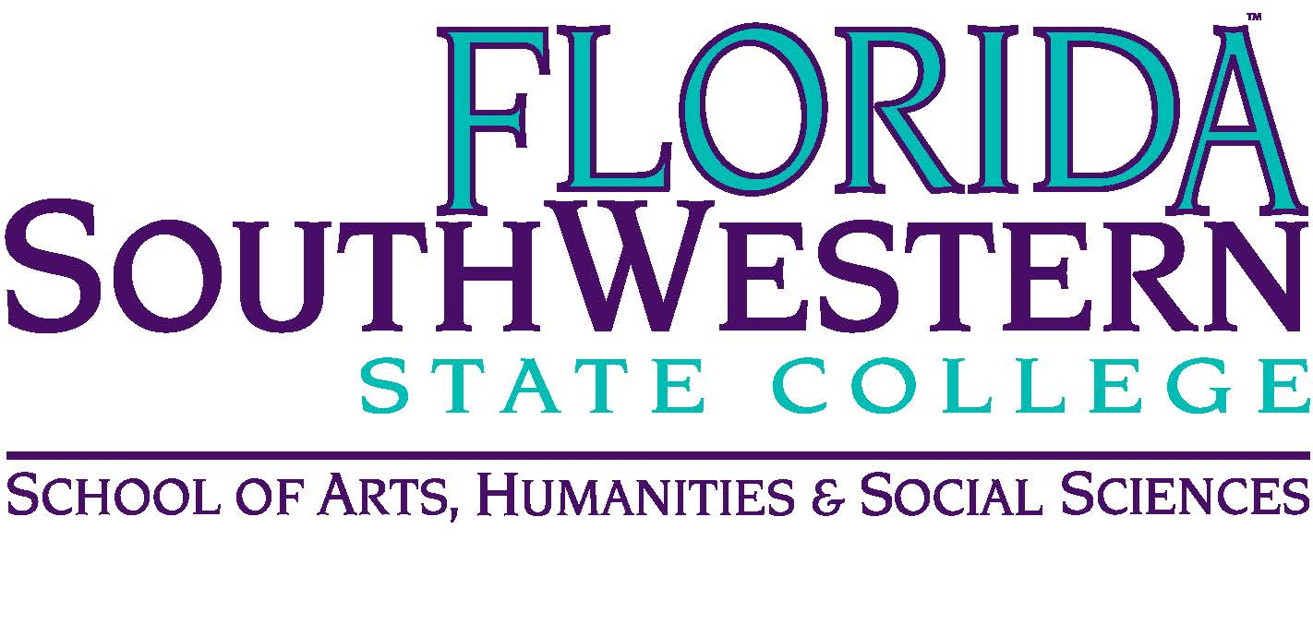
Department of Humanities and Fine Arts
Meeting Minutes
Date: November 8, 2019, 10:30 a.m.
Location: Edison/Lee campus (L-141)
Chair: Dana Roes
Minutes: Michael McGowan

 | Present | Absent | Excused
Brown | X
Chase, S | X
Chase, W | X
Doiron | X
Hoover | X
Lublink | X
McGowan | X
Mompoint | X
Pritchett | X
Roes | X
Sutter |  | X
Smith | X
Swanson |  | X
Molloy | X
Krupinski | X
Wurst |  | X
Guests

- Opening
  - Call to Order: 10:30 a.m.
  - Attendance taken
  - Minutes from October approved
- Announcements:
  - Black Maria Tonight
  - Food Pantry Volunteering on 11/22 (we’re packaging 2,500 meals)
  - Brain Bowl: Monica/Dale – six students are going to Orlando today, first competition (weekly practices are fun, HUM students as well as Science and Math students are involved)
  - Symposium: “Truth” on 11/21 from 3-5 pm
  - Mike McGowan’s new book, David Foster Wallace and Religion (Bloomsbury)
  - Theater update: Stuart mentioned “The Seagull” from 11/7-10 and 11/14-16. Opening night was tough: difficult for young actors, but everyone rose to the occasion. Checkov isn’t easy to understand for many Americans. Only one matinee on Sunday at 2 pm.
  - Music: see handouts for updates

- Information items
  - Sarah: PD Committee update:
    - Deadline: end of month Nov. 29th for Jan-March
    - Pedagogy Conferences: End of January in Daytona Shores (Monica and Elijah are presenting): Jan. 30-31.
    - SWFL Symposium on Teaching/Learning: two days, Thursday-Friday of the week at end of January, guest speaker, accepting proposals for presentations. Theme: “Active Learning”. Types of proposals:
      - Workshop
      - Round Table discussion
      - Deadline: end of this week
- Discussion Items
  - Assessment Dispositions
- Next Meeting: January TBA
ACTION ITEMS:
- None.

