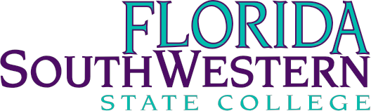
Library Faculty Department Meeting Minutes
Date: | November 10th, 2022
Time: | 9:00am- 10:00am
Location: | Zoom

Members | Present | Absent | Excused
Timothy Bishop | X
Jane Charles | X
Arenthia Herren | X
Richard Hodges | X
Martin McClinton |  |  | X
William Shuluk |  |  | X
Anthony Valenti | X
Victoria SanFilippo | X
Peter Van Leeuwen | X

- Librarian Updates – All

  - Tony: Currently facilitating one-on-one trainings on the Rialto Marketplace with librarians
    - Encouraging librarians for their input on collection development
  - Arenthia: Had a successful QEP event at Charlotte—great turnout and successful panel discussion with students and faculty members
    - Currently rearranging the OER Institute
  - Tim: Continuing to assist students with their Creative Capstone projects
    - Despite a continuous low turnout for one-on-one meetings for the projects, the meetings that do happen are productive and helpful conversations
ii. First-generation student Micro-workshop went well
  - Jane: Revised Student Satisfaction Survey for the library
    - Currently writing an article for Dataverse
ii. Emphasized the need for technical tracks for AA students
  - Victoria: Went to Gulf Coast High School to do a Research Instruction for four dual enrollment classes

- Director Updates - Dr. Hodges/Peter
  - Contract renewals (Dr. Hodges)
    - We have maxed out the number of students that can use Wall Street Journal (will be signing a 3-year long contract to fix the issue)
- Will move Westlaw to an FLVC contract in January
- Waiting on ProQuest representatives for their presentation on usage
  - Database suggestions (Peter)
    - Social Explorer (a data visualization platform): available on the A-Z Database List—encouraged librarians to check it out and see if it is worth keeping
- Ground News: a news media literacy platform that looks at the validity of source information and explains media bias (should we add this database?)

- Micro-workshops Spring 2023 – Arenthia

  - Emphasized the importance of offering multiple sections of one topic
- Arenthia requests librarians to complete and send her their schedule requests by the end of the semester to be ready by January
ii. Stressed the continuance of “word-of-mouth” to gain more attendees

- Strategic Initiatives Implementation/Programming Ideas – Dr. Hodges/All
a. Ran out of time to discuss—unanimous decision to have this discussion the week after Thanksgiving (tentative November 29, 2022 date)

- Questions/Concerns? – All

  - Tony: requests that information regarding this year’s Research Expo be added to the library homepage

Minutes recorded by Krista Biasella

