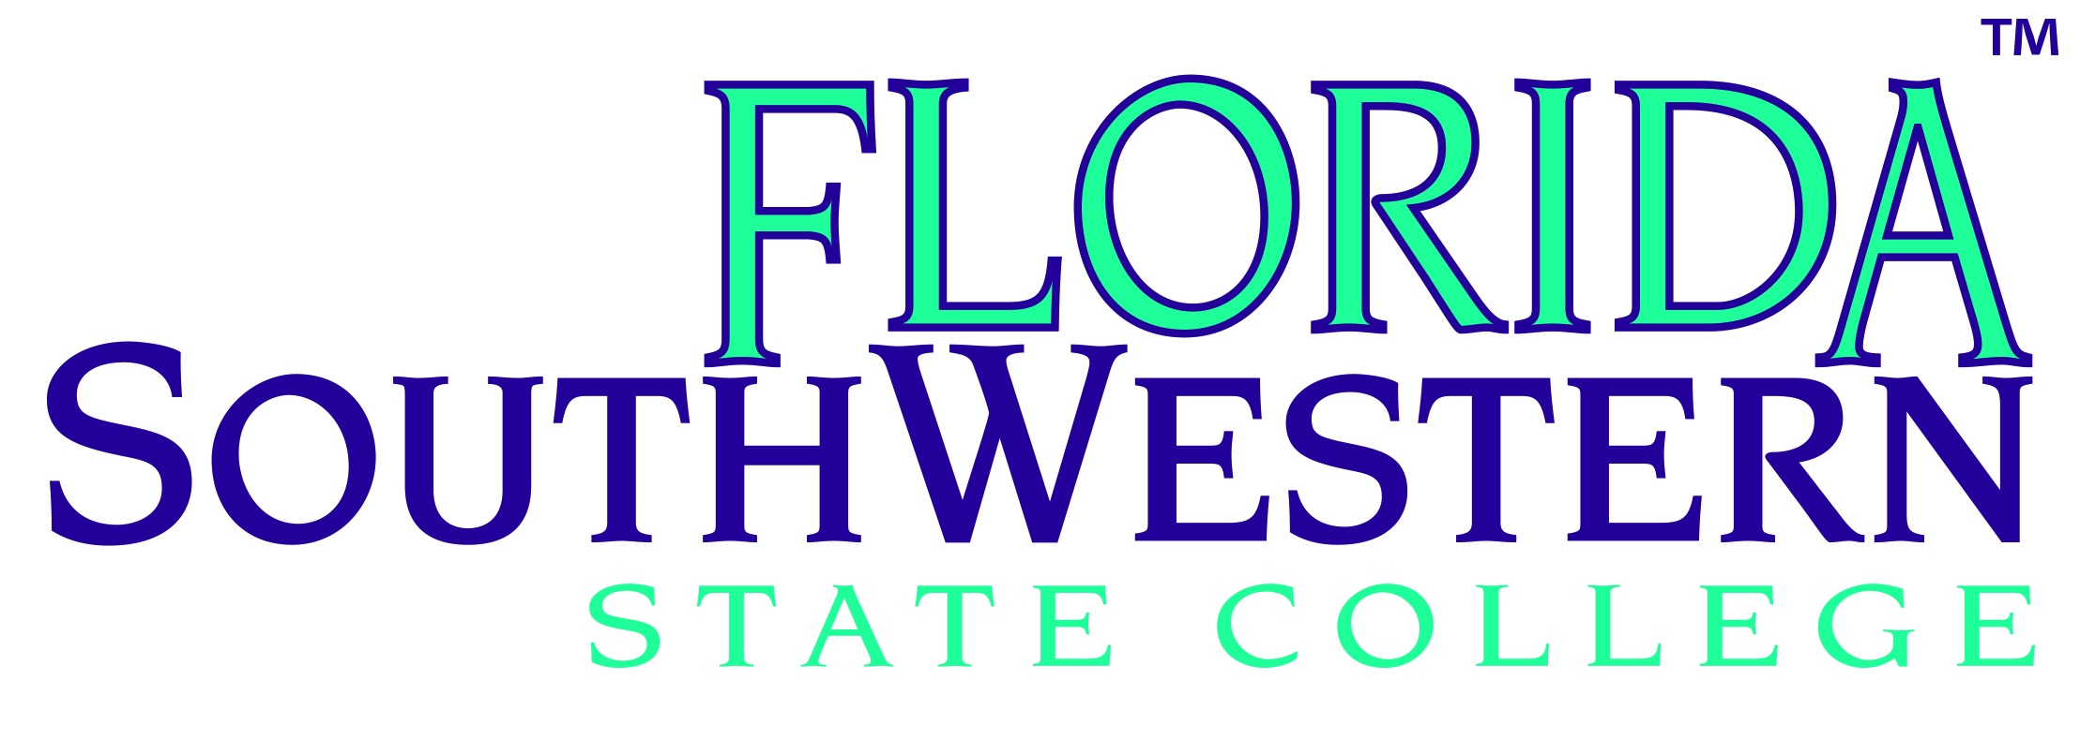
Agenda
Florida SouthWestern State College
District Board of Trustees
Charlotte Campus – O-117
November 14, 2017 CANCELLED
RESCHEDULED December 7, 2017
3:00 p.m.

Call to Order

Pledge to Flag

Introduction of Guests and Public Comment

President’s Report

Vote to Take Action On
- Approval of Minutes (a) New Member Orientation Meeting, (b) Regular Meeting and, (c) Charter School Governing Board Meeting September 26, 2017

Academic Affairs & Student Services Committee Report

Vote to Take Action On
- Course Deletions

Business Affairs & Facilities Committee Report

Vote to Take Action On
- Pre-Qualified General Contractors

- Continuing Services Engineering Firms

- Removal of College Property from Inventory

- FSW Foundation, Inc. – Certificate of Compliance

- FSW Foundation, Inc. – Direct-Support Organizations Audit Review Checklist

- FSW Foundation, Inc. – Audited Financial Report of FY Ended March 31, 2017

- FSW Financing Corporation – Certificate of Compliance

- FSW Financing Corporation – Direct-Support Organizations Audit Review Checklist

- FSW Financing Corporation – Audited Financial Report of FY Ended March 31, 2017

11(a). WALK-ON ITEM – Parking and Road Improvements on the Thomas Edison Campus

District Board of Trustees/Agenda
November 14, 2017
Page two

Consent Agenda
- Financial Services Consent Budget Amendments

- Approval of Personnel Actions

Information Only
- FSW Foundation, Inc. – Financial Statements as of June 30, 2017

- FSW Foundation, Inc. – Financial Statements as of September 30, 2017

- FSW Foundation, Inc. – Exemption Form 1023 and IRS Exemption Form 990

- FSW Financing Corporation, Inc. – Financial Statements as of June 30, 2017

- FSW Financing Corporation, Inc. – Financial Statements as of September 30, 2017

- FSW Financing Corporation, Inc. – Exemption Form 1023 & IRS Exemption Form 990

- FSW State College Monthly Financial Report

Institutional Advancement & Policy Committee Report

Vote to Take Action On
- Adoption of New District Board of Trustees Policy 6Hx6:1.10 (Emergency Operations)

- Approval of an Amendment to District Board of Trustees Policy 6Hx6:4.10 (Delinquent Accounts)

- WALK-ON ITEM – Approval of the Julia Rush Gift Agreement

Old Business – None

New Business

President’s Comments

Board Members’ Comments

Adjournment

Charter Schools Governing Board/Agenda
November 14, 2017
Page three

RECONVENE: The FSW State College District Board of Trustees reconvenes as the Florida SouthWestern State College Charter Schools Governing Board

Agenda
Florida SouthWestern State College
Charter Schools Governing Board
Charlotte Campus – O-117
November 14, 2017

Call to Order

Introduction of Guests and Public Comment

Reports to the Charter Schools Governing Board – None

Old Business – None

New Business

Other Business

Consent Agenda

- Collegiate High Schools Consent Agenda Budget Amendments

- Lee Campus Audited Financial Statements for FY Ended June 30, 2017

- Charlotte Campus Audited Financial Statements for FY Ended June 30, 2017

Information Only

- Collegiate High Schools Monthly Financial Report

President’s Comments

Board Members’ Comments

Adjournment

