**How to Set up Deflection in the OCLC Interlibrary Loan Policies Directory**

OCLC allows libraries to set up certain parameters in their Policies Directory so that certain types of items are restricted or excluded from interlibrary loan. CCLA’s new batchloading procedures will not take into account a college’s policy on what types of items are available for loan. CCLA will load all records (except eBooks) of a college’s collection. if they do not want to loan certain formats such as DVDs and CDs, the college will need to put these parameters in Policies Directory and the system will automatically mark those records as non-requestable.

To use this feature, please follow these instructions:

1. Go to the OCLC Policies Directory log in page at <https://illpolicies.oclc.org/dill-ui/SignIn.do> and log in using a valid OCLC authorization number and password.
2. The main policies page for your college should appear. Click on the Policies tab toward the top of the page.
3. A screen similar to this one should appear:  
     
   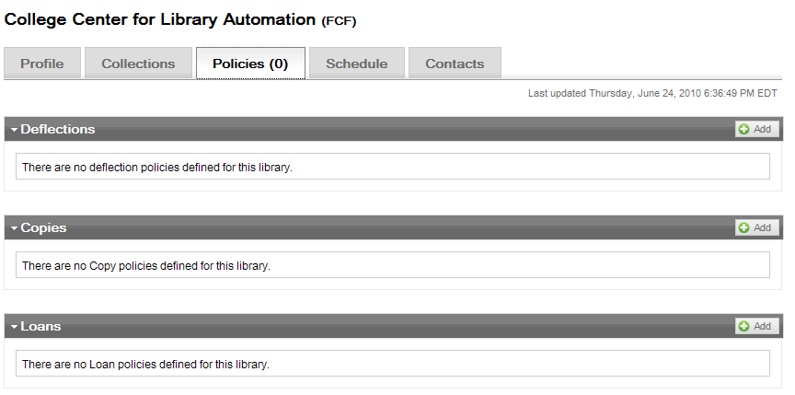  
     
   In the Deflections section, click on the Add button to create a rule.
4. A window box should appear:  
     
   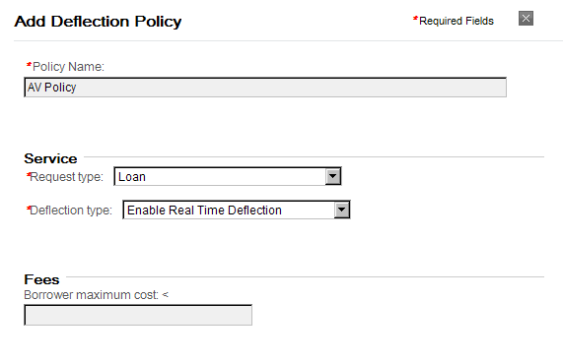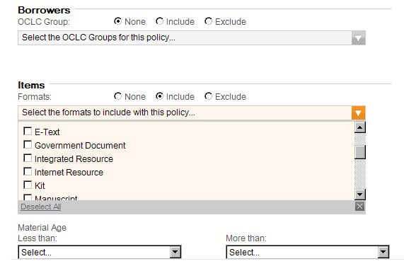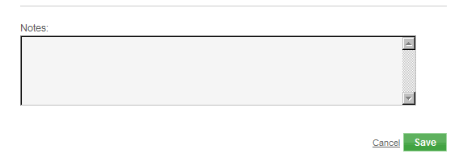  
     
   Fill out the following fields:
   1. **Policy Name:** Give the policy a name.
   2. **Service-Request Type:** Choose *Loan* for returnables or *Copy* for non-returnables.
   3. **Service-Deflection Type:** Choose “*Enable Real-Time Deflection*.”
   4. **Borrowers-OCLC Group:** Leave set at None.
   5. **Items-Formats:** Check *Include*, then click on the down arrow of the box below it to open the list of different formats. Click on the formats that you want to include in the deflection.
   6. **Items-Material Age:** Set if you want to limit by age.
   7. **Notes:** Enter any notes that you want.
5. Click Save. You should see your new policy in the Deflections section of your policies page.  
     
   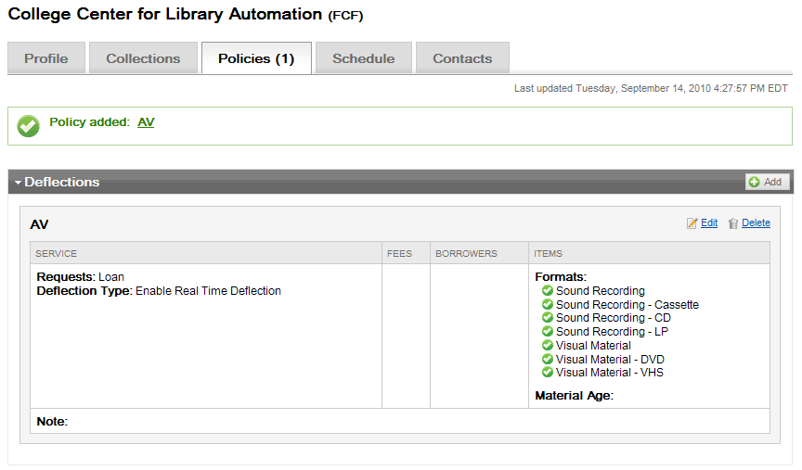
6. Click on Sign Out at the top of the screen.

Records that are owned by the college that meet this parameter will display with the institution’s symbol in lowercase. This indicates that the college owns the item, but they will not lend it to other OCLC ILL institutions.