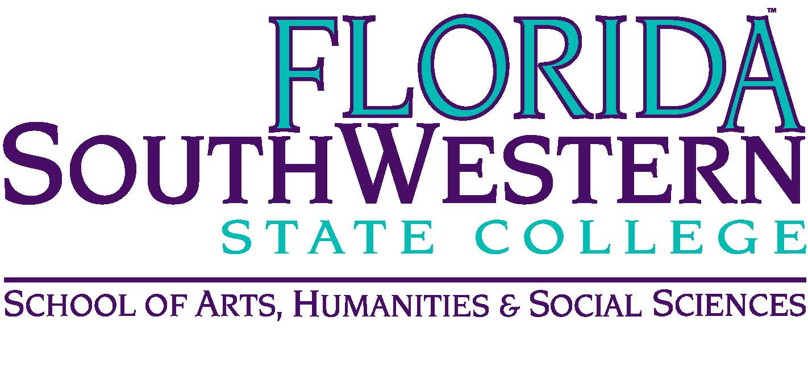
Department of Humanities and Fine Arts
Meeting Minutes
Date: February 11, 2021 – 10:00 a.m.
Location: Virtual/Online (Zoom)
Chair: Dana Roes
Minutes: Michael McGowan

 | Present | Absent | Excused
Brown | X
Chase, S | X
Chase, W |  |  | X
Doiron |  | X
Hoover |  |  | X
Lublink | X
McGowan | X
Mompoint | X
Pritchett | X
Roes | X
Sutter | X
Luther | X
Smith |  |  | X
Molloy | X
Krupinski | X
Wurst | X
Harrington | X
Chowdhury | X
Gresens | X
Others | Teed (briefly), Olsen, O’Neil

- Opening
  - Call to Order: 10:00 a.m.
  - Attendance taken
  - Minutes from January 2022 approved
- Announcements:
  - Myriam Mompoint, Congrats! (Myra Hale Walters Excellence Award)
  - Sabbatical Applications due today (2/11)
  - Also due today (2/11): Form 1
  - Textbook adoptions: coming end of March
  - Academic Achievement Award nominations due 2/25 (here’s a link: https://fsw.qualtrics.com/jfe/form/SV_aeNszb7rhbYMfKm)
  - Updates:
    - Theater: didn’t get an update from Stuart
    - Music: April 7 at 6 pm – Choir/string/guitar, April 19: Jazz, Concert, Bass ensemble (in garden)
    - Visual Arts: We’re getting rid of the ceramics classroom and changing it to a digital arts (even though we may hold onto the equipment until we know whether we’ll need it in the future)

- Information Items:
  - PD (Sarah): See link for ancillary funds (https://forms.gle/7RVyZdzS8CSj4qpt5).
  - Myriam: “Open Education Week” (people using OERs talk about how it’s going) is March 7-11 (asynchronous and done by team). Get a TLC certificate. If interested in hosting, 2/28 is the deadline to submit to Arenthia. Over the summer, a projected OER Institute.
  - This Wednesday at 10 a.m. – Jaime, Ryan, and Shimul on “Vulnerability in the Classroom”
  - Search Committees: 2 Humanities, 1 Digital Arts (we may get the philosophy line again in a couple years if demand picks up)
  - Molloy: Internship program (see him)
  - Faculty Senate: Brandon Jett is passionate about it, so Elijah withdrew his nomination. The “No Confidence” vote ended up being effective.
  - Assessment (Elijah): We are doing an Assessment review in April, extending our April department meeting for probably 1-2 hours. (We’re still the model for other departments on Assessment issues). (April 8)
  - Research Expo (Joe and Team Aspire): April 4-6. There are still poster slots and research slots. Reach out to Joe or Jessica Goodwin. (Check out the Digital Arts Exhibition on April 6)
  - Chair position: if you’re interested, send an email to Dr. DeLuca and Dr. Teed.

- Next Meeting:
  - 4/8/22 at 10:00 a.m. until noon (for Assessment review, too)
  - Zoom link: https://fsw.zoom.us/j/95723378548

