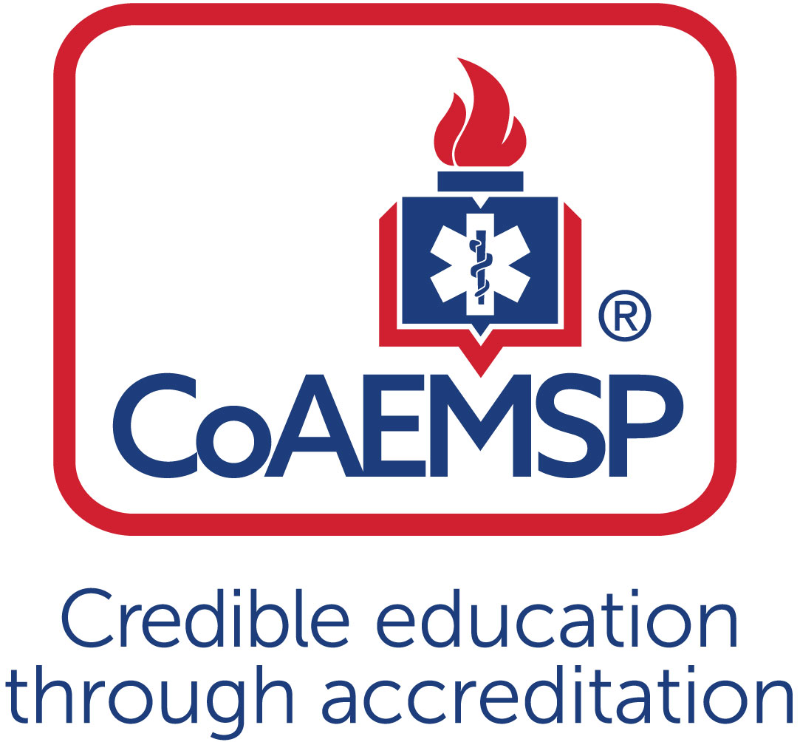
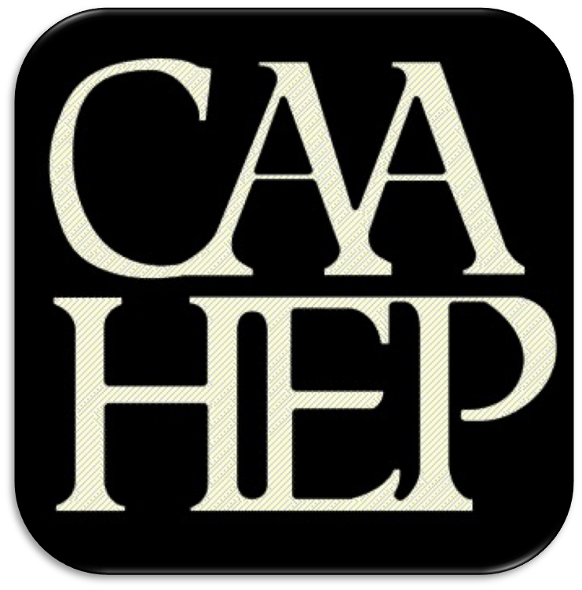

Advisory Committee Meeting Minutes

See last page for the purpose of the program’s Advisory Committee, including a description and list of responsibilities.

SPONSOR / INSTITUTION NAME: | Florida SouthWestern State College
CoAEMSP PROGRAM NUMBER: | 600034 | DATE, TIME, + LOCATION OF MEETING: | April 20,2021
CHAIR OF THE ADVISORY COMMITTEE: | Chief Dan Seiber

ATTENDANCE

Community of Interest | Name(s) – List all members. Multiple members may be listed in the same category. | Present – Place an ‘x’ for each person present | Agency/Organization
Physician(s) (may be fulfilled by Medical Director) | Dr. Alex Rodi, DO
Employer(s) of Graduates Representative | Bruce Gastineau  Larry Arfmann  Arthur Wolf  Curtis Rine  Randy Krause  Noemi Fraguela  Joseph Maguire | x  X  x | Assistant Chief Collier County EMS  Division Chief Lehigh Acres Fire  Collier County Training Captain  Charlotte County Fire Training Captain  Ft. Myers Beach Division Chief of EMS  Training Captain Collier County EMS  Deputy Chief Lee County EMS
Key Governmental Official(s) | Dan Summers  Britton Holdaway |  | Director, Emergency Management Services, Collier  Planning Manager Lee County
Police and Fire Services | Daniel Sieber  Jason Fair  Lance Pullen  Roy Brown | X | EMS Division Chief San Carlos Park Fire  Public Safety Director Charlotte County  City of FT Myers Deputy Chief of Operations Fire
Public Member(s) | Tom Brennan  James Connelly |  | Retired EMS/Fire Chief  Community Member/Prior Student
Hospital / Clinical Representative(s) | Theresa Foley  Risa Wildeman  Cathy Bartoszek  Lisa Cefalo  Kathleen Boyd  Noah Bourk  Amanda Garcia  Arlyn Fernandez  Jana Turcotte  Jennifer Craft  Louisa Smith  Mr. Dolan Abuaouf | x  x | Lee Health  NCH  Physicians Regional  Bayfront Health  Bayfront Health  Lee Health Trauma Center  Lee Health  Physicians Regional  Lee Health  Lee Health  Physicians Regional  Director of Academics and Medical Education at Lee Health
Other
Faculty | Linda Welch  Mike Knoop  Tracy House  Tamara Mole  Matthew Stachler  Tresa Hibben  Rima Stevens  Megan Davis  Leticia Guevara | X  x  x | EMS Support Specialist – EMS/FIRE Programs, FSW  EMS Support Specialist – EMS/FIRE Programs, FSW  EMS Support Specialist – EMS/FIRE Programs, FSW  EMS Support Specialist-EMS/Fire Programs, FSW  Program Coordinator-FSW  Program Coordinator-FSW  Clinical Coordinator-FSW  Clinical Adjunct-FSW/Lee County EMS  Clinical Adjunct-FSW/Lee County EMS
Sponsor Administration² | n/a | n/a | n/a
Student (current) | Alicia Keen |  | Paramedic Student FSW
Graduate | Jared Sullivan  Jessica Huckeby  Becca Green |  | Paramedic Graduate  Paramedic Graduate/Collier county EMS  Paramedic Graduate/Lee county EMS
Program Director, ex officio, non-voting member | Joe Washburn | x
Medical Director, ex officio, non-voting member | Dr. Alex Rodi

Agenda Item |  | Discussion | Action Required | Lead | Goal Date
 | Call to order | Dan Sieber | Yes / No | Sieber
 | Roll call | Welcome please sign into zoom chat that will be our roll call and record of who was here. | Yes / No | Sieber
 | Review and approval of meeting minutes | Review Minutes from October 2019 and May 2020.  Motion Approved and 100% I’s. | Yes / No | Sieber
 | Endorse the Program’s minimum expectation  [CAAHEP Standard II.C. Minimum Expectation]  - “To prepare competent entry-level Paramedics in the cognitive (knowledge), psychomotor (skills), and affective (behavior) learning domains with or without exit points at the Advanced Emergency Medical Technician and/or Emergency Medical Technician, and/or Emergency Medical Responder levels.”  - Establish / review additional program goals | Sieber: calls motion to endorse program minimums : “To prepare competent entry-level Paramedics in the cognitive (knowledge), psychomotor (skills), and affective (behavior) learning domains with or without exit points at the Advanced Emergency Medical Technician and/or Emergency Medical Technician, and/or Emergency Medical Responder levels.”  Motion Approved and 100% I’s. | Yes / No
 | Endorse the Program’s required minimum numbers of patient/skill contacts for each of the required patients and conditions  [CAAHEP Standard III.C.2. Curriculum]  - NEW Appendix G: Student Minimum Competency Matrix (effective July 1, 2019)  - Review summary graduate tracking reports | See Below  Sieber: Now we are going to speak about the G report. It has all the Minimum numbers for skills etc for the students.  Washburn: You are currently looking at one students G report. That is in the program they are half way through. The items in red we anticipate them going to green. Keep in mind none of these students have started any field work and or field experience. They have done only so far half of their clinical rotation. If you look in table one the first column, this is what the minimum recommendations are from our accreditation body. We have matched those minimum numbers at this time, this is our 3rd cohort utilizing these numbers. But we just received our first cohorts grad numbers so we feel like we need atleast 3 graduated groups numbers before we make any adjustments. To make sure we are not overzealous in raising them.  Sieber: Any questions or comments? About the G report or the minimums.  Arfamann: The red numbers are not a bad thing right?  Washburn: Its not a bad thing in this groups current position. If this was a student who was getting ready to graduate we would not be able to graduate them because they did not meet the programs minimums. We are constantly reviewing this report and having the students review it as well. Especially in the hospital settings, we have a clinical associate with them to help facilitate some of those peds numbers.  Stevens: This new cohort has completed 72 hrs of the 140 hrs of clinical. They still have 65 left. I am adding an extra peds ed shift to each semester. I do have a Clinical Associate who has a peds background to go with them.  Sieber: Motion to endorse Program minimums.  McGuire: Motion  Arfamann: Second  Sieber: Motion Approved. | Yes / No | Washburn
 | Review the program’s annual report and outcomes  [CAAHEP Standard IV.B. Outcomes]  - Annual Report data  - Thresholds/Outcome data results  - Graduate Survey results  - Employer Survey results  - Resources Assessment Matrix results  - Other | Sieber: Annual Report and outcome data is next.  Washburn: Our annual report as of 2017 was redesigned by our accrediting body. It’s looking in the rears of not the past year but the year before that. This is from 2019. One of the reasons for that is that we do not send out any kind of surveys until they have been graduate for 6 months. The accreditation body realizes that in order to do that they need to redesign the annual report so that they can have that info. For 2019 we met all of our requirements accept our retention area. All areas need to be at the 70% threshold. We were at a 62.5%. We knew this was going to happen so we need to create a plan of action. What we did was we took applications, required them to take an entrance exam, and then did an interview. We started this with our 2019-2020 cohort. We selected 24 students that did the best across all areas. Prior to that we would take everyone which was anywhere from 50 to 60 students. We would only graduate around 30 students. So with this cohort we had 40 students and only 25 graduate. When we are not selective in the early process we get students who may not be prepared for the long time commitment for our program. I think what you will find in our next annual report is that we will have passed the threshold of 70%. For our pass rates for the National Registry we met that threshold we had 87.5 pass rate. Me also again met the threshold of positive placement. That’s them out there working out in the field as a medic and we are at 72% for that. Graduate surveys we sent out 100%.  Sieber: Any questions from the group about the annual report? Any suggestions on the retention piece or how to get an employer to respond to the surveys? Ok moving on to other assessment results.  Tammy: We do a RAM survey every year. The students and and staff including advisory board fill them out. The summary of reasons for drops 6 failed Theory 1 which is our very first semester. 6 of them dropped for employment reasons. About 7 of them dropped for unknown reasons. The 3 top positive comments that we received, they liked the open lab and the equipment that we have. The hands-on experience and the field internship/ CA’s. The negative comments where that there was too much hospital and clinical time. We had a few comments about negativity of preceptors to students. They also did like some of the CA”S. Some people said the CA’s where great and then others not so much. I just looked at the recent Ram Surveys from 2020 and they had some of the same comments as well.  Washburn: I think the confusion for the Medics when they do the hospital time is that we are giving them the opportunity to be in a variety are areas ICU, stepdown units etc. For them it doesn’t seem to translate into emergency. A lot of the medics feel a lot of the hospital time should be spent in the ER. They fail to understand that they are getting exposed to the whole healthcare system. I think that we could do a better job of getting to understand that early. But if you compare our clinical hours to other schools nationally we are probably very low in our hrs. When you look at the state of FL compared to other states we are one of the lowest numbers for hours in the Medic program. We can work on getting them to understand it better. But where we are placing them today they need to understand the continued health care system and gets them to see a variety of medical conditions.  Stevens: I think their challenges are when I put them in a regular unit, they feel being with one nurse they only see what that nurse gets to see aka 4 same patients, they are medics they only want to see them for a limited time. I explained to them that that’s where they get most of the skills met and they can see the treatment progression. Im trying to explain the medic side of it to the nurses and educators, it’s a different culture. Its just a matter of miscommunication etc.  Davis: Playing off what Washburn was saying we need to instill into the students that’s it’s not all about what we are doing its about why we are doing it as well. All of the different floors play off of our emergency side of things. Which makes everyone a better provider at the entry level.  Turrcotte: As we move forward, I know now we are (Lee Health) are currently closed for Medics and EMT’s, I really hope for Fall we are able to open up. We won’t know till mid-summer. As we do move forward, if there is anything I can do to help support your message to the units and the directors so that they can filter that down. So that they know how important it is to have those medics on those floors. So they can say this is what they look when they come in the ER here is the transition though the diseases process.  Stevens: Yes, that would be wonderful thank you Jana. | Yes / No
 | Review the program’s other assessment results  [CAAHEP Standard III.D. Resource Assessment]  - Long-range planning  - Student evaluations of instruction and program  - Faculty evaluations of program  - Course/Program final evaluations  - Other evaluation methods | See above. | Yes / No
 | Review program changes (possible changes)  - Course changes  (schedule, organization, staffing, other)  - Preceptor changes  - Clinical and field affiliation changes  - Curriculum changes  - Content  - Sequencing | Sieber: Moving on to changes in the program.  Stevens: Because of Covid we had to make some changes, we where having trouble getting the students into the OR to get our intubations and other skills. We where able to reach out to a cadaver lab service and we booked for 2 days in June. And we are going to have the students do some intubations.  Washburn: When Professor Stevens was convinced we were not going to get back into the OR. She was able to reach out to company out of Sarasota that will transport a cadaver to our facilities. The cadaver will be here for 48 hrs. in that 48 hrs we will do multiple rotations with the students for them to achieve the intubations. Are hope is that that wont be the end of there intubations experience our hope is that if OR services did open up in Fall that even though the clinical is done, maybe we can try to get them in the OR for one day. To do a couple more lives intubations. Speaking with Dr. Rodi between the cadaver lab and the sim lab those will be their intubation commitment and sign off.  Sieber: Unfortunately, that’s the sign of the times. | Yes / No
 | Review substantive changes (possible changes)  [CAAHEP Standard V.E. Substantive Change]  - Program status  - Program personnel: PD, Lead Instructor, other  - Addition of distance education component  - Addition of satellite program | Sieber: Now moving on to substantive changes to the program.  Washburn: From a personnel perspective the college is in the search for a Dean for the School of Health Professions. Currently we are under the interim Dean who is the Vice Provost of the college Dr. Norman. They have started a search committee. I was hopeful that was going to happen by July 1. But it appears the first round many of the candidates withdrew or dropped out. So the search was closed. I think they will be starting a new coming up shortly. I don’t anticipate them filling the position until January 1st. From a program prespective we have lost one of our program coordinators. Professor Tressa Hibben is no longer working for FSW. So we are in the process of filiing that postion. We hope to have interviews at the end of the month. Hopefully we will have someone to till that slot and have them teach in both EMT and Paramedic. We will then send out a notification to the Advisory Board when that happens as well as post on social media. Nothing else is changing. We spoke in our last meeting about increasing clinical hours but due to covid we are going to have to wait until we get back to normal. | Yes / No
 | Other identified strengths | Sieber: We are video the final testing, opened up some eyes and created as much objectivity as possible with grading.  Arfmann: We have found that the last few hires that went through FSW they have been very prepared. Both EMT and Medics.  Mcgurie: I think that Covid unfortunately caused major problems but I think with this group coming though now they have a lot more experience in distributive technology. That will only help with outcomes. And what we are seeing is that the younger folks are coming in and helping the old folks adapt to different ways of learning. And it will probably only improve going forward. | Yes / No
 | Other identified weaknesses | Sieber: Concerns me that we are not getting into the clinical areas. Not sure there is a lot we can do about that.  Washburn: Yes, I would agree. The cadaver is going to the first time that we have that or use one. I agree they won’t be able to see a variety of airways. I am feeling better that we will have a human body vs. a simulated mannequin. Even pre covid the OR continues to be a challenge for our program. Especially with the increase in the nurse anesthetist programs. I know that Professor Stevens has tried to reach out to even just free standing OR centers. We just haven’t been successful.  Stevens: I did get a hold of NCH and they turned us down. Physical Regional same thing. The only place right now taking students is Cape Coral OR. We are waiting on the green light from Lee Health learning department.  Turcotte: I have been in this position since mid-summer last year. Let make sure I am clear with Lee Health only Cape coral hospital will allow medics in for intubations in the OR.  Stevens: Yes, that is the only one we have been utilizing for the last 2 years. I reached out to Health park they said no. Lee memorial we had a scheduling conflict with the EMTs so they said no more students. So, we would really like your help Jana when this is all over. If we can get 2 OR sites that would be great.  Turcotte: I know we have had some turnover with our educators. I will keep this on my radar. I would like to use the acute care OR before the ambulatory surgical centers.  Stevens: I did reach out to Sancutary and Coconut point and both said no.  Turcotte: I will touch base with you about this because intubations are really critical in there role so we want them to be proficient before they graduate. | Yes / No
 | Identify action plans for improvement |  | Yes / No
 | Other comments/recommendations |  | Yes / No
 | Staff/professional education |  | Yes / No
 | CoAEMSP/CAAHEP updates | See below. They are doing Accredicon this year but it is virtual. They have revamp anywhere from 25 to 30 forms. And created 15 forms for Covid. | Yes / No
 | Next accreditation process  (i.e., self-study report, site visit, progress report) | We are in the backlog for self-study report, so we are not sure when our site visit will happen. They are allowing virtual site visits. | Yes / No
 | Other business | Stevens: I am going to reach out to urgent cares and free- standing ERs. Hopefully we can send some EMT and Medics to those after we get affiliation agreements if they will let us in. Just to secure more options.  Dr. Rodi our Medical Director has tested positive for Covid. | Yes / No
 | Next meeting(s) | 4/2022 | Yes / No
 | Adjourn | Thank you everyone! | Yes / No

Minutes prepared by Date
Minutes approved by Date
If item #5 above was acted on, then:
Medical Director’s signature Date
Attach Appendix G > Table 1 to verify which required minimum numbers were reviewed and endorsed (if item #4 above was acted on)

PURPOSE OF THE ADVISORY COMMITTEE
The Advisory Committee must be designated and charged with the responsibility of meeting at least annually to assist program and sponsor personnel in formulating and periodically revising appropriate goals and learning domains, monitoring needs and expectations, and ensuring program responsiveness to change, and to review and endorse the program required minimum numbers of patient contacts. [CAAHEP Standard II.B. Appropriate of Goals and Learning Domains]

Additionally, program-specific statements of goals and learning domains provide the basis for program planning, implementation, and evaluation. Such goals and learning domains must be compatible with the mission of the sponsoring institution(s), the expectations of the communities of interest, and nationally accepted standards of roles and functions. Goals and learning domains are based upon the substantiated needs of health care providers and employers, and the educational needs of the students served by the educational program. [CAAHEP Standard II.A.]

Responsibilities of the Advisory Committee
- Review and endorse the minimum program goal.
- Review and endorse the required minimum numbers of patient/skill contacts for each of the required patients and conditions.
- Verify that the Paramedic program is adhering to the National Emergency Medical Services Education Standards.
- Review Program performance based on outcomes thresholds and other metrics (at a minimum credentialing success, retention, and job placement).
- Provide feedback to the Program on the performance of graduates as competent entry level Paramedics (for employers).
- Provide feedback to the Program regarding clinical and field opportunities and feedback on students in those areas.
- Provide recommendations for curricula enhancements based on local needs and scope of practice.
- Assist with long range planning regarding workforce needs, scheduling options, cohort size, and other future needs.
- Complete an annual resource assessment of the program.

The best practice is that the chair is not the Program Director. The Advisory Committee is advising the program.
Additional faculty and administration are ex-officio members.
Add rows for multiple members of the same community of interest If the program has additional named communities of interest, list the community of interest and the name(s) that represent each.
Additional program goals are not required by the CAAHEP Standards. If additional program goals are established, then the program must measure them.

