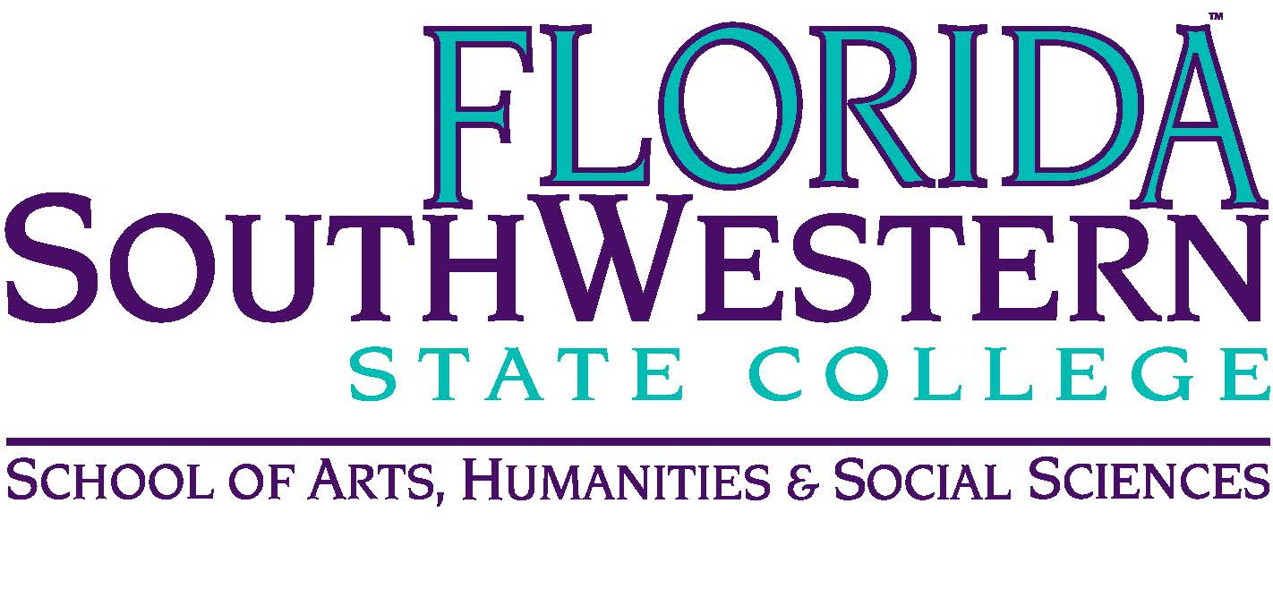
Department of Humanities
Meeting Minutes
Date: Oct. 13, 2023 — 2:00 p.m.
Location: Virtual (Zoom)
Chair: Monica Krupinski
Minutes: Mike McGowan

 | Present | Absent | Excused
Chase, W |  | X
Ciamparella | X
DeMoran | X
Harrington | X
Krupinski | X
McGowan | X
Mompoint | X
Pritchett | X
Sutter | X
Others

- Opening
  - Call to Order: 2:00 pm
  - August Minutes Approved at 2:10 pm
  - September Minutes Approved at 2:15 pm
  - Reminder: no meetings in Nov. or Dec.
- Committee Updates:
  - Assessment (Monique): What do we want to learn about our students? Joe said our goals can be operational. So, here are the goals for our dept.:
    - Development of HUM 2235
    - Our department’s AI policies
    - Comprehensive themes for HUM 2020 and HUM 2211
  - Monique will do the initial writing up of these:
    - DEV101 Curriculum Map done by December
    - She’ll send out for discussions during spring semester and organize the class. It likely won’t be ready until the fall 2024 semester.
- Announcements/Info/Updates:
  - Spring 2024 final exam schedules have been posted
  - Tues, Oct 17 Brandi’s poetry reading 7 pm
  - October events from Dr. Harris (see email)
  - Open House Oct 16th 3 - 6 pm Lee
  - Ancillary funds are back from PD committee
    - 7th and 21st of each month now submitted to Dr. Bilsky
    - For review/approval because of state funding

- To Do List:
  - Monique H. is handling development of HUM 2235
  - Anna C. will sponsor the ASL club.
  - Search Committee for HUM line: Mike M., Anna C., Monica K.
  - Adjunct mentors: Check to see if they have any requests for PD topics (from PD Committee), and send topics to Monica, and ask Adjuncts for which topics they would like training.
  - AI discussion at Dean’s request: we’ll work on this later.
  - Syllabi will open Oct 16th in Simple Syllabus. Chairs have to approve new syllabi changes and templates. On Oct. 17, the Simple Syllabi open for spring semester.
    - Be sure to submit after all changes are made
    - Please email me a heads-up if you resubmit
    - Closing dates–you can’t make changes after
- Items for Discussion:
  - Advising update – Andy Hahn / November: Send concerns or arguments for your classes to Monica. Tie your argument into FSW’s emphasis on work force development, making the argument for why class X would be beneficial for students who are interested in career path Y.
  - McGraw-Hill Go (Fall 2024) – They have an e-book that is built into Canvas shell. Cost: $70. Upsides: one less thing the student needs to do (buy the book), and dual enrollment students get the book easier. Downside: students who would normally find a less expensive route (e.g., borrowing from the library or buying an earlier edition) won’t be able to. Monica will ask whether (a) they can opt out and (b) purchase a hard copy instead if they prefer. A few HUM Profs were not convinced we need it.
  - Saturday Pathways cohorts – Les has done this before, said the students were better but you have to give up your weekend. As of now, no one is asking HUM or PHIR classes to be taught on Saturdays, but the ask may come in the future.
  - Gen Ed course revisions–State DOE – Philosophy outcomes were broader than expected, Mike M. said, which is good because they’d give professors the freedom to teach how they want. HUM professors had major objections with their Gen Ed outcomes.

