Once signed into AccuTrack (System Administration) expand “Edit Sign-in Logs” “Student” “Sign In”

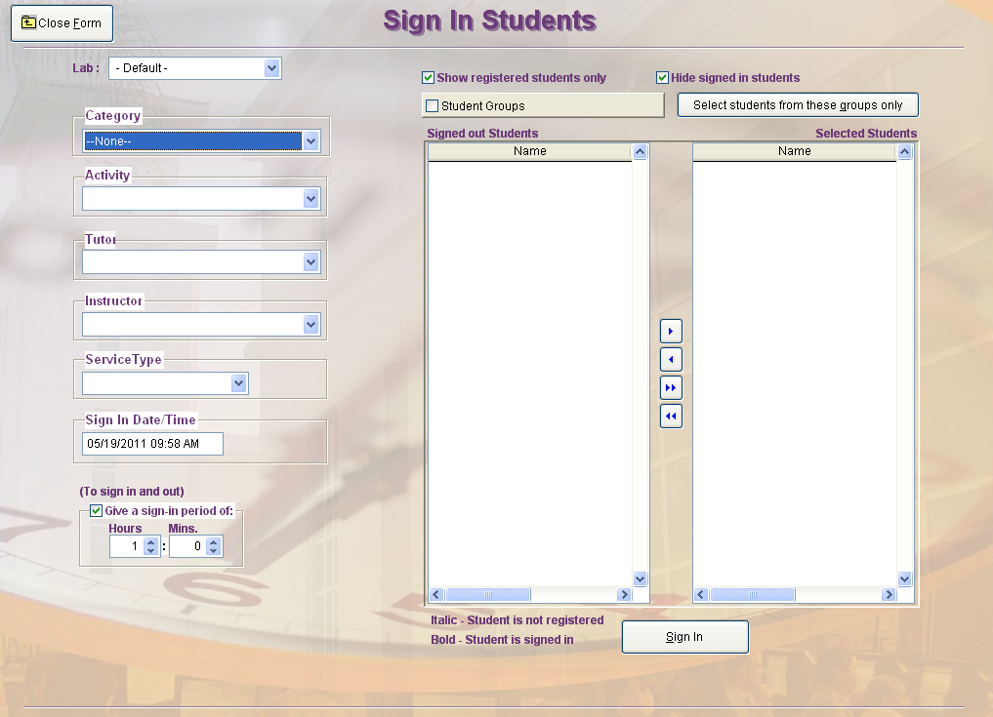
- Make the appropriate selections for the following:
- Category
- Activity

- Type in the desired value for “Sign In Date/Time”

- Make sure the checkbox for “Give a sign-in period of:” is checked (then step 4)

- Select how long the student(s) was in the lab

- In the “Signed Out Students” box, select the name of the student(s) you would like to sign in and award hours to

- Click the right arrow to move the selected student(s) to the “Selected Students” box
Note: You can select multiple students by holding the “Ctrl” key when making your selections

- Click “Sign In”

Additional Notes:
- When the checkbox for “Show registered student only” is checked, only students registered for the activity you selected will populate in the “Signed out Students” box
  - If a student is not registered for their class in AccuTrack, see the document on how to register a student for their class
- If the student you are trying to award hours to is currently signed in, you may have to uncheck the “Hide signed in students” checkbox to see their names in the “Signed out students” box for selection

