COMPUTER SCIENCE MINUTES
FSW Computer Science Department Meeting  Dr. George Kodsey Chair- Present  Dr. Kenneth Belcher- Present  Professor Kerry Cramer- Present  Dr. Rushell Hopkins- Present  Professor Aretha Pugh- Present  Dr. Roger Webster- Present  Professor Frederick Bruno- Present  Dr. Mark Snyder-Not Present | 09/8/2023 Time 2:00 p.m.
Item 1| Approval of the previous minutes.
A Dr. Ken Belcher motion seconded by Dr. Hopkins was approved unanimously.

Item 2 | Simple Syllabus.
Dr. Kodsey asked the faculty how well the simple syllabus is going so far. Everyone said it was going very well.

Item 3| AI and ChatGPT.
Dr. Kodsey led a discussion on the uses of ChatGPT. Rushell Hopkins said she was using AI in her Ph.D. thesis. Everyone shared insights on how AI could be used to facilitate discussions, answer student queries, provide additional learning resources and in cheating when writing programming assignments and/or other assignments.

Item 4| Enrollment data (see Figure 1).
Dr. Webster remarked that the latest enrollment figures show that since 2018 our AS degree in Computer Programming (total 2023 is 196) and the AS in Networking (total in 2023 is 95) went up each and every year. Our new program the BAS-IST in Computer Programming has a new enrollment for its very first year of 37 and the BAS-IST in Cyber Security/Networking has a new enrollment for its very first year of 30. We have a combined 358 students in the Department of Computer Science. Dr. Kodsey thanked all the faculty for their hard work to make this happen. 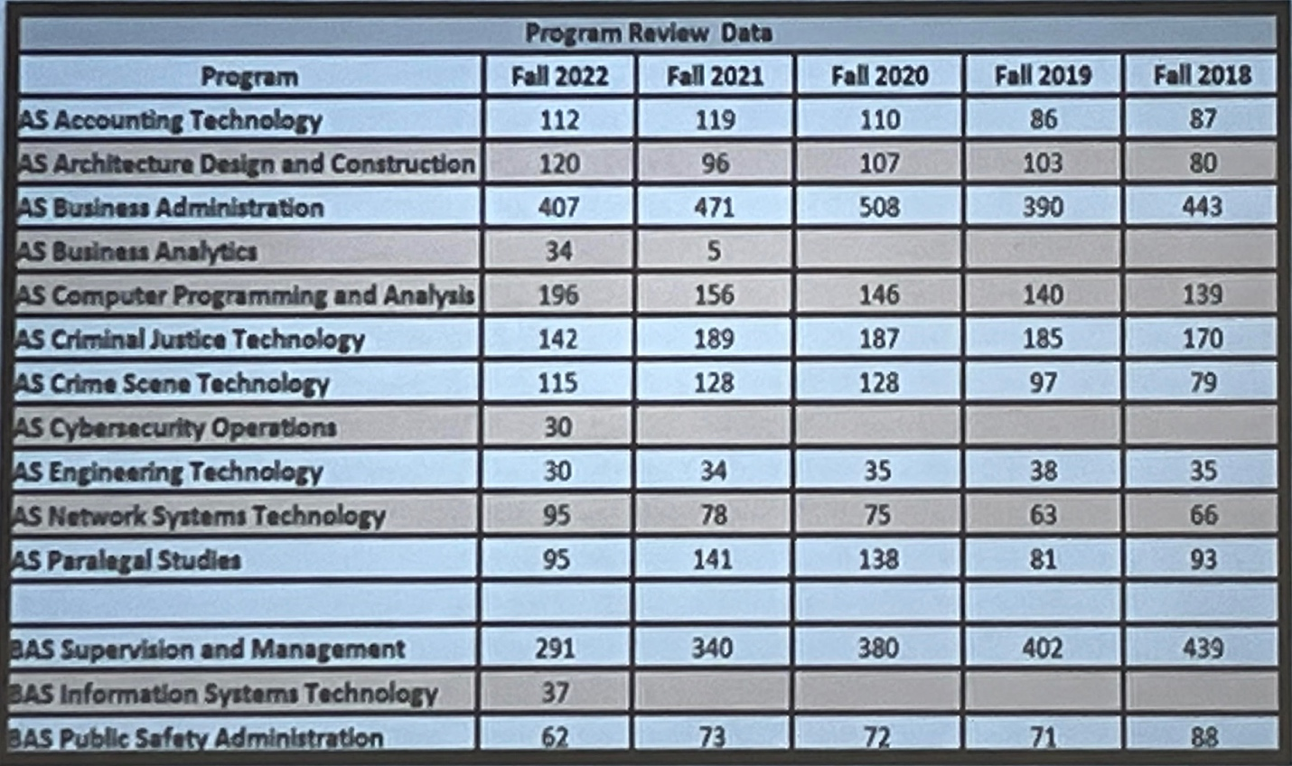
Figure 1 Latest SOBT Enrollments.

Item 5 | Learning Assessment
Dr. Hopkins described the importance of diverse assessment methods for evaluating student learning. The department agreed to explore various assessment approaches, such as projects, pre and post-tests, and presentations, in addition to traditional exams. It was suggested to follow Dr. Hopkins’ effective assessment strategies during the semester. Dr. Hopkins has made a canvas shell with all the information in it.
Item 6| GitHub repository.
Dr. Ken Belcher mentioned that he is using GitHub for students to put their projects into this repository, that way when they are interviewed, they can show employers the exact code project they did here at FSW. Dr. Belcher will report his results after the semester.

Item 7| Building K.
Dr. Kodsey discussed the current progress on building K.

Item 8| Continuing Contract.
Dr. Kodsey discussed continuing the contract for Dr. Webster. His subcommittee is currently Dr. Kodsey and Dr. Mary Conwell.

Item 9| Technology and Infrastructure.
Dr. Kodsey discussed Technology and Infrastructure and asked all to send him requests for software or hardware they need.

Item 10| Course Modalities.
Dr. Kodsey led a discussion on Course Modalities for Computer Science classes. It was agreed that online classes are largely preferred by most CS students and the schedule should reflect the needs and wants of our students to accommodate their busy schedules. Of course, there are some classes that better serve the CS students on campus. The best modality for COP1000 was discussed with the notion that completely online may not serve the students well and that perhaps live online or on campus or blended flex would be more effective however, further discussions are needed.

