School or Division | School of Arts, Humanities, and Social Sciences
Proposed by (faculty only) | Dr. Ryan Wurst
Presenter (faculty only) | Dr. Ryan Wurst
Note that the presenter (faculty) listed above must be present at the Curriculum Committee meeting or the proposal will be returned to the School or Division and must be resubmitted for a later date.
Submission date | 10/08/20
Course prefix, number, and title | DIG2118C - Digital Graphic Design

All Curriculum proposals require approval of the Curriculum Committee and the Provost. Final approval or denial of a proposal is reflected on the completed and signed proposal.
☐ | Approve | ☐ |  | Do Not Approve
Curriculum Committee Chair Signature |  |  |  | Date
☐ | Approve | ☐ |  | Do Not Approve
Provost Signature |  |  |  | Date
All Curriculum proposals require review by the Office of Accountability & Effectiveness.
☐ | Reviewed
Office of Accountability & Effectiveness Signature |  |  |  | Date

Section I, Important Dates and Endorsements Required
NOTE: Course and Program changes must be submitted by the dates listed on the published Curriculum Committee Calendar. Exceptions to the published submission deadlines must receive prior approval from the Provost’ Office.
Term in which approved action will take place | Fall 2021
Provide an explanation below for the requested exception to the effective date.
Type in the explanation for exception.

Any exceptions to the term start date requires the signatures of the Academic Dean and Provost prior to submission to the Dropbox.
Dean | Signature | Date
Dr. Deborah Teed
Provost | Signature | Date
Dr. Eileen DeLuca

Required Endorsements | Type in Name | Select Date
Department Chair or Program Coordinator/Director | Professor Dana Roes | Click here to enter a date.
Academic Dean or Provost | Dr. Deborah Teed | Click here to enter a date.

List all faculty endorsements below. (Note that proposals will be returned to the School or Division if faculty endorsements are not provided).
Dr. Ryan Wurst, Professor Dana Roes, Professor Shimul Chowdhury

Section II, Action
Please select one of the following | Course Discontinuation

Section III, Complete for Program Discontinuation
Select program of certificate for discontinuation | List name of program or certificate
Explain (below) the reason for the discontinuation
Explanation for discontinuation. Along with the summary, delineate the parties that have endorsed the Termination of this Program such as Advisory Board, Faculty, and/or Ad Hoc Committees. Submit Minutes of meetings and endorsements along with this form.
Teach out plan required: SACSCOC requires a teach out plan for the discontinuation of programs or certificates. Please refer to the teach out plan template available on the document manager. Attach the teach out plan to this document.
If this program or certificate discontinuation will require discontinuing courses, complete section IV

Section IV, Complete for Course Discontinuation
Enter course(s) to be discontinued (add rows if necessary)
Course Prefix and Number | Course title (as listed in the catalog)
DIG2118C | Digital Graphic Design

Section V, Justification for Proposal
Provide justification (below) for this proposed curriculum action
This is the first part in a two part process. The second will be a new course proposal. Below is a justification for the two steps:

It was brought to our attention by the Florida Department of Education that DIG 2118C is marked as an upper division course in the state numbering system. The state is requiring that we change this as it must be a lower division course.
The goal of the course is to introduce students to design and visual communication principles utilizing the computer as their main tool. The choice to move from a DIG to a GRA prefix does not change the goals or learning outcomes of the course. Below are the course descriptions in the state numbering system:

DIG 2118C:
INTRODUCTION TO THE PRINCIPLES OF GOOD VISUAL COMMUNICATION AND THE COMPUTER AS A TOOL FOR CREATING GRAPHIC DESIGN MATERIALS AND PRODUCTS USING PROFESSIONAL LEVEL SOFTWARE PACKAGES.

GRA 2103C:
THIS COURSE IS DESIGNED FOR ANY STUDENT WHO IS INTERESTED IN LEARNING HOW TO CREATE AND EDIT WELL-DESIGNED DIGITAL GRAPHICS FOR PROFESSIONAL USE.
TOPICS INCLUDE SKILLS RELATED TO DEVELOPING VECTOR AND PIXEL BASED GRAPHICS FOR PRINT AND WEB USING COMMERCIAL-GRADE GRAPHICS SOFTWARE AS WELL AS FUNDAMENTAL 2-D DESIGN PRINCIPLES. GAUGED FOR BEGINNERS WHO ARE COMPUTER COMPETENT.

Both descriptions are nearly identical in the learning outcomes for students in that they emphasize learning digital graphic design techniques through the use of software.

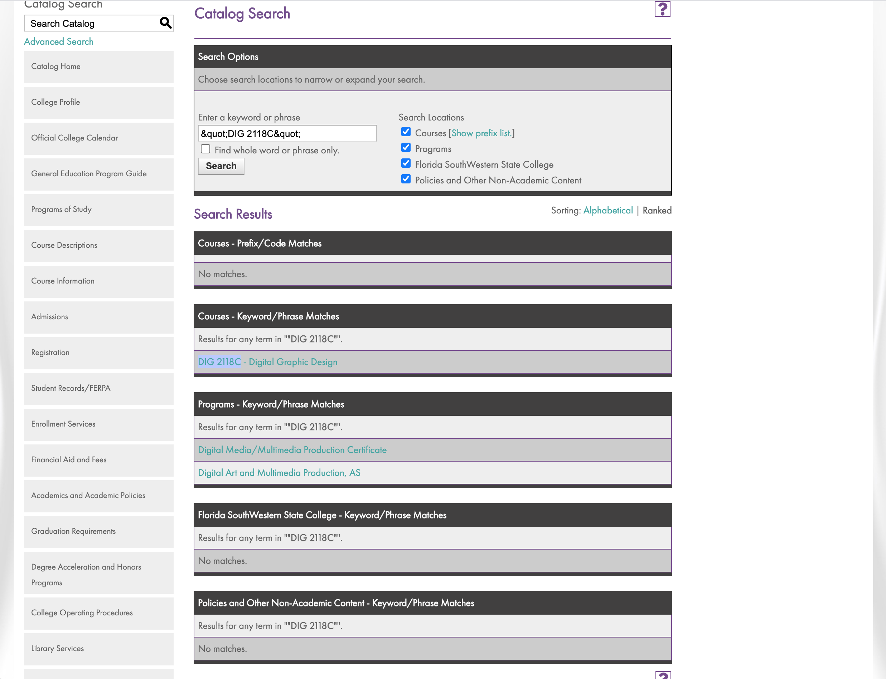

Email Exchange between Dr. Ryan Wurst and Dr. Deborah Teed
9-1-20
Hi All,

I have done the change of course paperwork to fix this issue. Changing this to the suggestion from the state, DIG 2111C, does not actually fit what we are teaching in the class. The DIG 2111C's focus is more on illustration than Graphic Design. We can keep the same course title if we change the prefix to GRA 2103C (the state name of the course is: Computer Based Design) This change of prefix won't effect how the course is taught.

Let me know if you see any issues in the Change of Course proposal and I will get it in for the September 8 deadline for curriculum.

talk soon,

Ryan Wurst, Ph.D.
Professor of Fine Art
Florida SouthWestern State College

It makes sense, Ryan, although I don’t see a huge difference in the descriptions apart from the detail
This will be for Fall 2021? Or are we asking for an exemption?

Deborah Teed, Ph.D.
Dean of Arts, Humanities & Social Sciences
8099 College Parkway
Fort Myers, Florida 33919
239.489.9248
dteed@fsw.edu

