Note required information: Program or certificate changes require a change to the catalog page. All change of program or certificate proposals must include the new catalog page, with all proposed changes, at the end of this document. All changes that affect the courses, words, numbers, symbols, program description, admissions requirements, and graduation requirements must be documented. Note before completing this proposal that all new courses and current prerequisite, co-requisite, core, or elective courses changes must have already been reviewed (or submitted for the same meeting) by the Curriculum Committee and approved by the Provost. The Track Changes feature in Word must be used to illustrate all changes to the catalog page.

School or Division | School of Business and Technology
Program or Certificate | Network Security Certificate
Proposed by (faculty only) | Mary Myers, Melinda Lyles
Presenter (faculty only) | Mary Myers
Note that the presenter (faculty) listed above must be present at the Curriculum Committee meeting or the proposal will be returned to the School or Division and be resubmitted for a later date.
Submission date | 1/4/2021

Section I, Important Dates and Endorsements Required
nOTE: Course and Program changes must be submitted by the dates listed on the published Curriculum Committee Calendar. Exceptions to the published submission deadlines must receive prior approval from the Provost’ Office.
Term in which approved action will take place | Fall 2021
Provide an explanation below for the requested exception to the effective date.
Type in the explanation for exception.

List all faculty endorsements below. (Note that proposals will be returned to the School or Division if faculty endorsements are not provided).
Mary Myers, Melinda Lyles, Fred Bruno

Section II, Proposed Changes
Do any of the changes affect the AA focus? (If so, a Change of Program proposal is also needed.) | ☐ Yes  ☒ No
Have the deans of the General Studies been contacted/consulted? | ☐ Yes  ☒ No
Have you attached an updated catalog page? | ☒ Yes  ☐ No
Change of School, Division, or Department | N/A
Change to program or certificate name | N/A
List below, any changes to the program or certificate prerequisites. Include course titles and credits if applicable.
N/A
List below, any changes to the General Education requirements. Include course titles and credits if applicable.
N/A
List below, any changes to the program or certificate Core requirements. Include course titles and credits if applicable.
Add: CNT 1512 Wireless Network Administration – 3 credits
Remove Any 1000 or 2000 level CGS, CNT, COP, or CTS Prefix 3 credits
Remove SLS 1331 - Personal Business Skills 3 credits or SLS 1515 - Cornerstone Experience 3 credits
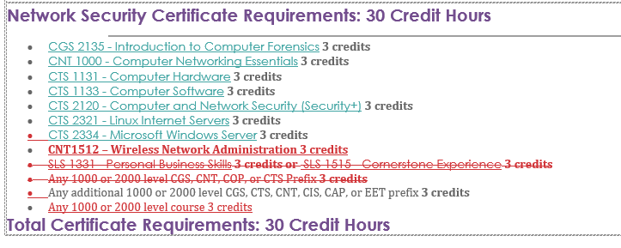
Add: Any 1000 or 2000 level course - 3 credits

List below, any changes to the program or certificate Elective requirements. Include course titles and credits if applicable.
N/A
List below, any other changes to the program or certificate requirements.
N/A
Change to program length (credits or clock hours to complete) | N/A

Include complete new catalog page as an attachment. Proposals without the new catalog page will not be reviewed by the committee.

Section III, Justification for proposal
Include state frameworks, accrediting or professional organization recommendations or requirements, workforce data, and/or crosswalks.

Provide justification (below) for each change on this proposed curriculum action.
In anticipation of the new BAS in IST, we need to add a class to the Network Security Certificate. The class is CNT 1512 - Wireless Network Administration. There is an upper-level class (CNT4514 - Wireless Networks and Portable Devices) that has CNT1512 as the prerequisite. By adding this class to the certificate, students will not have to take an extra class when they enroll in the BAS. This course is also being added to the AS in Network Systems Technology, so students who continue to the AS degree after the certificate will be able to satisfy that requirement.

To make room for CNT 1512 in the CCC, we are removing the more general requirement list of “Any 1000 or 2000 level CGS, CNT, COP, or CTS Prefix 3 credits.”

Currently, there is a requirement for students to take either SLS 1515 or SLS 1331 (3 credits). We are replacing this requirement with 3 credits of open electives (any 1000 or 2000 level 3-credit course) to add flexibility to the Certificate. Students may count SLS 1515 or SLS 1331, or another course of their choice toward this elective.

