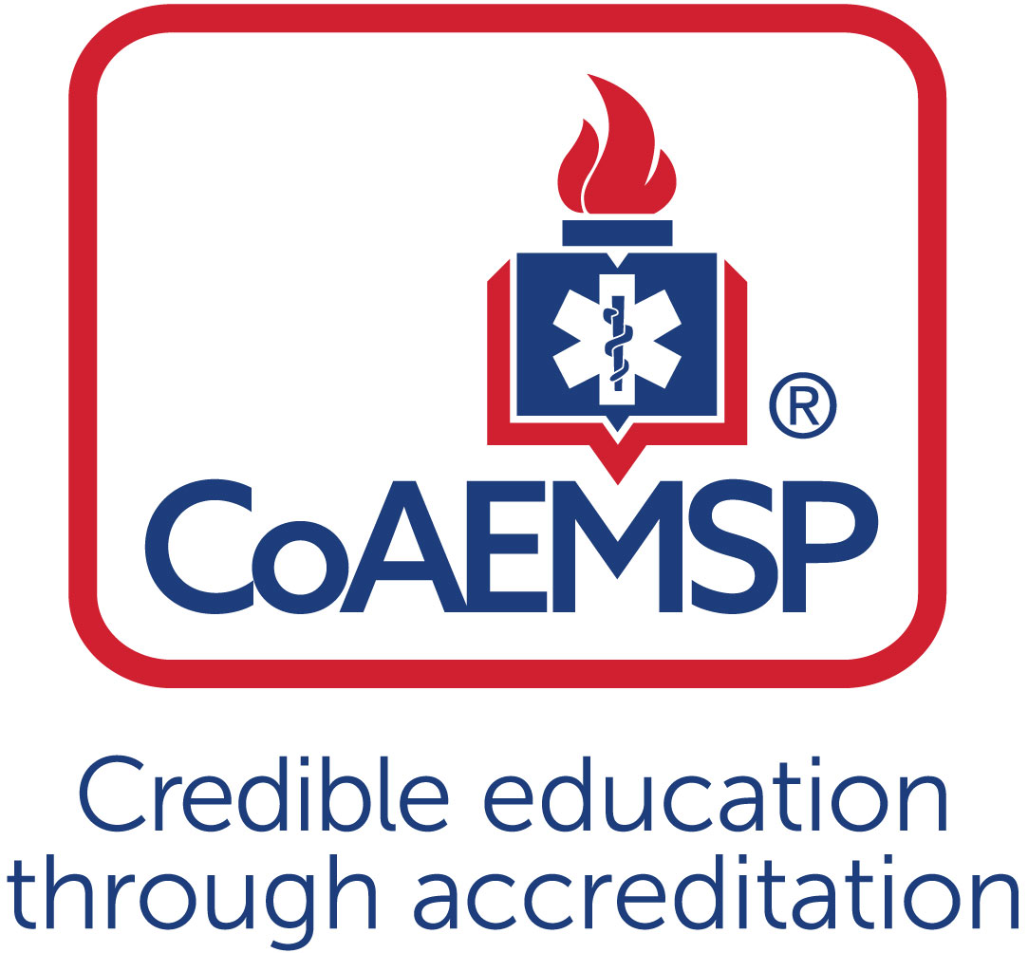

**Advisory Committee Meeting Minutes**

|  |  |  |  |  |  |  |
| --- | --- | --- | --- | --- | --- | --- |
| **SPONSOR / INSTITUTION NAME:** | Florida SouthWestern State College | | | | | |
| **CoAEMSP PROGRAM NUMBER:** | 600034 | | **DATE, TIME, + LOCATION OF MEETING:** | | | 1/5/23, 9 am Lee Campus AA 172 |
| **CHAIR OF THE ADVISORY COMMITTEE:** | Lt. Roy Brown | | | | | |
| **ATTENDANCE** | | | | | | |
| **Community of Interest** | | **Name(s) –** *List all members. Multiple members may be listed in a single category.* | | **Present** | **Agency/Organization** | |
| Physician(s) *may be fulfilled by Medical Director* | | Dr. Benjamin Abo, DO Paramedic | | X | Medical Director, EMS, Florida Southwestern State College | |
| Employer(s) of Graduates Representative | | Thomas Ouillette  Larry Arfmann  Rich Billian  Brandon Morris  Adrian Corujo | | X  X  X  X | Captain, Collier County EMS  Division Chief, Lehigh Acres Fire Rescue  Training Captain, Lehigh Acres Fire Rescue  EMS Battalion Chief, City of Cape Coral Fire Department  Deputy Chief, Lee County EMS | |
| Key Governmental Official(s) | | Dan Summers | | X | Director, Emergency Management Services, Collier | |
| Police and Fire Services | | Daniel Sieber  Roy Brown  Amy Stafford  Curtis Rine  Randy Krause | | X  X | EMS Division Chief, San Carlos Park Fire  Bonita Springs Fire Control and Rescue District  Hendry County EMS  Charlotte County EMS  Ft. Myers Beach Division Chief of EMS | |
| Public Member(s) | | Belinda Snyder  Dennis Keesal, M.D. FACEP | | X  X | Community Member – Non-medical  Community Member – Retired Physician | |
| Hospital / Clinical Representative(s) | | Risa Wildeman  Theresa Foley  Jana Turcotte  Arlyn Fernandez  Kristen Metz | | X | Naples Community Hospital (NCH)  Lee Health  Lee Health  Physicians Regional  Physicians Regional | |
| Other | |  | |  |  | |
| Faculty *ex officio, non-voting member*, | | Mike Knoop  Tracy House  Megan Davis  Christine Clemens | | X  X  X  X | EMS Support Specialist, Florida SouthWestern State College  EMS Support Specialist, Florida SouthWestern State College  Interim Program Manager, Florida SouthWestern State College  Program Coordinator, Florida SouthWestern State College | |
| Sponsor (FSW) Administration, *ex officio, non-voting member* | | Tami Such, Dean SHP  Tommy Mann, Senior Director SHP  Cassie Billian, Director EMS | | X  X  X | Dean, School of Health Professions, Florida SouthWestern State College  Senior Director, Health Professions Administration, FSW  Director, Emergency Services, Florida SouthWestern State College | |
| Current Student | | Alexzandria Fornal | | X | 2022-23 Paramedic Student, FSW | |
| Graduate | | Bobby Crews | | X | 2021-22 Paramedic Graduate, FSW | |
| Program Manager (interim) *ex officio, non-voting member* | | Megan Davis | | X |  | |
| Medical Director *ex officio, non-voting member* | | Dr. Ben Abo | | X |  | |

|  | **Agenda Item** | **Acted** | **Discussion** | **Action Required** | **Lead** | **Goal Date** |
| --- | --- | --- | --- | --- | --- | --- |
|  | **Call to Order** |  | Roy Brown called meeting to order at 9:04am | No | Brown |  |
|  | **Endorse the Program’s minimum expectation**  [CAAHEP Standard II.C. Minimum Expectation]   * Endorse the language *verbatim* for the Minimum Expectation   “To prepare competent entry-level Paramedics in the cognitive (knowledge), psychomotor (skills), and affective (behavior) learning domains with or without exit points at the Advanced Emergency Medical Technician and/or Emergency Medical Technician, and/or Emergency Medical Responder levels.” |  | Brown: “Approve and endorse the minimum expectations. The language verbatim for the minimum program expectation is To prepare competent entry-level Paramedics in the cognitive (knowledge), psychomotor (skills), and affective (behavior) learning domains with or without exit points at the Advanced Emergency Medical Technician and/or Emergency Medical Technician, and/or Emergency Medical Responder levels.”  Billian: Let the committee members know that this language is nothing new. It has been used from year to year by the previous leadership. Asked for suggestions regarding potential changes.  Abo: Asked if there is language regarding the equivalencies of simulation versus real patient contact.  Billian: Stated this is the minimum expectation language, for the program itself but, we would review and discuss the minimum patient contact and student expectations.  Motion: Approved and Endorsed with 100% I’s  Requested that all advisory board committee members complete the Program Resource Survey – provided link to Zoom members. | No | Brown/ Billian |  |
|  | **Review and endorse the program’s required minimum numbers of patient/skill contacts for each of the required patients and conditions** [CAAHEP Standard III.C.2. Curriculum]   * Appendix G: Student Minimum Competency Matrix (*effective August 1, 2022*) |  | **Discuss/Endorse/Approve the new CoAEMSP Student Minimum Competency Matrix. Minimum patient/skill contacts to be used with current 22-23 cohort as required by CoAEMSP.**  Brown: This is the portion where we are going to review and endorse the programs required minimum numbers of patient skills contacts for each of the required patient contacts.  Davis: Student Minimum Competencies that are being put forth by FISDAP and endorsed by CoAEMSP, our accreditation. With these new changes we are implementing the new student minimum competency or also known as the SMC. The new form in which the student will go by with their skills in lab, clinical, field, and their capstone internship. This report replaces the previous G- report. When using the G- Report students would know what scenarios they were walking into based on the patient encounters they needed. Gave example of student needing 10 summative pacing, getting to the end of the semester with 4 remaining summative pacing’s needed and knowing what scenario she was walking into.  Went through the SMC page by page and explained that these are the minimums required. Stated they are a bit lower than the numbers previously required. Committee ask to review the minimum numbers outlined in the SMC report provided and to consider that we currently have a Paramedic class that is double the size in comparison to what we have had in the past. We would like to start with the minimums to ensure that the students can accomplish this and accomplish the minimums well. We want to ensure we are graduating quality students.  Brown: I would like to open this up for discussion for everyone’s opinions and feedback prior to voting.  Clemens: Going with the minimums allows us to use this large group of students and track the data and adjust moving forward.  Brown: My personal opinion on this is that with all the new changes this is a great way to get a new baseline and then reevaluate in 2024 to see how the year went.  Davis: Explained the 5 different tables (Table I Ages, Table II complaint and conditions, Table III – Individual Skills, IV – field and capstone experience during internship, Table V – EMT skills competency).  Summers: “Is there any comment from the group on the stroke simulation. Further discussion on stroke”  Davis: We are working heavily with our simulation department. We have high fidelity manikins that are able to simulate many different symptoms. We are having each student complete at least one rotation at Gulf Coast which is our stroke center here in Ft. Myers. We are making sure our students are seeing stroke patients.  Summers: “Thank you! I think its probably my absence of visibility on how intense the scenarios are. If you all hitting that one strong, I think that is really good news.”  Mann: As of yesterday, our simulation and AHA training center was approved for stroke certifications. In conjunction with BLS and ACLS we will be offering stroke certifications through AHA and the University of Miami. This will be open to all of the EMS Programs.  Abo: “Are you limited to what stroke screening is used or taught.”  Mann: “No, we are not. We follow AHA and use the screening that are predominantly used in the area.” Encouraged Abo to pop into one of the classes.  Abo: “Just a technicality, stroke centers are not supposed to be designated as comprehensive.”  Brown: “Is there anyone on Zoom with any questions or concerns.”  Brown: “All in favor of this motion – 100% I’s – Okay, motions passes – Thank you, everyone.” |  | Davis |  |
|  | **Annual Report and Outcomes**  [CAAHEP Standard IV.B. Outcomes]  X Graduate Surveys   * Employer Surveys * Resources Assessment Matrix   X Thresholds/Outcomes |  | Brown: Discuss some graduate surveys and specific outcomes.  Davis: Graduate surveys from our 21-22 graduates. They filled these surveys out on their last day.   * Students commented on the notes that they were given as study guides contributed positively to their ability to pass the program. * They found their text and homework to be very beneficial in their ability to succeed. * Their prescription homework allowed them to focus on studying * They think learning pharm throughout the program instead of one semester at the beginning of the program would be more beneficial.   “We are going to take this into consideration to determine how we can improve.”   * Students felt strongly that their instructors were passionate and helpful.   Billian**:** Reviewed Paramedic Program Outcomes handout  Highlighted that we track retention, enrollment. Discussed drastic increase of cohort size. Started with 42 students. Going into the spring semester we have a total of 36. Explained students impacted by Hurricane Ian and college offering of “H22”. Allows student to return in Fall 2022 without having to pay for tuition and fees.  Paramedic National Registry Exam Outcomes – 2 – 2021 cohorts as of October 80% and 80.3% pass rate. Our goal is for this number to continue increase.  Employment – positive placement in the 90 percentiles.  Abo: “As a goal, I would love to see our first pass rate go up. Discussed report card that was reviewed at the last state meeting. 80% is really good but, I want to see our goal as over 95%.” I am curious how many had jobs lined up and how many students stayed at their same department. Did the graduates stay in EMS for over 5 years?  Snyder: “I am new here but I have a comment about the presentation about the numbers. How do theses numbers compare to national or state numbers? How does this relate to what your goals were? Review the trends and provide data for an outsider to know what may have happened. Give an outsider information on what drives the data.  Abo: “national averages for accredited stuff – pass rate overall is 84.3%. For the state of Florida pass rate is 61% for the average. We are new to the national registry as of 2017. Prior to that we had one set state exam. It was going to cost 2 billion dollars to rewrite the state test. I am a question writer for the national registry. It is tough to look at the numbers and get a lot out of it but you can make a good hypothesize and get a lot of it. Overall, a huge goal of the state medical director and myself is to get these numbers up.”  Sieber: “The challenge largely comes back in your lap of okay why are there 3 schools that have 98 plus percent in this state versus not. I have no idea what the answers are but, I do know that the educator’s group is going to try to get together to discuss best practices – like whether the educators should go through the national registry exam.”  Abo: “The highest pass rate in Florida was 88%, overall.”  Mann: “Director Billian and I have talked about this at length months ago. My goal is first time pass rate of 90% pass rate. We are going to reinforce what students are going to be tested on throughout the program.”  Abo: Discussed preceptor discrepancy in teaching what is needed in the field verses the national registry. Preceptors need to be on the same page and be very motivating to the students on what they study. Discussing with preceptors why we teach to the national standard.  Billian: Discussed our new initiative of sponsoring and hosting EMT and Paramedic Nationally Registry Test Prep. Also, sent our instructors through the Paramedic Prep.  Abo: Asked if field preceptors are doing training or welcome aboard.  Davis: We send out preceptor training to all of the departments to encourage an understanding of our program requirements, national standard, and uniform requirements.  Reviewed that Collier County requires their preceptors to also complete their own required training. Lehigh uses their experienced FTO’s to supervise, and Charlotte County as well. Lee County EMS may be moving forward with a specific preceptor as well.  Morris: Asked if FSW’s attrition rates are comparable to other schools in the area?  Billian: We do not currently have the data comparison however, we can look into obtaining it and bringing it forward during the next meeting.  Mann: Discussed the impact of Covid and Hurricane Ian on the attrition rate to not only FSW’s EMS programs but, also all health professions programs. Mentioned how the staff and faculty have been supportive of student success. A lot of what we are seeing is that life is getting in the way for students. Our goal is to continue to get embedded with our student population to determine what they need from us to ensure they are retained. | Yes – explanation of how to analyze the data provided.  Monitor students data first time pass rate after completion of Test Prep.  Research other PMD programs attrition data. | Davis/Billian |  |
|  | **Other Assessment Results**  [CAAHEP Standard III.D. Resource Assessment]   * Long-Range Planning   X Student   * Faculty * Program * Other |  | **Final Competency of Paramedic – Comprehensive FISDAP Final Results (2020-21 and 2021- 22 cohorts)**  **2021-22 cohort – 17 students**  **100% Pass Rate First Attempt**  **2020-21 cohort – 16 students**  **94% Pass Rate First Attempt**  **100% Pass Rate Second Attempt** |  | Billian |  |
|  | **Discuss challenges to the effectiveness of clinical and capstone field internship**  *This may include the impediments to attaining or retaining affiliates* |  | Billian: Explained exit interview results of 21-22 cohort. Students mentioned unfriendly clinical preceptors at times and feeling as if the nurse they had been partnered with did not want a student. Mentioned the importance of working with clinical preceptors to remind them of their impact on students and the profession as a whole.  Requested suggestions to ensure the students clinical experience is positive.  Mann: Discussed the importance of communication and expectations of the Paramedic scope of practice with Nurses. Suggested that frequent in-person communication occur between program personnel and floor nurses on a continuous basis. Mentioned that the clinical facilities are going through many personnel changes and utilize travelers.  Abo: Feels strongly about personally going into the facilities to help educate what the Paramedic students can and should do within the setting.  Clemens: Advocates for Paramedic CA’s to be stationed in the hospital with the students.  Mann: Moving students from floor to floor doesn’t resolve the challenge.  Abo: “Until I moved to Florida – I had never seen/heard of someone from the school going to the clinical site with students.”  Clemens: Teaching hospitals welcome students.  Mann: Nurses in most of the hospitals only get paid a dollar to be motivated to teach.  Abo: Nurse educators are not medic educators therefore; we can embrace and  Snyder: Asked if students see the same preceptors every time.  Mann: Students see multiple preceptors throughout their clinical/field rotations. Mentioned that nurse educators are spread to multiple locations. Mentioned the importance of building relationships with our partners frequently. Covid impacted our leadership personnel significantly. We are in the phase of relationship and bridge building.  Snyder: Do you have a designated outreach person?  Mann/ Billian: No – we have our leadership staff and our clinical coordinators that interact with the hospital partners.  Snyder: Suggested monthly workshop used to educate the clinical staff.  Abo: Get an outreach meeting together to partner with our clinical facilities to discuss how we can serve each other. Out reach will help to meet their needs.  Brown: “Each party needs one another.”  Crews: “I have a different prospective as a student going into the clinical setting. When we get there, we have our onboarding and orientation regarding what’s need for our reports. When we get to the hospital we need more education on how to find your charge nurse and making sure that you are with your appropriate level. For example: I cannot be with an EMT. I should be with a Paramedic or Nurse.” Recommend talking with the charge nurses to make sure we are with the correct provider. We do clinicals throughout the entire course.  Recommended that students bring a print out of what they have covered in the program up to their point of clinical to educate their preceptor on their scope. Medications and individual student expectations will be helpful.  Davis: Discussed that we will be doing rounds within the clinical setting to ensure that students feel they are getting their value out of the time.  Davis: Limited OR rotations provided from Clinical Sites – Covid impacts. Lee Health gave limited OR rotations. NCH is open to allowing our students in the OR which is not something that was available in the past. |  | Billian |  |
|  | **Program Changes** *(possible changes)*   * Course changes * Preceptor changes * Clinical and field * Curriculum   + Content   + Sequencing |  | Brown: Schedule for Fall 2022 went to non-shift friendly however, prior we had a shift friendly class for quite some time.  We are going to track retention and student success from shift friendly cohort versus non-shift friendly however, it will take some time.  Discussion on possible allowance of seats for each dept/ agencies.  Open Discussion/Suggestions:  Brown: Mentioned how throughout the years the scheduled has changed back and forth between shift friendly and non-shift friendly depending on the needs of the community/students.  Arfmann: “Our take is we like the shift friendly, it worked internally better for us because we knew our employee was going to be in school on X day. It was easy for us to accommodate the shift changes that allowed them the time off. With this new schedule, we have educational leave however, they are having to find coverage and it is making it harder on our employees to make it to class on time. I would always move the employee to a different shift so that they would always be off when they had to be in school.  Davis/ Billian: Encouraged hearing from other departments.  Morris: “For us it almost doesn’t make a difference because we send 6 people a year for each class. It would be impractical for us to put all 6 people on one shift and it would also be unfair if one shift received all of the leave and the other shifts did not. I also recognize that you probably have many students that are not working shift and the consistency for them probably helps a lot. “  Brown: First time he heard a department would allow shift change for education.  Morris: Cape Coral allows it because their educational leave is not based on shift. It is based on rank and seniority.  Brown: A shift friendly Paramedic schedule cannot accommodate every shift likely resulting in some shift employees not be able to accommodate the chosen shift schedule.  Crews: “I talk to some guys at work they say I am just waiting for so and so to put on a shift friendly class. So maybe just alternate every other cohort.”  Brown: Is the schedule based on how many students we can secure meeting the chosen schedule?  Davis: We went with a non-shift friendly schedule this year because of the feedback provided by our clinical associates that this schedule would allow them to be more available.  Mann: This was a resource decision made by administration a few months ago. The cohort was polled – with a less 5% stating that they would be negatively impacted by a non-shift schedule. We will pull data and revisit this decision to see how we can best support our students, partners, and grow the program.  Abo: There will always be pros and cons to the schedule decision. Gave example of Sarasota County Fire – If class fell on their shift the student would go to class during the day and then return to duty. We can talk with the departments to determine the best option.  Mann: We were approached by many departments stating we need more graduates.  Abo: “Since 2003 there is no Paramedic shortage. This is distributive shock.” There are different societal issues, money, education issues that impact this. Paramedic school is just one part.  Brown: Thoughts on holding seats for each department?  Sieber: Concerns about departments making promises that they cannot keep up with resulting in a seat unfilled. Investment on the student’s behalf is important.  Clemens: “historically the program was always a set schedule, except for within the last 2 years and the program was always very successful.” Consistency in the schedule positive impacts our CA’s and our clinical schedule.  Mann: Holding seats for departments is difficult to ensure fairness amongst all and fill seats. Expects our Paramedic program to grow.  Brown: Doesn’t remember an issue getting students from the various fire departments into the program.  Sieber: The challenge is students taking the path of least resistance. We should focus on the quality of this program and post our positive data.  Morris: Gave example of a 2nd attempt student who was put on a waiting list and then got in. Stated Cape Coral has not had any issues with the current process. Holding seats for the departments may take away from the civilians. Consider an allotment for EMS and Fire in general and not just by department. |  | Brown |  |
|  | **Substantive Change** *(possible changes)*  [CAAHEP Standard V.E. Substantive Change]  X Program Status   * Sponsorship * Sponsor Administrator Personnel * Program Personnel * Addition of Distance Education * Addition of Satellite Program |  | Program Status – Students who became national registry Paramedics:  2019-2023 NRP testing scores  36 Attempt, 64% 1st, 81% within 3 attempts  2017-2018 NRP testing score  38 attempt 63% pass 1st, 71% 2nd  Change in Program Personnel:  New Medical Director: Dr. Ben Abo  New Dean: Dr. Tami Such  New Sr. Director: Tommy Mann  New Organizational Structure to include Director and Program Manager (Megan Davis – Interim Program Manager and Cassie Billian, Director). Director is able to focus more on community outreach, public relations, college duties, and our Fire Science responsibilities. The Program Manager – Oversees admin and procedures associated with the Paramedic and EMT program.  Program Coordinator – Matt Stachler no longer employed by FSW.  Position will be posted in the coming weeks. Please help us to identify candidates and get the word out (Clinical Associates, Program Coordinators, Adjuncts)  Morris: Asked if openings are campus specific?  Billian: No. we have opening across 3 of our locations.  Davis: Explained Aladtec and allowance of CA’s to sign up for shift based on their schedule. Discussed decision to schedule PMD lab in the morning and the lecture in the afternoon to assist with student focus and clinical associate availability. We are looking for quality individuals that contribute to a positive culture for our department and towards our students.  Sieber: Asked for a flyer that he can share with the Medical Care Council and Lee County Fire Chiefs Association.  Brown: “Before we move onto to number 9, I just want to make a comment, like Mr. Mann was saying back when we were talking about attrition there’s been so many changes. Of course, welcoming Dr. Abo to the program and everyone else to their new positions but, I just want to commend everyone on how well the program has done with all these changes that seem to be happening all at once and then you add in Covid and you add in these other things. I think we are doing a really great job considering everything that has happened. “ | Billian to send flyer to Sieber | Billian | Completed  1/9/23 |
|  | **Other Identified Strengths** |  | FSW is hosting our first Paramedic National Registry Exam Prep and will be tracking the data/outcomes. We intend to continue to offer this opportunity to students. FSW will be funding the 21-22 cohort to attend along with the instructors of the program. We also extended this opportunity to the community and our partners.  Billian: As a new director I wanted to reach out to the committee to ask what are some things we are doing well and where are some areas that we can improve.  Sieber: “Getting our bang for our buck, historically, as someone who is representing footing the bill from a lot of these students, from our tax payers. Getting them out and letting them passing the test and putting them through our process and get them credentialed as a medic. I think you’ve done a phenomenal job historically.”  Discussed student feedback from students that complete alternative programs in comparison to FSW students.  Brown: Get the accreditation information out there.  Keesal: Asked if there is a difference between students that are already employed in the field versus those that are not on there National Registry results.  Clemens: Discussed that national registry information differs from what students are taught in the field. Many of our students are employed in the field or work in the medical field. The field experience is good however, there may be some bad habits that we have to combat with the national registry education.  Abo: Commended the program for the quality of what we do, the quality of the motivation for students, and overall how we listen to what the departments and students are asking. |  | Billian |  |
|  | **Other Identified Opportunities** |  |  |  |  |  |
|  | **Other Identified Threats** |  | Increase number of Paramedic programs in the area that are not CoAEMSP accredited:    1. Hodges  2. Braxton  3. Ricky Rescue  Davis: These threats will continue however, we can educate the students and community on our accreditation status and the importance that this has.  Mann: The quality of the program is what we speak to as a community. We will never speak ill of another program. We are working with marketing on who we are, what we are, our strategic goals, and where we are going over the next 12 months. Our success is our student population and our feedback from our community partners.  Ouillette: Runs Paramedic Academies which is the first step to county credentialing. FSW students are noticeably prepared and ahead of where education was 30 years ago. |  | Davis |  |
|  | **Other Identified Weaknesses** |  | CA surveys reflect the need for updated equipment especially on the Collier and Charlotte Campus.  Billian: Part of our strategic goals for the next year is to work with marketing and the foundation to get our success stories out there for not only student recruitment but, also donor interest.  Asked for feedback on other areas of weakness?  Knoop: Budget as it relates to lab equipment or lab supplies.  Clemens: This has been an issue for a while however, over the last year we have made tremendous improvement.  Brown: “I agree”  Clemens: Suggested a need for airway manikins. |  | Billian |  |
|  | **Action Plan for Improvement** |  | Working with marketing and foundation to get FSW EMS success stories out into the community for recruitment of students/staff, rebranding, and donor interest. |  | Billian |  |
|  | **Other Business** |  | Billian: “Just a closing statement, I am a huge advocate for looking for ways to support and partner with our agencies. Clinical/field partners. I want to open it up – If you have any needs or ideas, any areas of additional collaboration from us or are students, please let Megan and I know. We want to continue to secure and the build the relationships that we have with all of you.” |  | Billian |  |
|  | **Next Meeting(s)** |  | Next meeting with be scheduled in the beginning of 2024 |  | Brown |  |
|  | **Adjourn** |  | Motion for adjournment at 10:54am |  | Brown |  |

Minutes prepared by Cassie Billian Date 1/18/2023

Minutes approved by Date