AGENDA
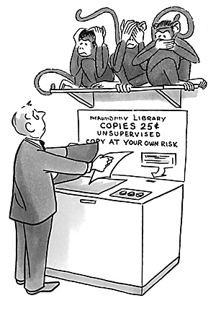

Edison State College – Charlotte Campus

Learning Resources Center

October 20, 2009

10:00 AM – 11:00 AM

Attendees: LRC Staff
Location: LRC Office
Please bring: Agenda and pen

10:00 AM – 10:05 AM | Welcome | Phenessa Jones
10:05 AM – 10:20 AM | LRC Quality  - MLA and APA Review  - Circulation Cross-Training  - Reference Cross-Training | All
10:20 AM – 10:40 AM | Operations  - Concerns  - Student assistants  - Monthly thematic display (i.e. November – American Indian Heritage Month, National Geography Awareness Month, Thanksgiving and Celebrate Author’s Week, Nov. 2-8)  - Area Updates – Reference, Circulation, Office Management, and Audiovisual | All
10:40 AM – 10:50 AM | Campus/LRC Updates  - New Student Assistant starting October 27th – Robert Boies  - New Fall Schedule  - Search Committee | Phenessa Jones
10:50 AM – 11:00 AM | Wrap – up  - Open Discussion  - Q & A | All

