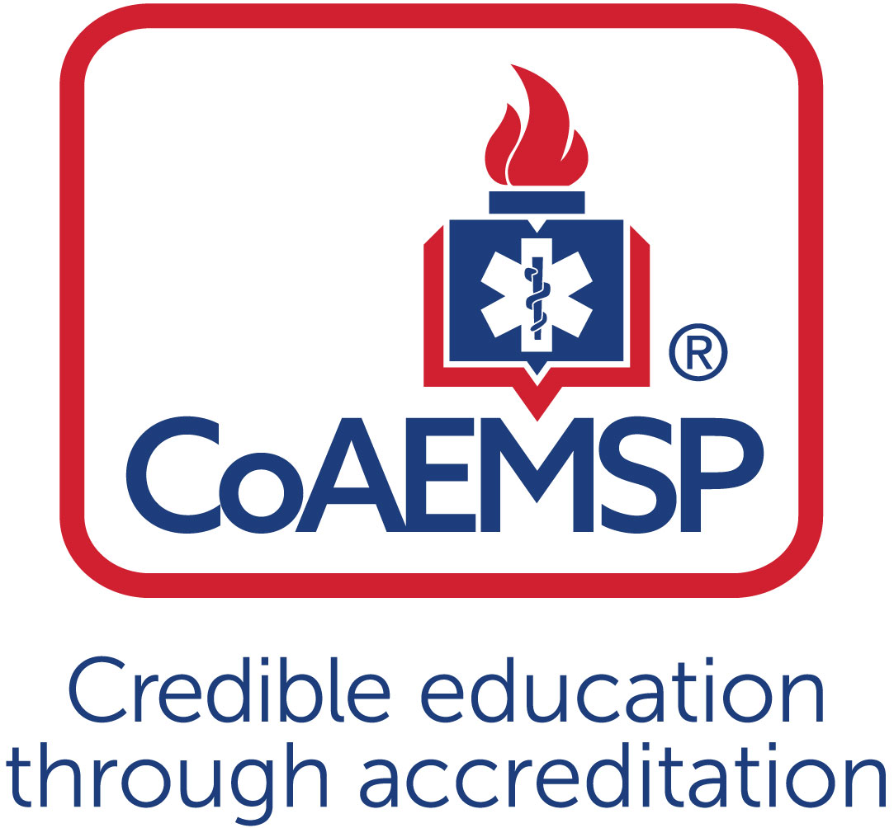

Advisory Committee Meeting Minutes

SPONSOR / INSTITUTION NAME: | Florida SouthWestern State College
CoAEMSP PROGRAM NUMBER: | 600034 |  | DATE, TIME, + LOCATION OF MEETING: |  |  | 04/09/2019 09:00 FSW LEE Campus B135
CHAIR OF THE ADVISORY COMMITTEE: | Chief Dan Seiber
ATTENDANCE
Community of Interest |  | Name(s) – List all members. Multiple members may be listed in a single category. |  | Present | Agency/Organization
Physician(s)  may be fulfilled by Medical Director |  | Dr. Alex Rodi, DO |  | x
Employer(s) of Graduates Representative |  | Ben Abes  Anthony Demos  Noemi Fraguela  Ryan Lamb  Joe Maguire  Gerard Mallet  Michael Marcus  Nathan McManus  Lance Pullen  Curtis Rine  Daniel Sieber  Bill VanHelden  Arthur Wolf |  | x  X  X  X  X  X | Acting Director, EMS Chief  Cape Coral Fire Department  Training Captain, Collier County EMS  Cape Coral Fire, Chief of Professional Standards  Lee County Emergency Medical Services  Charlotte County Fire/EMS, Director of Emergency Management  Lee Health, Trauma  Charlotte County Fire/EMS, EMS Training Captain  Fort Myers Fire, Division Chief of Training  Charlotte County, Captain of Fire Training  San Carlos Park Fire District  Charlotte County Public Safety Director  Collier County EMS
Key Governmental Official(s) |  | Dan Summers |  |  | Director, Emergency Management Services, Collier
Police and Fire Services |  | Anthony Demos  Ryan Lamb  Lance Pullen  Curtis Rine  Daniel SIeber |  | x | Cape Coral Fire Division  Cape Coral Fire, Chief of Professional Standards  Fort Myers Fire Division, Division Chief of Training  Charlotte County, Captain of Fire Training  San Carlos Park Fire District
Public Member(s) |  | Tom Brennan  James Connelly |  | X  x | Retired EMS/Fire Chief  Community Member/Prior Student
Hospital / Clinical Representative(s) |  | Michael Marcus  Theresa Foley |  | X  x | Trauma Program Manager, Lee Memorial Health System  Lee Health
Other
Faculty  ex officio, non-voting member, |  | Linda Welch  Mike Knoop  Tracy House  Matthew Stachler  Stewart Shrader  Tresa Hibben  Rima Stevens  Kari Duckworth  Roy Brown |  | X  X  X  X  X  X  X  x | Instructional Assistant – EMS/FIRE Programs, FSW  Instructional Assistant – EMS/FIRE Programs, FSW  Staff Assistant – EMS/FIRE Programs, FSW  Clinical Coordinator-FSW  Pharmacology Adjunct Professor-FSW  Clinical Coordinator-FSW  Clinical Coordinator-FSW  Pharmacology Adjunct Professor-FSW  Clinical Coordinator-FSW
Sponsor Administration,  ex officio, non-voting member |  | n/a |  | n/a | n/a
Current Student |  | Dillon Haire |  | x | Paramedic Student FSW
Graduate |  | Rebecca Greene |  | x | 2013 Paramedic Graduate
Program Director  ex officio, non-voting member |  | Joe Washburn |  | x
Medical Director  ex officio, non-voting member |  | Dr. Alex Rodi |  | x

 | Agenda Item | Acted | Discussion | Action Required | Lead | Goal Date
 | Call to Order | x | Everyone welcome, Introductions around the room of everyone and agency/or organization they are from. |  | Sieber
 | Review and Approval of Meeting Minutes | x | Review Minutes from last year, Any questions? None. Motion to Approve Minutes. Granted. | Meeting Minutes Approved | Sieber
 | Program Goals & Learning Objectives  [CAAHEP Standard II.C. Minimum Expectation]  - Endorse the language verbatim for the Minimum Expectation  “To prepare competent entry-level Paramedics in the cognitive (knowledge), psychomotor (skills), and affective (behavior) learning domains with or without exit points at the Advanced Emergency Medical Technician and/or Emergency Medical Technician, and/or Emergency Medical Responder levels.” | x | 1st order is to approve/endorse the CAAHEP Language for Minimum Expectation. Motion to approve and second. Motion granted.  Program Resource Survey was passed out please fill it out asap and turn it in anonymously. | Committee approved language for Minimum Expectation | Sieber
 | Review and endorse the program’s required minimum numbers of patient/skill contacts for each of the required patients and conditions  [CAAHEP Standard III.C.2. Curriculum]  - Appendix G: Student Minimum Competency Matrix (effective July 1, 2019) | x | Discuss the new Appendix G Minimum Competency the report was ran for the last 2 cohorts. Today we must approve the numbers. CoAemps has recommended minimums for each section, red items on the report I printed out are not being met based on our old chosen numbers. I think we should go with the CoAemps recommended minimums for now to see how we do. Rima, Dr. Rodi and I got together and said yes this is possible in a clinical setting. We came up with a matrix for clinical associates so when a student says I need a, b, c, d they will make sure it happens. We are starting this Summer 2019 term. These numbers per COAMEPS has to come from clinical and ride times now not lab. We were using the last lab of the course to catchup can’t work anymore. Now that Rima is here just focusing on ride times and clinicals, it should be much better in terms of all the students getting the correct credit for all PCR’s and meeting minimums. She also meets with them periodically throughout the semester to make sure they are on track. Motion to approve CoAemps minimums as our own. Approved. | Approved and endorsed the Student Minimum Competency matrix | Washburn
 | Annual Report and Outcomes  [CAAHEP Standard IV.B. Outcomes]  - Graduate Surveys  - Employer Surveys  - Resources Assessment Matrix  - Thresholds/Outcomes | x | Going over the 2017 Annual Report CoAemps has made some changes, so when capturing the data before they went by calendar year, well we could not capture all the data need ie. graduate surveys have to be done 6 months after graduation. So now we are looking one year behind. So instead of 17-18 cohort we are looking at 16-17 cohort. In the annual report each section has a threshold of 70%. If we don’t meet that we have to answer a whole bunch more questions.  We did not meet Retention and Attrition thresholds. We scored a 63.8 I believe. So, we did not have a selection process. We added a A&P classes, also added a pharm class those 2 things added to the attrition as well as people just getting jobs.  Next annual report the state exam part will be based on the NREMT testing scores. Also, they are requiring us to send out 100% of the graduate surveys. Mike has done that, but he has also called them all and has had a better shot of actually getting them filled out over the phone.  Discuss the resources assessment matrix of students. Handout given of the Ram data and what types of questions we are all asked including students. A summary of the data was also given out.  Program Faulty time 17-18 they said was low but we have not made any changes since last cohort who said it was fine. We follow the state guidelines for 1 instructor/6 students in lab. Complaints about communication, we are in the process of trying to make changes based on prior accreditation standards changes. And we had two different professors, this cohort 18-19 has only Professor Stachler through the whole course. So, this issue should be resolved this term. 17-18 also said they has no interaction with Medical Director. Again, we have done nothing different from last cohort. Dr. Rodi offers for them to come to the ER for their clinical time. It has dropped way off in attendance. This current cohort we have scheduled days for them to go with Dr.Rodi.  Financial Support and Resources: of the 16-17 cohort a good percentage of them were employed Fire Fighters so they were not paying out of pocket. 17-18 did not have as many, we are going to get w/ financial aid and see if they can reach out to them more and inform them on the aid and that they are getting the support they need. So that we can bring those numbers up.  Lab Equipment and Supplies: We have spent more money on lab equipment in 17 then in 16. And even more in 18-19. New Zols M Series, more mannequins.  Do we have an anonymous way to collect info from students as they go throughout the program? Or maybe a box they can put suggestions in anonymously. CoAemps is now requiring us to survey every single class. 18-19 cohort is when that has begun. Maybe a survey that is passive and ongoing. Basically, saying hey we want your feedback. Is there a way if they select a certain answer it opens up more questions like with our Annual Report? No. Maybe there is an anonymous survey tool on the computer they can fill out when feeling frustrated, or they think there is a need. | Have committee complete their RAM paperwork | Sieber/Washburn
 | Other Assessment Results  [CAAHEP Standard III.D. Resource Assessment]  - Long-Range Planning  - Student  - Faculty  - Program  - Other | x | Program Faculty 0.97 0.94 (faculty number for lab and communication)  Medical Director 0.99 0.86 (9 students stated no interaction)  Support Personnel 0.91 0.91  Curriculum 0.95 0.94  Financial Resources 0.95 0.77 (30% had issues with financial support)  Facilities 0.97 0.89 (Issues with Lab equipment & supplies)  Clinical Resources 0.92 0.84 (Hospital clinical preceptor issues)  Field Internship UNKNOWN 0.99 (Numbers not available for 2016/2017)  Learning Resources 0.93 0.97 Up  Physician Interaction 0.89 0.79(Physician/Student interactions down)
 | Discuss challenges to the effectiveness of clinical and capstone field internship  This may include the impediments to attaining or retaining affiliates | x | Professor Stephens: We have been having trouble getting students in the OR rotation. We pick up 4 facilities then lost 2. We are just not getting enough facilities on board.  Clinicals- Hospitals w/ a lot of schools is a problem. We share same unit and every unit is limited on how many students can be on it. We had a problem w/ IVS. Nurses can’t start them and medics can so it caused confusion with the hospital.  Field issues with students no understanding team lead and not getting that to happen in the field.  2016 we were still teaching skills when they were doing final ridetime. End of 2016 that has stopped Coaemps says they are in charge of the call now. That needs to be translated to the agencies.  Preceptor problems them just not wanting student their, or them asking why you are even assigned here we don’t run enough calls etc.  Professor Stephens: Can we assign preceptors that are student friendly.  Joe: Assigning medics to preceptors is something we do want but its not feasible. Every single truck is assigned to a different agency. Not all counties are doing it the same. It would be nice to have that building block concept. They get a different preceptor almost every time. Its basically just contract language that these places have to go by and the availability of trucks. We need to set a goal over 2 years and get everyone together, put all the issues o the table and collectively find a solution. Test it out with a small group. Then make tweaks from there. It is up to student to show preceptor the goals and what they need. The agencies have these people on the preceptor list and they are not answering. Can we give you the information and see if you can talk with them.  Wolf: No, I have no control over them.  Is there going to be a point when no place can take another education institution/ride group? Collectively yes the group agrees eventually that will happen. Lee health collectively has 1400 to 1500 students right now at anytime.  Right now its on the student to call find he preceptor on duty for that shift/unit. Ben Abes and Joe spoke about paying the preceptors a stipend through the college. We talked to a lawyer from Florida state and they said they didn’t see a problem with it. Mr. Abes talked to the county and they were not satisfied with the states answer. County attorney did not answer any affirmative on it.  Students working for agencies and not getting to Clinical’ s on time.  Clinical--  1-OR resource is limited. Unable to fulfill hours’/ intubations skills to meet minimum requirements for each student. (Lost GCMC and LMH)  One student/per day is allowed to OR. Only 3 days of the week is utilized for paramedics to attend.  2-Orient Hospital staff to paramedic purpose of clinical rotation to various units, to include OB/Peds/ICU/PCU/ED.  3-Allowing Paramedic students to fulfill certain skills, such as  IV starts, med passing, OB delivery and neonatal assessments.  4- Limited amount of students allowed in certain units. Results in not adequate amount of hours spent to allow ample exposure to patient contacts of all ages.  Field--  1-Student's understanding of Team Lead and the required numbers for graduation.  2-Preceptors who are not student friendly
 | Program Changes (possible changes)  - Course changes  - Preceptor changes  - Clinical and field  - Curriculum  - Content  - Sequencing | x | Course Changes: Added EMS 2600 Lab in the 1st semester and will be removing EMS 2677 Lab III in the final semester. It was no longer serving a purpose really, so the new lab will be a skills driven lab and assessments math for pharm. So when the next semesters labs come they will do scenario based activities.  We now have Rima Stephens to over see clinicals.  Clinical Preceptors changes now include OB/GYN Nurses, and Pediatric Nurses  Program to change in the field is to increase capstone to 540 hrs. We will be running the G report constantly to see were they are at to make sure they are getting all the stuff they need on time. They are having regular reviews with Professor Stephens.  Curriculum content is National standards based. All textbooks were reviewed for standard content any content missing was supplemented with additional text or internet content. Coordinated with different color highlights to semesters. Also used this content to make our own test questions. Consulted with Dr. Rodi. We will continue to analyze them and changing them making tweaks as we go.  Sequencing for the 2019 cohort:  1st semester  A&P1 BSC 1085C  EMS 2600 Intro  EMS 2600 Lab  EMS 2522 Pharmacology  2nd semester  A&PII BSC 1086C  EMS 2601 Paramedic Theory  EMS 2601 Paramedic Theory lab  All Medical in this term  3rd semester  EMS 2602 Paramedic theory II  EMS 2602 Paramedic theory II Lab  All trauma this term and peds ob  EMS 2646 Clinical  EMS 2648 Field Experience  4th Semester  EMS 2661 Field Internship |  | Seiber
 | Substantive Change (possible changes)  [CAAHEP Standard V.E. Substantive Change]  - Program Status  - Sponsorship  - Sponsor Administrator Personnel  - Program Personnel  - Addition of Distance Education  - Addition of Satellite Program | x | Program Status  2016-2017 NRP testing scores  30 Attempt, 57% 1st, 60% 2nd  2017-2018 NRP testing score  38 attempt 63% pass 1st, 71% 2nd  Change in program Personnel  New Dean: Dr. Paula Tropello  Clinical Coordinator resignation  Joe Barry  Clinical Coordinator title change to Program Coordinator  New Hire:  Program Coordinator Rima Stevens  Program Coordinator Tresa Hibben |  | Washburn
 | Other Identified Strengths | x | Quizzes and exam are written by FSW Faculty or Clinical Associates. Item analysis is completed on all high stakes exams and reviewed with Medical Director
 | Other Identified Opportunities | x | Doing some planning for future- identify assignable preceptors with the help from Wolf and Maguire
 | Other Identified Threats | x | Increase number of Paramedic programs in the area  1. Hodges  2. MCI
 | Other Identified Weaknesses | x | High attrition rate they are not passing A/P one and two, or they are leaving in the middle because its just not for them. We are need to look at a different group of people.
 | Action Plan for Improvement | x | Move schedule to a rotting shift. Based on calendar for B shifts lee county, also putting the schedule out for the whole year so they can make arraignments as necessary.  Have students take an entrance exam and interview as a selection process.
 | Other Business | x | May 2020 is when the self-study will be due then towards the end of 2020 they will want to meet with the Advisory Board. And interview you.
 | Next Meeting(s) | x | 4/2020 |  | Washburn
 | Adjourn | x |  |  | Sieber

Minutes prepared by Date
Minutes approved by Date

