School or Division |  |  | School of Business and Technology
Program or Certificate |  |  | Business Analytics
Proposed by (faculty only) |  |  | William Van Glabek
Presenter (faculty only) |  |  | William Van Glabek
Note that the presenter (faculty) listed above must be present at the Curriculum Committee meeting or the proposal will be returned to the School or Division and must be submitted for a later date.
Submission date |  |  | 10/10/2020
Course prefix, number, and title |  |  | QMB 2100 Business Statistics
All Curriculum proposals require approval of the Curriculum Committee and the Provost. Final approval or denial of a proposal is reflected on the completed and signed proposal.
☐ | Approve | ☐ |  |  | Do Not Approve
Curriculum Committee Chair Signature |  |  |  |  | Date
☐ | Approve | ☐ |  |  | Do Not Approve
Provost Signature |  |  |  |  | Date
All Curriculum proposals require review by the Office of Accountability & Effectiveness.
☐ | Reviewed
Office of Accountability & Effectiveness Signature |  |  |  |  | Date

Section I, Important Dates and Endorsements Required
nOTE: Course and Program changes must be submitted by the dates listed on the published Curriculum Committee Calendar. Exceptions to the published submission deadlines must receive prior approval from the Provost’ Office.
Term in which approved action will take place | Fall 2021
Provide an explanation below for the requested exception to the effective date.
Type in the explanation for exception.

Any exceptions to the term start date requires the signatures of the Academic Dean and Provost prior to submission to the Dropbox.
Dean | Signature | Date
Dr. Debbie Psihountas
Provost | Signature | Date
Dr. Eileen DeLuca

Required Endorsements | Type in Name | Select Date
Department Chair or Program Coordinator/Director | Dr. Jennifer Patterson | 10/10/2020
Academic Dean or Provost | Dr. Debbie Psihountas | 10/10/2020

List all faculty endorsements below. (Note that proposals will be returned to the School or Division if faculty endorsements are not provided).
William Van Glabek, Dr. Jennifer Patterson, Dr. Tim Lucas

Has the Libraries’ Collection Manager been contacted about the new course and discussed potential impacts to the libraries’ collections?
Bill Shuluk was contacted. The impact of this course will not negatively impact the library.

Section II, New Course Information (must complete all items)
List course prerequisite(s) and minimum grade(s) (must include minimum grade if higher than a “D”). | STA 2023 – Statistical Methods 1  With a minimum grade of a “C”  Note: STAT2023 has the following prerequisites: Testing, or MAT 1100 (with a “C” or better), or MAT 1033 or higher (with a “C” or better)
Provide justification for the proposed prerequisite(s). | This course requires a strong quantitative background.
Will students be taking any of the prerequisites listed for this course in different parts of the same term (ex. Term A and Term B)? | No
List course co-requisites.
Provide justification for the proposed co-requisite(s).
Is any co-requisite for this course listed as a co-requisite on its paired course?  (Ex. CHM 2032 is a co-requisite for CHM 2032L, and CHM 2032L is a co-requisite for CHM 2032) | No  List the co-requisite
Course credits or clock hours | 3 course credit hours
Contact hours (faculty load) | 3 hours
Are the Contact hours different from the credit/lecture/lab hours? | No
Select grade mode | Standard Grading (A, B, C, D, F)
Credit type | College Credit
Possible Delivery Types (Online, Blended, On Campus) | Online, Blended, On Campus
Course description (provide below)
The course is an introduction to Business Statistics and provides students with quantitative skills that are required to collect and analyze. This course introduces basic mathematical and statistical methods and models, as well as their software applications, with an emphasis on Microsoft Excel, for solving business problems and/or in making business decisions. Topics include descriptive and inferential analytics, hypothesis tests, correlation, forecasting, linear and multiple regression, and decision analysis. This course demonstrates how to apply selected statistical techniques to a wide variety of problems and situations arising in the areas of business, economics, finance, and management.

General topic outline (type in outline below)
- Make business decisions examining business situations with quantitative methods.
- Apply measures of central tendency to grouped data
- Apply measures of dispersion to sample and population data
- Distinguish between discrete and continuous distributions
- Create business reports and analyses
- Select and apply appropriate analytical tools in the analysis of quantitative and qualitative data.

Learning Outcomes: For information purposes only.
IV. Course Competencies, Learning Outcomes and Objectives

A. General Education Competencies and Course Outcomes

1. Integral General Education Competency or competencies:
General Education Competency: Evaluate

Course Outcomes or Objectives Supporting the General Education Competency Selected:
- Develop an understanding of statistical and quantitative techniques applicable to a wide range of business situations.

General Education Competency: Think
Course Outcomes or Objectives Supporting the General Education Competency Selected:
- Explain how quantitative methods are used in business

2. Supplemental General Education Competency or competencies:

B. In accordance with Florida Statute 1007.25 concerning the state’s general education core course requirements, this course meets the general education competencies for ….
Part B would only be included in the course outlines of those courses are included in the FSW Catalog as a General Education Core Course. If this is not a core course, then outline letter C would become B.

C. Other Course Objectives/Standards
- Provide a basic understanding of the value and use of quantitative methods in administrative and operational problem solving and decision-making in business situations.
- Apply measures of central tendency to grouped data in problem solving for management decision making.
- Apply measures of dispersion to sample and population data.
- Create business reports and analyses in a fair, objective, and unbiased manner.
- Select, understand, and apply appropriate analytical tools in the analysis of quantitative and qualitative data from a variety of business scenarios.
- Distinguish between discrete and continuous distributions.

Copy and Paste the SCNS Course Profile Description below (http://scns.fldoe.org/scns/public/pb_index.jsp
).

Statewide Course DetailBrowse Statewide Courses: GO
Discipline
111-QUANTITATIVE METHODS IN BUSINESS
Discipline Definition
NONE
Prefix
QMB-QUANTITATIVE METHODS IN BUSINESS
Prefix Definition
COURSES WITH THIS PREFIX DEAL WITH THE APPLICATIONS OF MATHEMATICAL, STATISTICAL, AND RESEARCH CONCEPTS TO BUSINESS, ECONOMICS, FINANCE, AND MANAGEMENT PROBLEMS. COURSES INCLUDE STATISTICAL APPLICATIONS IN BUSINESS; ECONOMETRICS; BUSINESS RESEARCH; OPERATIONS RESEARCH; MANAGEMENT SCIENCE; AND MATHEMATICAL PROGRAMMING FOR RESEARCH.
Century Title
100-199-BASIC BUSINESS STATISTICS
Decade Title
100-109-BASIC BUSINESS STATISTICS
StateWide Course
QMB 100-BASIC BUSINESS STATISTICS
Status
ACTIVE
Transfer
GUARANTEED TRANSFER TO INSTITUTION OFFERING SAME COURSE.
Course Intent
LOWER
Prerequisites
NONE
Corequisites
NONE
Profile Description
1. DESCRIPTIVE STATISTICS 2. PROBABILITY THEORY 3. STATISTICAL INFERENCE 4. STATISTICAL RESEARCH METHODS 5. APPLICATIONS * CREDITS: 2-4 SEMESTER HOURS

ICS code for this course | ADVANCED AND PROFESSIONAL - 1.15.05 - BUSINESS AND MANAGEMENT
Institutional Reporting Code | 11505 Business and Management
Degree Attributes | AA - AA Course
Degree Attributes (if needed) | Choose an item.
Degree Attributes (if needed) | Choose an item.
Degree Attributes (if needed) | Choose an item.
Should any major restriction(s) be listed on this course? If so, select "yes" and list the appropriate major restriction code(s) or select "no". | No  List applicable major restriction codes
Is the course an “International or Diversity Focus” course? | No, not International or Diversity Focus
Is the course a General Education course? | No
Is the course a Writing Intensive course? | No
If Replacing a course, combining a Lecture/Lab or splitting a C course – Is there a course equivalency?
Is the course repeatable*?  (A repeatable course may be taken more than one time for additional credits. For example, MUT 2641, a 3 credit hour course can be repeated 1 time and a student can earn a maximum of 6 credits).  *Not the same as Multiple Attempts or Grade Forgiveness | No  If repeatable, list maximum number of credits
Do you expect to offer this course three times or less (experimental)? | No

Impact of Course Proposal
Will this new course proposal impact other courses, programs, departments, or budgets? | Yes
If the answer to the question above is “yes”, list the impact on other courses, programs, or budgets? | STA 2023
Have you discussed this proposal with anyone (from other departments, programs, or institutions) regarding the impact? Were any agreements made? Provide detail information below.
Discussed with department chairs within SoBT, Professor Don Ransford, and Dr. Martin McClinton.
Impact Report
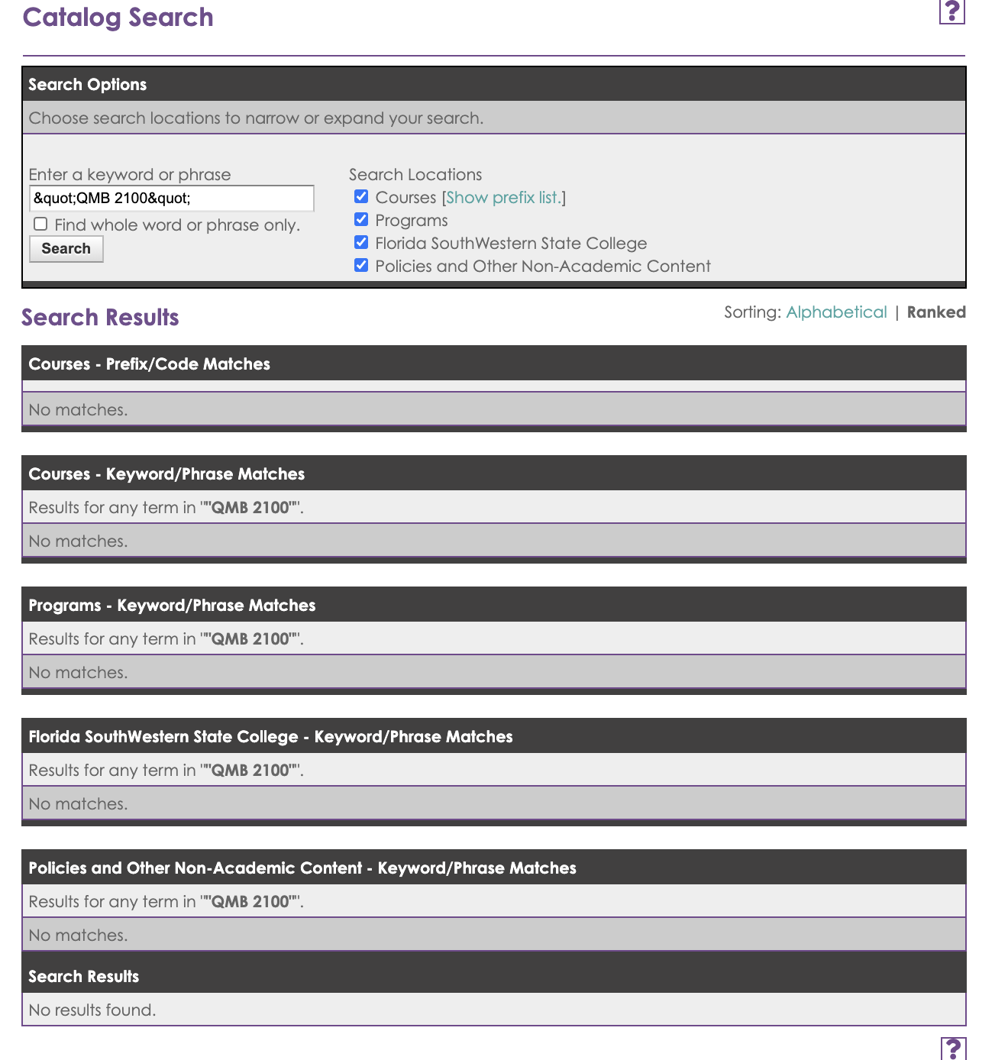

Section III, Justification for proposal
Provide justification (below) for this proposed curriculum action.
This course is part of the proposed AS in Business Analytics.

QMB 2100 uses the student’s background in analyzing data to reject or accept the null hypothesis as a starting point. QMB 2100 will use statistical analysis to make objective and unbiased business decisions. The course will focus on mining data, discovering meaningful patterns in data and, based on the findings, derive actionable insights and communicate them to executives.

