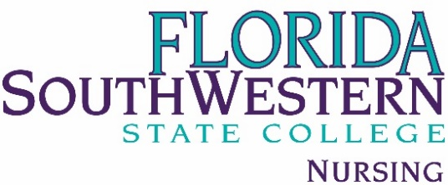

FT FACULTY AND STAFF COUNCIL AGENDA

Friday, August 20, 2021
1:00pm-3:00pm ZOOM: 851 5387 6912

Topic | Presenter
Welcome Back | Dr Voelpel
March to ACEN Begins | Dr Voelpel
Curriculum Updates | Chair Davis  Director Holbrook  Campus Coordinators: Dr Vitale and Prof Sweeney
COVID-19 shots and clinical placements | Dr Voelpel
Pinning Fall 2021 | Professor Lambert
Legislative Changes | Dr Vitale
Sigma Theta Tau | Professor Jenner
Library Advisory Board | Professor Goodwin
Questions and Comments | All

