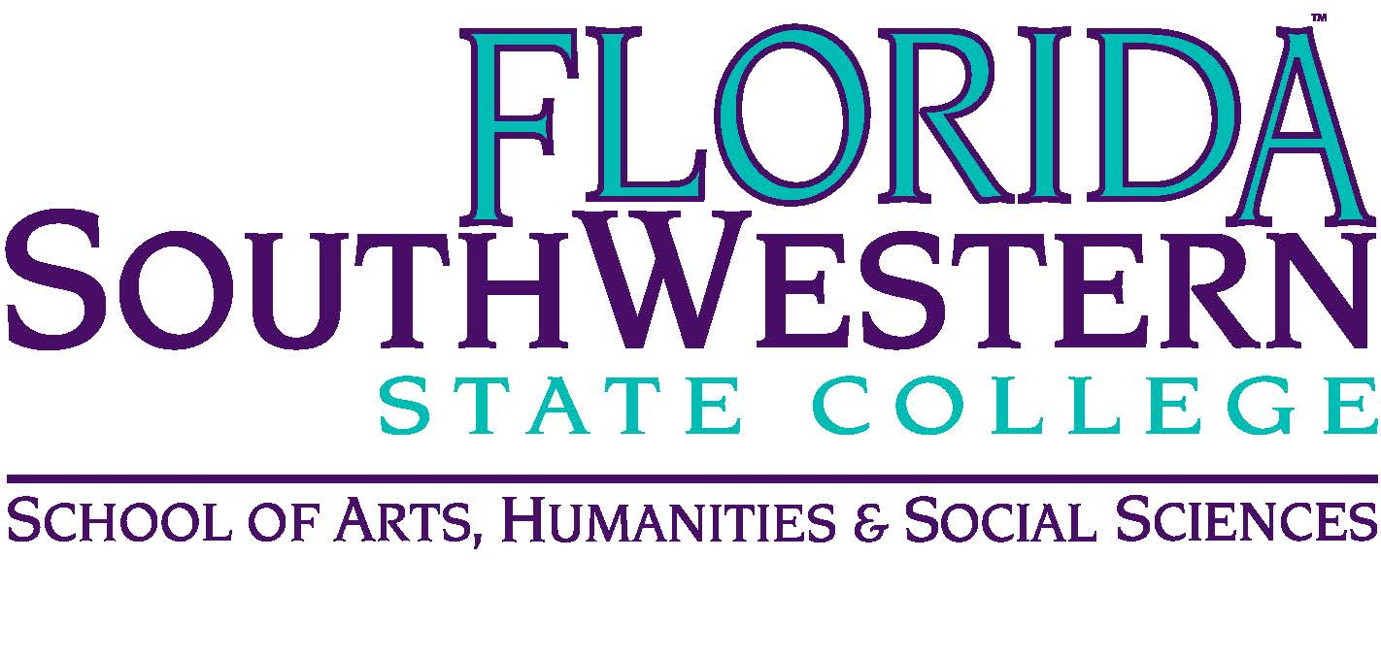
Department of Humanities and Fine Arts
Meeting Minutes
Date: April 14, 2023 — 9:30 a.m.
Location: Virtual (Zoom)
Chair: Elijah Pritchett
Minutes: Mike McGowan

 | Present | Absent | Excused
Brown |  |  | X
Chase, S | X
Chase, W | X
Chowdhury | X
Doiron | X
Harrington | X
Krupinski | X
Luther |  | X
McGowan | X
Molloy | X
Mompoint | X
Moore |  | X
Olguin | X
Pribyl | X
Pritchett | X
Roes | X
Sutter | X
Others | Puls, O’Neil, Quimby

- Opening
  - Call to Order: 10:00 a.m.
  - Attendance taken
  - Minutes from Feb. 2023 approved.
  - Remembering Tom Smith
- Committee Updates:
  - OER – nothing new to report
  - Learning Assessment – looking to new accrediting institutions. It’s not clear who’s going to be doing what moving forward. The potential new accrediting body: “Higher Learning Commission”
  - PD – Still funding available for $150 for ordering books. Also the fall travel application process is open (and summer is still open).
  - Hiring Committees – Two candidates are being interviewed soon in arts, and one in music. HB 999 has the Board doing the hiring. They can delegate to the President.
  - Union/Contract – We’re also undergoing large contract changes. All positions have been affected by these contract negotiations. Look for your raise and back pay. If you’re interested in working on Union issues, they’re looking for volunteers.

- Dept. Updates
  - Fine Arts – Dana is leaving. We have to select a new Chair. Fall Faculty Symposium on “Study Day” – instead of ARC grant presentations on duty days, we’ll potentially do a “5-minute speed talk” on research we’re doing, followed by reception for faculty.
  - Digital Arts – Shimul led a Capstone project (theme: “Illusions and Delusions”), which we should try to go to if possible.
  - Music – Tuesday Orchestra concert in BB Mann.
  - Audio Tech – Recording at BB Mann went well. Also our students are writing/recording music for FSW’s marketing department. Internships are going well. There’s a potential scholarship program this fall for Audio Tech.

- Department and College Business, Discussion Items:
  - Florida Legislature – send articles to each other to keep us informed
  - Florida Heritage Project – May 4th downtown talk at 2 pm (there’s also a Virtual Presentation) and 3:15 on-site presentation about origami.
  - Dana Roes, Ron Doiron – both will be missed.
  - Department Split, Chairs – No one volunteered for the Humanities Chair position. Mike Molloy will throw his hat in for Chair of Arts.
  - New Business – none to mention.

- Next Meeting: Fall 2023
- Action Items: NA

